VELMA 2.1 Supplement to VELMA 2.0 User Manual

December 30, 2021

Robert B. McKane ([mckane.bob@epa.gov](mailto:mckane.bob@epa.gov))

Allen F. Brookes ([brookes.allen@epa.gov](mailto:brookes.allen@epa.gov))

Jonathan J. Halama ([halama.jonathan@epa.gov](mailto:halama.jonathan@epa.gov))

Kevin Djang ([djang.kevin@epa.gov](mailto:djang.kevin@epa.gov))

Bradley L. Barnhart ([bradleybarnhart@gmail.com](mailto:bradleybarnhart@gmail.com))

Paul B. Pettus ([ppettus@gmail.com](mailto:ppettus@gmail.com))

Vivian Phan ([phan.vivian@epa.gov](mailto:phan.vivian@epa.gov))

U.S. Environmental Protection Agency

Office of Research and Development

Center for Public Health and Environmental Assessment

Pacific Ecological Systems Division

Corvallis, Oregon 97333

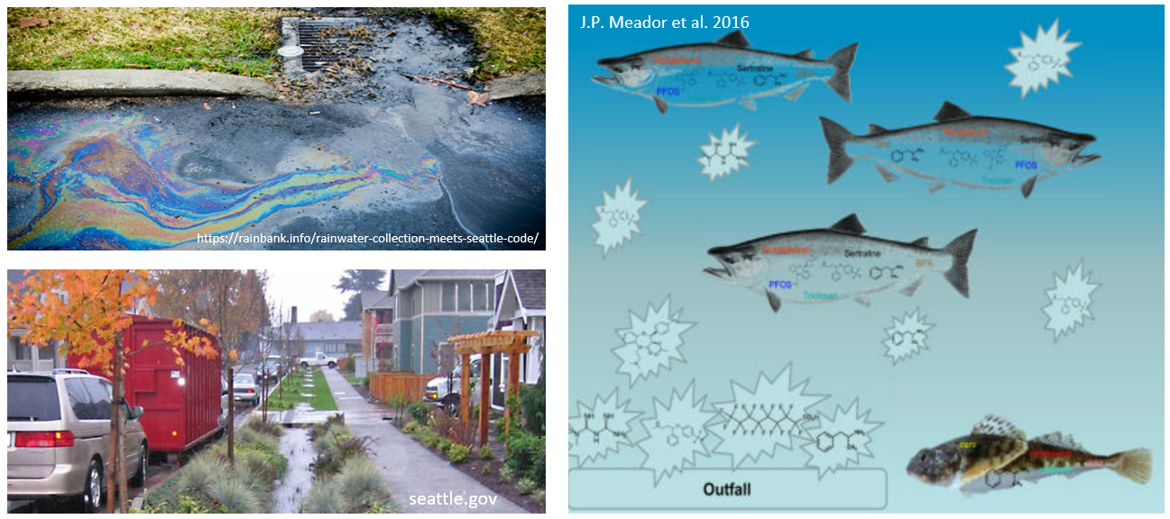

# Acknowledgements

The information in this document has been funded in part by the U.S. Environmental Protection Agency. It has been subjected to the agency’s peer and administrative review, and it has been approved for publication as an EPA document. This research was additionally supported in part by NSF grants 0439620, 0436118, and 0922100. We thank our many colleagues who have contributed advice and data during the course of developing VELMA 2.1 and its applications: Heather Golden, Chris Knightes, Don Phillips, Jim Markwiese, Paul Mayer, Joe Ebersole, Nathan Schumaker, Jana Compton, Renee Brooks, Peter Leinenbach, Lisa Chang, Rob Elleman, Angela Adams, Michael Rylko, Catherine Gockel, Dan Brown, Peter Murchie, Rich Fulford, Tom Hollenhorst, Joel Hoffman, John Johnston, Karretta Venable, and many other EPA colleagues; Ed Rastetter, Bonnie Kwiatkowski with the Marine Biological Laboratory; Courtney Zambory with the Oregon Department of Fish and Wildlife; Marc Stieglitz with the Georgia Institute of Technology; Sherri Johnson, Barbara Bond, Mark Harmon, Fred Swanson, Julia Jones, Suzanne Remillard, and other colleagues with the HJ Andrews Long Term Ecological Research (LTER) program; Tarang Khangaonkar with the Pacific Northwest National Laboratory; Ed Kolodziej, Kathy Peter, Joel Baker, Tessa Francis, Nick Georgiadis, Stefano Mazzilli, Guillaume Mauger with the University of Washington; Isaac Kaplan, Hem Nalini Morzaria Luna, Brian Cluer with NOAA; Joe Kane, Justin Hall, Paula Swedeen with the Nisqually Community Forest; David Troutt, Chris Ellings, Sayre Hodgson with the Nisqually Tribe; Cindy Spiry and Matt Baerwalde with the Snoqualmie Tribe; Phillip North, Philip Murphy, Jake McDermott, Michelle Totman with the Tulalip Tribe; Susan Dickerson-Lange and Julia Jay with Natural Systems Design; Mitch Attig and coworkers with the Columbia Land Trust; Jamie Robertson with the Nature Conservancy.

Disclaimer

Neither the United States Environmental Protection Agency (USEPA) nor the Georgia Institute of Technology (GT) makes any warranty or assume any legal liability or responsibility for the accuracy, completeness, or usefulness of any information, product, or process described herein. Reference to any special commercial products, process, or service by trade name, trademark, manufacturer, or otherwise, does not necessarily constitute or imply endorsement, recommendation, or favoring by the USEPA or GT. The views and opinions of the authors do not necessarily reflect those of the USEPA.

# EXECUTIVE SUMMARY

This main purpose of this VELMA 2.1 tutorial supplement to the original VELMA 2.0 User Manual (McKane et al. 2014) is to document concepts and methods for modeling effects of green infrastructure and stormwater (gray) infrastructure on contaminant fate and transport in urban and mixed-use watersheds.

This supplement also describes new and updated methods developed since 2014 User Manual to significantly extend VELMA’s applicability for a wider range of environmental conditions and decision support needs. For example, VELMA 2.1 procedures are described for explicitly modeling surface water and chemical transport on impervious surfaces to stormwater pipe inlets (drains) and outlets to streams and estuaries. Methods are described for setting up and modeling green stormwater infrastructure (rain gardens, bioswales, riparian buffers, etc.) and its effectiveness for reducing stormwater contaminant runoff through bioretention and enhanced degradation.

We have strived to make the VELMA 2.1 tutorial information in this document as user-friendly as possible . There is a lot of material packed into its nearly 300 pages, so we recommend that users take full advantage of the Table of Contents Navigation feature in Word. Click the View menu and check “Navigation Pane” to see this. It can help you browse the full scope of chapter topics (click on any chapter heading to go directly to that chapter) or search for a topic of interest in the “Search Document” window.

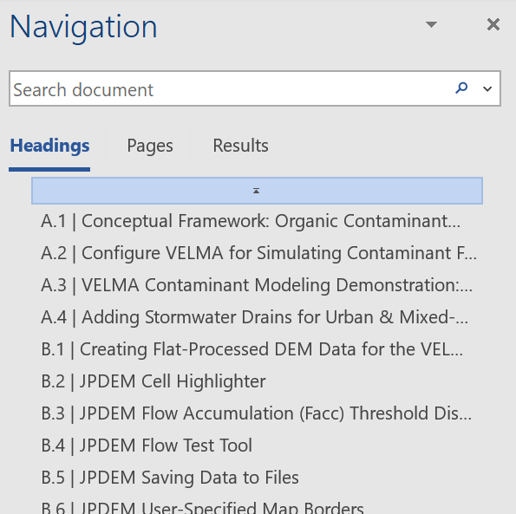

*R.B. McKane*

*12/28/2021*

**Reference**

McKane, R, A Brookes, K Djang, M Stieglitz, A Abdelnour, F Pan, J Halama, P Pettus, D Phillips (2014) Velma 2.0 User Manual and Technical Documentation. U.S. Environmental Protection Agency

Contents

Acknowledgements 2

EXECUTIVE SUMMARY 3

A.1 | Conceptual Framework: Organic Contaminant Modeling Using VELMA 6

A.2 | Configure VELMA for Simulating Contaminant Fate and Transport 23

A.3 | VELMA Contaminant Modeling Demonstration: Longfellow Creek Example 28

A.4 | Adding Stormwater Drains for Urban & Mixed-Use Watershed Applications 71

B.1 | Creating Flat-Processed DEM Data for the VELMA Simulator 82

B.2 | JPDEM Cell Highlighter 87

B.3 | JPDEM Flow Accumulation (Facc) Threshold Display 92

B.4 | JPDEM Flow Test Tool 96

B.5 | JPDEM Saving Data to Files 99

B.6 | JPDEM User-Specified Map Borders 103

B.7 | JPDEM User-Specified Border Mask 107

B.8 | JPDEM for Viewing Map Differences 117

B.9 | JPDEM Sub-Reach Delineations 124

B.10 | Flow Path Modification with the JPDEM Channel Cutter 139

C.1 | VELMA Reach Mapping 151

C.2 | How to Run VELMA in Parallel Mode 155

C.3 | Rationale for Parallel Velma and Reach Segmentation 163

D.1 | Acquisition & Generation of VELMA Input Data 165

D.2 | Soil Data Mapping and Parameter Initialization 170

D.3 | Initialize a Spatial Data Pool Using an Ascii Grid 181

D.4 | Create Initial Soil and Plant Chemistry Spatial (ASCII Grid) Data Pools 185

D.5 | Create Land-zoning Maps for a VELMA Application 201

D.6 | Add Georeferenced Projection Information to VELMA Output ASCII Maps 207

D.7a | Create Multiple-Location Weather Drivers – Alternate Methods Using Pseudo Weather Stations 210

D.7b | Statistical Climate Addendum: Development of Statistical Models Based on Monthly PRISM / Daymet Data 222

D.8 | Cell Data Writer Configuration 235

D.9 | Set Up VELMA biomass Outputs as Inputs to BlueSky 238

D.10 | Default Tidewater Model Configuration 250

E.1 | Mapping Surface Layer Permeabilities 254

E.2 | VELMA Surface Chemistry Pools 265

E.3 | Deposition of Surface Chemicals 271

E.4 | Implementing Green Roof Applications in VELMA 275

E.5 | Irrigation Disturbance 281

E.6 | Groundwater Storage Mechanism 284

E.7 | Spatial Data Writer Key Words for Generating ASCII VELMA Outputs for Data Visualization 287

# A.1 | Conceptual Framework: Organic Contaminant Modeling Using VELMA

**Overview** *(Tutorial A.1_HowTo_VELMA Contaminant Modeling Conceptual Framework)*

This document describes the conceptual framework underpinning the use of VELMA 2.1 to model fate and transport of organic contaminants within watersheds. We review how VELMA 2.1 simulates contaminant fate and transport within soils and hillslopes as a function of two processes: (1) the partitioning of the total amount of a contaminant between sorbed (immobile) and aqueous (mobile) phases; and (2) the vertical and lateral transport of the contaminant’s aqueous phase within surface and subsurface waters.

Subsequent sections describe the interplay of contaminant sorption/desorption processes with VELMA’s ecohydrological processes that control vertical and lateral transport within soils, hillslopes and watersheds.

***This “HowTo” VELMA document is a companion to the two others listed below. We recommend reading this A.1 concepts document before the other two.***

* Tutorial A.2 – Configure VELMA for Simulating Contaminant Fate and Transport
* Tutorial A.3 – VELMA Contaminant Modeling: Longfellow Creek Example

1.0 Introduction

Hundreds of thousands of organic contaminants have been and continue to be produced and released into the environment in a range of quantities. Some are persistent organic pollutants (POPs) resistant to environmental degradation (El-Shahawi et al. 2010). Pesticides, solvents, pharmaceuticals and industrial chemicals are a few examples. Because of their persistence, POPs can bioaccumulate and adversely affect terrestrial and aquatic food webs and human health.

Therefore, it is important to understand the “life cycle” of organic contaminants after they are released into the environment. Where and when is a contaminant deposited and in what quantities? How is it then adsorbed, degraded and transported within natural and built environments, and what is its fate in space and time?

Answers to these questions are elusive, requiring some combination of environmental monitoring (refs), advanced analytical methods (refs), and data synthesis and analysis tools. Computer simulation modeling can potentially play a larger role in data synthesis and analysis, though adequate tools are few.

VELMA 2.0 (McKane et al. 2014) has been enhanced as VELMA 2.1 to simulate the fate and transport of organic contaminants within watersheds, providing an opportunity to facilitate data synthesis and analysis for projects having enough monitoring and ecotoxicological data (refs).

This document provides a guide for using VELMA 2.1 to model fate and transport of organic contaminants. Our intent is to provide a state-of-the-science tool that addresses a specific modeling gap, namely, a spatially-distributed and scalable model for simulating process-level hydrologic and biogeochemical controls on contaminant sorption-desorption, degradation and vertical and lateral transport within soils and watersheds. Other documents in this VELMA 2.1 package illustrate new techniques for simulating the effectiveness of natural and engineered green infrastructure – riparian buffers, rain gardens, bioswales, pervious pavements, green roofs and others – for reducing contaminant loads to surface and groundwaters.

VELMA 2.1 is designed to allow users to model essentially any organic contaminant in the EPA Comptox library for which solubility, partitioning, degradation and other supporting coefficients are available (<https://comptox.epa.gov/#/>). Comptox provides information for over 760,000 chemical substances, the majority of which are organic contaminants (Williams et al. 2017; McEachran et al. 2017).

2.0 Conceptual Framework

In VELMA 2.1, contaminant fate and transport within soils and hillslopes is primarily controlled by two processes: (1) the partitioning of the total amount of a contaminant between sorbed (immobile) and aqueous (mobile) phases; and (2) the vertical and lateral transport of the contaminant’s aqueous phase within surface and subsurface waters. Sections 2.1 and 2.2 describe the conceptual basis for the partitioning and transport modeling steps in VELMA.

2.1 Contaminant Partitioning between Sorbed and Aqueous Phases

VELMA 2.1 incorporates the methods of Piwoni and Keeley (1990; <https://permanent.access.gpo.gov/lps49292/issue6.pdf>) to describe the processes by which organic contaminants are partitioned between sorbed (bound by soil, immobile) and aqueous (dissolved, mobile) phases within soil columns, such as those represented in VELMA. The section on “Sorption Estimation” in Piwoni and Keeley (1990), presented below as Figure 1, provides a concise summary of the processes, parameters and calculations used to estimate partitioning of any given contaminant into its sorbed and aqueous phases. These parameters and methods have been built into VELMA 2.1.

*(continued)*

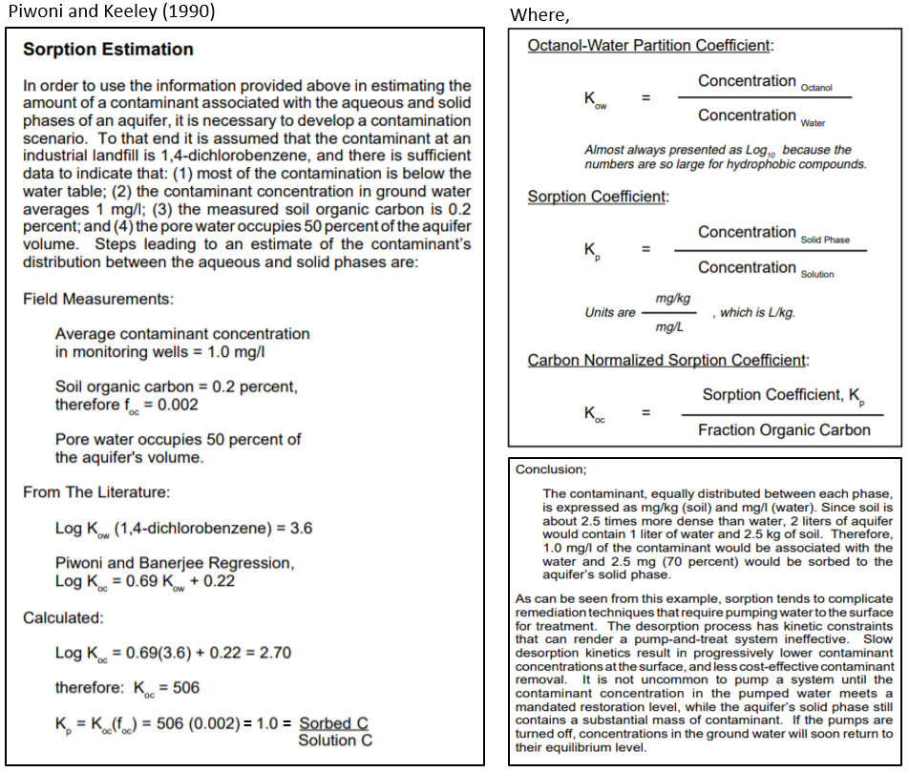

**Figure 1. Quoted material from Piwoni and Keeley (1990) describing an adaptable set of equations for estimating the partitioning of a contaminant, in this case 1,4-dichlorobenzene, between groundwater (aqueous phase) and soil organic matter (sorbed phase).**

Figure 1 describes several contaminant model parameters that require additional comment. KOW is the octanol-water partition coefficient for a specified organic chemical. Octanol is used as a standard organic chemical for calculating hydrophobicity of organic contaminants, particularly lipids. When an organic contaminant of interest – dichlorobenzene in the Figure 1 example – is placed in a well-mixed, octanol-water system, KOW is the ratio of the contaminant’s concentration in the octanol phase to its concentration in the aqueous phase. This octanol-water partitioning procedure is determined experimentally.

VELMA 2.1 users can find the published KOW value for contaminants of interest in EPA’s Comptox library (<https://comptox.epa.gov/#/>). Comptox also provides estimates for other contaminant biophysical constants that VELMA requires, for example, solubility in water (mol/L) and biodegradation half-life (days) – See sections 3.0 – 3.4 for details.

As described in the lower left panel of Figure 1, two additional pieces of information – the amounts of soil organic carbon and water within each soil layer – are needed before VELMA can translate the unitless ratio for the octanol/water partition coefficient, KOW, to the more meaningful soil/water sorption coefficient, KP.

That is, KP must be calculated to address the question: What portion of the total amount of a contaminant within a soil layer is sorbed by soil (mg contaminant/kg bulk soil) versus that which is dissolved in soil water (mg contaminant/L)?

There are three steps to answering this question.

Step 1: Recall that octanol only provides a proxy, ratio-based measure of a contaminant’s affinity for soil organic matter and, further, that soil organic matter concentrations tend to vary greatly with depth and across soil columns and landscapes. Therefore, to translate KOW to KP, it is first necessary to obtain estimates of how a specified mass of soil organic matter is distributed within soils, both vertically and laterally. Because VELMA is a grid-based watershed model with each grid cell representing a 4-layer soil column, users must specify the total amount of soil organic matter (carbon g/m2) within each soil column in the modeled watershed. In VELMA, well-decomposed (unidentifiable) soil organic matter is referred to as “humus”. Typically, this task can be accomplished using SSURGO-quality soil survey data (see VELMA 2.1 How To documentation, “Tutorial D.2 – Soil Data Mapping and Parameter Initialization”). With that information, VELMA internally calculates the vertical distribution of humus carbon for soil layers 1-4. Details on VELMA’s soil carbon submodel and its application can be found in Abdelnour et al. (2011; 2013) and McKane et al. (2014).

Step 2: With the specified survey-based spatial estimates of soil organic carbon (humus), VELMA internally calculates the carbon normalized sorption coefficient, KOC. This requires user input of published empirical regression parameters describing the relationship between KOW and KOC. For example, the lower left panel of Figure 1 uses linear regression parameters (log KOC = 0.69*log KOW + 0.22) described by Piwoni and Banerjee (1989).

They found that the same parameters accurately predicted sorption of 1,2-dichlorobenzene and other organic solvents, within the limits of their experimental system. Contaminant-specific regression parameters for calculating KOC can often be applied to chemically similar contaminants, with the caveat that soil organic matter concentrations and mineralogy are within the range of experimental conditions for which the regression was developed (Piwoni and Banerjee 1989; Ho et al. 2005).

VELMA 2.1 allows users to specify parameters for published linear regression equations describing contaminant sorption behavior. While linear regression is perhaps the most common approach for modeling contaminant sorption, it can lack accuracy across broad contaminant and soil organic matter concentration ranges. More robust nonlinear sorption regression options, such as Freundlich, Langmuir and others (Ho et al. 2005), will also be built into VELMA.

Step 3: VELMA then uses the regression-based estimate of KOC (Step 2, above) to internally calculate the soil sorption coefficient, KP (Figure 1, lower left panel). This third step also requires an estimate of the water content of the soil layer, which VELMA internally calculates for each day of the simulation. The ecohydrological processes by which VELMA simulates soil water content are described in section 2.1.

The preceding information is more concisely summarized in Table 1, below. Table 1 also includes a contaminant solubility parameter that users must enter into VELMA, so that the model can internally calculate the amount (mol/L and g/m2) contaminant that can be dissolved into solution. Section 3.3.2 provides details.

**Table 1. Summary of coefficients for dynamically estimating the amount of a specified contaminant associated with the aqueous and solid (sorbed) phases within soil columns in VELMA.**

|  |  |  |  |
| --- | --- | --- | --- |
| **Contaminant coefficient** | **Definition and explanation** | **Units** | **Data Source** |
| Log KOW | **Octanol-Water Partition Coefficient.** KOW (log10) is the experimentally determined ratio of a contaminant's concentration in the octanol (C8H17OH) phase of a two-phase octanol-water system. KOW is a standard indicator of a contaminant’s affinity for adsorption by organic matter. Higher KOW values indicate strongly sorbed, less mobile (hydrophobic) chemicals. | unitless ratio, Log10 | User enters KOW value into VELMA based on EPA Comptox website, <https://comptox.epa.gov/dashboard>. Note that Comptox expresses KOW as KP, a confusing use of terminology because KP recalculates KOW to address the effect of variations in soil organic matter on contaminant sorption. |
| fOC | **Soil Organic Carbon Fraction**. In VELMA, fOC varies with soil type and depth and changes dynamically with climate and management. It is used to convert a contaminant’s octanol-water partition coefficient, KOW, to KOC (see below). | Fraction (0-1) = [(g soil humus carbon) / (g bulk soil)]. VELMA calculates fOC per soil layer per grid cell per day. | In VELMA, users specify initial humus (soil organic matter) values (g C/m2) according to soil survey or other data, for example, NRCS soil survey map data. VELMA then calculates initial fOC values and subsequent daily changes in fOC in response to environmental and management drivers (McKane et al. 2014). |
| Log KOC | **Organic Carbon Normalized Sorption Coefficient.** KOCis calculated based on published regressions relating KOC to KOW and fOC. For example: log KOC = 0.69*(KOW) + 0.22 for 1,4-dichlorobenzene (Piwoni & Banerjee 1980). KOC is used to calculate KP (see below). | Unitless, log10 | Users need to specify published regression parameters that VELMA uses to calculate KOC as a function of KOW and fOC. See Figure 1 (left panel). Also see Figure 5 for KOC regression coefficient parameter names in VELMA. VELMA uses these coefficients to internally calculate daily changes in Log KOC, which is used in turn to internally calculate KP. |
| KP | **Soil-Water Partition Coefficient.** KP describes the partitioning of contaminant between soil and water, expressed as the ratio  [(mg/kg bulk soil) / (mg/liter water)]. VELMA internally calculates KP = KOC (fOC), where KOC is the antilog of log KOC. Thus, KP is conceptually similar to KOW, however, KP provides a more precise estimate of contaminant sorption by factoring in the dominant effect of soil organic matter on sorption in soils. Higher KP values indicate less mobile (hydrophobic) chemicals. | Unitless ratio | VELMA internally calculates daily changes in KP based on methods of Piwoni and Keeley (see Figure 1). |
| Solubility | **Solubility** of a specified contaminant in water. | mol/L | EPA Comptox website, <https://comptox.epa.gov/dashboard> |

2.2 Ecohydrological Regulation of Contaminant Fate and Transport

VELMA provides a detailed treatment of the hydrological processes that control how water moves within watersheds – vertically within soil columns, and laterally along hillslopes and eventually to streams. As water moves through the watershed it can pick up and transport solubilized contaminants, which can be sorbed, desorbed, or not, at any point along a flow path, depending upon changing hydrologic and biogeochemical conditions.

Figure 2A and Figure 2B conceptually describe the VELMA 2.1 hydrologic submodel, focusing on soil water pools and fluxes affecting transport of dissolved contaminants and nutrients. Details on hydrologic equations parameters and equations can be found in Abdelnour et al. (2011) and McKane et al. (2014).

The most significant VELMA 2.1 updates Figure 2A and Figure 2B include spatially explicit transfers of surface water, SW (Figure 2A). VELMA 2.1 dynamically simulates daily transfers of surface water and dissolved contaminants and nutrients in and out of each grid cell on a daily time step. Impervious and semi-pervious surfaces can be simulated, including pavement, roofs, rock outcroppings, etc. Geospatially defined curbs, stormwater drains, and pipes can intercept and redirect surface flow to specified outflows (Figure 2B). Curb cuts for directing stormwater runoff to roadside rain gardens can also be simulated. In short, the addition of a spatially-explicit surface layer to VELMA 2.1 makes it possible to better simulate water/contaminant/nutrient fate and transport in urban and mixed-use watersheds to a high degree of geographic specificity (5 or 10-meter grids) where such data are available. Where centralized urban stormwater databases are not available, stormwater drains and pipes can be imputed using road network grid GIS databases and general stormwater system knowledge of municipal stormwater managers (Halama et al. in preparation).

In summary, Figures 2A and 2B need to be considered together to understand the hydrologic processes in VELMA 2.1 affecting contaminant fate and transport in urban watersheds equipped with stormwater infrastructure. Not shown in these figures are the interacting biogeochemical processes and parameters that modify hydrologically-driven contaminant transport processes in VELMA 2.1. These are: (1) Solubilization of contaminants deposited on impervious surfaces (SW in Figure 2A) or on soil layer 1; (2) Contaminant sorption-desorption kinetics between sorbed and aqueous phases; (3) and contaminant degradation. Modeled biogeochemical processes and parameters for these processes are described in Tutorial A.1 subsection 2.1 (above), and Tutorial A.2. It is the interaction of these hydro-biogeochemical (ecohydrological) processes that control transport of dissolved contaminants within cells, between neighboring cells, and to distant cells and outfalls to stream channel cells via storm drains and pipes.

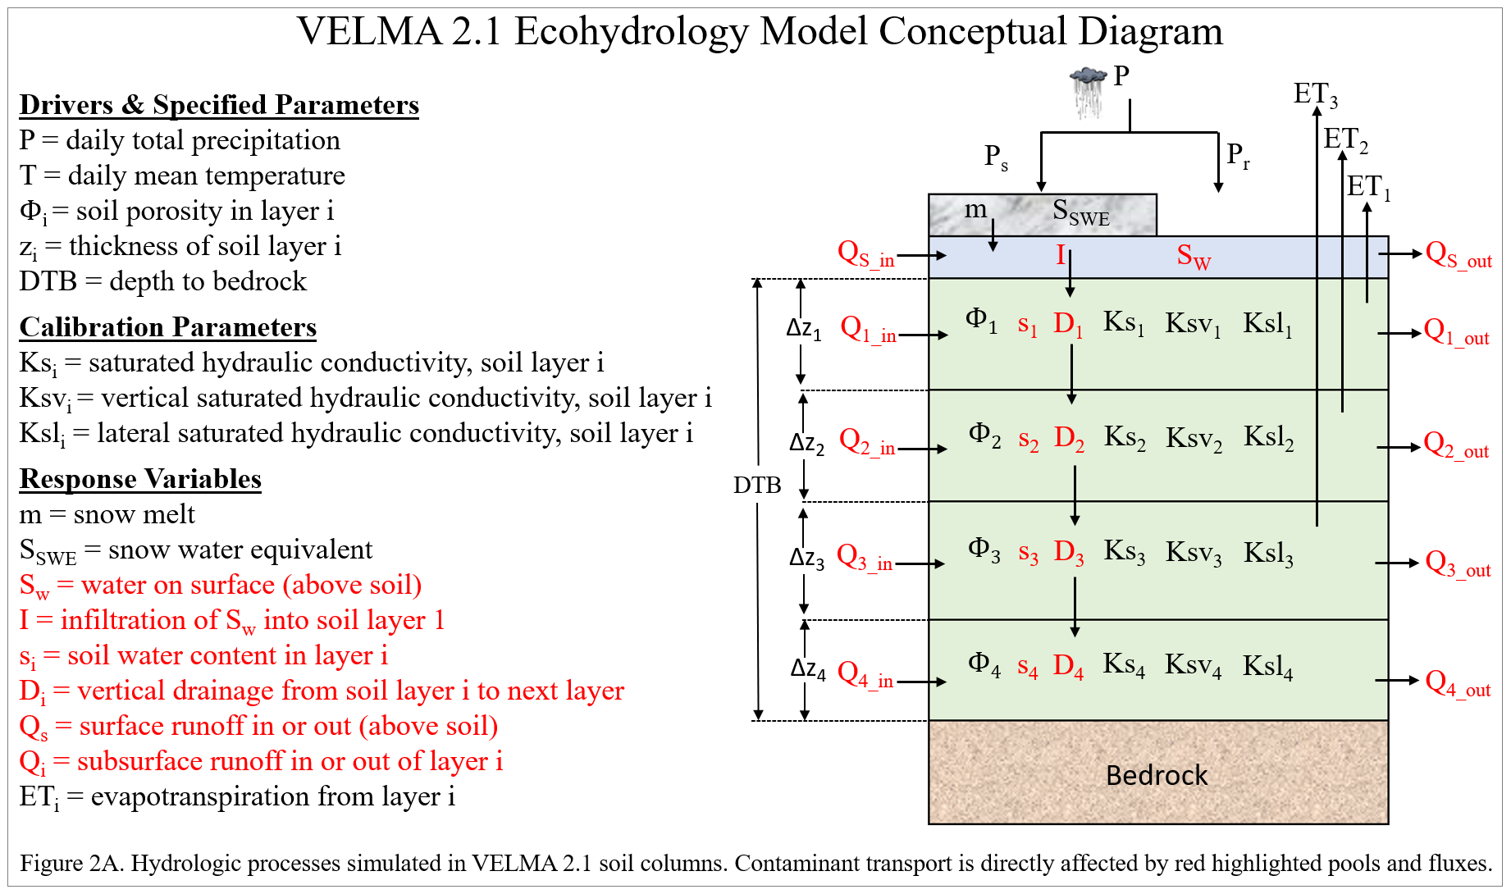

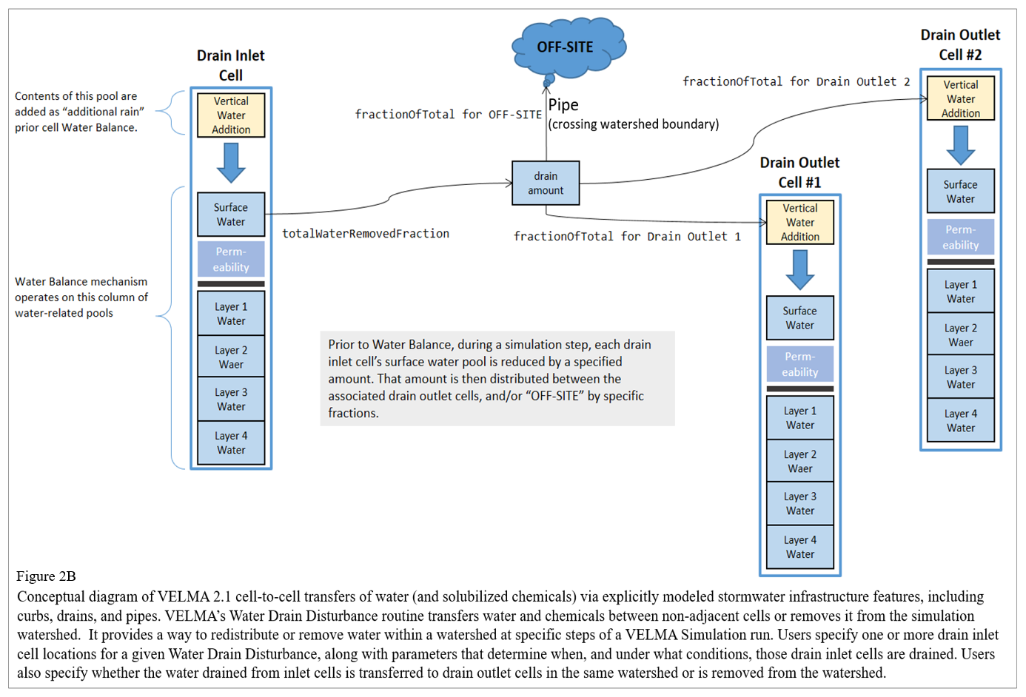

2.3 Other Processes Affecting Contaminant Fate and Transport

Organic contaminants added to a VELMA simulation configuration can also undergo degradation. Contaminant degradation in VELMA is based on generalized organic matter decay equations and applied using microbial efficiency and decay parameters (Potter et. al 1993; see McKane et al. 2014).

No other soil and plant processes currently occur for contaminants. Plant uptake of contaminants is not currently simulated but is functionally possible with VELMA’s existing plant-soil submodel (McKane et al. 2014) and could be added later to address phytoremediation actions.

2.4 Summary of Processes Controlling Contaminant Fate and Transport in VELMA

The following bullets summarize fate and transport concepts described in the preceding sections, in the context of steps outlined in subsequent sections for configuring VELMA 2.1 to simulate contaminant fate and transport in watersheds for which it has been parameterized.

Steps

1. No contaminant processing occurs unless contaminants are initialized into soil columns at time zero of a simulation, or are configured to deposit onto the surface during a simulation run. Section 5.0 provides details for instructing VELMA on how much, when and where to deposit a contaminant.
2. Contaminant amounts deposited onto the surface are transported laterally (to other surface cells) and vertically (infiltrating to the top soil layer) based on water movement calculated by VELMA’s water-balance mechanism, coupled with the contaminant’s specified solubility (section 3, below). Yellow highlighting in Figure 2 (section 2.2) illustrate the pertinent infiltration (I) and runoff inflows and outflows (Qin, Qout ) that VELMA internally calculates each day.
3. Contaminant amounts within soil layers undergo partitioning into aqueous and sorbed amounts. Sorbed amounts are a function of soil organic matter (humus) and soil water amounts (sections 2.1 and 2.2).
4. The aqueous (dissolved) portions of the contaminant within the soil layers undergo lateral and vertical transport based on VELMA’s water-balance mechanism (Figure 2 highlighted fluxes), coupled with the contaminant’s specified partition coefficients controlling sorbed/aqueous ratios (sections 2.1 and 2.2).
5. Sorbed contaminant amounts occurring within soil layers decompose using the same Potter equation employed for VELMA’s core chemistry calculations (McKane et al. 2014) (section 3.3.3).
6. Steps 2 through 5 occur for any cell containing contaminant amounts for every time step of the simulation run.

3.0 How to Configure VELMA to Simulate Contaminant Fate and Transport

VELMA 2.1 supports the addition of one or more organic contaminants to a simulation configuration.  
As described in the following sections, users need to add each contaminant with its own set of parameters in order to simulate fate and transport of specific organic contaminants (e.g., DDT) during a simulation run.

Configuring one or more contaminant parameterizations requires configuration of an equal number (or more) of VELMA disturbance parameterizations to introduce specified amounts of the contaminant into the simulation state. VELMA disturbances can be configured to introduce specified amounts of contaminant to specific locations (grid cells) of the simulated watershed and at specified days during the simulation run.

Note that unlike VELMA’s atmospheric nitrogen deposition parameter, “nin”, there is no designated parameter in the VELMA 2.1 that users can use to automate uniform, watershed-scale daily additions of a contaminant. However, an alternate method for implementing uniform daily amounts of contaminant deposition can be used to create a contaminant deposition map and supporting parameters to deposit spatially and temporally uniform amounts of a contaminant to all cells within the watershed. Users have option of creating deposition maps that are uniform or variable in time and space across a watershed.

VELMA 2.1 is programmed to automate the process of generating Spatial Data Writers that produce grid-based data arrays (ascii grid files) describing spatial and temporal changes in contaminant pools and fluxes during a simulation. VELMA saves these ascii grid files (.asc) to the VELMA results folder. At the end of a simulation, users can load these ascii grid files into ArcGIS or other GIS-based visualization tool to develop spatial and temporal visualizations and animated movies showing contaminant fate and transport within the modeled watershed. When a user sets up a contaminant simulation run, VELMA automatically sets up a generic Spatial Data Writer prefix name that cannot be modified but to which the user can add a suffix name that defines specific contaminants and pools to be saved as ascii grids in the VELMA results folder. Section 23.0 in the VELMA 2.0 User Manual (McKane et al. 2014) provides details for setting up Spatial Data Writers.

3.1 Optional: How to Configure VELMA for Simulating Contaminant Fate and Transport in Parallel Mode

This optional section provides instructions for setting up a contaminant fate and transport simulation for one or more contaminants, but while running VELMA in parallel mode – that is, for simultaneously running separate simulations in parallel for the multiple subwatersheds that make up a larger basin. The option of running VELMA in parallel mode can save time for simulating large watersheds. However, this is unnecessary if the simulated watershed is less than 10 km2.

Running in parallel model, VELMA will merge hydrologic and biogeochemical outputs from each subwatershed’s pour point to the appropriate downstream reaches, such that spatial and temporal model outputs are entirely consistent with outputs when VELMA is run for the entire watershed. The only difference between running VELMA in parallel mode versus whole-watershed model is that parallel mode takes significantly less time.

To set up a parallel mode simulation, start with a “proven”, VELMA simulation configuration – i.e., a simulation configuration .xml file that is already calibrated and known to run reliably and accurately for the study site.

Load that simulation configuration .xml file into JVelma – for details, see McKane et al. (2014) – and immediately change its “Simulation Run Name”, then save it. This creates a copy of the original .xml that you can modify with contaminant additions, while saving the original .xml for single-process use.

With the new copy of the proven simulation configuration loaded into JVelma, adding one or more contaminants involves the following steps for each contaminant you wish to add:

1. **Use JPDEM to discover and note the subwatershed outlets of interest for running VELMA in parallel model.** For instructions see the tutorial named “Tutorial B.9 – JPDEM Sub-Reach Delineations”.
2. **Parameterize a VELMA 2.1 simulation configuration for MULTI (parallel) model runs.** For instructions see the tutorial named “Tutorial C.2 – How to Run VELMA Parallel Mode”.
3. **Add a new Contaminant parameterization group to the MULTI simulation configuration.** For instructions see the tutorial named “How-to” documentation named “Tutorial A.2 – Configure VELMA to Add Organic Contaminants”.
4. **Add one or more Disturbance parameterization groups to the simulation configuration file (.xml) to add specified amounts (g/m2) at specific times and locations during the simulation.** For instructions see the tutorial named “Tutorial A.3 – VELMA Contaminant Modeling: Longfellow Creek Example”
5. **(Optional) Add one or more Spatial Data Writer parameterization groups to produce spatially-explicit map results for the contaminant.** For instructions see the tutorial named “Tutorial D.8 – Cell Data Writer Configuration”.  
   Note: The DailyResults and any configuration Cell Data Writer .csv files automatically include columns for any contaminants added to simulation configuration. Only Spatial Data Writers must be explicitly parameterized.

Save the changes to the simulation configuration .xml file. It is now ready for use in VELMA Parallel Mode.

3.2 How to Add a Contaminant Parameterization to a VELMA Configuration

With a proven VELMA simulation configuration loaded into JVelma,  
click the Edit🡪Contaminants🡪“Add a New Contaminant” menu item, as shown in **Figure 3**, below:

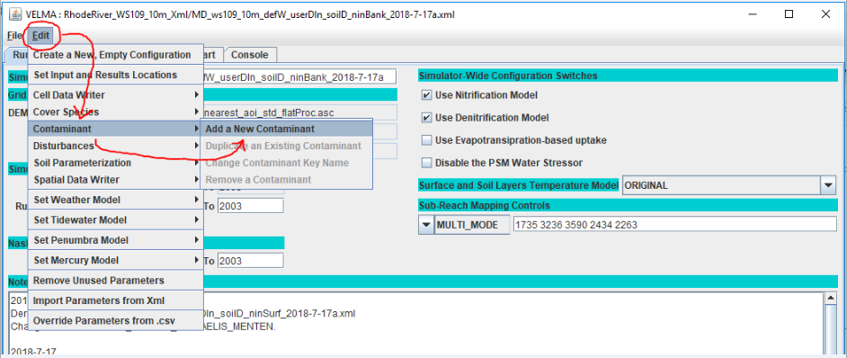

**Figure 3.**

In the “Unique Contaminant Name” pop-up dialog (Figure 4**)** that opens next, provide a name for the contaminant. The name should begin with an alphabet character and may consist of only alpha-numeric and underscore (“_”) characters and must remain unique among all contaminants in the configuration.

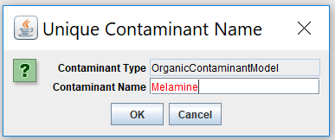  
**Figure 4.**

Clicking OK in the “Unique Contaminant Name” dialog adds a new parameterization group to the simulation configuration, and changes JVelma’s display to the “All Parameters” tab, with the Item-level filter set to only display the parameters for the newly-added contaminant.

In the display below, click the “Parameter” column header to sort the parameters by name.

*(continued)*

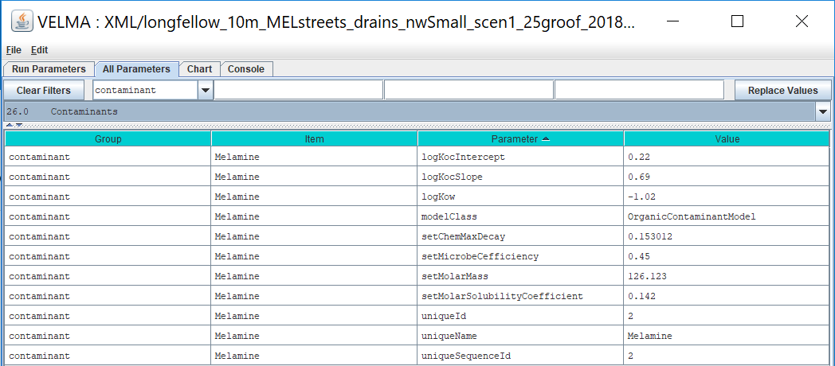

**Figure 5.**

Note that when you first establish a contaminant Group/Item, all adjustable parameter values are initially highlighted in yellow, indicating that they are currently unset and need to have Values entered. In Figure 5, the user has left no adjustable parameters unset. Preset parameter values that are never highlighted and should never be adjusted. Preset parameters include “modelClass” and “uniqueName”. In Figure 5, the user preset values for these parameters as “OrganicContaminantModel” and “Melamine”, respectively, when using the “Edit/Contaminant/Add a New Contaminant” menu.

3.3 How to Set Contaminant Parameter Values

VELMA users can set contaminant parameter values using the graphical user interface shown in Figure 5. Sections 3.3.1 – 3.3.5 break out several categories of contaminant parameters shown in Figure 5. In these sections, VELMA users must enter a value for parameter names that are initially highlighted in yellow. Note that Parameter names are also presented in camelCase (<https://en.wikipedia.org/wiki/Camel_case>). Definitions, units and data sources are provided for each parameter. Users can find values for most contaminant parameters through searching publicly available sources, such as EPA’s CompTox library or publications. If data are not available for a contaminant, users should consult with an expert to discover unpublished data, or to seek advice on the feasibility of using data for a biochemically similar contaminant.

3.3.1 Parameters for Sorbed-Aqueous Contaminant Partitioning

VELMA 2.1 users need to enter values for just three parameters that affect partitioning of a contaminant between sorbed (bound by soil) and aqueous (dissolved) phases within soil. These are listed in Figure 5 under the Parameter column: logKow, logKocInterceptand logKocSlope. Column 4 of Figure 5 shows where users enter values for these parameters for the contaminant specified. The following notes describe data sources for these parameters.

logKOW =octanol-water partition coefficient, expressed as the logarithm of the experimentally determined ratio for chemical concentration in octanol phase / chemical concentration in aqueous phase. See Section 2.1 for additional details. Log KOW values for most contaminants can be found in EPA’s Comptox library (<https://comptox.epa.gov/#/>). **CAUTION:** Comptox generally refers to KOW as KP, an unfortunate break from established nomenclature. In VELMA, we follow established nomenclature, such as found in Piwoni and Keeley (1990), whereby KOW is reserved for octanol-water partitioning, and KP is reserved to address the important effect of soil organic matter content (fOC) on contaminant sorption for a particular soil. See Figure 1 for additional details. Therefore, for a given contaminant, VELMA users will need to set the logKow parameter value (see Figure 5) to the KP value in Comptox.

logKocIntercept = unitless slope intercept parameter for an empirically-derived linear regression describing the correlation of Log KOC to KOW for the contaminant of interest. Users need to search the literature for regression equations representative of the contaminants and soil characteristics of interest. See Figure 1 in Section 2.1 and Piwoni and Keeley (1990) for examples and further explanation.

logKocSlope = unitless slope parameter for an empirically-derived linear regression describing the correlation of Log KOC to Log KOW for the contaminant of interest. See Figure 1 and Piwoni and Keeley (1990) for an example. Depending upon the contaminant to be simulated, users may need to search the literature for a representative regression equation.

Reminder: VELMA internally recalculates all other partitioning parameters (fOC, Log KOC, KP) described in Table 1, as a function of the preceding parameter values and simulated daily changes in soil water and humus content.

3.3.2 Contaminant Solubility Parameter

setMolarSolubilityCoefficient= solubility (mol/L) of a contaminant in water. Contaminant solubility values can be found in EPA’s Comptox library (<https://comptox.epa.gov/#/>).

setMolarMass = contaminant molecular weight (g/mol). Comptox provides the molecular weight for all contaminants in its library. Users need to enter this so that VELMA can calculate solubility

When the user provides these two parameters, VELMA calculates a *gramSolubilityCoefficent* value “behind the scenes” as:

*gramSolubilityCoefficient = molarMass * molSolubilityCoefficient*,

with units, g/L = g/mol * mol/L

All of which leads to the behind the scenes calculation for surface contaminant solubility and vertical transfer:

*totalChemTransferAmount = Math.min(totalWaterFlow * gramSolubilityCoefficient, totalChemAmount)*

3.3.3 Contaminant Decay Parameters

setMicrobeCefficiency= the unitless microbial efficiency (range [0.0, 1.0]) of degradation of organic contaminants in soil, that is, the ratio of carbon assimilated/total carbon consumed, whereby the difference is that respired as carbon dioxide. Typical microbial efficiencies range from 0.45 to 0.55.

setChemMaxDecay = the maximum daily decay rate constant (fraction per day) of a specified contaminant. The Comptox library (<https://comptox.epa.gov/#/>) lists the half-life for most organic contaminants, from which the daily maximum decay rate constant can be calculated and specified for this parameter. Users can enter the specified half-life value into an online calculator to calculate the decay constant. For example, see <https://www.calculator.net/half-life-calculator.html?type=2&chalflife=4&cmeanlifetime=&cdecayconstant=&x=35&y=16>. Note that decomposed contaminant amounts are not tracked by the simulation and not reported in its results. This is because contaminants almost always make up an insignificant fraction of the total amount of organic matter within soils.

3.3.5 Parameters That Can Be Left Alone (purposely not yellow highlighted)

uniqueName = the parameter name that you specified while adding the contaminant parameterization to the configuration. After that initial specification, we recommend never changing this parameter’s value, because it is used as part of the name for the contaminant’s spatial data pools. If you do change a uniqueName’s value, any disturbances referencing its spatial data pools must be updated to reference those pool names as well.

modelClass= parameter set by VELMA when you add the contaminant to the simulation configuration. Do Not Change this parameter’s value. Ever.

uniqueId **=** parameter that VELMA generates automatically, and should be left as-is.

uniqueSequenceId = determines the sequence in which the contaminants are processed during each VELMA simulation step. It is provided for future, possible enhancements to the contaminants code that would let one contaminant interact with another. However, that functionality is currently unavailable, and the uniqueSequenceId values that JVelma generates for you can be left as-is.

4.0 Specifying the Names of a Contaminant’s Spatial Data Pools

Spatial Data Writers are how a VELMA reports spatially-explicit simulation results. Users have the option of setting up Spatial Data Writers to report a simulation result for an output variable for every cell in the simulation grid. This feature is especially useful for displaying 2D or 3D maps in VISTAS (<http://blogs.evergreen.edu/vistas/vistas-software/>), ArcGIS, or other software equipped to display model output in a landscape-oriented format. For details, see Section 23, page 96, in McKane et al. (2014).

A given contaminant parameterization is associated with 2 types of spatial data pools:

* A single-layer Surface Pool
* Multi-layered Soil Pools (4 total)

Both pools store per-cell (and per-cell, per-layer for the layered pool) quantities of the contaminant itself.

Unlike VELMA’s core chemistry pools, contaminant spatial data pool names are constructed using a common prefix and a unique suffix. To provide proper key-name for disturbances or spatial data writers parameterized to reference or modify contaminant pool values, you must know how to construct the specific pool name for a specific contaminant pool.

The contaminant’s surface pool prefix is “CONTAMINANT_SURFACE_” and the suffix is the contaminant’s uniqueName parameter value shifted to all-uppercase.

Example:  
If uniqueName = “DDT”, the surface pool key-name is: CONTAMINANT_SURFACE_DDT.

Similarly, the contaminant’s layered pool prefix is “CONTAMINANT_LAYERS_” and the suffix is the uniqueName parameter value, again, all-uppercase.

Example:  
With uniqueName = Glyphosate, the layered pool key-name is: CONTAMINANT_LAYERS_GLYPHOSATE.

5.0 Contaminant Deposition

Adding one or more OrganicContaminantModel parameterizations to a VELMA simulation configuration does not add any actual chemical amounts to the simulation run. To introduce amounts of the contaminant(s) into the contaminant pools, you’ll need to parameterize one or more disturbance events.

You can use Surface Deposition disturbances, or Set Spatial Data By Map disturbances (or one or more instances of both) to introduce contaminant amounts into the contaminant pools.

For general information on how to configure these disturbances in VELMA, see the following.

* Surface Deposition:  
  Tutorial E.3 – Surface Chemical Deposition
* Set Spatial Data by Map:  
  Tutorial D.3 – Initialize a Spatial Data Pool Using an Ascii Grid

The important difference between using the above disturbances with VELMA’s core chemistry pools and with contaminants is that you must provide the prefix+suffix contaminant pool names to the disturbance, as described in Section 4.0, “Specifying the Names of a Contaminant’s Spatial Data Pools”, rather than simply looking up the key-names in a table as you would for NO3-N, for example.

6.0 Simulation Results for Contaminants

When a VELMA simulation configuration contains one or more contaminants, an additional daily results file is written as part of the simulation’s results. The file is named DailyContaminantResults.csv, and contains daily-averaged values for each contaminant’s surface and layered pools as well as surface and layered watershed loss amounts (the amount calculated to have left the watershed via transfer from non-channel to channel cells).

Additionally, Cell Data Writers specified for a VELMA simulation configuration contain rows reporting the surface and layer amounts (g/m2), and the surface and layer lateral-outflow amounts (g m-2 d-1) for each contaminant in the simulation configuration.

Column names for contaminant results mimic (with slight variations) the prefix-suffix rules outlined in Section 4.0, “Specifying the Names of a Contaminant’s Spatial Data Pools”. Any contaminant results data column will begin with the keyword “CONTAMINANT_” (or “Contaminant_” in some cases). Surface-data columns follow CONTAMINANT_ with “SURFACE”, and finally, after these keywords, the uniqueName value for the specific CONTAMINANT appears.

7.0 Demonstration: VELMA Simulation of PCB and Melamine Fate and Transport in a Seattle Watershed

This section describes a VELMA simulation beta test that illustrates how multiple factors – hydrologic processes, contaminant solubility and partition coefficients (log Kow, an indicator of hydrophobicity) collectively affect fate and transport of two organic contaminants – melamine and PCB – within a subwatershed of Longfellow Creek in West Seattle, WA.

Melamine is present in tire residues and is a known constituent of urban stormwater runoff and possible contributor to prespawn mortality of coho salmon in Seattle area streams (Peter et al., 2018).

PCBs are persistent in some Seattle area brownfields and Superfund sites, as well as in the Puget Sound food web, including apex predators such as Chinook salmon and killer whales (Washington Department of Ecology, 2018).

**Table 2. Biochemical properties that differentiate fate and transport behavior of melamine and PCB. Source of values shown:** [**https://comptox.epa.gov/dashboard**](https://comptox.epa.gov/dashboard)**.**

|  |  |  |  |
| --- | --- | --- | --- |
| **Contaminant** | **Solubility (mol/L)** | **log KOW (unitless)** | **Maximum Decay Rate (fraction/day)** |
| Melamine | 0.142 | -1.02 | 0.15 |
| PCB 026 | 0.0000012 | 5.48 | 0.05 |

In summary, Table 2 shows that in comparison to melamine, PCB is about 106 times less soluble, and decays about 3 times more slowly.

Figure 6 illustrates how these biochemical properties differentiate the fate and transport behavior of melamine and PCB within a subwatershed of the Longfellow Creek watershed in West Seattle, WA.

*(continued)*

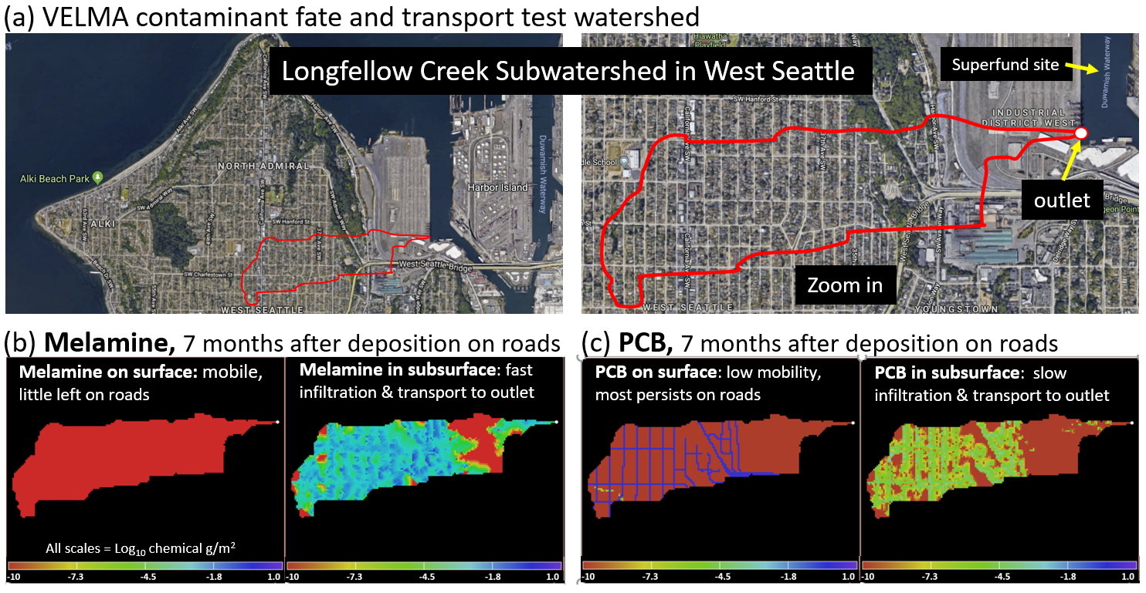

**Figure 6.** We conducted a beta test of VELMA 2.1 or a subwatershed of Longfellow Creek in West Seattle. This preliminary demonstration compares fate and transport of melamine and PCB. (a) The test subwatershed includes residential and industrial districts that drain to the outlet (white dot, upper right frame) in the Lower Duwamish Waterway Superfund site. This hypothetical simulation compares fate and transport of a one-time (June 1, 2011) deposition of 1 g/m2 each of melamine and PCB onto all road surface VELMA cells (10 m2) within the subwatershed boundary (red outline in frames (a) and (b)). Melamine is present in tire residues, and is a relatively soluble and hydrophilic (low KOW and KP sorption coefficients) constituent of urban stormwater runoff and possible contributor to prespawn mortality of coho in Seattle area streams (Peter et al. 2018). In contrast, PCBs are relatively insoluble, hydrophobic (high sorption coefficients) and persistent within soils, marine sediments and the Puget Sound food web, including endangered Chinook salmon and killer whales. Our VELMA test simulations results for December 31, 2011 (7 months after PCB and melamine deposition on road surfaces) illustrate how these contrasting chemical properties lead to (b) melamine’s rapid vertical and lateral (west to east downslope gradient) transport toward to the outlet, leaving almost no residual chemical on the source roadways; and (c) PCB’s persistence on road surfaces with up to six orders of magnitude less PCB in near-surface soil layers compared to melamine. For this demonstration, soil organic matter content did not vary across the watershed, and storm sewer drains and pipes were not simulated pending acquisition of these data sets.

8.0 References

Abdelnour, A., Stieglitz, M., Pan, F., & McKane, R. (2011). Catchment hydrological responses to forest harvest amount and spatial pattern. *Water Resources Research*, *47*(9).

Abdelnour, A., McKane, R. B., Stieglitz, M., Pan, F., & Cheng, Y. (2013). Effects of harvest on carbon and nitrogen dynamics in a Pacific Northwest forest catchment. *Water Resources Research*, *49*(3), 1292-1313.

Bahadur, R., Amstutz, D. E., & Samuels, W. B. (2013). Water contamination modeling—a review of the state of the science. *Journal of Water Resource and Protection*, *5*(02), 142.

El-Shahawi, M. S., Hamza, A., Bashammakh, A. S., & Al-Saggaf, W. T. (2010). An overview on the accumulation, distribution, transformations, toxicity and analytical methods for the monitoring of persistent organic pollutants. *Talanta*, *80*(5), 1587-1597.

Ho, Y. S., Chiu, W. T., & Wang, C. C. (2005). Regression analysis for the sorption isotherms of basic dyes on sugarcane dust. *Bioresource technology*, *96*(11), 1285-1291. <https://pdfs.semanticscholar.org/982f/3099249a9e0cb60a46c3675110d28f56d42b.pdf>.

McEachran, A. D., Sobus, J. R., & Williams, A. J. (2017). Identifying known unknowns using the US EPA’s CompTox Chemistry Dashboard. *Analytical and bioanalytical chemistry*, *409*(7), 1729-1735.

McKane, R.B., A. Brookes, K. Djang, M. Stieglitz, A. Abdelnour, F. Pan (2014). VELMA 2.0 User Manual and Technical Documentation. USEPA/ORD Report ORD-010080, Safe and Sustainable Waters Research Program, September 30, 2014. (Downloadable here: <https://www.epa.gov/water-research/visualizing-ecosystem-land-management-assessments-velma-model-20>.

Peter, K. T., Tian, Z., Wu, C., Lin, P., White, S., Du, B., ... & Kolodziej, E. P. (2018). Using High-Resolution Mass Spectrometry to Identify Organic Contaminants Linked to Urban Stormwater Mortality Syndrome in Coho Salmon. *Environmental science & technology*, *52*(18), 10317-10327.

Piwoni, M. D. and Banerjee, P. (1989). Sorption of volatile organic solvents from aqueous solution onto subsurface solids. *Journal of Contaminant Hydrology*, *4*(2), 163-179.

Piwoni, M. D., & Keeley, J. W. (1990). Basic concepts of contaminant sorption at hazardous waste sites. US Environmental Protection Agency, Superfund Technology Support Center for Ground Water, Robert S. Kerr Environmental Research Laboratory, Ada, OK. Report Number: EPA/540/4-90/053. <https://nepis.epa.gov/Exe/ZyPDF.cgi/2000L079.PDF?Dockey=2000L079.PDF>.

Potter, C. S., Randerson, J. T., Field, C. B., Matson, P. A., Vitousek, P. M., Mooney, H. A., & Klooster, S. A. (1993). Terrestrial ecosystem production: a process model based on global satellite and surface data. *Global Biogeochemical Cycles*, 7(4), 811-841.

Washington Department of Ecology. 2018. Toxic chemicals in Puget Sound. Link: <https://ecology.wa.gov/Water-Shorelines/Puget-Sound/Issues-problems/Toxic-chemicals>. AND, University of Washington Tacoma Puget Sound Institute, <https://www.eopugetsound.org/terms/407>.

Williams, A. J., Grulke, C. M., Edwards, J., McEachran, A. D., Mansouri, K., Baker, N. C., ... & Richard, A. M. (2017). The CompTox Chemistry Dashboard: a community data resource for environmental chemistry. *Journal of cheminformatics*, *9*(1), 61.

# A.2 | Configure VELMA for Simulating Contaminant Fate and Transport

#### Overview (Tutorial A.2 – Configure VELMA for Simulating Contaminant Fate and Transport)

This document is a broad overview of how to configure VELMA 2.1 to model fate and transport of organic contaminants within watersheds. Summaries and instructions are provided for

* Configuration Steps for A VELMA Contaminant Simulation Run
* Adding a Contaminant Parameterization to a VELMA Configuration
* Parameters That Should Be Left Alone
* Decay Parameters
* Parameters for Sorbed/Aqueous Partitioning
* Specifying the Names of a Contaminant’s Spatial Data Pools
* Contaminant Deposition
* Simulation Results for Contaminants

***This Tutorial document is a companion to the two listed below:***

* Tutorial A.1_HowTo_VELMA Contaminant Modeling Conceptual Framework
* Tutorial A.3 – VELMA Contaminant Modeling: Longfellow Creek Example

1.0 Introduction

VELMA supports the addition of one or more Organic Contaminants to a simulation configuration.  
Each contaminant is added as its own set of parameters, and models one specific organic contaminant (e.g., DDT) during a simulation run.

Organic contaminants added to a VELMA simulation configuration undergo degradation and lateral and vertical transport during each simulation step. No other processes occur for contaminants.

Currently, only one type of degradation is available, based on equations developed by C.S. Potter, et. al, and parameterized by microbe efficiency and a maximum decay factor.

Unlike VELMA’s core chemistry pools (NH4-N, NO3-N, etc.), there is no global, initial amount of contaminant added to the simulation state at simulation start.

Configuring one or more contaminant parameterizations requires configuration of an equal number (or more) of VELMA disturbance parameterizations to introduce actual amounts of the contaminant into the simulation state. VELMA disturbances can be configured to introduce specific amounts of contaminant to specific locations of the simulation watershed and arbitrary steps during the simulation run.

Each parameterized contaminant adds its own surface and layered spatial data pools, and loss-tracking temporal data arrays to the simulation state at runtime. Spatial Data Writers may be configured for contaminant pools, but the pool key-name provided to the Spatial Data Writer parameterization is derived from a common root and the contaminant-specific parameterization pool names – this is unlike any other spatial data pool naming currently employed by the VELMA Simulation Application.

2.0 Overview: Configuration Steps for **a** VELMA Contaminant Simulation Run

Start with a proven VELMA simulation configuration – i.e., a simulation configuration .xml file that is already calibrated and known to run reliably and accurately for the study site.

Load that simulation configuration .xml file into JVelma, and immediately change its “Simulation Run Name” (i.e. the run_index parameter’s value), then save it. This creates a copy of the original .xml that you can modify with contaminant additions, while saving the original .xml for single-process use.

With the new copy of the proven simulation configuration loaded into JVelma, adding one or more contaminants involves the following steps for each contaminant you wish to add:

1. Add a new Contaminant parameterization group to the simulation configuration.
2. Add one or more Disturbance parameterization groups to the simulation configuration to introduce amounts of the contaminant to the simulation run and specific times and locations.
3. (Optional) Add one or more Spatial Data Writer parameterization groups to produce spatially-explicit map results for the contaminant.  
   Note: The DailyResults and any configuration-specified Cell Data Writer .csv files automatically include columns for any contaminants added to simulation configuration. Only Spatial Data Writers must be explicitly parameterized.

Save the changes – the simulation configuration .xml is now ready for use with JVelma.

3.0 Adding a Contaminant Parameterization to a VELMA Configuration

With a proven VELMA simulation configuration loaded into JVelma,  
click the Edit -> Contaminants -> “Add a New Contaminant” menu item, as shown below:



In the “Unique Contaminant Name” pop-up dialog that opens next, provide a name for the contaminant.  
The name should begin with an alphabet character, and may consist of only alpha-numeric and underscore (“_”) characters, and must remain unique among all contaminants in the configuration.

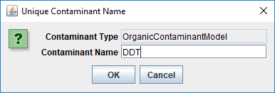

Click OK in the “Unique Contaminant Name” dialog adds a new parameterization group to the simulation configuration, and changes JVelma’s display to the “All Parameters” tab, with the Item-level filter set to only display the parameters for the newly-added contaminant.  
(Click the “Parameter” column header to sort the parameters by name)

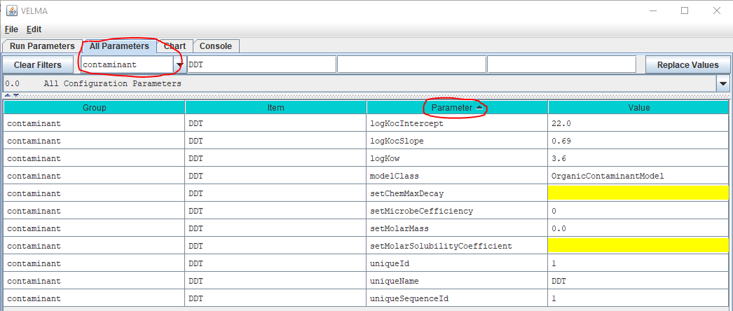

Some of the parameters have default values already set for them (although it is likely you will want to change them for the specific contaminant you are adding), some are set and should not be changed, and some are highlighted yellow, indicating that they are currently unset, and need to have values provided for them.

4.0 Parameters That Must Be Left Alone

The modelClass parameter is set by JVelma when you add the contaminant to the simulation configuration. Do *Not* Change this parameter’s value. *Ever*.

The uniqueName parameter is set to the name you specified while adding the contaminant parameterization to the configuration. After that initial specification, we recommend never changing this parameter’s value, because it is used as part of the name for the contaminant’s spatial data pools.  
If you do change uniqueName’s value, any disturbances referencing its spatial data pools must update those pool names as well.

The uniqueId parameter was generated automatically and should be left as-is.

The uniqueSequenceId determines the sequence in which the contaminants are processed during each VELMA simulation step. It is provided for future, possible enhancements to the contaminants code that would let one contaminant interact with another. However, that functionality is currently unavailable, and the uniqueSequenceId values that JVelma generates for you can be left as-is.

5.0 Decay Parameters

The setMicrobeCefficiency parameter is the fractional (range [0.0, 1.0]) efficiency of microbe activity upon this organic contaminant.

setChemMaxDecay is the maximum daily decay rate constant (fraction per day) of this contaminant.  
Note: Comptox (<https://comptox.epa.gov>) et. al list the half-life for most organic contaminants, and the value for the setChemMaxDecay parameter can be calculated from the half-life. Various calculators are available on the web, for example: <https://www.calculator.net/half-life-calculator.html>

6.0 Parameters for Sorbed/Aqueous Partitioning

logKocIntercept (unitless) is the intercept parameter for the linear-regression equation describing the correlation of LogKoc to LogKow for this contaminant.

logKocSlope (unitless) is the slope parameter for the linear-regression equation describing the correlation of LogKox to LogKow for this contaminant.

logKow (units of log10 Kow) is the Octanol-water partition coefficient for this contaminant.

setMolarMass is this contaminant’s mass, in grams per mol (g/mol).

setMolarSolubilityCoefficient is the solubility coefficient of this chemical in mol per liter (mol/L).

7.0 Specifying the Names of a Contaminant’s Spatial Data Pools

A given contaminant parameterization is associated with 2 spatial data pools:

* A single-layer Surface Pool
* A multiple-layer “Layered” Pool

Both pools store per-cell (and per-cell, per-layer for the layered pool) quantities of the contaminant itself.

Unlike VELMA’s core chemistry pools, contaminant spatial data pool names are constructed using a common prefix and a unique suffix. To provide proper key-name for disturbances or spatial data writers parameterized to reference or modify contaminant pool values, you must know how to construct the specific pool name for a specific contaminant pool.

The contaminant’s surface pool prefix is “CONTAMINANT_SURFACE_” and the suffix is the contaminant’s uniqueName parameter value shifted to all-uppercase.  
Example:  
If uniqueName = “Glysophate”, the surface pool key-name is: CONTAMINANT_SURFACE_GLYSOPHATE.

Similarly, the contaminant’s layered pool prefix is “CONTAMINANT_LAYERS_” and the suffix is the uniqueName parameter value, again, all-uppercase.

Example:  
With uniqueName=DDT, the layered pool key-name is: CONTAMINANT_LAYERS_DDT.

8.0 Contaminant Deposition

Adding one or more OrganicContaminantModel parameterizations to a VELMA simulation configuration does not add any actual chemical amounts to the simulation run. To introduce amounts of the contaminant(s) into the contaminant pools, you’ll need to parameterize one or more disturbance events.

You can use Surface Deposition disturbances or Set Spatial Data By Map disturbances (or one or more instances of both) to introduce contaminant amounts into the contaminant pools.

For general information on how to configure these disturbances, see the following

* Surface Deposition:  
   Tutorial E.3 – Surface Chemical Deposition
* Set Spatial Data by Map:  
  Tutorial D.4 – Create Spatial Soil and Plant Chemistry Pools

The important difference between using the above disturbances with VELMA’s core chemistry pools and with contaminants is that you must provide the prefix+suffix contaminant pool names to the disturbance, as described in the section “Specifying the Names of a Contaminant’s Spatial Data Pools” above, rather than simply looking up the key-names in a table as you would for (example) NO3.

9.0 Simulation Results for Contaminants

When a VELMA simulation configuration contains one or more contaminants, an additional daily results file is written as part of the simulation’s results. The file is named DailyContaminantResults.csv and contains daily-averaged values for each contaminant’s surface and layered pools as well as surface and layered watershed loss amounts (the amount calculated to have left the watershed via transfer from non-channel to channel cells).

Additionally, Cell Data Writers specified for a VELMA simulation configuration contain rows reporting the surface and layer amounts, and the surface and layer lateral-outflow amounts for each contaminant in the simulation configuration.

Column names for contaminant results mimic (with slight variations) the prefix-suffix rules outlined in the “Specifying the Names of a Contaminant’s Spatial Data Pools” section earlier in this document:  
Any contaminant results data column will begin with the keyword “CONTAMINANT_” (or “Contaminant_” in some cases). Surface-data columns follow CONTAMINANT_ with “SURFACE”, and finally, after these keywords, the uniqueName value for the specific CONTAMINANT appears.

# A.3 | VELMA Contaminant Modeling Demonstration: Longfellow Creek Example

#### Overview (Tutorial A.3 – VELMA Contaminant Modeling Demo: Longfellow Creek Example)

This document is a detailed step-by-step tutorial for configuring VELMA 2.1 to simulate contaminant fate and transport within a watershed. The tutorial example used is a subwatershed of Longfellow Creek, a mixed-use urban watershed draining in Seattle, WA.

***This A.3 contaminant modeling tutorial is a companion to the two listed below:***

* Tutorial A.1_HowTo_VELMA Contaminant Modeling Conceptual Framework
* Tutorial A.2 – Configure VELMA for Simulating Contaminant Fate and Transport

This tutorial provides instructions for running a specific example scenario using VELMA 2.1’s graphical user interface (GUI).

Through that process scenario it introduces VELMA 2.1 and some of its capabilities. It is *not* a comprehensive guide to VELMA 2.1. Refer to the documentation (McKane et al. 2014) and the VELMA 2.1 tutorials enclosed here for further information.

Requirements and Preliminaries

Section I Topics:

* Hardware Requirements
* Running PowerShell
* Checking for Java 8
* Installing Java 8
* VELMA .jar Files

*(If you are already familiar with these topics and confident your computer meets their requirements, you may skip ahead to Section II.)*

**Hardware Requirements: You will need a computer with the following**

* Windows 10 as its operating system.
* 4 Gigabytes (“GB”) of RAM at a minimum (8 GB is preferred, more than that even better).
* Approximately 20 GB of disk space available for used.  
  (A little less may still work, and more cannot hurt.)

**Running PowerShell: You must be able to access and run a Windows PowerShell**

1. Click the Windows Start Menu button  to open the Start Menu.
2. Without clicking on any items in the Start Menu, type the word “powershell”.  
   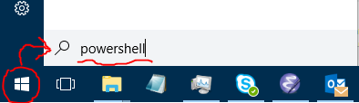
3. As you type, the Start Menu should automatically search for powershell-related items on your computer. If Powershell is available (and it should be on any standard Windows 10 computer) then it will appear as one of the items the Start Menu’s search results list, and likely as the “Best match” item:  
   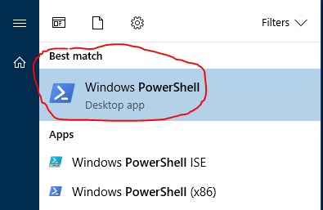  
   (If no item named “Windows PowerShell” or “Windows PowerShell (x86)” appears in the Start Menu search results, you do not have access to PowerShell. You will need to install it or gain access to it before proceeding. However, Windows PowerShell is part of the standard Windows 10 distribution, and *should* be available.)
4. Start a Windows PowerShell console by clicking on the “Windows PowerShell” item in the Start Menu search results list.  
   A console window should open like this:  
   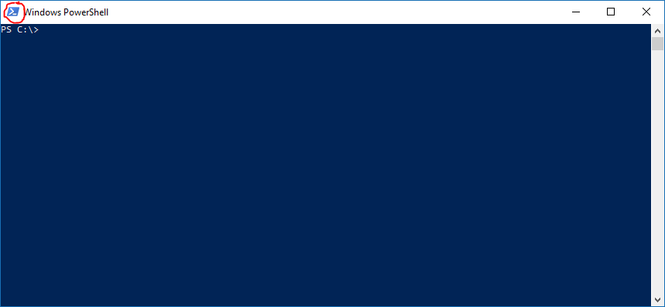*(Your console window may have different dimensions, colors, and fonts than the example above.  
   You can customize all of these settings by right-clicking the PowerShell icon – circled in red above.)*

**Checking for Java 8: You must have a Java JRE, version 8 or later, installed on the computer**

1. Verify whether JRE installation and version using the PowerShell window you started above. (Or, open a new PowerShell window if you have already closed it.)  
   At the PowerShell window’s prompt, type the following command: java -version
2. If you have a Java JRE installed, you should see something like this:  
   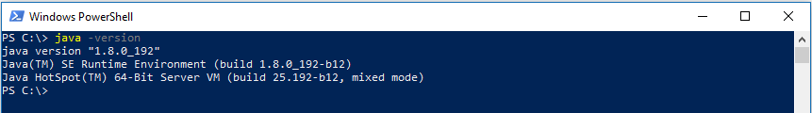If the version begins with “1.8” or a higher number (e.g. “1.9”) you have an acceptable Java JRE installed and available.  
   However, if the version begins with “1.7” or a lower number, you will need to install a newer, more-recent Java JRE.
3. If no Java JRE is installed or accessible, then you will see something like this:  
   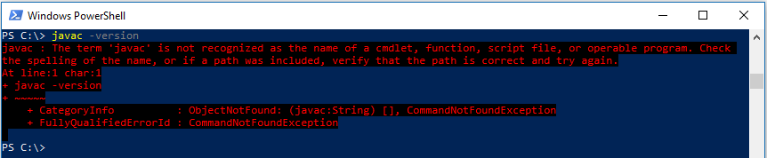*(Note: the example above used “javac” to trigger a “not found” message on a computer that actually has a Java JRE installed. On a computer without a Java JRE, typing “java” would have had the same-looking result.)*

**Installing Java 8: How to install it onto your computer**

* Go to the following Oracle company webpage:  
  <https://www.oracle.com/technetwork/java/javase/downloads/jre8-downloads-2133155.html>  
  The page looks like this: (see next page)  
  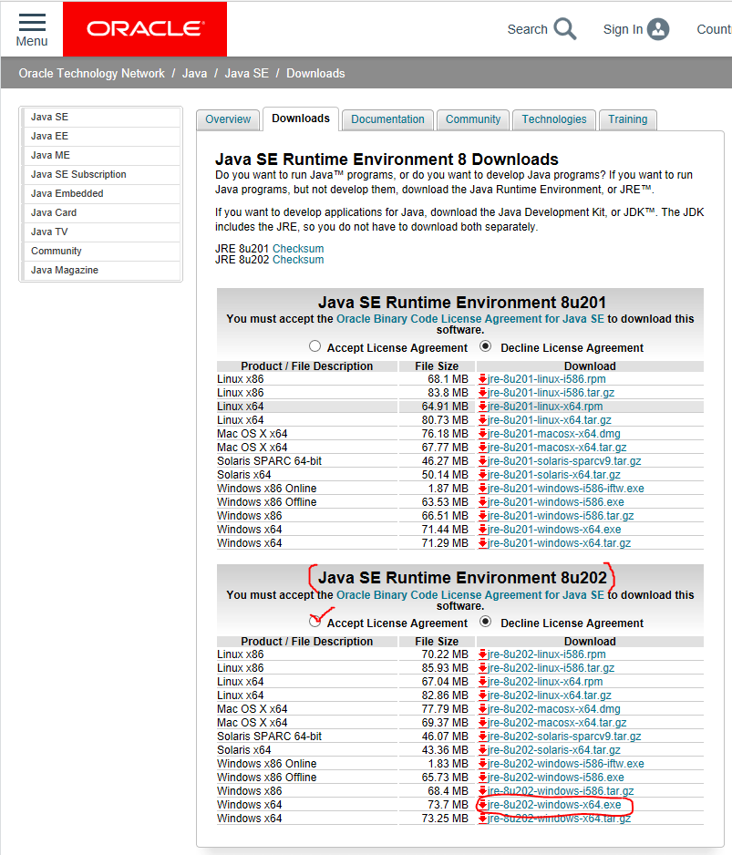  
  In the “Java SE Runtime Environment 8u202” section of the page, click “Accept License Agreement”, then click the Windows x64 installer link: “jre-8u202-windows-x64.exe”.  
  After downloading the .exe file to your computer, double-click it to run the installer, and follow the installer instructions.

**Note: You must have VELMA’s .jar files installed and available on your computer at this point.**

Starting the VELMA GUI

Section II Topics:

* Starting the VELMA GUI
* Overview the VELMA GUI’s Layout

The VELMA GUI is named JVelma.jar. You can start the GUI by double-clicking the JVelma.jar file from a File Explorer window, but we do not recommend this method because VELMA will likely run out of memory during a simulation. Double-click starting the GUI allocates a default (and relatively small) amount of memory to the process – it’s usually not enough. To explicitly specify the amount of memory the GUI runs with, follow the steps below:

Open a PowerShell window (as described in part I of this guide) and type the following startup command at the window’s prompt:  
  
java -Xmx1g -jar “C:\Some\full\Path\JVelma.jar”  
  
Here’s an example:  
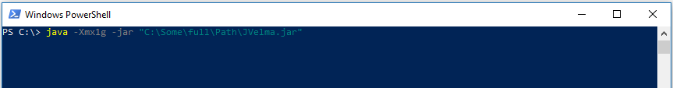  
*(If –but only if-- your path contains NO whitespace, you can omit the double-quotes” – see Appendix 1 for further discussion as well as other tips.)*

Here’s what each part of the command means:

* 1. java invokes the Java JRE, which in turn will start and run the GUI.
  2. -Xmx1g allocates 1 Gigabyte of memory to the GUI/simulator.  
     The “-Xmx” part indicates “memory allocation” do the Java JRE, the “1” is how much, and the “g” means “in Gigabytes”. You can allocate more memory by increasing the numeral (e.g. from 1 to 4) but if you allocate more memory than your computer can make available, JVelma will fail to start properly.
  3. -jar indicates to the java JRE that the next argument on the command line is the .jar file to run (and the directory path of its location).
  4. C:\Some\full\Path\JVelma.jar is the “fully qualified” directory path and name of the JVelma.jar file – i.e. the VELMA GUI.  
     Of course, this example path should be replaced by the actual, fully qualified path to the location of JVelma.jar on your computer.  
     “Fully qualified” means that the path starts at a disk drive letter, and includes all directory names (separated by backslashes) down to the JVelma.jar file itself.

**If the JVelma GUI successfully loads and starts, you will see the screen below:**

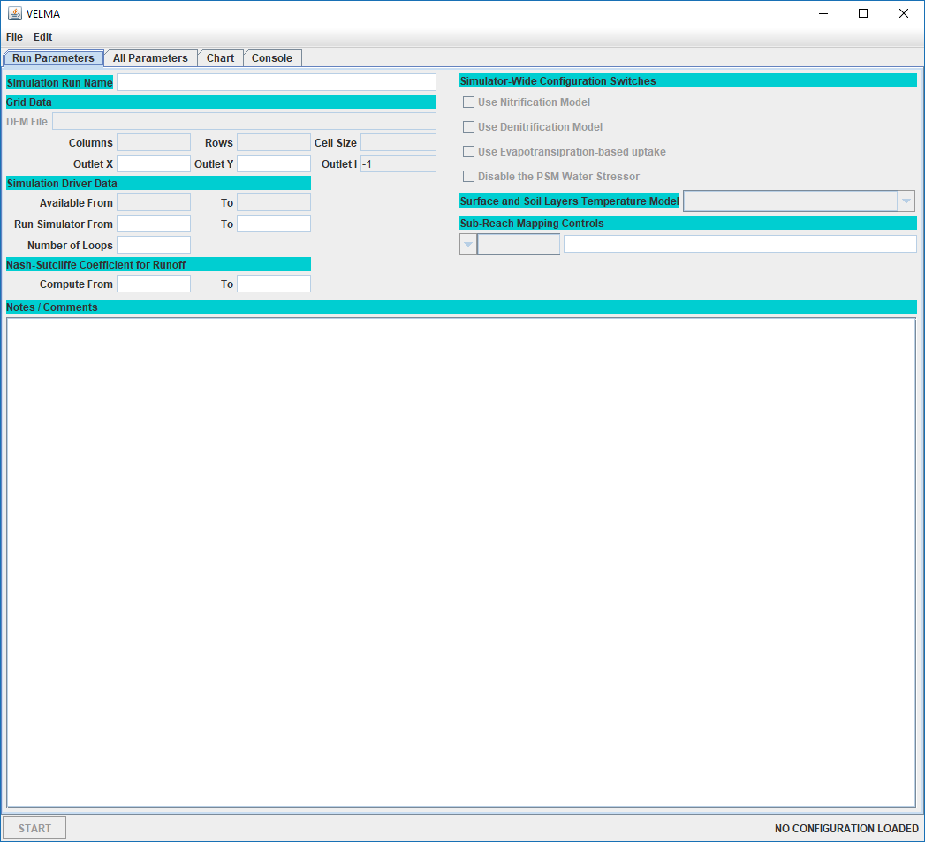

Note the “NO CONFIGURATION LOADED” message in the lower-right corner of the GUI’s panel.

This means you are ready to load a VELMA simulation configuration and run it.

**Here is a brief overview of the GUIs layout and features:**

(If you closed the GUI after performing the steps above, re-open it by following those steps.)

When VELMA starts, you see the blank GUI and the menus and tabs used for configuring and running simulations. The image below shows the top portion of the main GUI panel:  
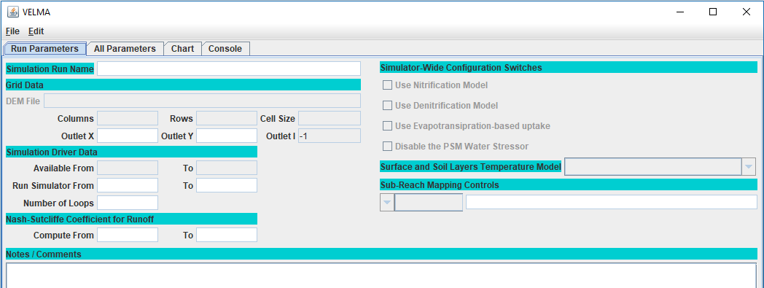

Key Features of the main GUI panel:

* Two drop-down menus: 
  1. The “File” menu contains items for loading and saving simulation scenarios.  
     (It also contains an “About” item which reports VELMA’s version info.)
  2. The “Edit” menu contains various items for creating and modifying a simulation scenario’s configuration / parameters.
* Four Tabs: 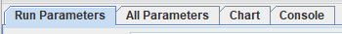 each tab switches the GUI to display a different panel:
  1. **Run Parameters**: a high-level summary of the scenario.  
     Some core parameters and their values are accessible here for convenience.  
     The Notes / Comments section displays any notes about the scenario you wish to record.  
     The Run Parameters tab is initially visible when the VELMA GUI is started.
  2. **All Parameters**: the complete list of all the scenario’s parameters and their values, along with a set of filter controls that can be used to narrow the set of visible parameters.
  3. **Chart**: during simulation runs, this panel displays user-selectable graphs of the simulator’s runtime behavior.  
     When the GUI isn’t running a simulation, this panel displays a “Currently Unavailable” message.
  4. **Console**: during simulation runs, this panel displays status messages that the simulation engine would have otherwise written to the PowerShell window. Use the messages in this panel to troubleshoot model crashes.  
     When the GUI isn’t running a simulation, this panel is mostly blank.

Loading and Running an Example VELMA Simulation

Section III Topics:

* Running a VELMA Simulation
* Monitoring a running VELMA Simulation

The Longfellow watershed example data contains several pre-configured example VELMA simulation scenarios. You can load and run them using the VELMA GUI.

**Running a VELMA simulation from the GUI**

1. Start the VELMA GUI, following the steps from part II of this guide.
2. Open a File Explorer window and navigate to the XML folder of the Longfellow_Example directory. As an example: (details and file names will differ on your computer)  
   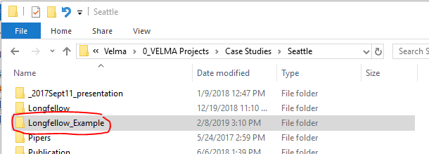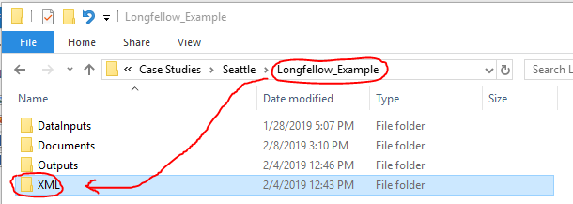  
   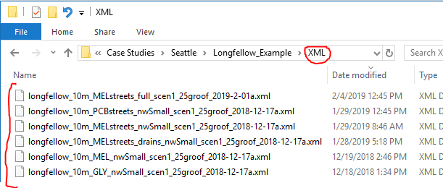  
   The XML directory contains .xml files – each file contains the configuration for one VELMA simulation scenario.
3. In the VELMA GUI, click the “File” 🡪 “Load Configuration From VELMA XML File” menu item:  
   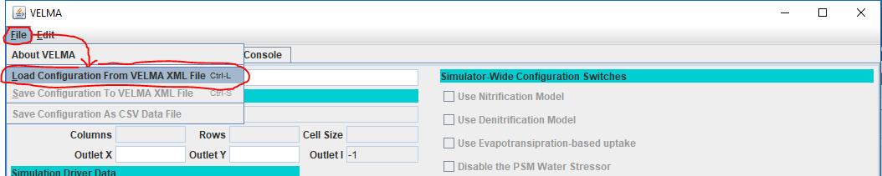This will open “Select Velma XML File to Load” file browser dialog window.
4. In the selector window, navigate to the LongfellowExample\XML directory using the “Look In:” directory field’s drop-down navigation list:  
   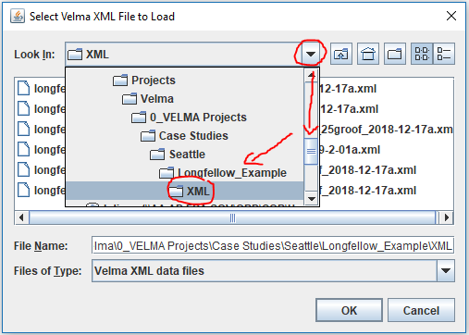
5. Select the longfellow_10m_MELstreets_nwSmall_scen1_25groof_2018-12-17a.xml scenario’s configuration file and click the OK button.  
   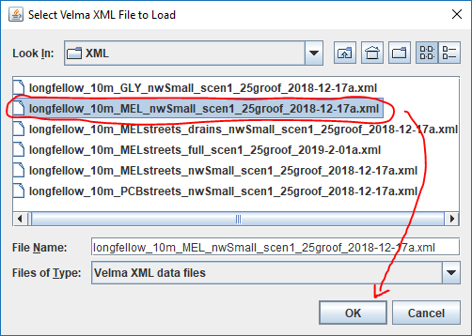
6. The VELMA GUI will load the scenario’s configuration.  
   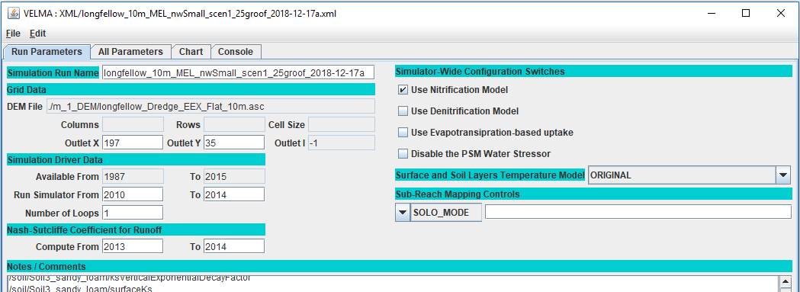Notice that the “Columns”, “Rows” and “Cell Size” parameters are blank, and the “Outlet I” parameter is -1. This is because the configuration’s paths to its input and output (Results folder) data need to be changed to locations specific to your computer. (If these parameters are not blank, you should still explicitly set the Input and Output locations, as described in the following step!)
7. Set the scenario’s Input and Output locations to correct values for your computer.  
   Click the “Edit” 🡪 “Set Input and Results Locations” menu item (“Results” is synonymous for “Output”):  
   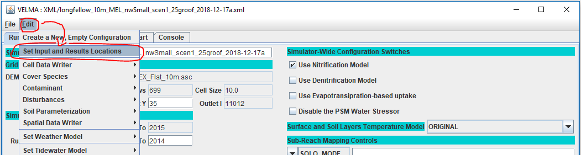  
   This opens the “Set Locations for Simulator Input and Results Data” dialog window:  
   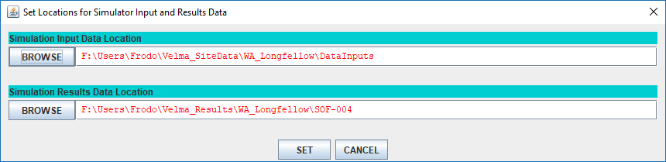  
   Notice that the Input and Results locations names are red. This indicates that the locations are not found on the current computer.  
   For these example scenarios, the input location is the Longfellow_example\DataInputs directory, and the results (or outputs) location is the Longfellow_example\   
   Set correct input and output locations by any of the following methods:
   * Click the BROWSE buttons to open File Explorer windows, navigate to the appropriate directories and click “Open” to select them.
   * Click the text fields for the Input and Results location names and type in the fully-qualified path names to appropriate directories.
   * In a Windows File explorer, navigate to the appropriate directory, double-click the location name text box, then right-click and click the Copy item.  
     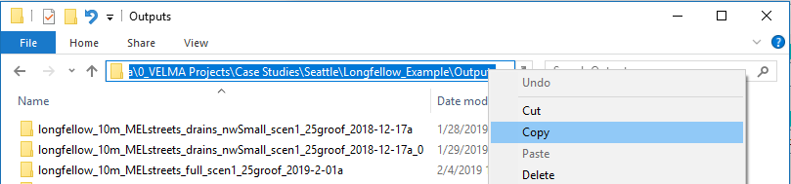  
     Finally, return to VELMA GUI’s “Set Locations …” window, click into the appropriate location name text filed and type Ctrl-v (“paste”) to paste the full path in place.

Once the input and output locations have been set correctly, they will display in black.  
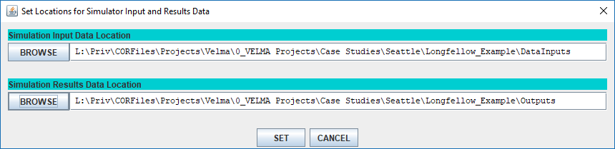  
Click the SET button to set the locations for the configuration.

1. Once the Input and Output (a.k.a. “Results”) locations have been correctly set, the Run Parameters panel should show valid values for the “Columns”, “Rows”, “Cell Size”, and “Outlet I” parameter values:  
   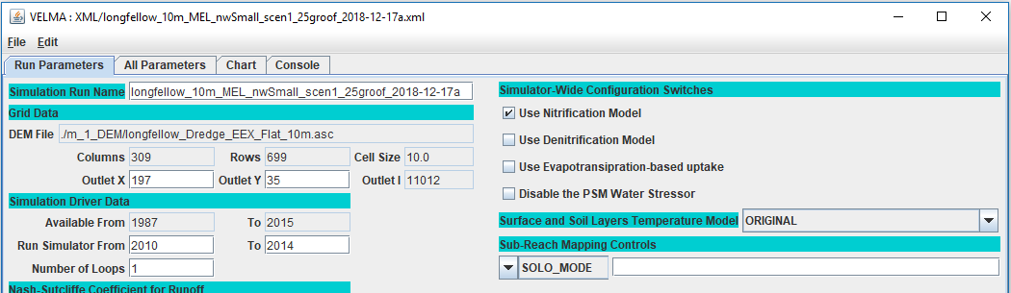
2. Save the new Input and Output locations you’ve specified for the scenario’s configuration.  
   Changes make in the GUI are NOT automatically written back to the original .xml file!  
   Click the “File” 🡪 “Save Configuration to VELMA XML File” menu item.  
   This opens the “Save Configuration to XML dialog. A box stating “The file already exists. Replace it?” will pop up. Hit “yes”. 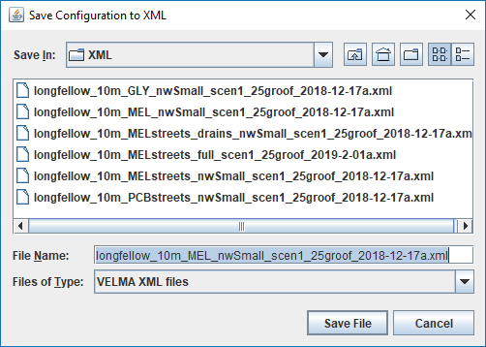  
   The dialog will open to the same directory you loaded the .xml from, so you should be able to click the “Save File” button without changing anything.
3. Click the “Start” button in the lower-left corner of the VELMA GUI to start the simulation running.

**Monitoring a Running VELMA Simulation**

After the clicking Start, the simulator status indicator in the lower-right corner should change  
from: 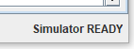to: 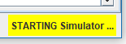, which indicates that the VELMA simulator engine is initializing and preparing to run. Depending on the size of your simulation and how capable your computer is, this can take anywhere from a few seconds to many minutes.  
When the simulator completes initializing, it will start running, and the lower-right corner status message will change to look like this: 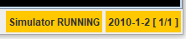.  
The GUI will also automatically shift to display the “Chart” tab panel, with the “Time Series” chart as its default display as shown below:

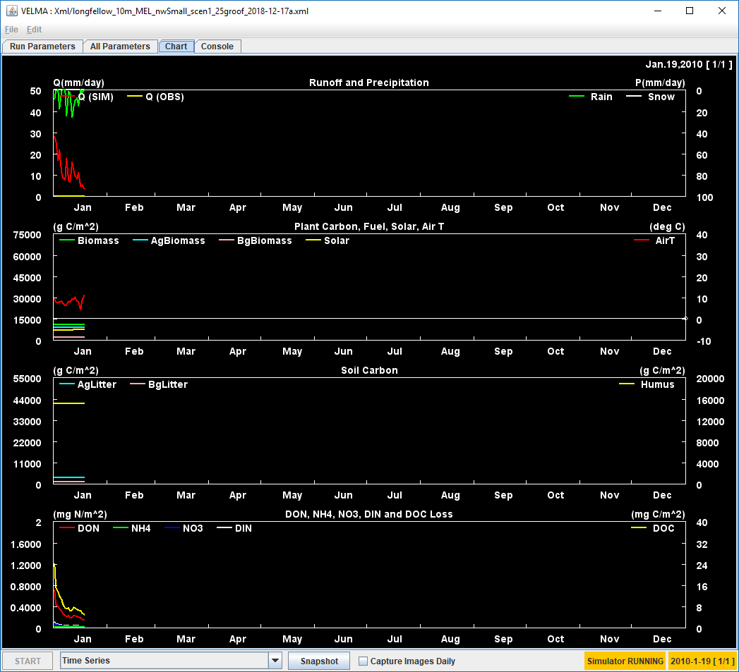

You can shift between the various tab panels in the GUI while a simulation is running, but you should not (and generally, cannot) alter the simulation parameters, although you can view them.

The most useful tab panels during a simulation run are the “Chart” and “Console” panels.

The type layout of runtime data displayed in the Chart panel is selectable via the Display Selector that appears next to the Start button when the Chart panel is active. Click the selector’s  drop-down button to display the list of data/layouts. The following screen-capture shows using the selector’s list to change the Chart panel to display Soil Moisture spatial (and some temporal) data:

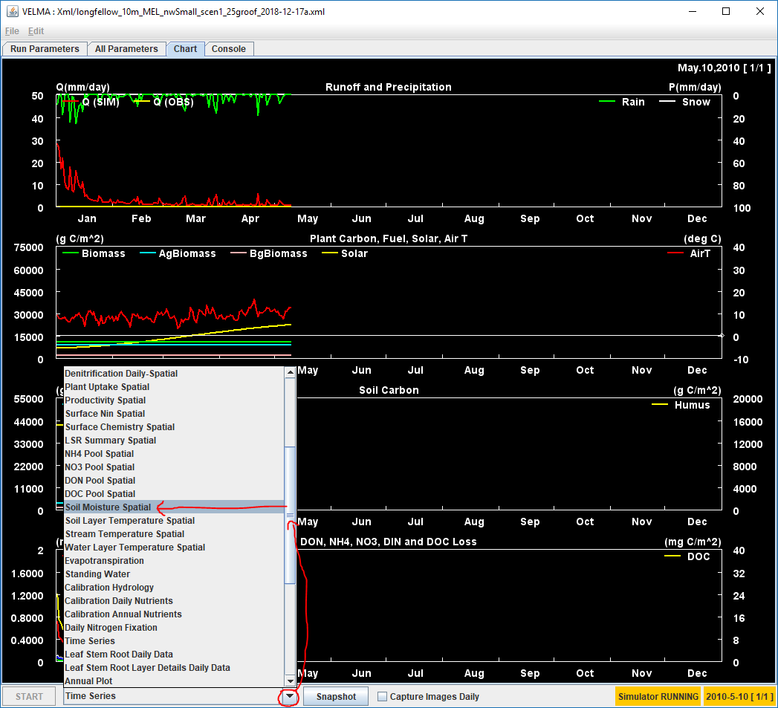

Here is what the Chart display looks like after the above selection: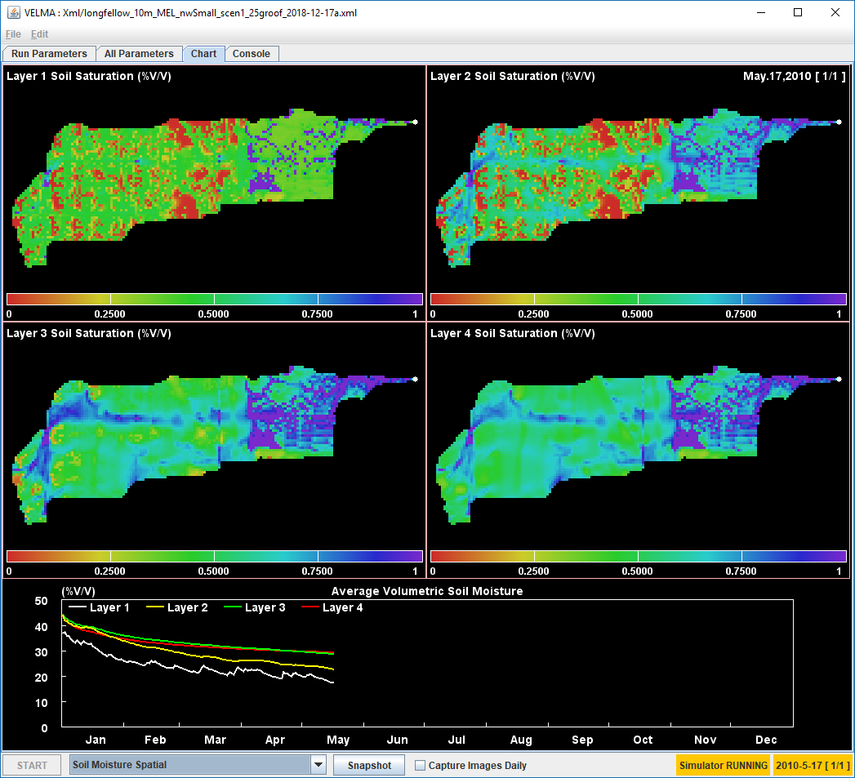

Clicking the “Snapshot” button captures the current Chart display. The captured image appears in the simulation’s results directory as a .PNG file with the word “out_” prefixed to the simulation name.

Clicking the “Capture Images Daily” checkbox makes the GUI capture one .PNG per simulation step (i.e. day) until it is clicked again (i.e. unchecked). The images captured appear in the simulation’s results directory as a group of .PNG files, each name prefixed with “day_” and suffixed with the year and Julian day of the image (e.g. “_2011_278”) just before the “.png” file-extension.

The “Console” tab panel displays tracing statements about the current state of the simulation run.  
The following screen capture shows the Console for a typical simulation run. Note that the simulator prints at least one “INFO” statement per simulation day, and each statement contains a real-time time-stamp, along with simulation-time date and day information. Periodic disturbances that were configured as part of the simulation are also noted.

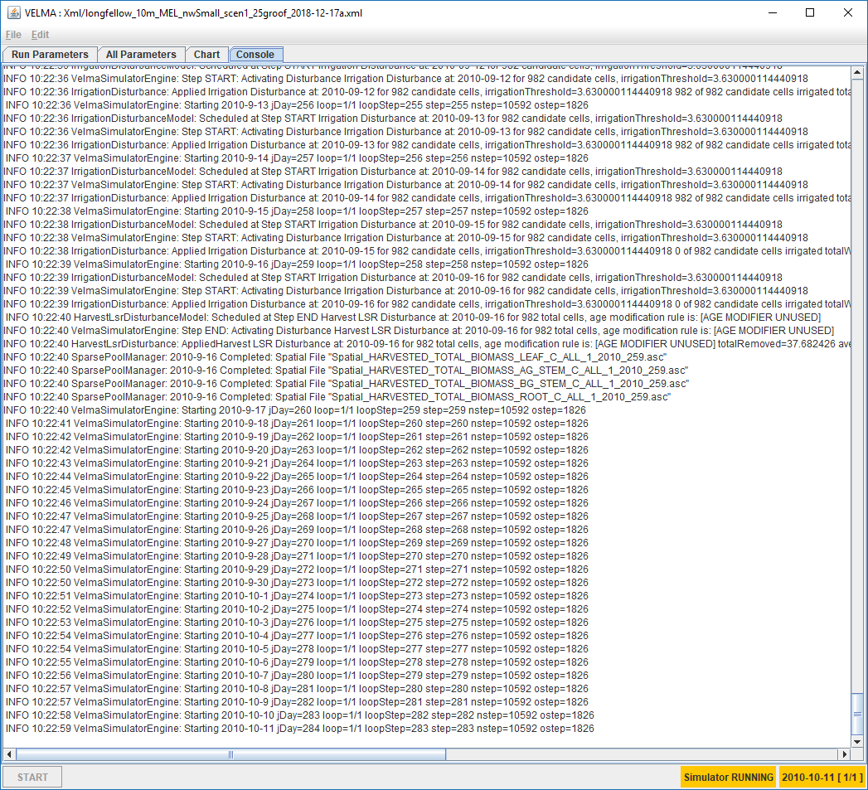

Reviewing the Results of a VELMA Simulator Run

**Section IV Topics:**

* Results Location
* Types of Results

**Results Location: Where Are Results Files Located?**  
VELMA simulation results are written to multiple files in a directory specified by the simulation configuration. You specified the output location in step 7 above, as part of loading and running a simulation, but if you’ve forgotten what the location was, you can find it using the “All Parameters” tab panel’s parameters table:

1. Click the drop-down selector button along the upper-right side of the All Parameters tab panel and open the panel’s Parameters Outline selector list: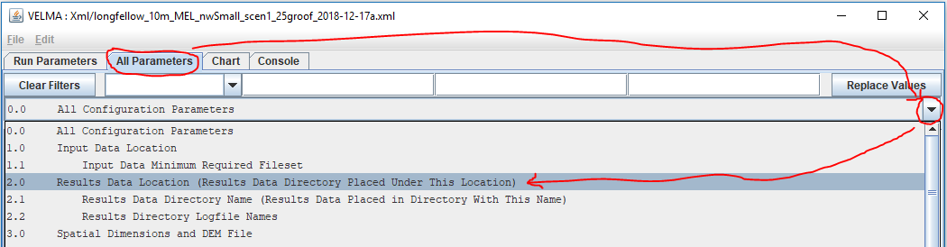
2. Click “2.0 Results Data Location …” – this will populate the parameter column filters with a set of filter terms (circled in blue below) that filter down the parameters displayed in the table. In this case, the single parameter displayed is the one that specifies the location of your simulation run’s results. That Parameter is initializeOutputDataLocationRoot, and its Value is the fully-qualified path to directory that contains your simulation’s results directory.  
   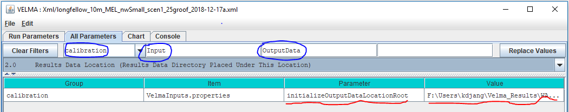
3. The value (i.e. path) may be truncated by the bounds of the table’s column width.  
   You can click-drag the side of the GUI to make it wider, but a quick way to see the entire results location is to right-click the Value column field and select the “View Description” option in the context menu that opens:  
   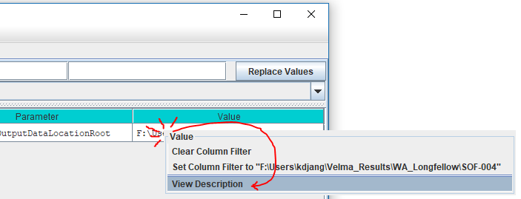This opens a small dialog box that contains the full value of the parameter:  
   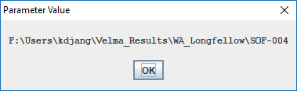  
   *(Unfortunately, you cannot click-highlight 🡪 copy the text from this dialog window. Hopefully, we can implement that handy feature in the future.)*

As mentioned above, the value of the initializeOutputDataLocationRoot parameter is not the directory that your simulation results are stored in. They are stored in a directory of their own, *underneath* the initializeOutputDataLocationRoot location.  
  
The name of your simulation results is specified by the run_index parameter.  
To find its value:

1. In VELMA GUI’s “All Parameter’s tab panel, click the “Clear Filters” button, then type run_index (not leading or trailing whitespace, single underbar “_” character) into the middle filter text field, then press the Return (a.k.a. Enter) key:  
   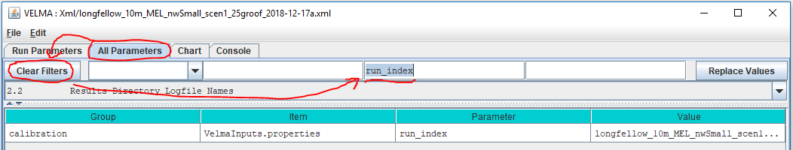
2. The entire value may not be visible in the column’s field – use the right-click 🡪 “View Description” mentioned above to display the full name:  
   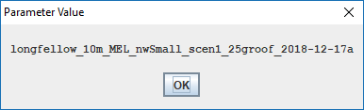

So, for the above examples, the simulator will write output files to the following directory:

F:\Users\kdjang\Velma_Results\WA_Longfellow\SOF-004\longfellow_10m_MEL_nwSmall_scen1_25groof_2018-12-17a

Assuming you’ve run the example simulation (as outlined by this guide above) find the results directory for the example simulation run on your computer and open that location in a File Explorer window.

**Types of Results: What Data is Available in The Output Files?**  
As previously noted, a single VELMA simulation run produces multiple results files of various types of data. Here are descriptions of a few of the most pertinent for the example simulation you just ran.

**GlobalStateLog.txt**  
This text file contains a copy of most of the information that is written to the VELMA GUI’s “Console” panel. You can view its contents in a text editor (e.g. Microsoft’s Notepad).  
A successful simulation run should contain a log message like following near the bottom of the file:

INFO 10:45:54 VelmaSimulatorEngine: Simulation run completed.

You can search for this message in a PowerShell window using the Select-String command, as a quick way of verifying the simulation ran to completion: 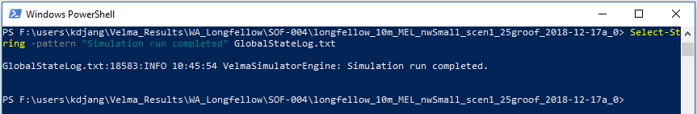  
If the simulation in the example screenshot above hadn’t completed, the -Pattern “Simulation run completed” would not have been found in GlobalStateLog.txt and the Select-String command would have returned a blank line.

The GlobalStateLog.txt file contains only most – instead of all – of what is written to VELMA GUI’s Console panel because setting up the GlobalStateLog.txt file itself is part of the VELMA simulator’s initialization. Before that initialization is completed, VELMA can echo log messages to the Console window, but not to GlobalStateLog.txt – because it hasn’t been initialized yet.  
You can usually ignore this distinction. However, if you find a GlobalStateLog.txt file *without* the “Simulation run completed” message, but also no error or warning messages, then it’s likely that an error occurred early in the simulator initialization process. Check the GUI’s Console panel (use the panel’s scroll bar, if necessary, to review the very top of the log) for warning or error messages.

**DailyResults.csv**  
This is a file of comma-separated values (.csv) that reports a lot of the core data state of the VELMA simulator. You can open this file in Notepad, but it’s more useful to view it in Microsoft Excel, or load it into R for analysis.

Here’s a screenshot of the first few rows of the example run’s DailyResults.csv file: 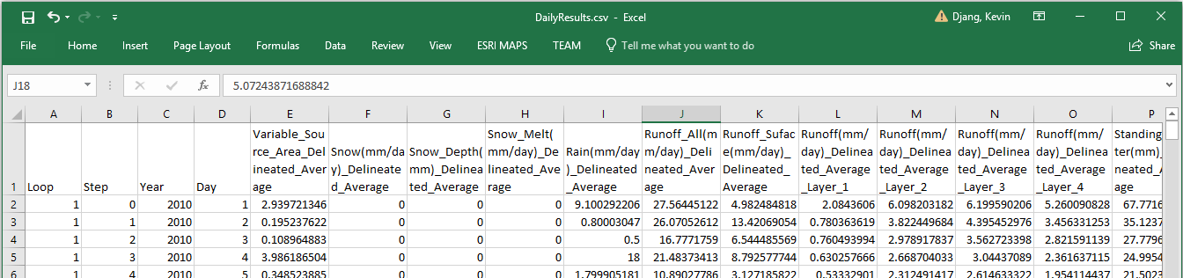  
  
Each row in the file is one simulation step’s worth of data, and the first four columns in each row provide information about which simulation step the data is for.

Using Excel, provides a quick way to visualize DailyResults data via graphs.  
Here is a graph of the first year’s “Runoff_All” column data: 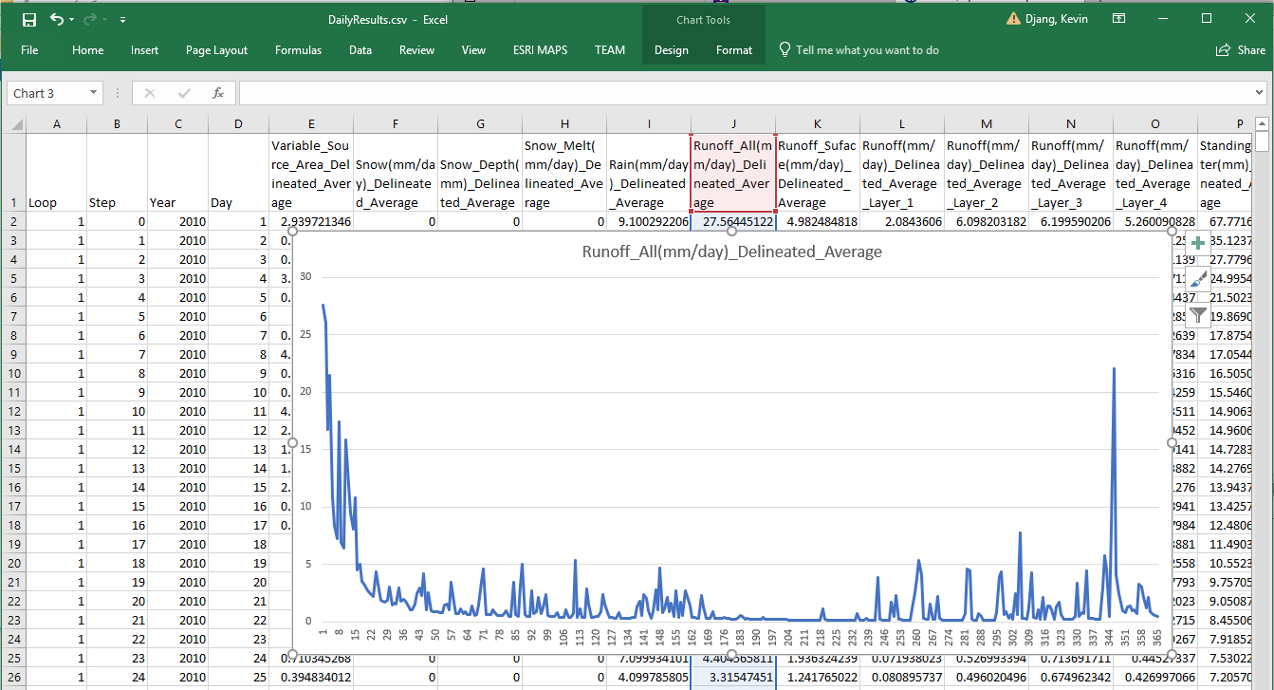  
Runoff_All is an important data column: it reports the amount of water (in mm/day) that flows out of the watershed’s outlet. When observed data for the watershed is available (and converted to matching units) it can be compared to Runoff_All either graphically (i.e. as in Excel above), or numerically (e.g. calculation of a Nash-Sutcliffe coefficient) to determine how well the simulated runoff matches reality.  
*(Unfortunately, we do not have observed runoff data for our example scenario.)*

The majority of the data columns in DailyResults are “Delineated_Average” data.  
Delineated averages are computed by summing the amounts for every cell in the watershed, then dividing the total by the number of cells in the watershed. The amount reported does not necessarily represent any specific cell amount, only any average.

**DailyContaminantResults.csv**  
VELMA simulation configurations that include one or more contaminants will include a ContaminantResults.csv file as part of the output. As its name suggests, this file’s structure mimics DailyResult’s, but it contains different data in its columns (apart from the first four columns, which duplicate DailyResults).  
For each contaminant configured in the simulation, it reports layer-specific, delineated-average daily amounts, along with surface and aggregate (i.e. not layer-specific) soil loss amounts. The loss amounts represent the amount of contaminant (in g/m2) transported out of the watershed each simulation day.

Our example simulation has one contaminant configured (Melamine), with cell-specific deposition during April of the second year of the simulation run, so VELMA generates a DailyContaminantResults file with data columns for Melamine.

Here is a screen capture of the DailyContaminantResults.csv in Excel, showing a few of the days surrounding the deposition: 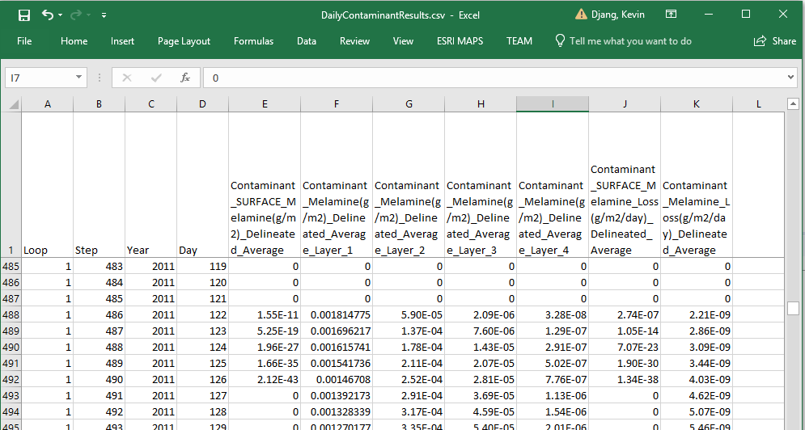  
Here is an example of using Excel’s graphing functions to quickly view how the surface and per-layer delineated-average amounts vary over the first 60 days after deposition: 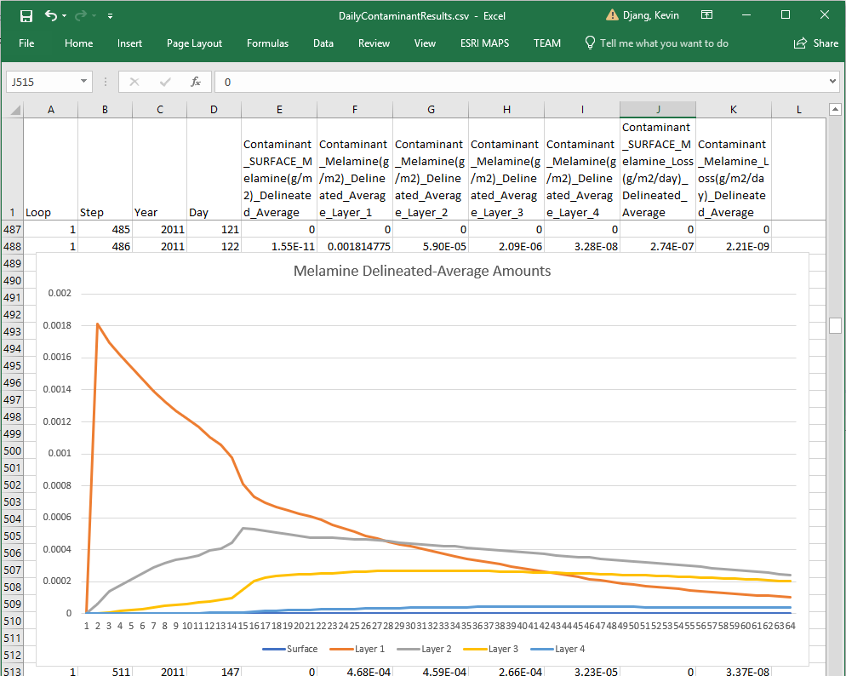

**Cell-Specific Results**As mentioned above, results in the DailyResults.csv file are mostly delineated averages. To gather cell-specific data, a simulation must specify one or more Cell Data Writers, or Spatial Data Writers as part of the simulation scenario’s configuration.

A *Cell Data Writer* configuration tells the VELMA simulator to gather and report a wide variety of data for a specific cell location within the watershed. The results appear in a comma-separated value (.csv) file -- with a file name that includes the cell location -- in the output directory.

A *Spatial Data Writer* configuration tells the VELMA simulator to gather the amounts of one specific data type and report it for every cell. The results appear one or more Grid ASCII (.asc) map files – with file names that include the data type and simulation date-stamp – in the output directory.

**Cell Data Writer Files**  
Our example simulation includes 3 Cell Data Writer configurations: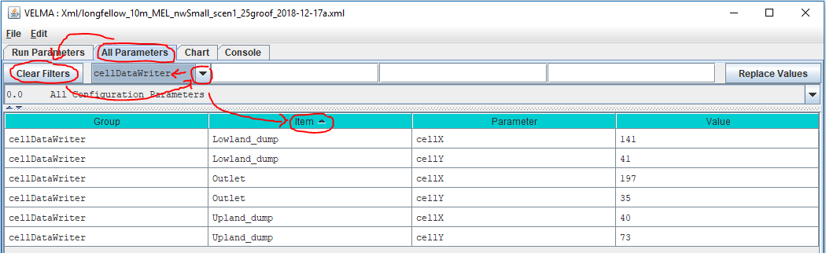  
As you can see, each configuration includes an Item name, and x and y cell location parameter values.  
Each configuration generates cell-specific data in an output directory file with a cell-specific name (you can use the Powershell, as shown below, or Windows Explorer to obtain this information): 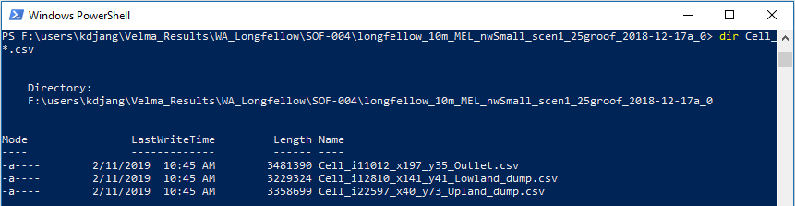

Like DailyResults and DailyContaminantResults .csv files, a row of data in a Cell_ .csv file represents one simulation step, with specific data type amounts for that step in each column. However, unlike DailyResults, the data amounts are not averaged – they are raw amounts – and are specific to a cell location.

Here is a screen-capture of the upper-right corner of the Output Cell_ results .csv file opened in Excel: 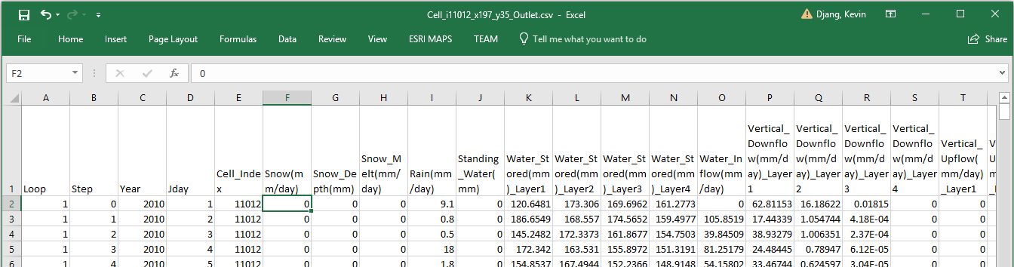

When a simulation scenario includes Contaminants (as our example scenario does), Cell Data Writer files include rows for the Contaminant lateral flow (the amount hydrologically transferred out of the cell) and pool amounts (the raw amount in each layer of the cell and on the surface).

Here is a screen capture of our example scenario’s outlet cell Melamine amounts for the first 60 days after deposition: 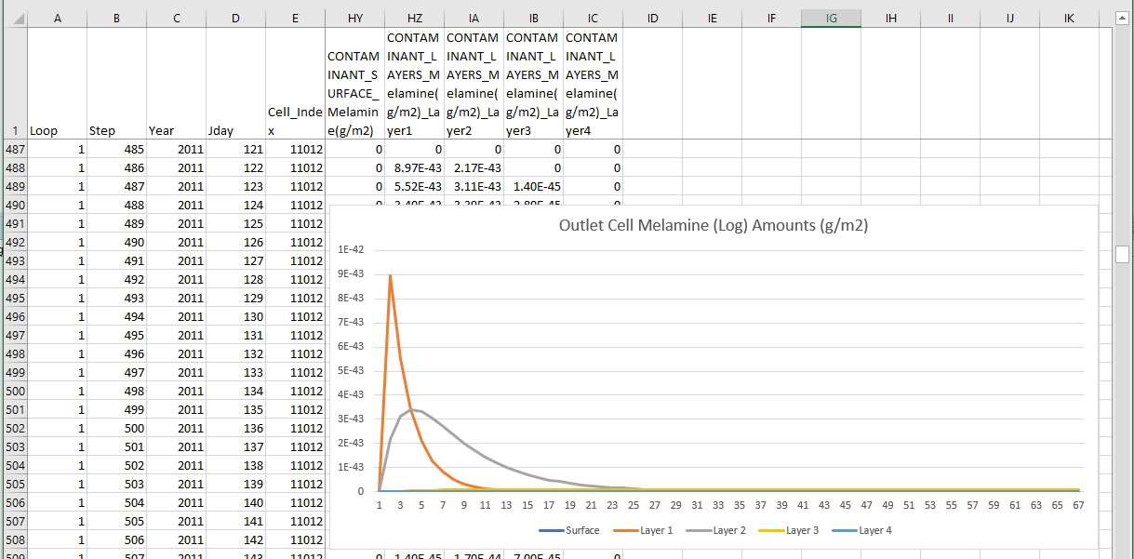

Compare this with the DailyResults delineated-averaged graph of the *average* Melamine across the watershed. For the same time span, graphs show some general similiarity, but the specific amounts at the Outlet are distinct from the delineated-average of the watershed as a whole.

To further emphasize the distinction, here is a graph of the same simulation time span, but for one of the other Cell Data Writers configurations in our example. This Cell Data Writer was configured to capture data at one of the cells Melamine is deposited (unlike the outlet cell): 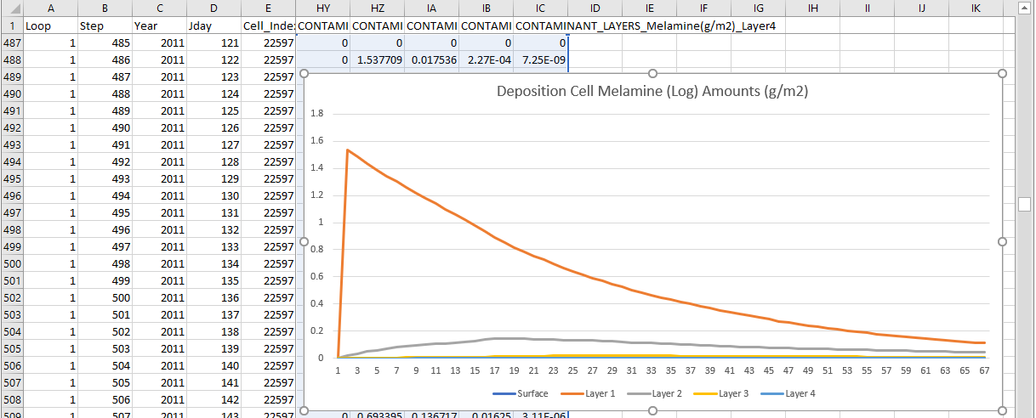

For further information about Cell Data Writers, refer to:  
Tutorial D.8 – Cell Data Writer Configuration  
in the “HowTo” documentation folder for VELMA 2.1.

**Spatial Data Writer Files**  
Our example simulation includes several Spatial Data Writer configurations. The following screen capture shows the “All Parmeters” table filtered to display the parameters for one of them: 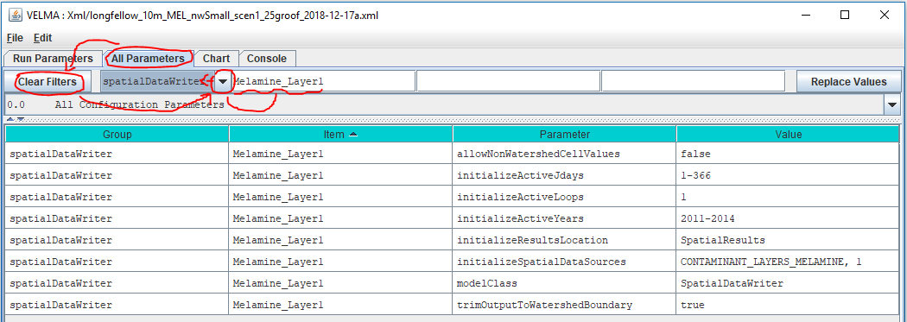  
Configuring a SpatialDataWriter requires more parameters than a Cell DataWriter, because the data pool and the simulation steps to capture must be specified for the simulator. This Spatial Data Writer above catpures the Melamine amounts in soil layer 1 (per the initializeSpatialDataSources parameter) for each day (simulation step) in the range of years [2011, 2014]. It will write the data as series of uniquely-named .asc files to a directory named “SpatialResults” (the initializeResultsLocation parameter’s value) which the simulator will create as a subdirectory of primary output directory during the simulation run.  
(All of the Spatial Data Writer in our example simulation scenario are configured to report the same simulation states to the same initializeResultsLocation.)

Checking our example simulation output directory confirms that “SpatialResults” exists, and that it contains (a lot) of *.asc files: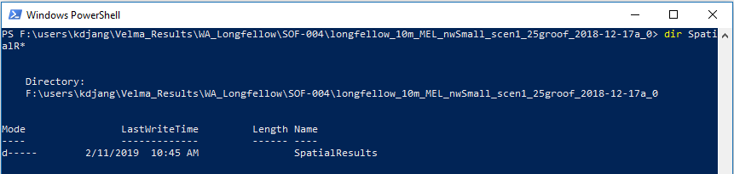

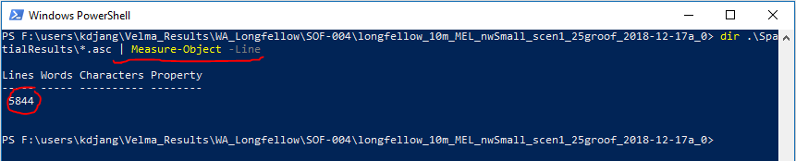  
*(The* “| Measure-Object -Line*” portion of the PowerShell command to list all *.asc files in .\SpatialResults directory reidirects the command to report the number of files, instead of listing their names.)*

The fact that we’ve generated 5,844 .asc files of spatially-explicit (i.e. map) data highlights a rule of thumb about Spatial Data Writers: each file written reports amounts for the every cell in the watershed, but only for one simulation step. To record one year’s worth of Spatial Data for one data pool requires writing 365 (or 366 in a leap year) files, and this multiplies as more Spatial Data Writers are configured for more data pools. If you need spatially-expicit maps of the simulation’s runtime behavior, this is worth the running time and disk space it incurs – however, it’s prudent to ensure your computer has enough disk space before you start.

You can view the .asc files created by Spatial Data Writers in ESRI’s GIS tools, or any GIS tools that support the ESRI Grid ASCII file format. You can also view them in VISTAs, or JPDEM, or open them in a simple text editor (e.g. Microsoft’s Notepad) and cut-paste the contents into Excel. This last option is unwieldy for anything but small (in terms of row and column count) .asc files.

Spatial Data Writer file names are prefixed with the text “Spatial_”, and have the dot-extension “.asc”. Their names include the name of the data they report, and the loop, year and Julian day of the simulation run that the data was reported for.

As an example of finding specific file: referring to the contaminant data graph from the deposition cell’s Cell Data Writer file in the previous section, Melamine first appears in soil layer 1 at the deposition cell on Julian day 122 of 2011. To look at the state of Melamine amounts in soil layer 1 fifteen days after that (Julian day 137), we need to find the .asc file with the following file name characteristics:

* The prefix “Spatial_”
* followed by the name of the data (“MELAMINE”)
* followed by a Layer indicator (“L#1”)
* ending with the loop, year and Julian day values (“1_2011_137” in this case)
* with “.asc” as the dot-extension suffix.

Without knowing the exact filename, this information should be enough to find the file we want, using the dir command, in a PowerShell window: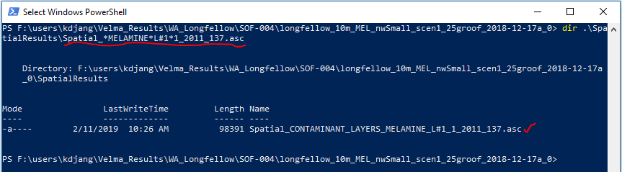

Changing A VELMA Simulation Configuration

Section V. Topics

* Create a Copy
* Change the Copy
* Save Your Work
* Remove Obsolete Original Parameters
* Save Your Work(!)

This section demonstrates how to modify and existing VELMA simulation configuration to create a related, but different scenario: we’ll use the original example introduced in this guide as a starting point, then change how and where its Melamine contaminant is deposited during the simulation run.

**Create a Copy of the Original Example Simulation Configuration**

1. Start the VELMA GUI and load the  
   longfellow_10m_MEL_nwSmall_scen1_25groof_2018-12-17a.xml  
   configuration file, as described in parts II and III of this guide, however do not start the simulation running.
2. The name of the example simulation is in the “Simulation Run Name” text field, in the upper-left corner of the GUI’s “Run Parameters” page. 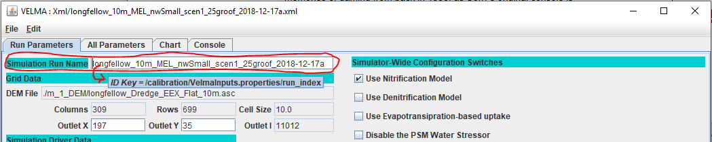Pro tip: click into the text box, then leave your mouse cursor hovering over it – after few seconds, a pop-up tool-tip message will appear, displaying the parameter’s name.
3. Edit the value of the Simulation Run Name from:  
   longfellow_10m_MEL_nwSmall_scen1_25groof_2018-12-17a  
   to  
   longfellow_10m_MELroads_nwSmall_scen1_25groof_2018-12-17a  
   and then press the Tab key (The Return/Enter key will not do, you must press Tab).
4. Click the File 🡪”Save Configuration to VELMA XML File” menu item, 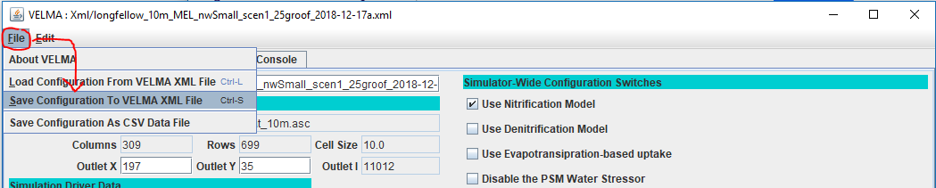which opens the “Save Configuration to XML” dialog window: 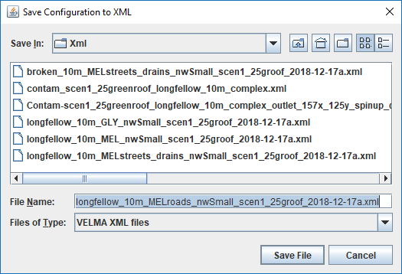  
   The dialog should open to the same directory that you loaded the original example configuration .xml file from, and the File Name should already contain the new Simulation Run Name you specified in step 3 above.   
   Click “Save File”.  
   You now have a copy of the original example .xml file saved in the same directory under the new Simulation Run Name.

**Change the Copy of the Simulation Configuration to Make a New Scenario**

The original example scenario deposited 10g of Melamine onto the surface of one watershed cell on the 122nd day of 2011, and onto another watershed cell 60 days later in the same year. It used a Surface Deposition Disturbance configuration to do this.

To view the Deposition Disturbance’s configuration, click the “All Parameters” tab, then the Clear Filters button, then click the drop-down button and select “disturbance” in the Group selector filter. Finally, type Melamine_Dump into the Item filter text field: 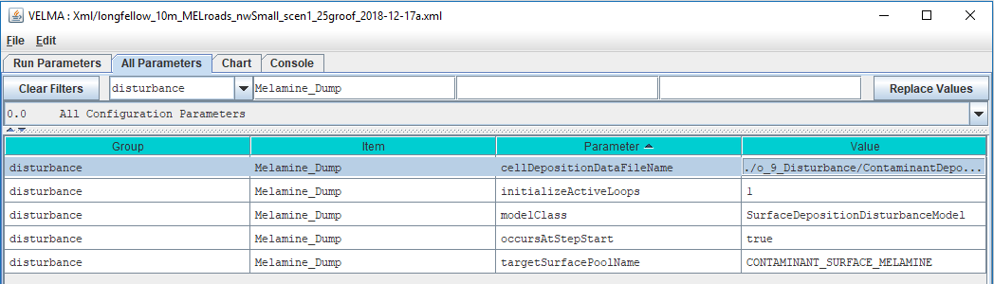

Although this configuration has relatively few parameters, it is not evident where the deposition location and dates mentioned earlier are specified. That’s because they are “hidden” inside file specified by the cellDepositionDataFileName parameter: its value is the name of a file that contains the deposition details:  
 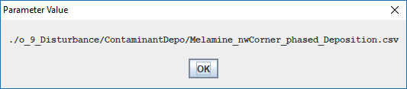  
Printing the contents of the file reveals the schedule:

22597,2011,122,10

12810,2012,182,10

The first number in each row is the linear index of a cell in the watershed.  
The trio of numbers that follow indicate the year, Julian day, and the amount of contaminant to deposit on the cells surface.

The deposition data file can contain many more cells than this example, and each cell can have multiple trios of (year, jday, amounts) associated with it. This allows configuration of a wide variety of deposition scenarios.

However, VELMA provides another way to effect deposition of contaminants onto the cells of a simulation’s watershed: specify a map (an .asc file) with deposition amounts, as well as when the amounts in the map should be applied to the cells. This kind of disturbance configuration is called a “Set Spatial Data by Map” disturbance, a long-winded name providing a good idea of its function.

VELMA allows multiple disturbance configurations within one overall simulation configuration, so let’s add the new disturbance before removing the old.

1. In the VELMA GUI’s All Parameters tab, click the Edit 🡪Disturbances 🡪 “Add a Disturbance” sub-menu item. 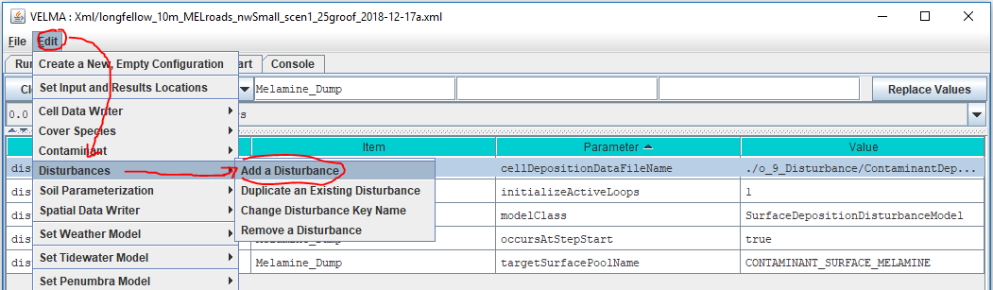
2. In the “Specify Disturbance Model Type and Name” dialog, click the drop-down list of the “Disturbance Type” selector and select “SetSpatialDataByMapDisturbanceModel”.  
   (You may have to sroll down in the list to see it): 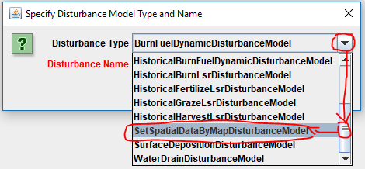
3. Specify the Disturbance Name as “Melamine_Roads”, then press the Tab key.  
   (You must press the Tab key, the Return/Enter won’t do for this step.) 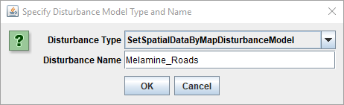  
   At this point, the “Disturbance Name” label should stop displaying in red.  
   Click the OK button.
4. The All Parameters tab panel should be automatically filtered to display the new disturbance parameters it’s parameterization table:   
   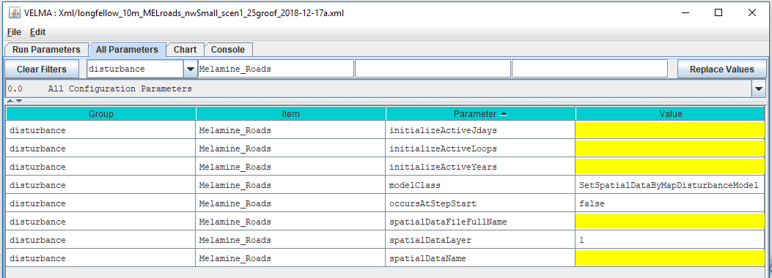
5. Some parameter’s values are filled in by default, while others are highlighted in yellow to indicate that their values are missing.  
   Click into the “Value” column fields of the following parameters and set their values as follows:
   * initializeActiveJdays = 122
   * initializeActiveLoops = 1
   * initializeActiveYears = 2011

Do not change the modelClass parameter’s value: its default is correct as-is.

* occursAtStepStart = true (edit the default “false” to “true”)

The above parameterization causes deposition on the same date as the first of the two cells in the original example’s Surface Deposition Disturbance configuration.

* spatialDataFileFullName = ./o_9_Disturbance/ContaminantDepo/AllRoadCells_1d0.asc

The above file and location are part of the example simulation’s DataInputs files collection.  
The AllRoadCells_1d0.asc file specifies 1.0 (grams) for every cell identified as a road cell within the simulation watershed’s DEM map area, and 0.0 grams for every other cell in the map.  
Preparing this map is not a trivial undertaking, and requires GIS tools and expertise.  
Refer to other sources for further information.

* spatialDataLayer = 1
* spatialDataName = CONTAMINANT_SURFACE_MELAMINE

The parameters above tell the disturbance which data pool to deposit amounts into, and which layer of the pool.

The disturbance’s parameterization should now look like this:

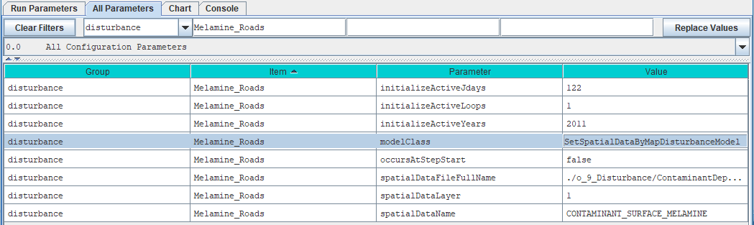

**Save Your Work!**

Take a moment to save the new scenario’s current state, by repeating step 4 from the “Create a Copy …” instructions above. This time, when you click the “Save File” button, the GUI will warn you that you are about to overwrite an existing .xml file. 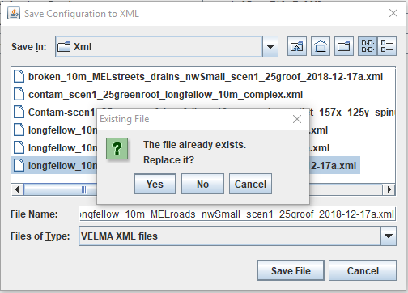  
That’s what you want in this case, so click “Yes” to save/overwrite and proceed.

**Remove the Original Example’s Surface Deposition Disturbance From the New Scenario**

Now that we’ve added a new contaminant deposition (by way of the Set-by-Map disturbance) to the new scenario, we can remove the original scenario’s deposition disturbance.

1. Click the Edit 🡪 Disturbances 🡪 “Remove a Disturbance” sub-menu item: 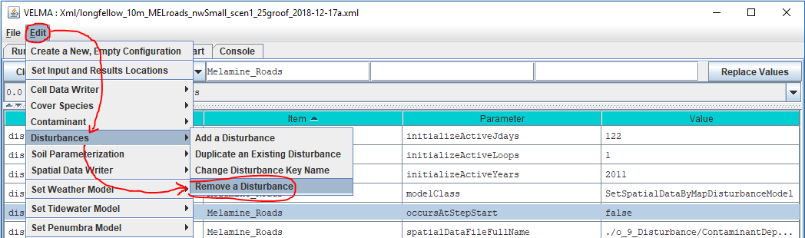
2. In the “Select the Disturbance Items to REMOVE”, click the checkbox for the “Melamine_Dump” SurfaceDepositionDisturbanceModel in the SELECT column of the table:   
   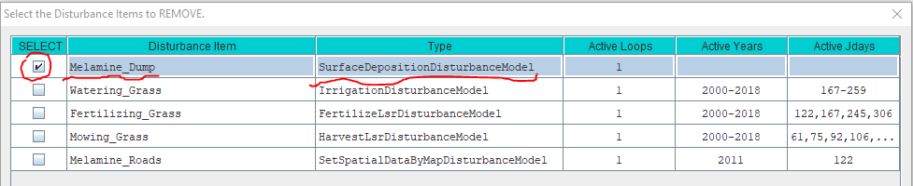Then click the OK button at the bottom of the dialog box, and the OK button at the bottom of the subsequent confirmation box:  
   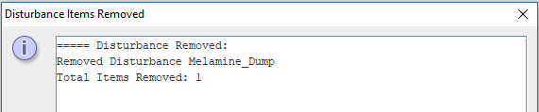
3. You can confirm that the original “Melamine_Dump” disturbance has been removed by click “Clear Filters” then selecting the “disturbance” drop-down filter, and typing modelClass in the Parameter filter text field: 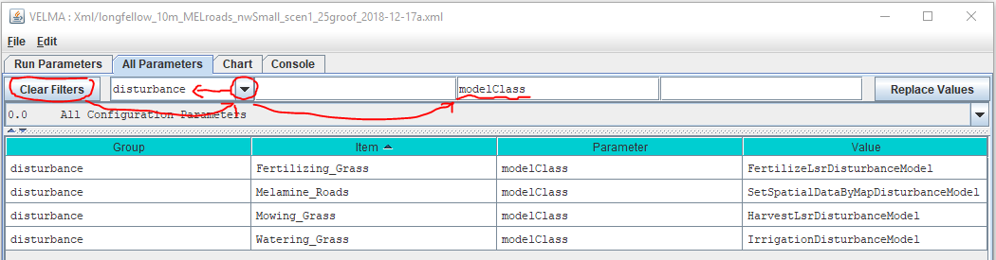

**Save Your Work!**

Repeat step 4 from the “Create a Copy …” instructions above.

Run the New Scenario

Section VI Topics:

* Start the New Scenario
* Contaminant-specific Runtime Displays
* Comparison of Results

At this point you can click the Start button and run the new scenario, or, if you closed the VELMA GUI after saving the new scenario to an .xml file, re-start the GUI and re-load the new scenario, then start the scenario running.

**Contaminant Runtime Displays**

When the GUI is running a scenario that includes one or more contaminant configurations, the GUI provides two types of displays for charting contaminant amounts during the simulation run: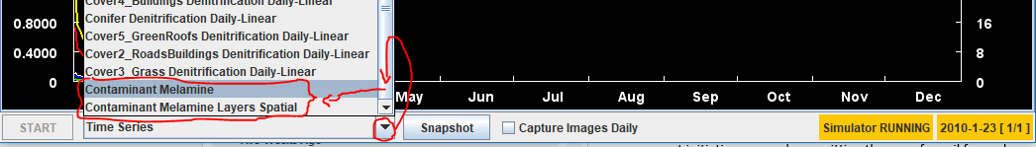

When the new scenario simulation run reaches the 2nd year (2011), select “Contaminant Melamine”.

The “Contaminant Melamine” display shows spatially-explicit contaminant amounts for the surface and for the sum of the amounts in the soil layers, as well as the daily, delineated-average amount in the watershed:

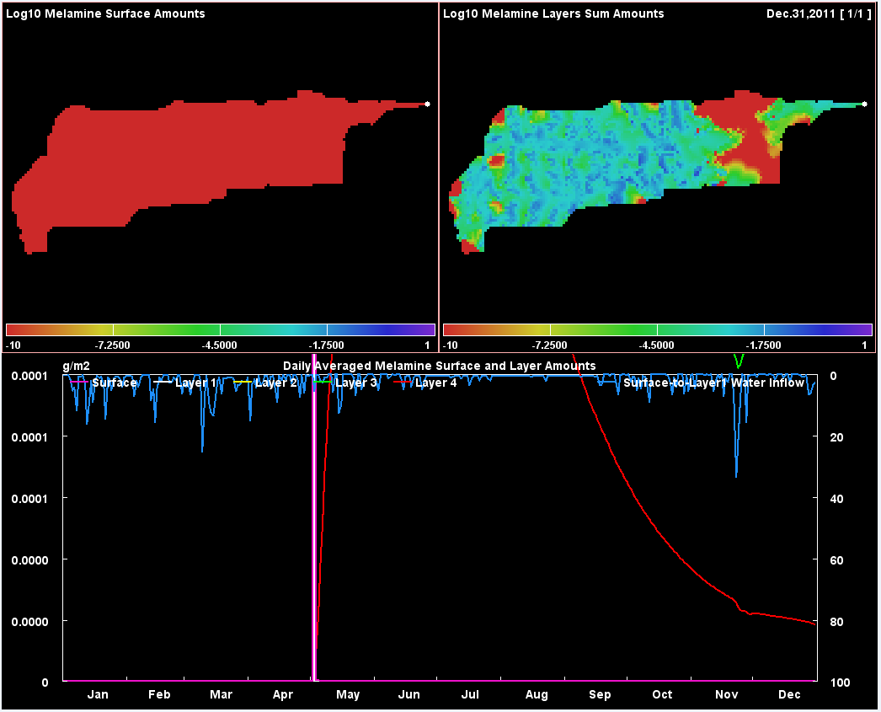

(The Daily Averaged values displayed in the bottom chart are the same values reported for surface and layers in the DailyContaminantsResults.csv file.)

Notice that the spatial (map) portions of the display chart the Log10(amount) value per cell.  
The total range of amounts can be several orders of magnitude. Displaying using a log scale provides a color ramp that is easier to see.

When the new scenario simulation run reaches the middle of the 3rd year (2012), select “Contaminant Melamine Layers Spatial”. This display shows spatially-explicit, layer-specific contaminantamounts for each of the four soil layers:

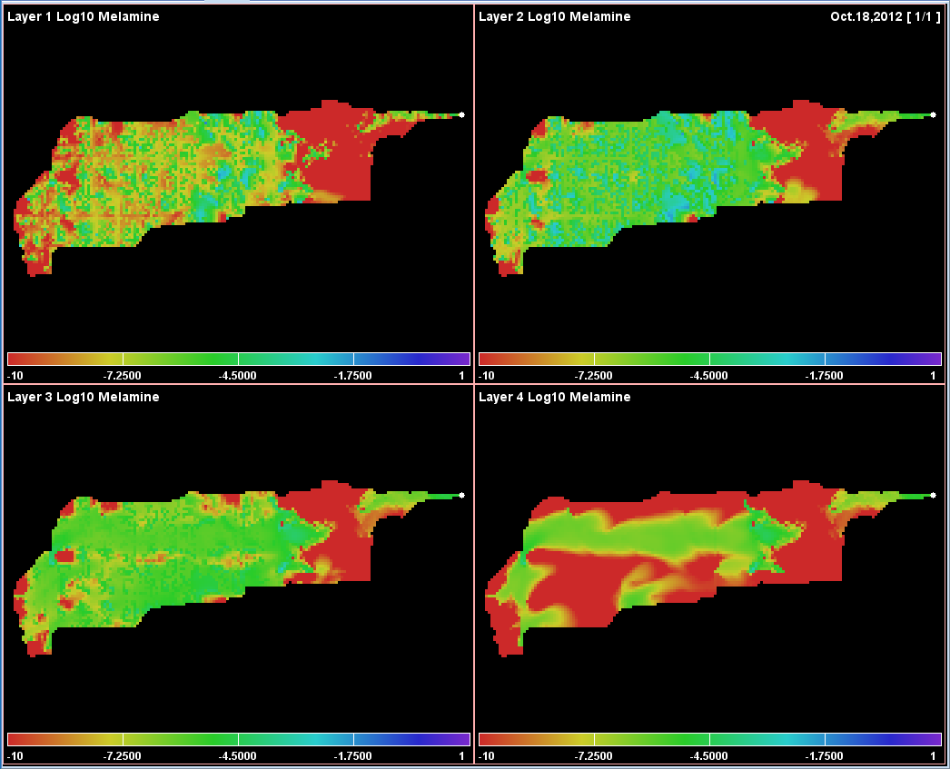

**A Quick Comparison / Contrast Between the Original and Modified (New) Scenarios**  
The difference between our two example simulation scenarios is where we deposit the contaminant onto the surface of the watershed’s cells. However, in both scenarios, the first deposition occurs the same day of 2011.

With that in mind, here are the spatial portions of the “Contaminant Melamine” displays for both simulations, on the same day, shortly after deposition.

**Original Scenario: Deposition at a specific cell:**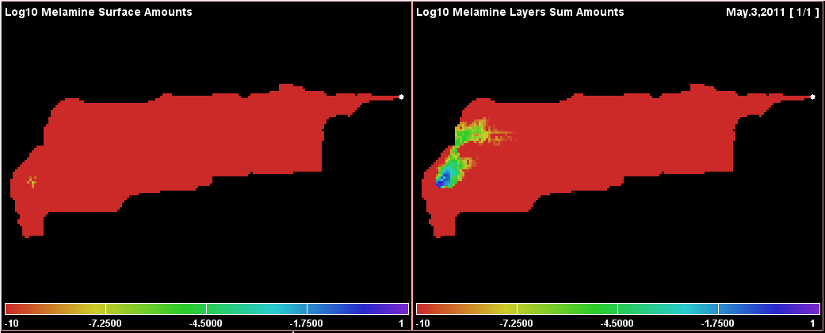

**Modified (New) Scenario: Deposition on all road cells:**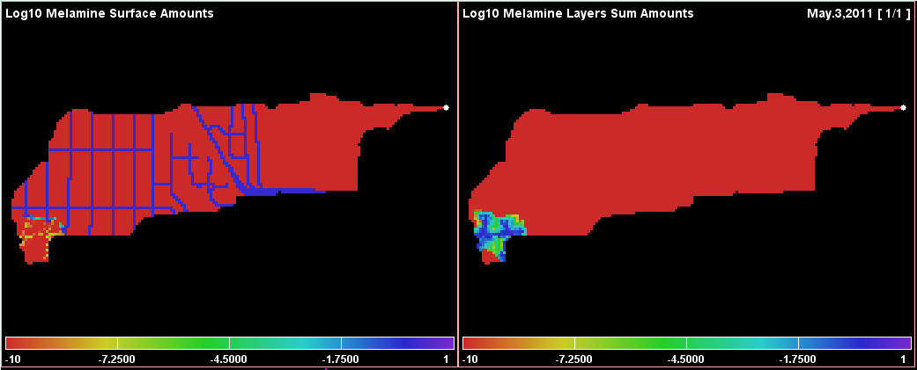

Some points to keep in mind while comparing the displays above:

* Melamine is relatively soluble and travels readily when waterflow occurs.
* In the example watershed, the highest and steepest cell elevations are along the west (left) side of the map. This seems to explain the rapid development of a melamine plume at that location, that is, steep slopes favor rapid runoff from impermeable roads onto more permeable off-road surfaces.
* The original example’s deposition cell location has high permeability, while road cells do not.

For additional information on how permeability is specified, see:  
Tutorial E.1 – Mapping Surface Layer Permeabilities.

Appendix 1 – Miscellaneous Tips and Shortcuts

How To Avoid Typing File Paths in Windows 10

You can avoid typing the name of a directory name as a parameter for VELMA by instead finding it in a File Explorer window and copy-pasting it from there.

Navigate the File Explorer to the desired directory, double-click the location name text box, then right-click and click the Copy item. (Pro Tip: after double-clicking to highlight-select, you can type Ctrl-c instead of using the “Copy” menu item.)  


The text of the full path to the File Explorer’s current location is now copied to the Windows system clipboard.

You can right-click 🡪 Paste (Pro Tip: or type Ctrl-v) that location text into VELMA parameter value fields, or onto the command line of a PowerShell.

Whitespace in Paths in Windows 10 and VELMA   
The Windows 10 PowerShell console window separates text typed onto its command line by whitespace. This means that any directory or file path containing whitespace must be enclosed in double-quote characters to preserve the entire path as a single element on the command line.

For example, without quotes, the following path:

C:\User\dpines\a\path with some\whitespace\foo.txt

Is “seen” by the PowerShell console as three separate elements:

“C:\User\dpines\a\path”, “with”, and “some\whitespace\foo.txt”

To force PowerShell to “see” the path as a single element, it needs to be enclosed in double-quotes, like this:

“C:\User\dpines\a\path with some\whitespace\foo.txt”

However, when paths containing whitespace are specified as parameter values in the VELMA GUI, they **must not** be enclosed in double-quotes.

Windows 10 Path Separators and VELMA

Windows 10 uses the backslash “\” character as a separator between directory and file names.

Example: C:\this\that\and\the\other.txt

Other operating systems (e.g. OSX and Linux) use the forward-slash “/” character.

VELMA *tries* to be platform-neutral about path separators.

When you specify a path, file, or path-and-file name as a VELMA configuration parameter in the VELMA GUI’s “Run Parameters” and “All Parameters” panels, you *should* be able to use either the backslash “\” or forward-slash “/” character as a separator.  
However, the following rules of thumb apply:

* Within a single path, please be consistent.  
  For example, don’t specify: C:\this/that\and/the/other.txt
* Although it tries to accept both, VELMA *prefers* forward-slash path separators.  
  If VELMA is rejecting an otherwise-legitimate, directory or file parameter value, edit its name to use forward-slashes and see if this resolves the issue.

Drag-and-Drop Simulation Configuration Scenario Files into VELMA GUI

Instead of using the File 🡪 “Load Configuration From VELMA XML File” menu item to load a VELMA scenario, you can locate the file in Windows File Explorer, then click-select-drag that file onto the VELMA GUI and unclick (“drop”) it

Caveat: There are only 2 areas within the GUI where you may successfully “drop” .xml files:

* The main table area of the “All Parameters” tab panel: 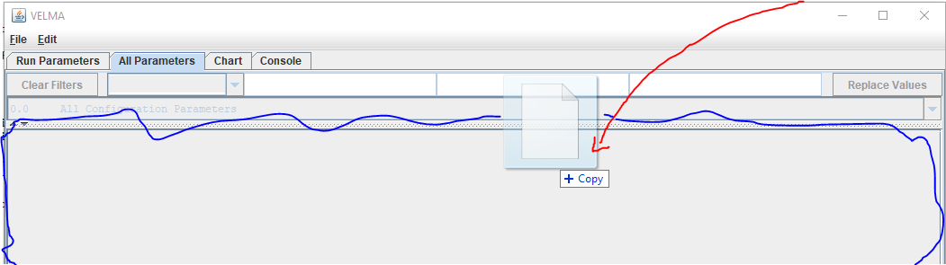
* The upper (i.e. non-Notes) area of the “Run Parameters” tab panel: 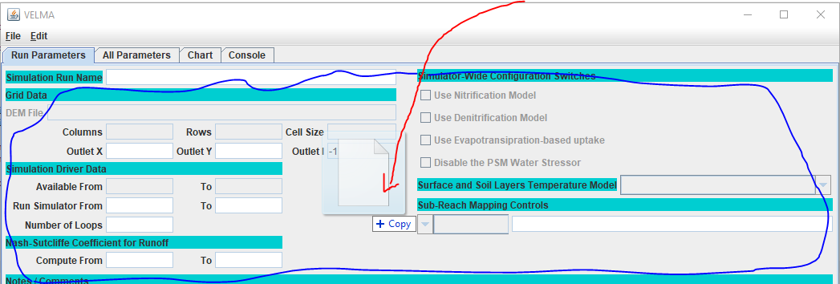

In both cases, if the .xml file is a valid VELMA simulation configuration file, the GUI loads its contents.

# A.4 | Adding Stormwater Drains for Urban & Mixed-Use Watershed Applications

#### Overview (Tutorial A.4 – Adding Stormwater Drains for Urban Contaminant Fate & Transport Applications)

Stormwater infrastructure – especially storm drains (catchments) and pipes when coupled with impervious surfaces – has a major impact on urban runoff and needs to be explicitly modeled to accurately predict contaminant fate and transport in urban watersheds.

This tutorial describes how to use VELMA’s Water Drain Disturbance routine to set up stormwater drains and pipes for simulating transfers water between non-adjacent grid cells, or remove it from the simulation watershed.

The Water Drain Disturbance provides a way to redistribute or remove water within a watershed at specific steps of a VELMA Simulation run.

As of September 2021, the Water Drain Disturbance routine has been shown to accurately represent stormwater runoff of surface water and entrained dissolved contaminants via stormwater drains and pipes, via the water drain disturbance feature in VELMA 2.1 (McKane et al. 2021).

General Procedure for Implementing Water Drain Disturbance

The Water Drain Disturbance transfers water between non-adjacent cells or removes it from the simulation watershed. It provides a way to redistribute or remove water within a watershed at specific steps of a VELMA Simulation run. Examples of use would be to explicitly simulate transfer of water through stormwater systems, detection ponds, or culverts.

Users specify one or more drain inlet cell locations for a given Water Drain Disturbance, along with parameters that determine when, and under what conditions, those drain inlet cells are to transfer water from the Surface Water spatial pool.

Users also specify whether the water drained from inlet cells is transferred to drain outlet cells in the same watershed, or is transferred beyond the watershed boundary, which will result in water transferred out to not be represented in the simulations hydrograph and hydrology statistics.

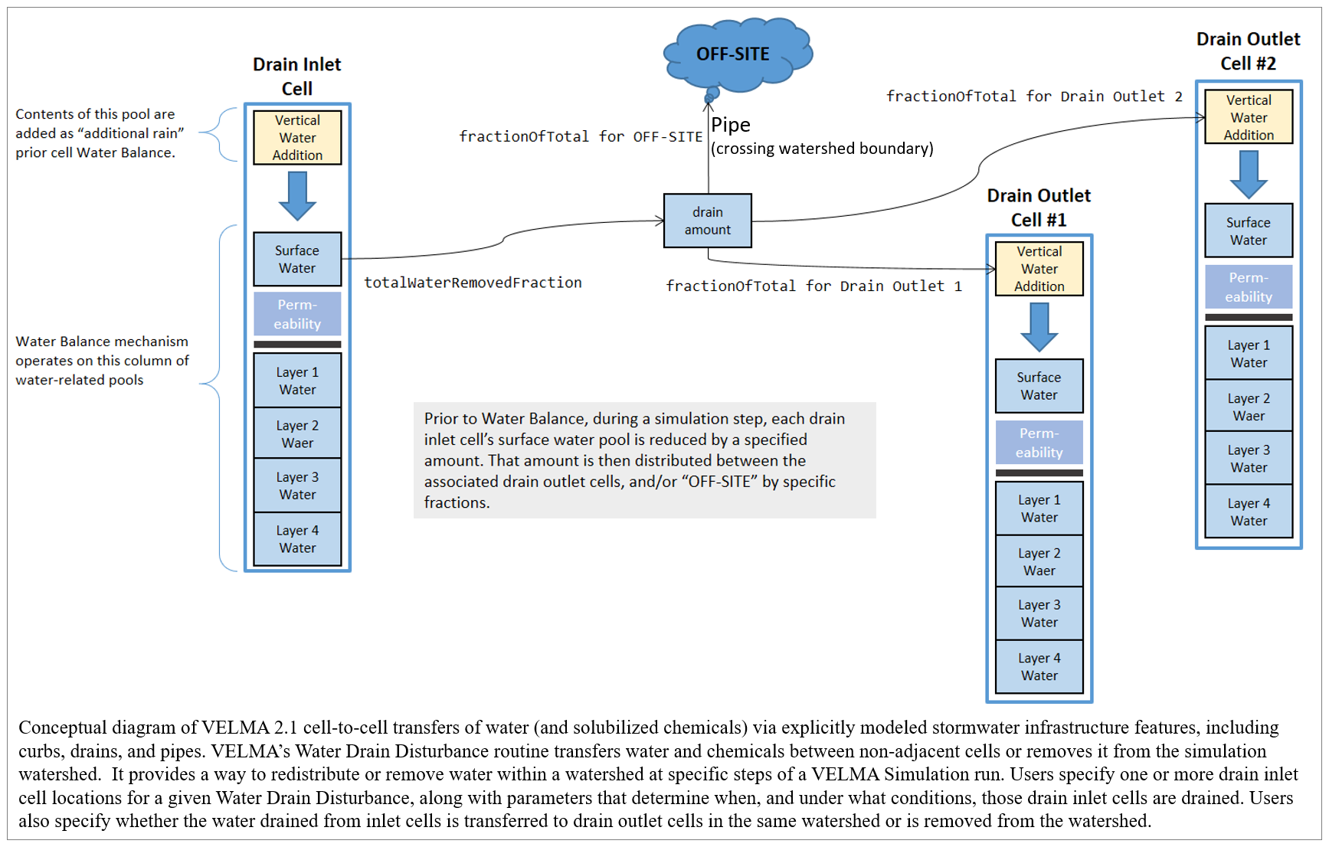

Water Drain Disturbances Have Several Significant Usage Restrictions

When configuring a simulation with Water Drain Disturbances, keep the following in mind:

1. Water Drain Disturbances use within a VELMA’s Parallel Mode is not recommended, though technically feasible. To be executed correctly, all water transfers must occur within the same sub-reach, or all water leaving a sub-reach should do so. Any water transfers that do occur across VELMA Parallel sub-reaches will be lost to the simulation due to how VELMA Parallel tracks water flowing from independent to dependent sub-reaches. See “HowTo VELMA Parallel Mode.docx” for VELMA Parallel mode details.
2. VELMA simulation configurations that employ Water Drain Disturbances must set their Sub-Reach mapping to SOLO_MODE, and this means that runoff data is not available except for the watershed’s primary outlet.
3. Water Drain Disturbances affect not only water amounts, but also transports nutrients and contaminants that are present at the corresponding surface pool (nutrients and contaminants that are within the layers are not impacted by this disturbance routine). Nutrient and contaminant quantities are transferred based on the percentage of the water volume transferred. Example: if 100% of surface water is transferred, 100% of contaminants at that same explicit cell surface location is also transferred. If 50% of surface water is transferred, 50% of contaminants at that same explicit cell surface location is transferred. The Water Drain Disturbance CSV file and optional impervious ASC map can both impact the water volume that is transferred.

Overview: Configuration Steps for a Water Drain Disturbance

Adding one or more Water Drain Disturbances to a VELMA simulation configuration via JVelma involves the following two steps:

1. Create the .CSV drain configuration data file designating the surface water transfer locations and percentages of water or amount of water in millimeters (when transfers are explicit by amount only water available is transferred; never more than any water present at any timestep).
   1. For applications requiring the explicit representation of water movement from catchment (inlet) to outflow (outfall) the use of Geographic Information Systems (GIS) data is leveraged to create CSV files for:
      1. urban applications representing stormwater systems.
      2. green infrastructure or agricultural applications representing land use change.
      3. Culverts installed under roadway systems (urban and forestry).
2. Add a new Water Drain Disturbance parameterization group to the simulation configuration, employing the drain configuration data file.

Creating a Drain Configuration Data File

A Water Drain Disturbance must know: 1) the catchment or inlet water drainage cell locations (formatted as 1D i-index form), 2) the outlet or outfall cell locations where drained water emerges (formatted as 1D i-index form) when the water should be transferred to a location within the delineation; otherwise if the water should transfer out of delineation the i-index can be blank or any valid i-index outside the delineation, and 3) when water is available how much water is transferred per timestep. See ***Formatting Notes*** below.

Water amounts transferred are controllable for both the fraction of inlet water to drain, and what fraction of the drained water to transfer to each connected outlet (when multiple outlets are present). The drain configuration data file specifies all this information in the form of a .CSV table. Each row of the drain configuration data file represents one inlet, the fraction of water inlet water to drain, and zero or more outlets, and the fraction of the drained water each receives. See ***Formatting Notes*** below.

For example, the water drain data below, configures a network of 2 inlets. Each inlet drains water to 2 separate outlets, and one of the “outlets” is “OFF-SITE” – meaning the water is removed from the simulation watershed when drainage occurs.

Inlet, inFraction, #ofOutlets, Outlet, outFraction, Outlet, outFraction  
227, 0.90, 2, 343, 0.50, 323, 0.50  
348, 0.75, 2, , 0.75, 390, 0.25

Formatting Notes:

* The #ofOutlets field value must match number of Outlet,outFraction pairs of fields that follow it.
* The inFraction, and all outFraction values must be in the range [0.0, 1.0]
* The outFraction values for a given inlet must collectively sum to 1.
* Specify the OFF-SITE location as an empty Outlet location field paired with an outFraction value.
* The OFF-SITE location may be specified for multiple inlets, but not multiple times for a single inlet.
* The example data above has header row, but a header row is not required.

The example configuration above results in the network of drains illustrated below:

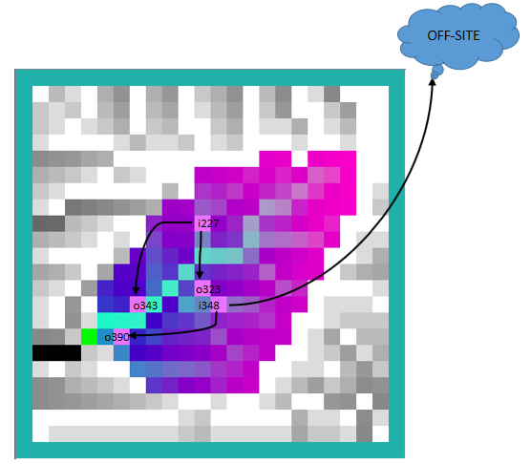

The following table summarizes the fields (left to right) for one row of a drain configuration data .CSV file:

|  |  |
| --- | --- |
| **Field** | **Meaning** |
| 0 | The linear index of an inlet cell location |
| 1 | The fraction of this inlet’s water to drain to outlets, range [0.0, 1.0] |
| 2 | The number of outlets associated with this inlet |
| 3 | The linear index of the first outlet cell location associated with this inlet. Setting the value to blank (but remember the comma!) indicates OFF-SITE drainage. |
| 4 | The fraction of the water drained from the inlet transferred to the first outlet cell’s Vertical Water Addition pool, range [0.0, 1.0] |
| < . . . > | <*repeat fields 3 and 4 for each additional drain outlet associated with this inlet*> |
| n | The linear index of the nth outlet’s cell location |
| n+1 | The fraction of the water drained from the inlet transferred to the nth outlet. |

Adding a Water Drain Disturbance Parameterization to a VELMA Configuration

Start with an appropriate VELMA simulation configuration .xml file.  
Load the file into JVelma and confirm that the enableReachMapping parameter’s value is SOLO_MODE.  
Next, click the Edit -> Disturbances -> “Add a Disturbance” menu item, as shown below:

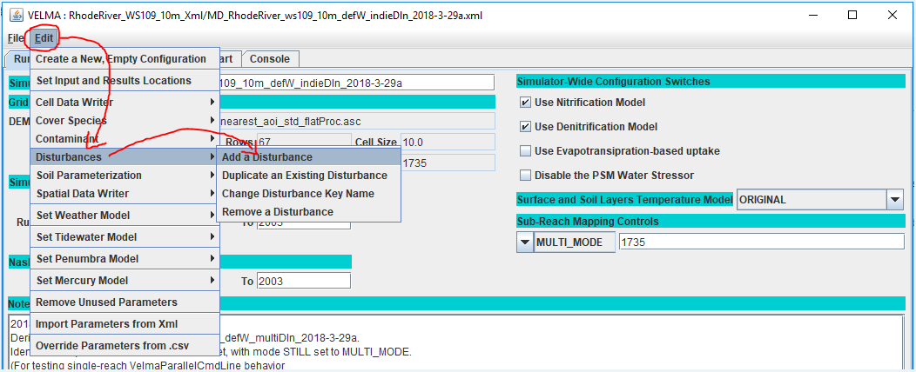

In the “Specify Disturbance Model Type and Name” pop-up dialog that opens, click the drop-down selector, scroll down, and click-select the “WaterDrainDisturbanceModel” type:

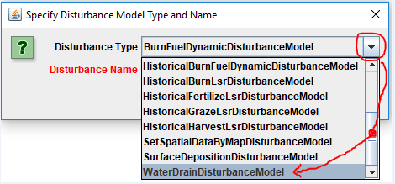

After selecting WaterDrainDisturbanceModel as the type, enter a unique name for the disturbance in the “Disturbance Name’ field of the dialog. Finally, click the OK button, which adds a new parameterization group to the simulation configuration and changes JVelma’s display to the “All Parameters” tab, with the item-level filter set to only display the parameters for the newly added Water Drain Disturbance.

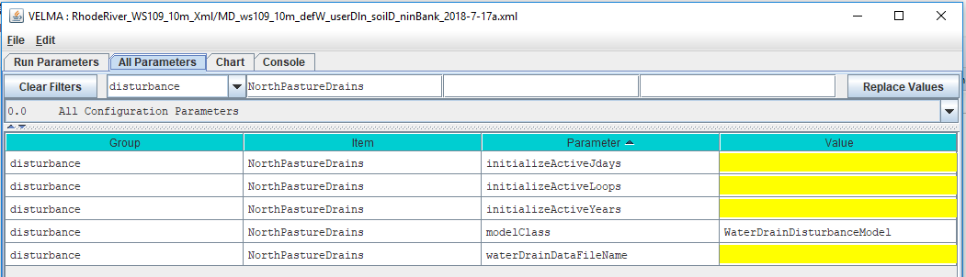

Parameters That Must Be Left Alone

The modelClass parameter is set by JVelma when you add the Surface Deposition Disturbance to the simulation configuration. Do Not Change this parameter’s value. Ever.

Parameterizing When Drainage Occurs

Specify values for the initializeActiveLoops, initializeActiveYears, and initializeActiveJdays, parameters to determine the loops, years, and Julian days of the simulation when drainage will occur. These parameters accept single values, a comma-separated set of values, a hyphen-separated value range, or a combination of values and ranges.

For example, to schedule drainage during the 3rd loop of a simulation, in years 2000 and 2002, for the first month of each active year:

initializeActiveLoops = 3  
initializeActiveYears = 2000, 2002  
initializeActiveJdays = 1-31

Parameterizing Where and How Much Drainage Occurs

All the details required for drainage inlet, outlet, and quantity are contained within the drain configuration data .CSV file (see the “Creating a Drain Configuration Data File” section above). Set the waterDrainDataFilename parameter to point to that file.  
You may specify the file by a fully-qualified path and name, a partial path and name, or only the name of the file. When the waterDrainDataFilename parameter’s value isn’t fully-qualified, JVelma assumes the file’s location is relative to the input location specified for the simulation run by the inputDataLocationRootName and inputDataLocationFileName (startups group) parameters.

Results Output for Water Drainage

The GlobalStateLog.txt file records an INFO statement for each WaterDrainDisturbance occurrence during a simulation run. No additional map files or DailyResults.csv columns are automatically generated. A simple visualization of WaterDrainDisturbance events can be viewed using the “VelmaDrainDisturbanceVisualizer.py” code. This code requires minor, yet direct, changes to the Python code.

The logged WaterDrainDisturbance events can also be processed into ASCII maps using the “curb_n_drainToAsciiMapConvertor.py” code, then provided to the VISTAS 3D visualization tool.

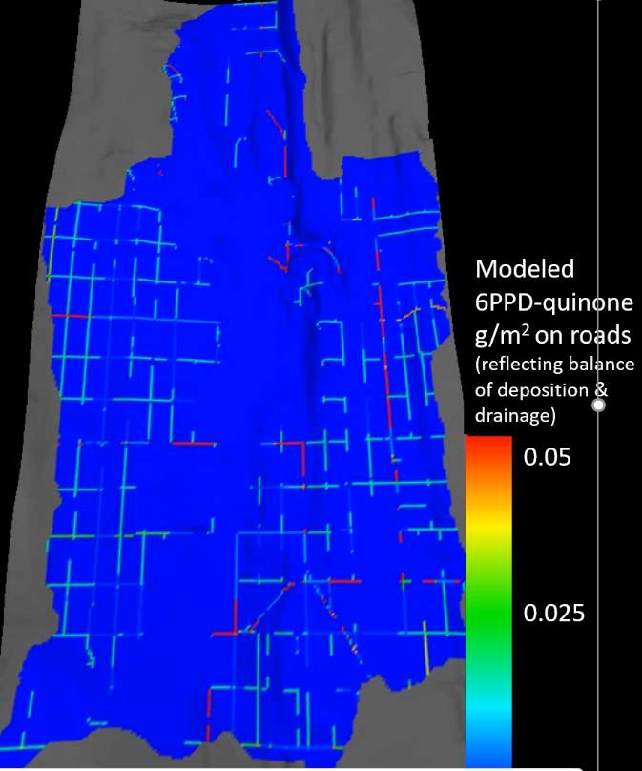

Above is a frame from a VISTAS video of 6PPD-quinone being deposited and routed along road surfaces due to the Water Drain Disturbance routing water along road surfaces to stormwater catchments. Details on this setup and generally how to a Water Drain Disturbance below.

Example of explicit Stormwater System modeling using the Water Drain Disturbance

Part of VELMA additions leading to version 2.1 allowed for the spatially explicit replicate municipal high-resolution spatial data describing stormwater infrastructure (roads, curbs, drains, pipe inlet and outlets) for densely developed urban watershed.

The Longfellow watershed is located within City of Seattle Washington’s West Seattle area. Most of this watershed is heavily urbanized with some lesser areas consisting of more natural areas such as the golf course and riparian corridor along the Longfellow Creek. But these more natural areas are overshadowed by this watershed’s end to end coverage of impervious roadways and parking lots paired with a modern stormwater system. The VELMA Urban Setup figure below represents the major components that allow VELMA to simulate urban landscapes. This HowTo document focuses on the translation of GIS stormwater data seen in the far-right map panel to the CSV file format described above.

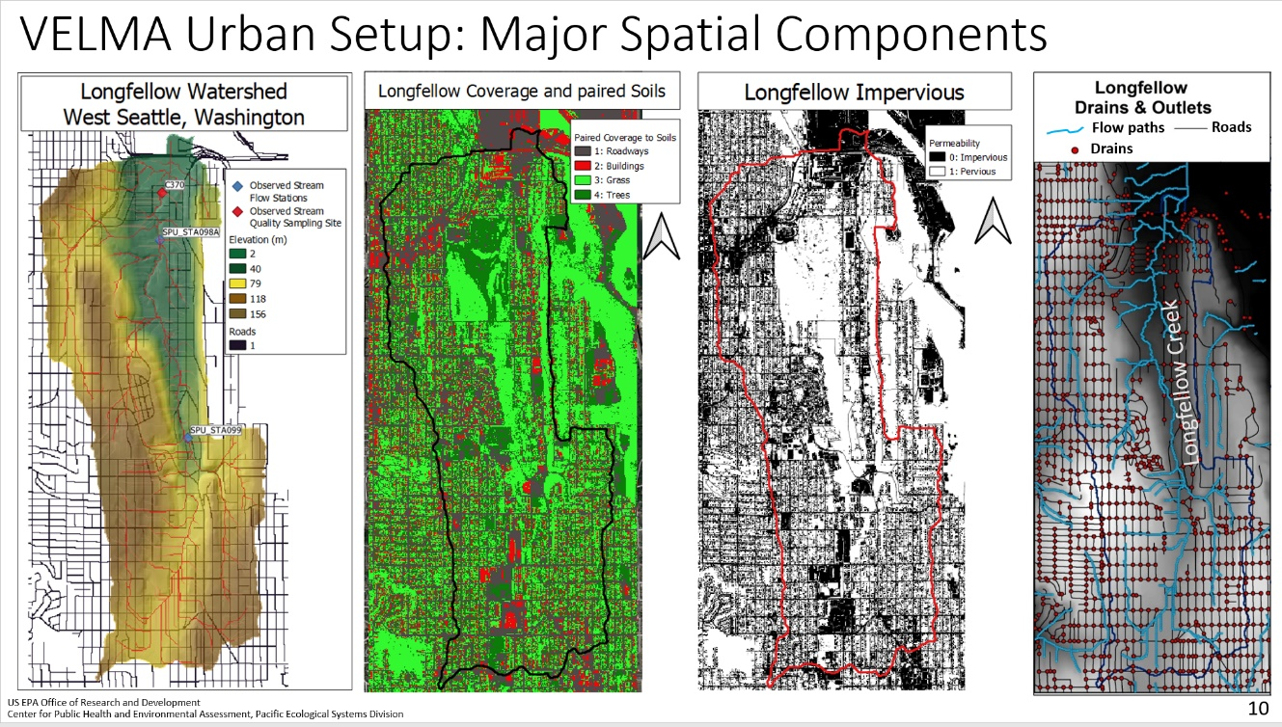

VELMA set up for explicitly modeling actual stormwater infrastructure in Longfellow Creek watershed, Seattle, WA (McKane et al. 2021).

The City of Seattle has publicly available GIS data representing their stormwater systems catchments, lateral pipes, mainline pipes, and outfall locations. These four stormwater components are separated regarding the GIS spatial data, yet all linked within the shapefile attributes tables using variable keys. Catchments contain a unique key linking to a lateral pipe or mainline pipe, lateral pipes and mainline pipes all have an uphill key linking to a downhill key linking to the next pipe piece, and all outfall locations have a key linking to final mainline pipe of that section of the network.

The Java based programming tool called “VelmaEndPtFromDrainWalker.java” was developed to “walk” the City of Seattle’s stormwater GIS data when provided the above key information as three data tables. The below image represents the tabular walking from key to key among one catchment to one lateral pipe to a mainline pipe. Most lateral pipes are the direct connection between the catchment and mainline pipes. There are cases where more than one lateral pipe was installed, and in those cases multiple lateral pipes are “walked”.

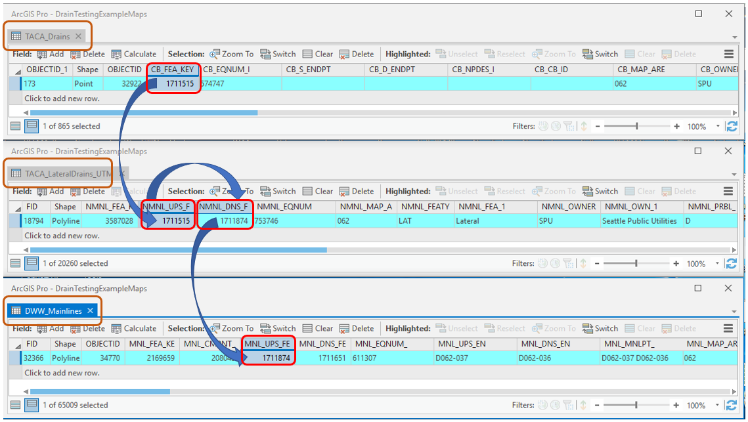

The below image represents the same tabular walking pattern among a series of mainline pipes to the final outfall point location.

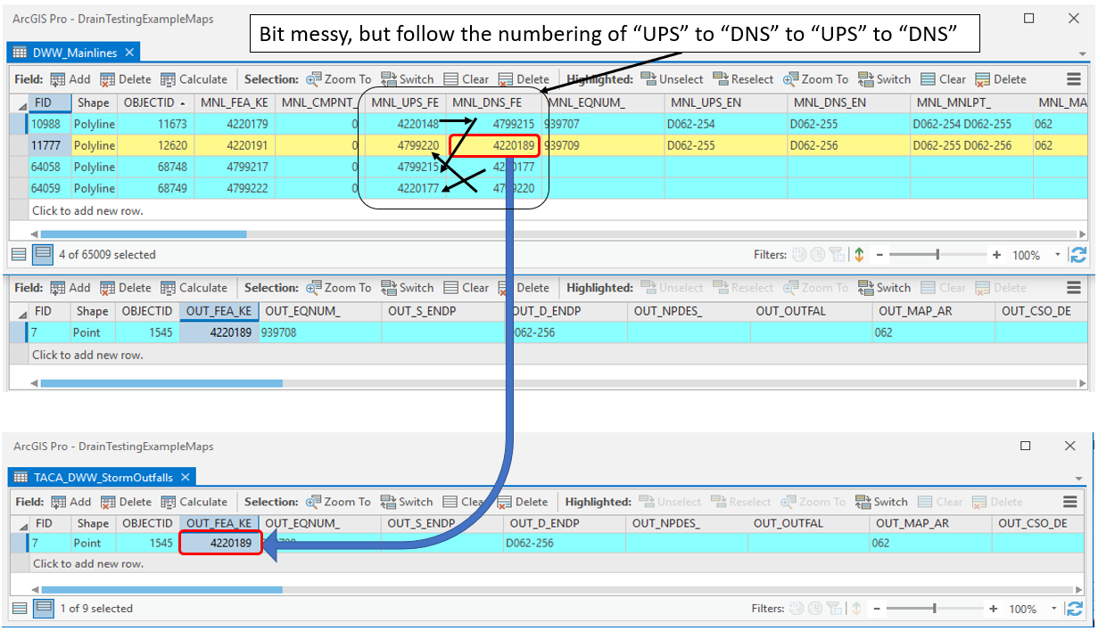

The output from the “VelmaEndPtFromDrainWalker.java” tool matches the format described above under section titled ***Creating a Drain Configuration Data File***. Below is a visual example of highlighting both the location of catchments to outfalls with the CSV file format.

*Note: though both the above tabular walking and below visual are both within Longfellow watershed, the above stormwater features in the tabular data are not the locations represented below.*

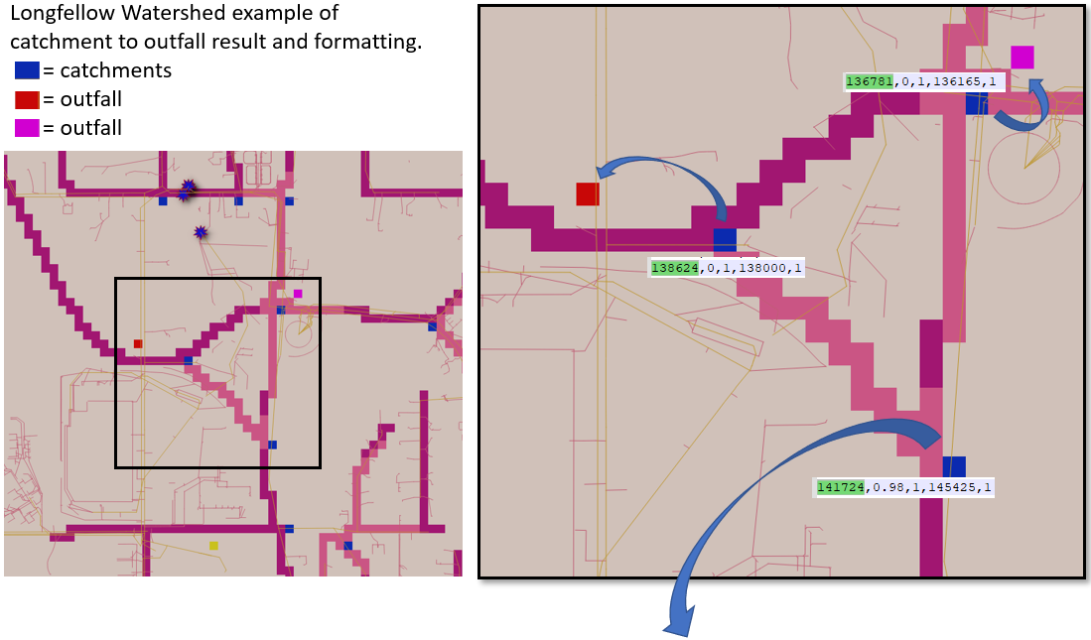

Curbed Streets

Street systems within an urban landscape can include curbs or drainage ditches that route water along roadways to curb stormwater drain inlets or catchment basins. This engineered system entirely removes the water from the original natural flow pathways and instead produces the water either:

unnaturally elsewhere within the watershed delineation (e.g., stream, detention pond, stormwater overflow vaults) shifting the hydrograph peak and timing, or

1. produces the water outside of watershed delineation which completely removes the water from the originating watershed’s hydrograph.

In either situation, within an ecohydrology model the water must be properly routed within the constraints of the modeling framework. Once the “VelmaEndPtFromDrainWalker.java” tool solves all catchments to outfalls, each catchment is processed in relation to the road network that is provided as a ASCII map matching the VELMA simulations cell resolution and spatial extent. If a catchment cell is on or directly neighbors a road cell the road network is walked for all cells road cells uphill until reaching another catchment cell or the top of the hill. The result is a series of inlet-to-outlet, inlet-to-outlet, etcetera Water Drain Disturbance events that in VELMA route water among a roadway to stormwater catchment inlets. The formatting of these “curb” Water Drain Disturbance events is identical to the stormwater catchment to outfall described in under section titled ***Creating a Drain Configuration Data File***. These curb disturbances and stormwater system disturbances are all output in a single CSV by the “VelmaEndPtFromDrainWalker.java” tool.

The below example highlights the four possible cell types the “VelmaEndPtFromDrainWalker.java” tool would determine.

* Stormwater Inlets (blue): driven by GIS stormwater data and in proximity of road network or impervious parking lots.
* Isolated Stormwater Inlets (green): driven by GIS stormwater data but were not in vicinity of road network or impervious parking lots.
* Curbed Streets (aqua): these were locations that were road cells uphill of a stormwater catchment or contained a direct linkage in series to a catchment.
* Non-curbed (black): these were road cells not determined to have a water routing path directly to a catchment cell. Note: an optional impervious ASCII map could represent water transfer along these cells, but such water would not be routed to a stormwater catchment cell.

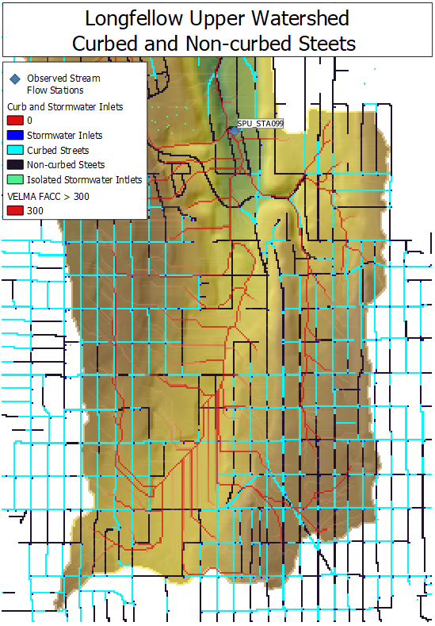

References

McKane, R.B., J.J. Halama, V. Phan, A. Brookes, K. Djang, E. Kolodziej, K. Peter. 2021. Model analysis and visualization of 6PPD-quinone fate and transport in Longfellow Creek watershed, Seattle, USA. 2021 International Emerging Contaminants (EMCON) Conference (virtual). U.S. Environmental Protection Agency clearance tracking number ORD-042888.

PowerPoint describing this work: <https://github.com/USEPA/VELMA_Public/blob/master/McKane%20et%20al%20EMCON_2021%20Presentation_9-13-21_v2%20with%20Notes.pptx>

# B.1 | Creating Flat-Processed DEM Data for the VELMA Simulator

**Overview***(Tutorial B.1 – Create Flat-Processed DEM Data for VELMA)*

The VELMA Simulator requires elevation data in the form of a georeferenced Digital Elevation Model (DEM) for any simulation it runs.

This DEM contains elevation data in the form of a grid for the area simulated.

The area specified must contain no "sinks" or "flat spots", so that when VELMA simulates runoff, it must be able to flow "off" the map area in some way. Water is not allowed to pool anywhere within the simulation area.

In order to ensure this "no flat spots rule", DEM data used by the VELMA Simulator first needs to be "flat-processed" to remove any sinks or flat spots.

This document explains how to use JPDEM – an enhanced Java version of the “PDEM” program (Pan et al. 2012) – to (1) flat-process raw DEM data files, and (2) determine the location of a watershed outlet and delineate the boundary the watershed area contributing to that outlet.

How to Acquire Digital Elevation Model Data

Elevation and other common GIS data can be retrieved from many local, state, and federal GIS repository libraries. The USDA’s “Geospatial Data Gateway” provides easy access to multi resolution USGS National elevation data along with many other types of natural resource data. Higher resolution data, like LiDAR can many times be found from alternative public and private stakeholders such as the “Puget Sound Lidar Consortium”. Other popular data, such as STATSGO and newer 10m gridded SSURGO soils GIS layers can also be acquired from the “Geospatial Data Gateway”

References

Geospatial Data Gateway - <https://datagateway.nrcs.usda.gov/>

Puget Sound Lidar Consortium - <http://pugetsoundlidar.ess.washington.edu/>

How to Use the JPDEM Tool to Process DEM data for Use with VELMA

To ensure the "no flat spots rule", DEM data used by the VELMA Simulator is first "flat-processed" to remove any sinks or flat spots.

Use JPDEM to prepare DEM data for use by the VELMA Simulator.

*Note*  
You must have a current version of Java (version 1.8 at this writing) installed on your computer to run JPDEM.

I. How to Create a Flat-Processed DEM

Start JPDEM

Open a Windows Command Line and enter the command:

C:\> java -Xmx1024m -jar C:\full\path\to\JPDEM.jar

The "-Xmx1024m" tells the Java Runtime Environment (JRE) to let JPDEM have 1024 megabytes (1 gigabyte) of working memory.

If your machine doesn't have that much memory, substitute a smaller value (e.g. "512" instead of "1024"). Alternately, if the .asc file of DEM data you intend to load is very large (and your machine has the memory) you may substitute a larger value (e.g. "2048" instead of "1024").

If the full path to the JPDEM.jar file contains whitespace characters, place double-quotes around the path.

Example:

"C:\full\path\with white space\to\JPDEM.jar"

Load the DEM Data into the JPDEM Tool

Load a "raw" DEM file into JPDEM (the file must be in standard ESRI Grid .asc format).

The easiest way to do this is to drag and drop a raw (unprocessed) DEM file into the open JPDEM window.

Alternatively, you can click the "File" menu, then select and click "Load DEM File".  
The "Select DEM File to Load" dialog window opens.

Browse to the location of your DEM file, and click the name of the DEM file.  
The DEM file's name appears in the "File Name:" text box.

Click "Load File" to load that file's data into JPDEM.  
The file is loaded, and an image of the file appears in JPDEM's map display.  
 If the file is too small (has few rows and columns), click the Image Scale up-arrow button to "zoom in".

Flat Process the DEM Data Using JPDEM

Click the "Tools" menu, then select and click "Flat-Process DEM Data (Standard)". The drop-down menu

currently provides a selection of methods to flat-process a DEM grid. There are currently four different JPDEM delineation algorithm implementations to choose from. We believe they all produce the same results (except possibly for cells on the edge of the DEM area -- which is an acceptable difference). However, they vary greatly in how long they take to run. We recommend using the "Experimental" algorithm for delineation because our experience is that it provides accurate results in a comparatively short amount of time.

The following is a quick summary of the alternate flat processing methods, including the strengths and weaknesses of each.

Standard

Feifei Pan's original PDEM algorithm and code, translated to Java.  
Raises and lowers cell elevations.  
May NOT completely process map -- has a "time-out" to keep it from running indefinitely.  
UNSAFE for use with maps that have had border-mask and/or channel dredge applied beforehand.

Alternate

Feifei Pan's original algorithm, implemented to with some simple Java optimizations.  
Raises and lowers cell elevations.  
May NOT completely process map -- has a "time-out" to keep it from running indefinitely.  
Is usually a bit faster than the Standard engine, but in a few cases has proven to run slower.  
UNSAFE for use with maps that have had border-mask and/or channel dredge applied beforehand.

Experimental (recommended)

Allen Brookes' complete re-implementation of Feifei Pan’s original algorithm.  
Only raises cell elevations.  
Will always completely process map (not proven formally).  
Is almost always much faster than either the Standard or Alternate engines.  
Can be disproportionately slowed down by large, contiguous flat areas adjacent to edges of the map.  
Can be safely used with maps that have had border-mask and/or channel dredge applied beforehand.

Enhanced Experimental

Allen Brookes' refinement of the Experimental algorithm.  
Primarily raises cell elevations (but may lower them as well).  
May NOT completely process map, but has a high likelihood of doing so.  
Is almost always faster than the Experimental engine.  
Can be disproportionately slowed down by large, contiguous flat areas adjacent to edges of the map.  
Can be safely used with maps that have had border-mask and/or channel dredge applied beforehand.

Enhanced + Divide-and-Conquer Experimental

Allen Brookes' additional refinement of the Experimental algorithm  
Primarily raises cell elevations (but may lower them as well).  
May NOT completely process map, but has a high likelihood of doing so.  
Is almost always faster than the Experimental Enhanced engine.  
Can be disproportionately slowed down by large, contiguous flat areas adjacent to edges of the map.  
Can be safely used with maps that have had border-mask and/or channel dredge applied beforehand.

After selecting (clicking) one of the preceding options, JPDEM will process the DEM, adjusting elevation data to remove flat spots or sinks within the DEM data's area.

If the processing takes more than a second or two, the display will periodically update, showing remaining flat spots in blue.

When the flat-processing algorithm finishes, the display shifts to a grey-scale representation, with darker-colored pixels representing cells with higher flow-accumulation values.

Save the Flat-Processed DEM Data from JPDEM To a File

After JPDEM finishes flat-processes DEM data, click the "File" menu, then click the "Save DEM As ..." submenu, and finally select and click the "Ascii Grid" menu item.  
The "Save DEM Grid to File" dialog window opens.

Browse to the location you wish to save the data in, then type a name for the file in the "File Name:" text box.

Finally, click the "Save File" button to save the DEM data to the specified file name and location.

*Notes:*  
Flat-processed DEM data may be loaded into JDPEM just like "raw" DEM data.

Flat-processed DEM date does not need to be flat-processed again after it is loaded into JPDEM.

However, to view the flow-accumulation grey-scale visualization of that flat-processed data, you must determine the flow data information for the flat-processed DEM values.

II. Watershed Delineation

Determining Flow Data for a Flat-Processed DEM

Load a flat-processed DEM .asc file into JPDEM, in the same way you would load a "raw" DEM file.

After loading the DEM data, click the "Tools" menu, then select and click the "Determine DEM Flow Data (Standard)" menu item.

JPDEM will then compute flow data (flow direction and accumulation values) for each cell in the DEM area.

Once the flow data is computed, JPDEM will shift the display to the flow-accumulation grey-scale visualization.

*Note*  
Loading a "raw" DEM file and then immediately trying to determine DEM flow data should not crash JPDEM, but it won't result in any meaningful information either.

*Note*  
The difference in results between the "(Standard)" and "(Alternate)" flow data algorithms should be zero or very small.

You may use either algorithm. The Alternate algorithm is somewhat faster, but often not much faster than the Standard algorithm.

Determining Watershed Delineation  
Flat-processed, flow-accumulated DEM data in JDEM may be used to determine the delineation relative to a specified outlet cell (i.e. the set of cells that flow "to" a specified "outlet" cell).

In order to compute the delineation for an outlet cell, you must first specify the coordinates of the outlet cell.

You can do this either by entering the zero-based x (column) and y (row) coordinates of the outlet cell in the "Outlet X=" and "Y =" number boxes, above JPDEM's map display, or by using the mouse.

To select an outlet cell using the mouse, do the following:

Move the mouse pointer over the cell you wish to select.

Press down on either the right or left mouse button.

A context menu should pop-up, containing information about the cell you are pointing at.

Holding the mouse button down, drag the mouse pointer onto the menu item containing cell info (the info should highlight), then release the mouse button.

The menu goes away, and the x and y coordinates for the cell you selected appear in the "Outlet X = " and "Y = " number boxes above the map display.

*Note*"Zoom in" on the map display by clicking the up-arrow button of the "Image Scale" to make selecting a specific cell easier. For example, at "Image Scale 3", for example, every cell is displayed by 3x3 pixels.  
However, on very large maps zooming too far in can crash the display, because it may run out of memory.

Once the coordinates of an outlet cell are specified, click the "Tools" menu, then select and click the "Delineate DEM Data (Experimental)" menu item.  
 JPDEM will then compute the delineation (i.e. the area of cells) for the currently specified "Outlet X =" and "Y =" values.

The resulting area is displayed in a logarithmic-coloring blue-red scale, superimposed over the grey-scale of the flow-accumulation display.

If the delineation looks incorrect, change the outlet cell coordinates and re-run the delineation.

When the delineation looks correct, record the "Outlet X =" and "Y =" values for future reference and use with JVELMA. (JPDEM does not "record" outlet values anywhere.)

References

Pan, F., Stieglitz, M., & McKane, R. B. (2012). An algorithm for treating flat areas and depressions in digital elevation models using linear interpolation. *Water Resources Research*, *48*(6).

# B.2 | JPDEM Cell Highlighter

**Overview** *(Tutorial B.2 - JPDEM Cell Highlighter)*

This tutorial explains how to use JPDEM’s Cell Highlighter functions to select one or more specific cells within the currently-loaded map (DEM or other spatial data) and display them in a distinct color. The highlighter makes those cell’s locations easier to spot and keep track of.

Follow these steps to use JPDEM’s Cell Highlighter functions to highlight the locations of selected cells:

Load a flat-processed DEM into JPDEM (see Section 1.1).

The Cell Highlighter controls are items in the View Menu:

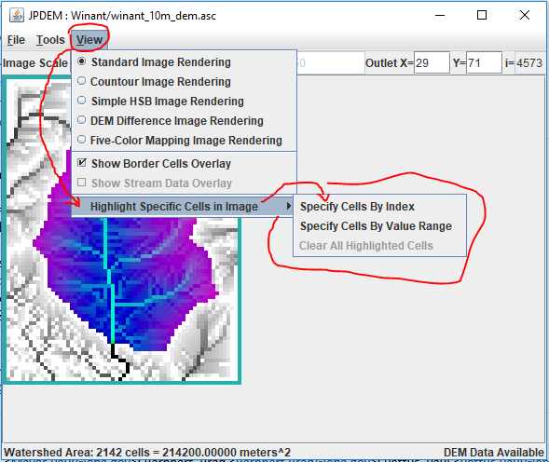

The “Clear All Highlighted Cells” item does exactly what it says, clearing the highlighting from any cells specified for highlighting. It’s only enabled when one or more cells *are* highlighted.

The two “Specify Cells …” options allow you to specify which cells to highlight.  
“By Index” means either by listing the linear indices of the cells, or by their (x y) coordinate pairs.

“By Value” means by specifying a range of cell values. All cells within the map whose values are within the specified range are highlighted.

Highlighting Cells by Index

Click the View -> Highlight Specific Cells in Image -> Specify Cells By Index menu item.  
The “Cells to Highlight” dialog box opens; note the instructions.  
Here is an example that specifies the 3 cells above the outlet location, using the (x y) coordinate pairs notation option. *Important! Notices that there is NO COMMA between the x and y values.*

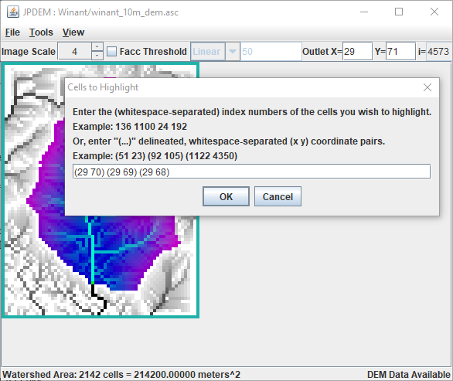

After entering the (x y) coordinate pairs and clicking OK, JPDEM highlights the specified cell locations over the current display/view option:

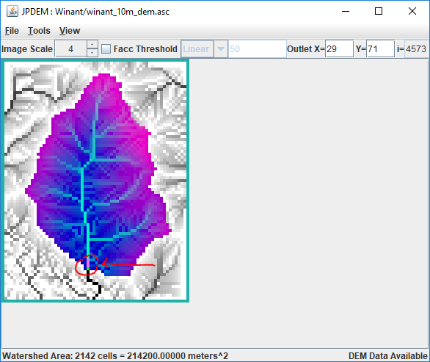

Highlighting Cells by Value

Click the View -> Highlight Specific Cells in Image -> Specify Cells By Value Range menu item.  
The “Cell Ranges to Highlight” dialog box opens; note the instructions.  
Here is an example that specifies all cells with values between 10 and 20, and between 90 and 100:

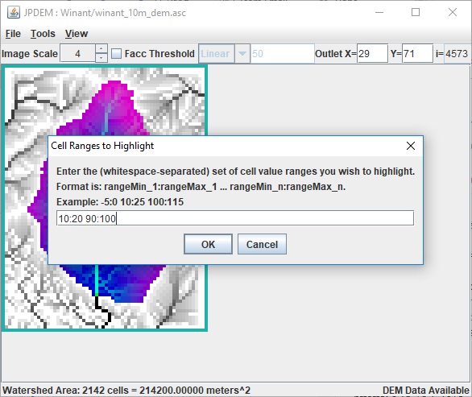

Notice that the notation differs from the Cell By index dialog, but that whitespace, NOT COMMAS, is still the delimiter in use.

After entering the low:high coordinate pairs and clicking OK, JPDEM highlights the specified cell locations over the current display/view option:

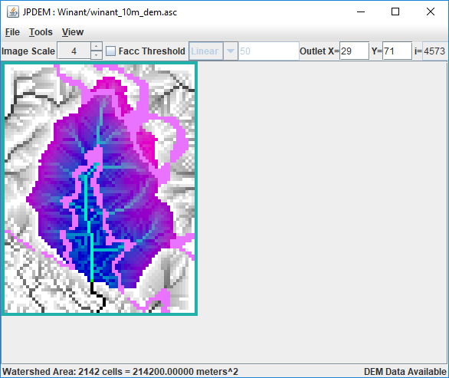

Notes and Limitations

Cell Highlighting (when specified) is visible for all the rendering modes selectable in the View menu. However, depending upon the selected View mode, the highlight color may be “pepto-pink”, cyan, or white:

|  |  |
| --- | --- |
| **View Rendering Mode** | **Highlighter Color** |
| Standard Image Rendering | Pepto-Pink |
| Contour Image Rendering | Pepto-Pink |
| Simple HSB Image Rendering | White |
| DEM Difference Image Rendering | Cyan |
| Five-Color Mapping Image Rendering | Pepto-Pink |

The Cell Highlighter does not permit specifying both cell index and cell values at the same time. You must choose one or the other, and changing from one to the other clears the previous cell-highlighting.

# B.3 | JPDEM Flow Accumulation (Facc) Threshold Display

**Overview***(Tutorial B.3_JPDEM Facc Threshold Display)*

This document explains how to use JPDEM’s flow accumulation threshold display to analyze and prepare a DEM to:

* Identify primary flow paths
* Select an outlet cell
* Delineate the watershed boundary for a selected outlet

In JPDEM, a DEM cell’s flow accumulation (“Facc”) is the number of upstream cells that flow into that cell. Cells with high Facc values are cells that have high water flow, and cells with high water flow are likely to contain channels.  
  
The JPDEM application’s Facc Threshold display control provides a way to quickly identify and visualize the cells in a (flat-processed) DEM whose Facc values are at or above a specified threshold. You can use the Facc Threshold display to get an idea of which areas and cells of a DEM are likely its main water channels.

JPDEM must have Facc values available for the currently-loaded DEM before the Facc Threshold display is used. JPDEM calculates the Facc values for a DEM during flat-processing, or when the “Determine DEM Flow Data” Tools menu item is run for a previously flat-processed DEM map.  
Perform either activity before using the Facc Threshold display controls.

Sidenote: JDPEM and VELMA both compute “flow accumulation” values for the cells of their specified DEM map, and both refer to these as the “Facc” values. However, VELMA calculates Facc values differently than JPDEM. JDPEM and VELMA Facc values for a given cell, while similar, are unlikely to be identical.

The Facc Threshold display controls are located in the center of JPDEM’s upper toolbar:

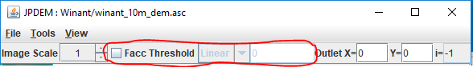

From left to right, the controls are: a checkbox that toggles the display on and off, a drop-down selector for specifying the threshold value’s type, and a number-entry field for specifying the threshold value.  
All three controls are disabled until a map file is loaded into JPDEM, and the type selector and number-entry field are disabled whenever the checkbox is unchecked.

Using the Facc Threshold Display by Example

In this example, we start with a DEM map that was previously flat-processed, then saved to a new .asc file (see Tutorial B.1 – Creating Flat-Processed DEM Data). We could also start with an unprocessed DEM map – the only difference being that our first step would change from Finding the Flow Data, to Flat-Processing the map.

**Step 1**  
Load the (flat-processed) DEM map from its .asc file, then click the Tools -> “Determine DEM Flow Data (Alternate)” menu item:

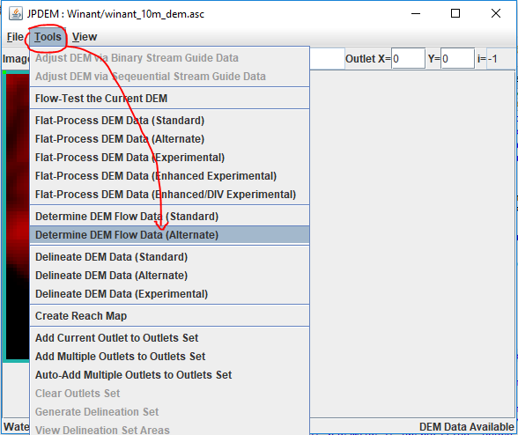  
You can use either the “(Standard)” or “(Alternate)” Determine DEM Flow Data item – but the Alternate algorithm is usually quicker.

**Step 2**Click the Flow Threshold checkbox control to enable the threshold display. The entire map turns red. Don’t panic! The default Facc threshold value is zero, and the display is showing you all the cells with Facc values > 0.0. Change the number-entry field value to 25.0 and press the Tab key. The display now shows all cells with Facc values > 25.0 in red.

|  |  |  |
| --- | --- | --- |
| **Facc threshold OFF** | **ON, with threshold = 0** | **ON, with threshold = 25.0** |
|  |  |  |

Try changing the threshold (always follow changing the value by pressing the Tab key) to successively larger values. Watch how the number of red cells that meet that Facc threshold dwindles. These are cells with high waterflow.

**Step 3**Set the threshold to a large value (2000.0), select one of the highlighted cells as an outlet (green cell, below), and delineate the watershed for that outlet (per Tutorial B.1 – Creating Flat-Processed DEM Data).

|  |  |  |
| --- | --- | --- |
| **ON, with threshold = 2200.0** | **After Delineation** | **Threshold display ON again** |
|  |  |  |

Delineation automatically toggles the threshold display OFF, because delineation and threshold data cannot be displayed at the same time. Click the Facc Threshold checkbox to re-enable the display.

Other Options and Some Limitations

You can change the type of the threshold value from linear to log using the drop-down selector.  
When the Log type is selected, the threshold display highlights cells whose log(Facc) value meets or exceeds the specific value.

As mentioned before, you cannot display threshold and delineation information at the same time, you must toggle between the two. Also, the threshold display is invisible (but not disabled) when you set the View option to any Image Rendering option apart from Standard.

# B.4 | JPDEM Flow Test Tool

**Overview *(****Tutorial B.4_JPDEM Flow Test Tool)*

This document demonstrates how to use JPDEM’s flow test tool to perform quality assurance on an existing DEM. The tool will report whether the DEM meets all the criteria needed to support a VELMA simulation.

Use JPDEM’s flow test tool to determine:

* Whether or not a DEM data map needs to be flat-processed or not.  
  Load the DEM .asc file in question into JPDEM and run the flow test tool. The tool will report whether the DEM contains any cells that do not have a flow path to the edge of the map. If the DEM passes the flow test, it does not require flat-processing, and can be used as-is with VELMA.
* Whether or not a flat-processing run of a DEM data map succeeded.  
  Some of the flat-processing algorithms (e.g. “Standard” and “Alternate”) do not have deterministic halting conditions. To prevent them from possibly running endlessly, they have arbitrary timeout limits. For extremely large maps, the timeout limit may occur before the map is completely flat-processed.  
  After flat-processing a map, run the flow test tool if you suspect the flat-processor did not complete its task. If the flow test succeeds, the map was completely flat-processed.
* Basic information about a DEM data map.  
  In addition to success or failure, the flow test tool reports some basic information about the map grid (total number of cells, total number of border cells, etc.)

The flow test tool is only enabled when JPDEM has map data loaded. The flow test tool does not expect or require any other preliminary steps; however, it can be run after additional processing (flat-processing, flow determination, etc.) have been run for JPDEM’s current data map.

To run a flow test, load a map into JPDEM, and click Tools -> “Flow Test the Current DEM”.

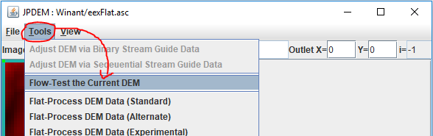

The flow test tool reports its results in a “DEM Flow Test” pop-up dialog window. (Unfortunately, the contents of the result window cannot be highlight-copied to the system clipboard. If you need to remember them, use the Windows 10 Snipping Tool to screen capture the window.)

Here are the results of running a flow test on a DEM file that has not be flat-processed:

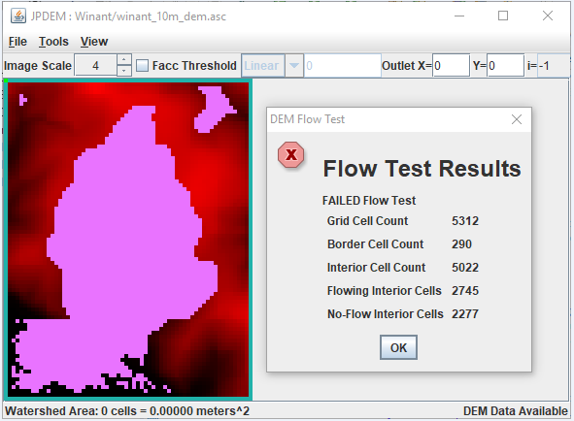

In addition to reporting failure and the number of cells that do not flow to the border of the map, the flow test tool sets Cell Highlighting for each “no-flow” interior cell.  
The no-flow cells remain highlighted until you explicitly clear the highlighting.  
To clear the highlighted cells, click the View -> “High Specific Cells in Image” -> “Clear All Highlighted Cells” menu item.

In contrast here are the results of running a flow test on a flat-processed version of the same DEM file:

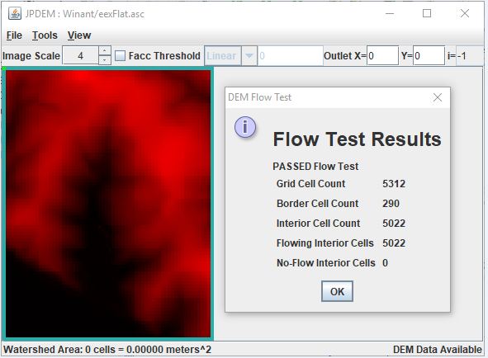

Here the flow test reports that all cells passed the test, and no cells are highlighted.

# B.5 | JPDEM Saving Data to Files

**Overview** *(B.5_JPDEM Saving Data to Files)*

This document explains how to use JPDEM’s file menu to save different types of data files and formats useful for various spatial analysis and visualization purposes.

JPDEM’s File menu contains multiple “Save” items, each of which allows you to save a specific type of data to a file (or set of files):

|  |  |
| --- | --- |
| **Save Item** | **Summary** |
| Velma Simulator Fileset | Saves the current DEM, Flow Direction and Flow Accumulation data in 3 separate .asc files. |
| DEM Data | Saves the current DEM data -- file type options available. |
| Flow Direction Data | Saves the current Flow Directions (“fdir”) data – file type options available. |
| Flow Accumulation Data | Saves the Flow Accumulation (“facc”) data – file type options available. |
| Highlighted Cells | Saves the current set of highlighted cells into an .asc file. |
| Current Image | Saves JPDEM’s current display as an image -- file type options available. Unique to this item: save the current image as a .gif, .jpg or .png file. |
| JPDEM State | Save’s JPDEM’s entire data state into a .csv file. Provided for JPDEM developers, and not generally useful to others. |

Many of the “Save” items also have sub-items that allow you to specify the format of the data file that is written:

|  |  |
| --- | --- |
| **File Type Option** | **Description** |
| Data Array | Writes data values to a .txt file, one value per line, tab-character suffixed. (This is a legacy format, now not commonly used.) |
| ASCII Grid | Writes data values to an .asc file with dimensions matching the currently-loaded DEM data grid. |
| Delineated ASCII Grid | As above, but data values for cells outside the current delineation are written as the ASCII Grid “nodata_value” (i.e. “-9999”). |
| Delineated Threshold ASCII Grid | As above, but data values for cells lying below the specified “Facc Threshold” value are written as the ASCII Grid “nodata_value” (i.e. “-9999”). |
| Image (.gif, .jpg, .png) | Only available for the “Save Current Image” menu item. |

Additional Details

Save VELMA Simulator Fileset

This item writes three separate .asc files for DEM, fdir, and facc data. The files all share the same name, but have the prefixes “DEM_”, “FDIR_” and “FACC_” prepended when they are written.

Note that although the item name declares this as a “VELMA” fileset, currently the facc values written are JPDEM values, not VELMA values (see the comments in the section “Save Flow Accumulation Data” above for more on why this distinction is important).

Save DEM Data

Selecting this item allows you to write JPDEM’s current DEM data to a file. The “current DEM data” means whatever JPDEM has currently loaded, in its current state. For example, if you click File -> “Load Map File Data” -> “Load as DEM File”, and then immediately click File -> “Save DEM Data As” -> “ASCII Grid”, the fil you save will be a duplicate of the file you loaded (apart from any filename differences you introduce). However, if you load a DEM file, flat-process it, and then “Save DEM Data As”, the files are likely to contain different data.

Save Flow Direction Data

When JPDEM flat-processes a map, it generates a flow-direction (“fdir”) value for each cell in that map. Flow direction data is also generated when the “Tools” -> “Determine Flow Data” item is run.

The flow direction value of a cell is a number between 1 and 8, uniquely identifying one of the cell’s eight adjacent cells. A flow direction value <= 0 indicates that flow direction data has not been computed yet.

The directional values for cell “C” are show below:  
  
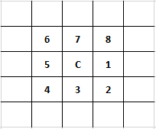

So, for example, if C’s fdir = 2, C’s flow direction is to the cell below and to the right of it.

Flow direction indicates only the primary direction that water will flow from a cell to its adjacent cells. Water may flow to adjacent cells in addition to the cell specified by the flow direction value.

Flow direction data may be saved as either an .asc grid file, or a delineated .asc grid file.  
The delineated .asc grid file option reports the “nodata_value” (i.e. -9999) for any cell that is not part of the current delineation. If no delineation has been performed yet, the entire .asc file will be nodata_value values.

Save Flow Accumulation Data

When JPDEM flat-processes a map, it generates a flow-accumulation (“facc”) value for each cell in that map. Flow direction data is also generated when the “Tools” -> “Determine Flow Data” item is run.

In JPDEM, the flow accumulation value of a cell is the number of “uphill” cells that flow into that cell. The term “flow into” means that a chain of fdir values leads from the uphill cell to the cell in question, i.e. primary flow directly is the only consideration when calculating a cell’s flow accumulation count.

Note that JPDEM and VELMA both contain flow accumulation data, but VELMA facc values differ from JPDEM’s. While both JPDEM and VELMA’s facc values contain the notion of “cells whose primary flow direction leads to me”, VELMA’s facc value additionally include a scaling component based upon the grid’s cell size, and whether flow direction is across an edge or corner cell.

JPEM fdir values give a fair idea of the high-vs-low flow areas within a flat-processed DEM and watershed, but they *cannot* be used as VELMA facc data. VELMA computes its own facc values from the (JPDEM-produced) flat-processed DEM it is provided with at initialization.

Flow accumulation data may be saved as an .asc grid file, or a delineated .asc grid file.  
The delineated .asc grid file option reports the “nodata_value” (i.e. -9999) for any cell outside the current delineation. If no delineation has been performed yet, the entire .asc file will be nodata_value values.

Flow accumulation data may also be saved as a delineated threshold .asc grid file: in this case, any cell that is not part of the current delineation, OR is below the specified Facc Threshold value is set to the nodata_value. Again, if no delineation has been performed, or no Facc Threshold has been set, the entire .asc file will be nodata_value values.

Save Highlighted Cells

When selected, this item writes an .asc file in which each cell has one of three possible values:

* Negative One (“-1”) indicates a cell that is not highlighted, and not part of the current delineation.
* Zero (“0”) indicates a cell that is not highlighted, but that is part of the current delineation.
* One (“1”) indicates a cell that is highlighted, regardless of whether it is part of the current delineation or not.

If no delineation has been performed, no cells will have value zero.  
If no cells have been highlighted, no cells will have value one.

Note: even when no cells are highlighted, if a delineation *has* been performed, saving a highlighted cells .asc file will provide a binary-coded (-1, 0) map of the delineated area. This is a legitimate, albeit sneaky, use of the functionality.

Save Current Image

The “current image” is whatever JPDEM is displaying when this item is selected/clicked. JPDEM will write the map image (*not* a screen capture of the entire JPDEM app window) to the file type specified (.gif, .jpg, or .png).

Note: Use the Windows 10 Snipping Tool if you want a screen capture of the entire JPDEM window.

Save JPDEM State

Selecting this item writes JPDEM’s current spatial data state to a comma-separated values (.csv) file.  
This function is provided for JPDEM developers. General users may find the contents difficult to interpret.

# B.6 | JPDEM User-Specified Map Borders

#### Overview (Tutorial B.6 – JPDEM User-Specified Map Borders)

JPDEM’s experimental (“EXP”) and enhanced experimental (“EEX”) flat-processing algorithms experience significant runtime slowdown when the DEM map they are applied to contains large waterbodies or other uniform-elevation areas of cells along one or more edges of the map.

This tutorial explains how to create a border mask that specifies these areas as being part of the map border (i.e. ignored during flat-processing and off-limits for delineation thereafter) can considerably speed up the flat-processing process.

Any DEM grid .asc file loaded into JPDEM must have its computational domain set prior to flat-processing. This is normally done automatically, when you use JPDEM’s “Load Map File Data” --> “Load As DEM File menu item”.

Setting the computational domain involves the following:

* The loaded DEM grid is prohibited from containing any NODATA_value(s).
* A default, single-cell-width border is imposed on the DEM grid.

However, you can instead load a DEM (or any) grid .asc file using JPDEM’s “Load Map File Data” --> “Load As Raw Map File” menu item, and in this case the grid .asc file is loaded as-is, without performing the steps to set its computational domain. A DEM grid .asc file loaded via the “Raw” menu item can subsequently be flat-processed if its computation domain is set, but to do this, the user must load a valid Border Mask Map .asc file.

The BorderMask Map .asc file must have the same column and row dimensions as the loaded DEM grid .asc map, and its cell data must consist solely of integer “1” and “0” values. Border cells must have the value “0” and interior cells must have the value “1”.

Running the “Load Map File Data” --> “Load Border Mask” menu item will load border mask data from the specified file, then set the computational domain of the currently-loaded DEM grid .asc file based on the bitmask of border/interior cells from the border mask map file.

Why Are User-Specified Borders Useful?

JPDEM’s experimental (“EXP”) and enhanced experimental (“EEX”) flat-processing algorithms experience significant runtime slowdown when the DEM map they are applied to contains large, uniform-elevation areas of cells along one or more edges of the map.

Creating a border mask that specifies these areas as being part of the map border (i.e. ignored during flat-processing and off-limits for delineation thereafter) can considerably speed up the flat-processing process.

Important Limitations

* You can only load a border mask map file for a DEM map that was raw-loaded.
* Your border mask map file must (at a minimum) specify the top and bottom rows, and the left-most and right-most columns of the mask as border cells.
* The border mask must encode border cell values as “0”, all other cells as “1”.
* You cannot load a second border mask map file for a given DEM file.  
  Once a DEM map’s computational domain is set, it cannot be set again.  
  To use a new border mask, re-load the original DEM file and then load the new border mask.

An Overview / Example of Using a Border Mask During Flat-Processing

For the following overview, the example data is:

* A DEM file (“Winant_2pnt5.asc”)
* A prepared border mask (“Winant_2pnt5_dmMask.asc”)
* A stream dredge channel guide (“Winant_2pnt5m__watershedDredgeMap_Corrected.asc”)

Step 1:   
Load the DEM file as Raw Data via the “Load Map File Data” --> “Load As Raw Map File” menu item.

Step 2:  
Load the Border Mask via the “Load Map File Data” --> “Load Border Mask” menu item.

At this point, we can see the user-specified border by highlighting cells that are < 0 meters in elevation.  
(For this particular map, the lowest elevation prior to setting the computation domain was zero meters. After loading the border mask and setting the computation domain, all border cells will have been “pushed down” below 0 meters in elevation.) In the image below, border cells are highlighted “pepto-pink”, while interior cells are shown with contour-rendering greyscale to make the contrast clear:

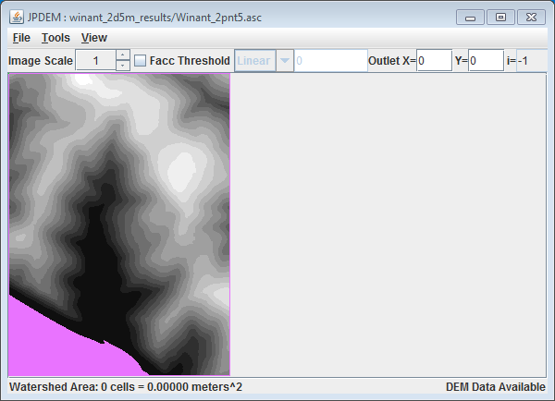

Notice that the top and bottom rows, and the left-most and right-most columns are part of the border. This was specified in the border mask file (“Winant_2pnt5_dmMask.asc”) and is required (per the prior Limitations list).

Step 3: (Optional)  
Load a stream burn-in dredge channel guide map via the “Load Stream File Data” menu item

This is not a necessary step, however, if you plan to perform a stream channel burn-in prior to flat-processing, you must load the data and run the channel-cutter on paired (DEM + border mask) + stream channel guide at this point (i.e. after raw-loading the DEM and loading the border mask, and before running the flat-processor).

Step 4:  
Run the EXP or EEX flat-processing algorithm from the Tools menu.  
(i.e. “Tools” --> “Flat-Process DEM Data (Experimental)” or “Tools” --> “Flat-Process DEM (Enhanced Experimental)”

Note: If you have performed a stream burn-in, do not attempt to flat-process the DEM with either the Standard or Alternate flat-processing algorithms.

If you have not performed a burn-in (Step 3), then it is possible -- but still not recommended -- to run either the Standard or Alternate flat-processing algorithms, however it is unlikely that they will produce better results than either the EXP and EEX algorithms.

Here’s what our example looks like after flat-processing using the EEX algorithm.  
Cells colored red meet the Facc Threshold indicated on the GUI, Cells colored green are channel guide cells that do not meet the Facc Threshold, Cells colored yellow-orange are channel guide cells that meet the Facc threshold.

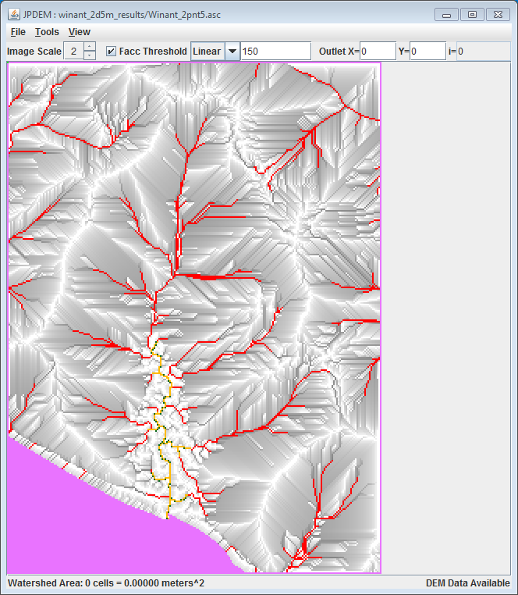

NOTE: Please see JPDEM tutorial B.7, “JPDEM User-Specified Border Mask Example”, which provides a more detailed example of how to create a DEM border mask that encompasses large waterbodies at the edge of a DEM. By including these flat features as part of the map border, JPDEM will ignore them during flat-processing of raw DEMs, considerably speeding up the flat-processing process.

# B.7 | JPDEM User-Specified Border Mask

**Overview** *(Tutorial B.7 – JPDEM User-Specified Border Masks)*

This JPDEM tutorial (B.7) builds on Tutorial B.6, “JPDEM User-Specified Map Borders”, specifically to provide a more detailed example of how to create a DEM border mask that encompasses large waterbodies at the edge of the DEM. By including these flat features as part of the map border, JPDEM will ignore them during flat-processing of raw DEM maps, considerably speeding up the flat-processing process.

Example

This is an example of how to flat-process a large DEM grid in JPDEM in a reasonable amount of time, by taking advantage of JDPEM’s user-specifiable border-mask functionality.

We start with the original “raw” DEM ASCII grid (.asc) file we wish to flat process: thornton_mask_v2_10m.asc

The header information for this file is:

ncols 681

nrows 990

xllcorner 548019.221

yllcorner 5281283.0124

cellsize 10

NODATA_value -9999

Initial efforts to flat-process this grid with JPDEM’s Standard (STD) and Alternate (ALT) flat-processing algorithms failed.

The grid is large enough, and has enough “flat spots” that these algorithms reach hard-wired, “unable to complete” timeout limits before all flat areas have been processed.

Attempts to flat-process this grid with the Experimental (EXP) and Enhanced Experimental (EEX) algorithms likewise failed. Unlike the STD and ALT algorithms, EXP and EEX do not have mandatory timeout limits, but neither algorithm was able to complete the flat-processing task after running continuously for more than 35 days.

Here is a screen-capture of the raw DEM file, loaded into JPDEM, with cells that have value == 0.0 highlighted in “pepto-pink”:

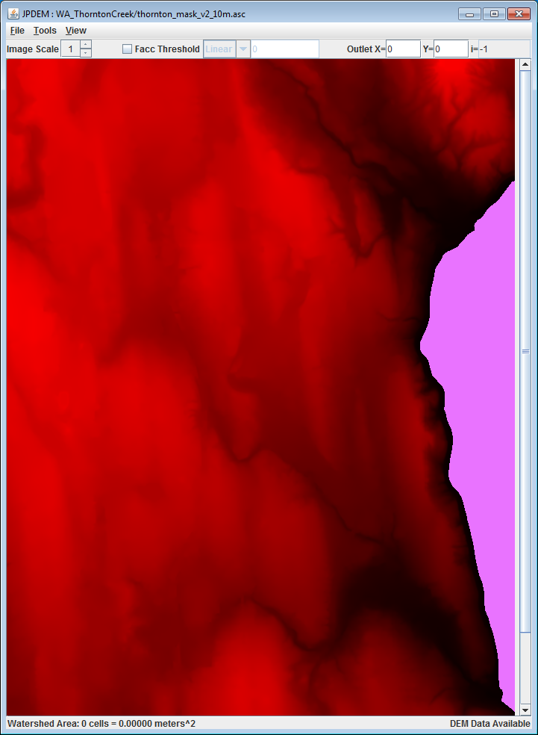

The highlighted, “all cells are zero” area on the right side of the raw DEM has a drastic impact on all the flat-processing algorithms, but because that area of uniform-value cells lies against an edge of the grid, the EXP and EEX algorithms in particular spend an inordinate amount of their processing time ensuring flow through that area and to the grid edge.

We can tell JPDEM to ignore the problem “all cells are zero” area by providing it with a border mask map that marks all the zero value cells as part of “off-limits” border of the grid. JPDEM *always* requires a border for flat-processing, and only flat-processes cells that lie within the border (“interior cells”). Loading an .asc file into JPDEM “as DEM” automatically designates the top and bottom rows, and the left and right-most columns of cells as the border. However, when an .asc file is loaded into JPDEM “raw”, no border is created, and the “Load Border Mask” menu item can subsequently be used to specify an arbitrary border that is applied to the raw-loaded DEM values.

A border mask .asc file’s grid values must be either “0” (for border cells) or “1” for (interior cells). The values must also be integers (i.e. “0.0” or “1.0” is not allowed).

A border mask must always include the default border as border cells; i.e. the top and bottom rows and left-most and right-most columns must be marked as border cells.

GIS tools like ArcMap can be used to create border mask .asc files of arbitrary complexity and detail, but for the thornton_mask_v2_10m.asc file, we can take advantage of the fact that the border we wish to create is either a cell in the top or bottom row, left or right-most column OR has a cell value of “0.0”.

We can encode this relatively simple set of rules into a small Awk script and run it in a Cygwin Bash command shell. A Python script would work as well, and we could run that under a DOS command prompt or Windows PowerShell console, but the Awk code is more succinct.

Note that the Awk script developed in this example is not a general-purpose script; it takes advantages of various specifics of the thornton_mask_v2_10m.asc file’s contents.

Here is the Awk script in its entirety:

# TOP of MaskMaker.awk

BEGIN {

IGNORECASE = 1;

headRows = 6;

}

# get the number of data rows from the header information

/^nrows/ {

dataRows = $2;

}

NR <= headRows {

print;

}

# handle data rows, transforming and emitting them on-the-fly

NR > headRows {

if (NR == (headRows + 1) || (NR - headRows) == dataRows) {

for (i=1; i<=NF; ++i) {

printf("%s%s",(i==1?"":" "),"0");

}

printf("\n");

} else {

for (i=1; i<=NF; ++i) {

s = "0";

if (i > 1 && i < NF) s = $i == 0 ? "0" : "1";

printf("%s%s",(i==1?"":" "),s);

}

printf("\n");

}

}

# BOT of MaskMaker.awk

We can generate a border mask .asc file for the thornton_mask_v2_10m.asc file by running the following command line in a Cygwin Bash console:

$ awk -f MaskMaker.awk thornton_mask_v2_10m.asc > thornton_borderMask_v2_10m.asc

Depending upon the mode of the Cygwin Base console, we may also need to translate the newline characters of the resulting mask file to run under Windows:

$ unix2dos thornton_borderMask_v2_10m.asc

unix2dos: converting file thornton_borderMask_v2_10m.asc to DOS format...

Here’s the resulting thornton_borderMask_v2_10m.asc file, “as Raw Map File” into JPDEM. Red (interior) cells have value 1, and black (border) cells have value 0:

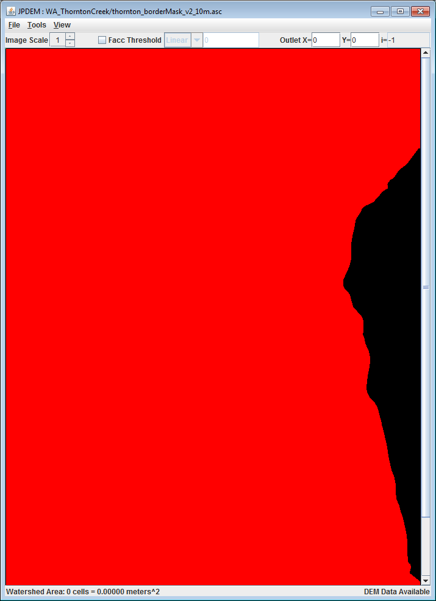

Now that we have a raw DEM map, and a border mask to overlay onto it, it’s simply a matter of…

Loading the DEM file “**as Raw Map File**” data . . .

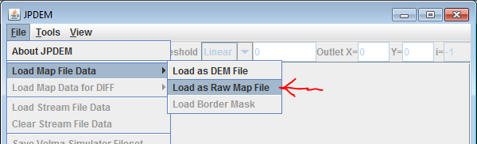

Loading the border mask file as “**Border Mask**” data . . .

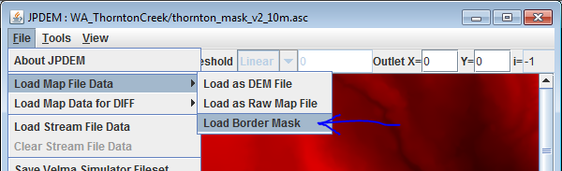

and finally, running a flat-processing algorithm on the combined DEM + custom border.

The STD and ALT flat-processors are *not* recommended for custom-border situations. Instead, the best bet is the EEX flat-processor (the EXP *may* work, but is not ideal) . . .

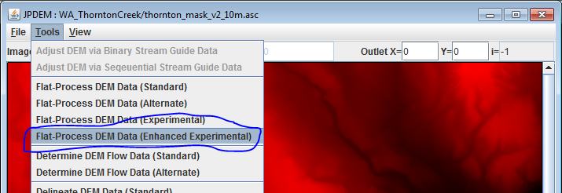

Here is the EEX flat-processed map, showing the completion message:

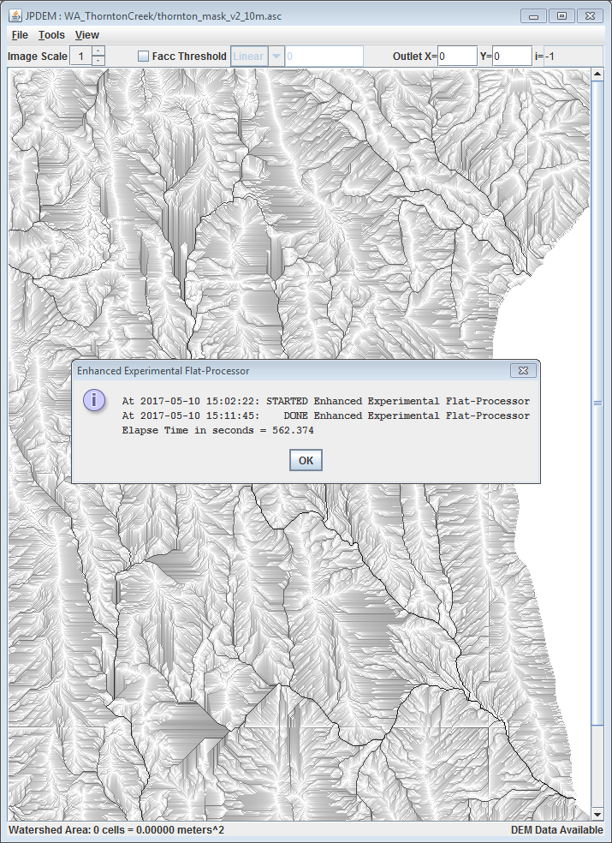

Here are the console messages from the sequence of steps: Load/raw, Load/border, EEX:

LoadPropertyFilesAction: file="D:\Users\kdjang\Velma_SiteData\WA_ThorntonCreek\thornton_mask_v2_10m.asc"

hasData=true ncol=681 nrow=990 xll=548019.221 yll=5281283.0124 isLlCenter=false cell=10.0 ndata=-9999.0 zmin=0.0 zmax=167.9841 delx=0 dely=0 minLogFacc=0.0 maxLogFacc=0.0

LoadDmMaskFileAction: file="D:\Users\kdjang\Velma_SiteData\WA_ThorntonCreek\thornton_borderMask_v2_10m.asc"

At 2017-05-10 15:02:22: Launching Enhanced Experimental Flat-Processor thread ...

Experimental Flat-Processor: processed 622821 cells

Experimental Flat-Processor: largest set processed = 4234

Internal Data State Report

Map Summary: Total Cols=681 Total Rows=990 Total Cells=674190

NoData cells: Actual=0

Buffer Cells: Expected=3338 Actual=51369 Suspect=0 !!! WARNING !!!

Interior Cells: Expected=670852 Actual=622821 Suspect=0 !!! WARNING !!!

At 2017-05-10 15:02:22: STARTED Enhanced Experimental Flat-Processor

At 2017-05-10 15:11:45: DONE Enhanced Experimental Flat-Processor

Elapse Time in seconds = 562.374

Some observations:

* The running time has dropped from many weeks to just under 10 minutes: a truly significant improvement in running time.
* The “!!! WARNING !!!” messages are triggered because the border is not the default, single-edge-cells border; future versions of the JPDEM code may be made “smarter” about issuing this warning.
* “Buffer Cells” refers to border cells.

**What About Stream Channel Cutting/Burn-In?**

To include a channel cut/burn-in in the above example, we would simply have performed the sequence of steps to load a stream channel guide file and run the cutter after the border mask load, and before running the EEX flat-processor.

Here is a delineation of the flat-processed map. The delineation does not actually touch the bottom grid edge as it appears to – the grid is simply taller than the JPDEM window:

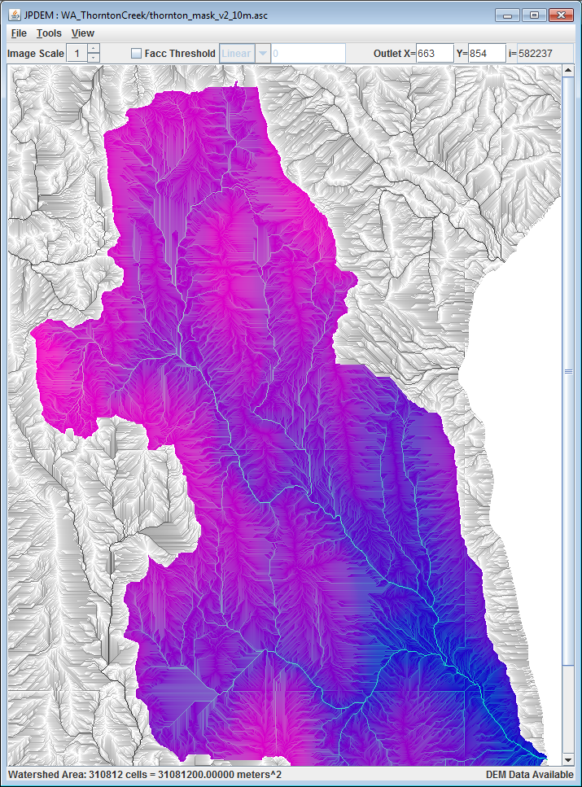

# B.8 | JPDEM for Viewing Map Differences

#### Overview (B.8 – JPDEM Viewing Map Differences)

This tutorial explains how to use JPDEM to compare elevation differences within a DEM before and after it is flat-processed. This quality assurance (QA) step allows users to assess the veracity of JPDEM’s flat-processing procedure. That is, where and to what extent did JPDEM alter the elevations of cells within the DEM? Note that this procedure is but a first step in a QA process that may include comparisons of a flat-processed DEM to other types of data not included in this tutorial. For example, does the flat-processed DEM provide flow routing (Facc values – see Tutorial B.3) consistent with mapped stream locations represented by the National Hydrography Dataset (NHD; <https://www.usgs.gov/core-science-systems/ngp/national-hydrography/nhdplus-high-resolution>)?

The JPDEM application’s File menu contains a “Load Map Data For DIFF” item that provides a way to compare two DEM files across all cells (the maps must have the same dimensions). Although its’ abilities are rudimentary relative to comparisons you could perform with true GIS systems (e.g. ESRI’s tools) JPDEM’s DIFFerencing function is a quick way to – for instance – compare a flat-processed map against the original, raw DEM map. (This is, in fact, precisely the use-case for which the DIFF function was added.)

The DIFF function allows you to load a second DEM .asc file after loading a first .asc file.  
The DIFF function replaces the first DEM file’s cell data with the difference between the second and the first file’s cell data, at every cell. After the DIFF function is completed, JPDEM’s cell data contains the difference values, and the display automatically shifts to the “DEM Difference Image Rendering Mode” – cells that differ should be relatively easy to spot in this mode.

A DIFF Example

Starting Assumption: e=we have both an original, raw DEM map .asc file, *and* have already flat-processed that DEM map in JPDEM and saved the results into a second .asc file that is also available.

The DIFF function calculates per cell differences as New Value – Current Value, where “New Value” refers to the file loaded for DIFF. To express the differences between an original .asc DEM file and a flat-processed .asc version of that DEM file such that a positive change in the processed .asc is expressed as a positive value, we should load the original DEM file first, then load the processed DEM file as the DIFF file.

(continued)

**Step 1**  
Load the original DEM file, using File -> “Load Map File Data” -> “Load as Raw Map File”.

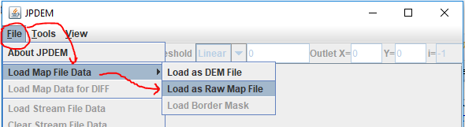

It *is* possible to use “Load as DEM File”, but when possible, load the original and the diff file as “raw” data.

In the “Select DEM File to Load” dialog that opens, find the original raw DEM .asc file, select it, and click “Load File” to load it into JPDEM as the current map data.

**Step 2**  
Load the flat-processed DEM file, using File -> “Load Map Data for DIFF” -> “Load as Raw Map File”.

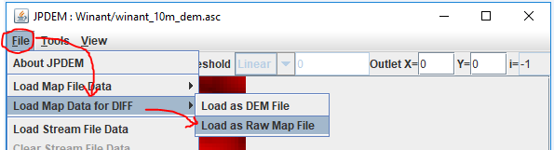

The flat-processed .asc file takes on the role as the “diff” map, the original .asc file is the current map.

Because the DIFF function replaces JPDEM’s current map data with difference values, a warning dialog opens before the difference map file finder dialog:

(continued)

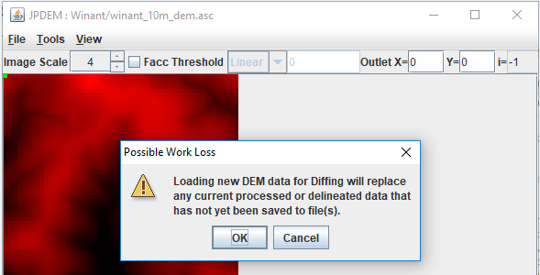

Click OK to proceed to the “Select Raw File to Load for DIFF” dialog and “Load File” load the diff file.

After the cell differences are calculated, JPDEM will contain (and display) the differences for each cell in the grid. The DEM Difference Image Rendering view is active:

* diff file cell value < map cell value = RED (darker -> more negative)
* diff file cell value = map cell value = WHITE
* diff file cell value > map cell value = GREEN (darker -> more positive)
* The current Outlet cell = GRAY
* Highlighted cells = CYAN

(continued)

Here is a comparison of our original raw DEM, the flat-processed DEM, and the difference display:

|  |  |
| --- | --- |
| **Original DEM (raw loaded)** | **Flat-Processed DEM (raw loaded)**  **(** |
|  |  |
| **Difference (Flat – Raw) Display** | |

The DIFF display clearly indicates the areas of the map that have been altered by flat processing.

**Step 3**

After the DIFF function has completed, JPDEM’s current map data is the set of cell difference values. You can view an individual cell’s values by clicking on a cell with the mouse right-button. The Facc and fdir values, if nonzero, are invalid, but the difference value is listed as the cell’s “dem=” value:

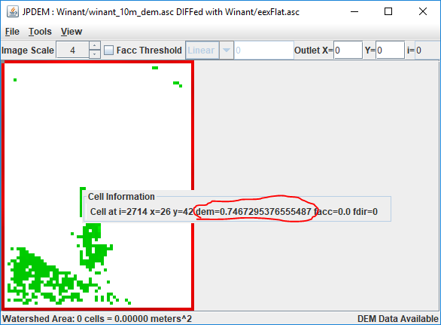

Use the View -> “Highlight Specific Cells in Image” -> “Specify Cells by Value Range” function to find differences within a specific range of difference.

Here we want to find all cells raised between 1.0 and 7.5 meters relative to the original DEM:

(continued)

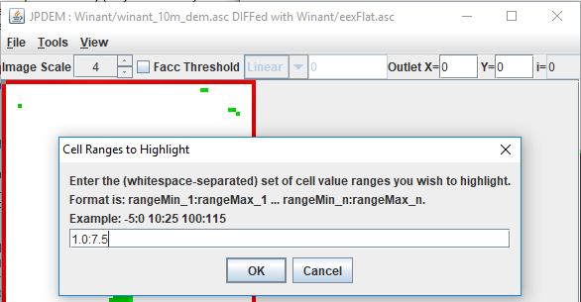

(continued)

The result highlights the specified cells in cyan, rather than the usual “pepto-pink”:

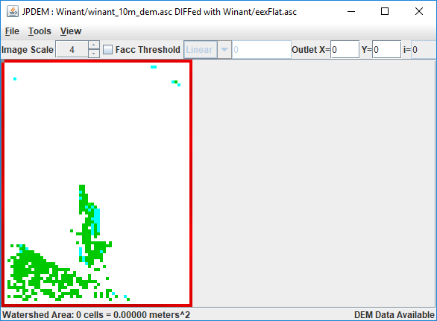

As noted in the Overview (page 1), this difference mapping procedure is but a first step in a QA process that may include comparisons of a flat-processed DEM to other types of data not included in this tutorial. For example, does the flat-processed DEM provide flow routing (Facc values – see Tutorial B.3) consistent with mapped stream locations represented by the National Hydrography Dataset (NHD; <https://www.usgs.gov/core-science-systems/ngp/national-hydrography/nhdplus-high-resolution>)?

# B.9 | JPDEM Sub-Reach Delineations

#### Overview (Tutorial B.9 – JPDEM Sub-Reach Delineations)

Large watersheds can include many sub-watersheds, each draining to their respective sub-reach outlets. VELMA users have the option of simulating the overall watershed using a single outlet, or breaking up the watershed into multiple delineated sub-watersheds (each with a sub-reach outlet) and simulating them in parallel. The latter option can be much faster computationally, especially for very large watersheds.

This tutorial describes how to use JPDEM to establish a set of sub-reach outlets, in preparation for using VELMA to simulate, in parallel, daily streamflow for a designated set of sub-watersheds / sub-reach outlets.

**Note:** Additional tutorials (C.1 – C.3) explain how to run VELMA in parallel mode. When running in parallel mode, VELMA is programmed to collect simulated daily streamflow information for each designated sub-reach outlet. VELMA uses that information to compute, for each sub-reach outlet, the sum of flow contributions from (1) all upstream grid cells draining to the sub-reach outlet, and (2) only those cells falling between the sub-reach outlet and the next upstream sub-reach outlet (thereby excluding flow from all other upstream cells).

Thus, aside from potential gains in computational efficiency, sub-reach delineations for running VELMA in parallel mode can help watershed managers tease apart streamflow responses to local and more distant upstream changes in land cover and land use.

*Warning: The functionality describe here is an initial draft that will be refined when the development schedule permits.*

The JPDEM application provides a collection of functions that, when applied in concert, allow you to determine a set of outlets for sub-reaches of an overall watershed’s area.

**Once identified, a set of outlets can be used to configure a JVelma simulation so that runoff information is generated for each of the sub-reach outlets.**

JPDEM Must Have Flat-Processed DEM and Flow Data Available for Delineation

Use JPDEM to flat-process the map containing your overall watershed before you use JPDEM to determine the sub-reach outlet locations. Flat-process the raw DEM .asc file, save it to a new .asc file, and then close JPDEM, restart it, and load the new, flat-processed .asc file. If you already have a flat-processed .asc file available, you can simply start JPDEM and load it.

Once you have flat-processed DEM map loaded in JPDEM, use the “Determine DEM Flow” tool to generate flow and direction information. (The delineation tools need this information to figure how which cells flow to which reach outlets.)

Click the “Tools” -> “Determine DEM Flow Data (Alternate)” menu item, as shown in the following image:

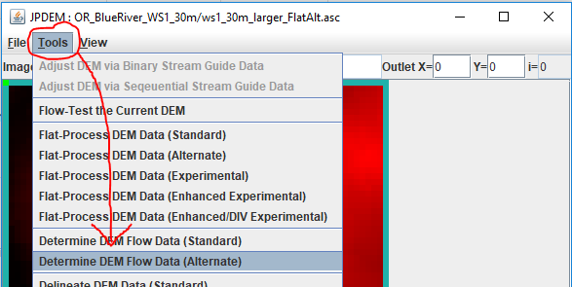

Delineate the Overall Watershed First

After JPDEM determines the flat-processed DEM’s flow data, the map display should so a grayscale image like this:

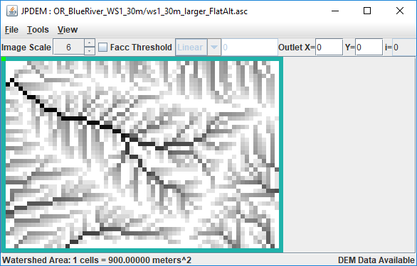

Set the Outlet X= and Y= fields to the x,y coordinates of the primary outlet for your watershed (i.e. the cell location of the pour point for the entire watershed), then click the “Tools” -> “Delineate DEM Data (Experimental)” menu item.

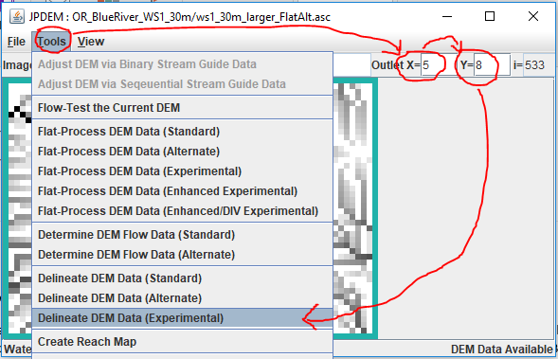

(continued)

Display the Overall Delineation, and the High-Flow Paths

Once it is delineated, the watershed is clearly marked in JPDEM’s map display: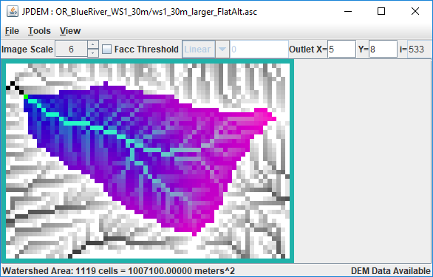

Usually, you’ll want to choose sub-reach outlet locations at forks in the highest-flow paths of the watershed. You can see those paths by clicking the “Facc Threshold” checkbox, then typing a cell count in the numeric field to its right.

In the example below, the Facc Threshold is set to 75, which means that any cell colored red has 75 or more cells flowing into it.

(continued)

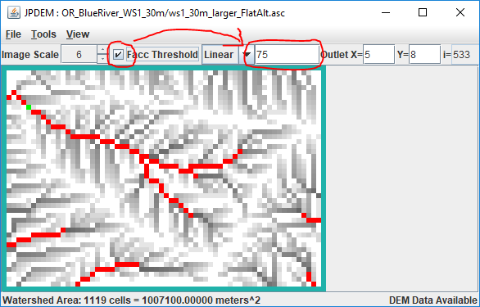

Note that when the Facc Threshold indicator is checked, the watershed area is not shown. You can switch back and forth between the two display modes by repeatedly clicking the Facc Threshold checkbox.

Determining Sub-Reach Outlets Manually

Using the Delineation and Facc Threshold displays, you can see which cells are in the overall watershed, and which of those in-watershed cells form the highest flow paths. The process of determining the cell locations of sub-reaches is as follows:

First, with the Outlet X and Y values set to the overall watershed’s outlet location, click the “Tools” -> “Add Current Outlet to Outlets Set”:

(continued)

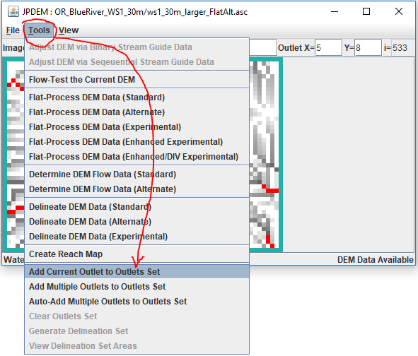

The “current outlet” is the outlet whose X and Y coordinates are specified in upper right numeric fields of JPDEM’s status bar.

Once the overall watershed’s outlet is recorded, adding other, sub-reach outlets is simply a matter of changing the current outlet X and Y values, and click the “Add Current Outlet …” menu item again.  
You can directly enter the X and Y value of each new sub-reach outlet into the Outlet X=, Y= fields, but if you don’t know the exact coordinates, you can left-click, then hold-left-button + drag-to-select “Cell at …” – when you un-hold the left mouse button, the current outlet will change to the selected “Cell at …” and you can then add it using the “Add Current Outlet …” menu item.

(continued)

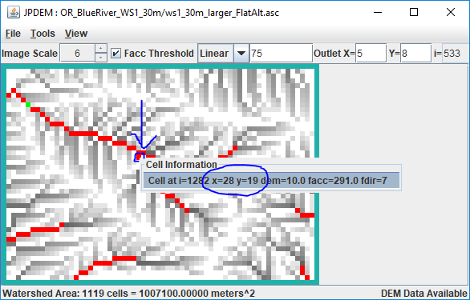

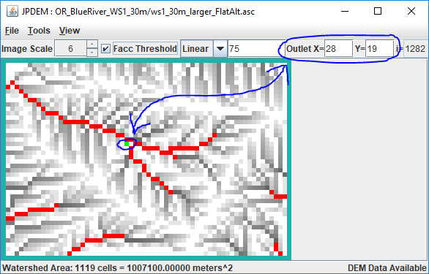

Unfortunately, if you add a cell to the outlet set by mistake, there’s no way to undo that particular cell’s addition. You must click the “Tools” -> “Clear Outlets Set” menu item, and the start over, re-adding the overall watershed outlet, and then all the sub-reach outlet cell’s in turn.

JPDEM doesn’t currently provide any confirmation when you “Add Current Outlet …”, however it does echo a statement to the console window it was started from.

Here’s an example, showing the addition of the overall watershed outlet (i=533) and three other cells as sub-reaches:

[ . . . ]

After clear, outlets set is {}

After add, outlets set is {533}

After add, outlets set is {1282, 533}

After add, outlets set is {1217, 1282, 533}

After add, outlets set is {1217, 1282, 1491, 533}

[ . . . ]

Note that the console status statement identifies cells by their linear indices, not their x,y coordinates.  
A cell’s linear index is its index counting left to right, across rows and down columns starting from the upper-left cell in the grid and ending with the lower-right cell. (For example, in a tiny 10x10 grid, the upper-left cell’s index is 0, and the lower-right cell’s index is 99.)  
  
The highlighted cell indices above are exactly the values that JVelma needs to track runoff for the sub-reaches you’ve specified. You can copy them from the console window to the system clipboard (highlight them with the mouse, then press return), or simply write the numbers down on a piece of paper for reference when you configure your simulation in JVelma.

However, if you started JPDEM by double-clicking the .jar file, there is no console log and the above output won’t be available. Also, the above doesn’t provide the X, Y coordinates, which are handy if you want to set Cell Data Writers in JVelma for each sub-reach.

(continued)

JPDEM does provide a way to view the Outlet Set, but it is a bit confusing.  
Click the “Tools” -> “Generation Delineation Set” menu item:

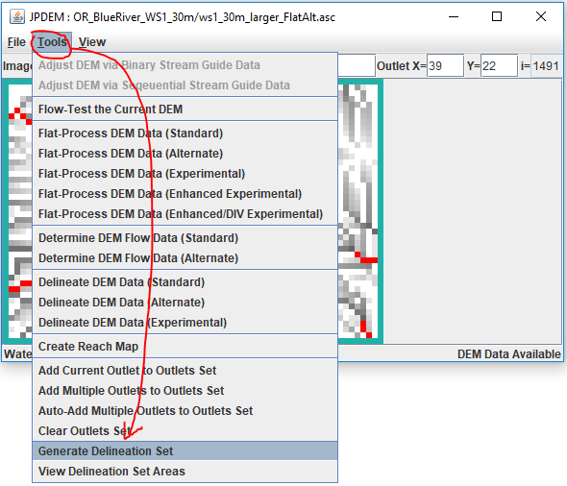

(continued)

This pops up a File Dialog – however, YOU’RE NOT ACTUALLY GOING TO GENERATE A DELINEATION SET.  
Simply Click the “Cancel” button:

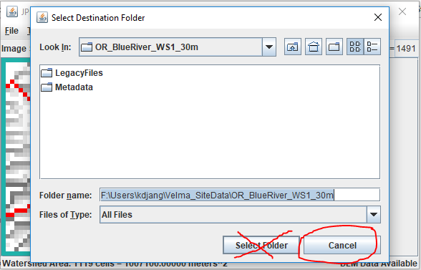

Clicking the cancel button brings up a summary dialog window, containing the details of the set of outlets, ***without*** actually performing the “Group Delineation” that it claims is completed:

(continued)

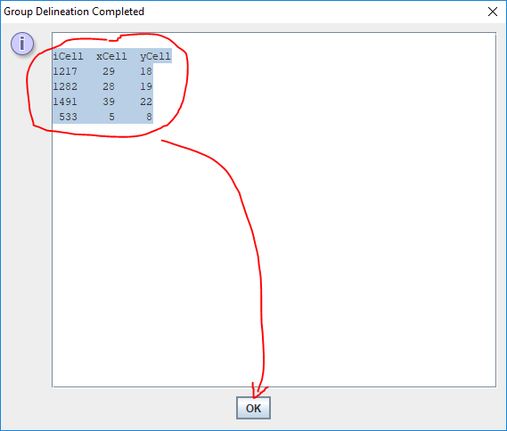

You can highlight-select-copy the text in this window.  
We recommend paste/saving it to a Notepad .txt file for later reference.

(continued)

You can also view the sub-reaches by clicking the “Tools” -> “View Delineation Set Areas” menu item, but the Image Scale is fixed at “1”, which may make small maps hard to read:

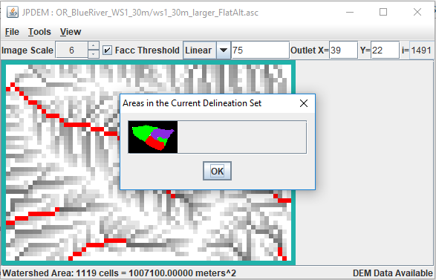

Using the Sub-Reach Delineation Outlets with JVelma

Once you’ve found a set of sub-reach delineations that identify the cells for which you want to determine runoff, you’ll need to configure a VELMA simulation configuration (using JVelma) to use those locations.

Start JVelma, and either create a new configuration using the DEM you found sub-reaches for, or load an existing .xml configuration file that uses that DEM.

In the “Run Parameters” Tab, under “Sub-Reach Mapping Controls”, click the drop-down selector and choose “MULTI_MODE”, then type the overall watershed outlet index value and the other sub-reach outlet index values into the numeric field to the right of the mode selector.

The following example shows an existing .xml configuration file being changed from solo mode to multi.

(continued)

T

The original configuration:

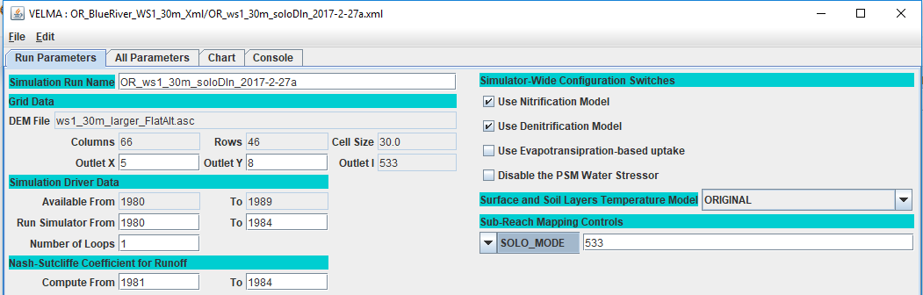

Setting the mode:

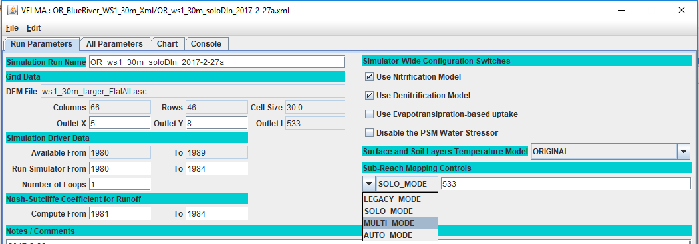

Adding the sub-reach indices:

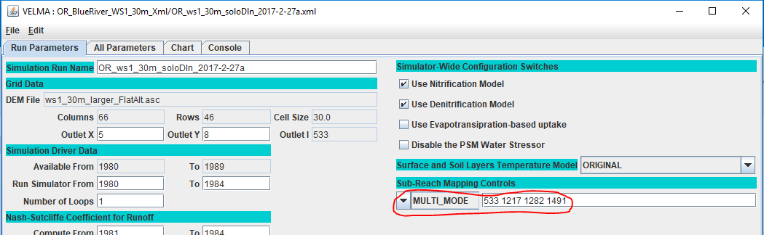

When this simulation configuration is started, the VELMA simulation engine notes the MULTI_MODE setting and the list of outlets, and reports runoff for each of the specified sub-reaches. It also writes an .asc file mapping the cells of the overall watershed to their specific reach-id values (which are listed in the ReachSummary.csv file).

After running the above simulation via JVelma, here is the ReachSummary.csv file’s contents, opened using Excel:

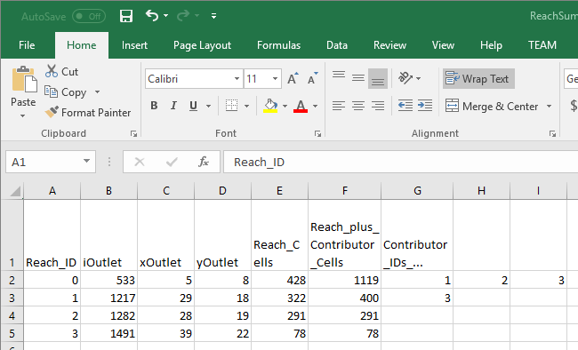

The ReachSummary.csv contains 1 row for each sub-reach, and lists the linear index and X,Y coordinates of the each reach’s outlet, plus the number of cells in the reach, and a list of the other reaches that flow into it.

The daily runoff values for each reach are listed in the ReachFlowResults.csv and ReachFlowContributions.csv files.

(continued)

Here are the first 10 simulation days from the ReachFlowResults.csv file:

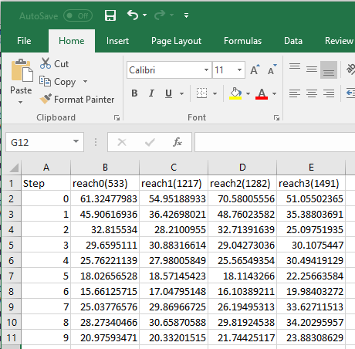

**AN IMPORTANT CONSIDERATION:**  
*The contents of the ReachFlowResults.csv and ReachFlowContributions.csv files depend upon how you run the VELMA simulation.*

When you use JVelma or VelmaSimulatorCmdLine to run your simulation, the contents of the ReachFlowResults.csv and ReachFlowContributions.csv files will show the same values.  
These values are the runoff values at each specified sub-reach outlet INCLUDING runoff from upstream reaches. The runoff values are in mm/day/number-of-cells -- where the number-of-cells is the cell count for the sub-reach PLUS the cell counts of upstream reaches.

When you use VelmaParallelCmdLine to run your simulation, ReachFlowResults.csv continues to report the runoff values as described above, but ReachFlowContributions.csv contents change: they now represent the runoff for ONLY the sub-reach area, in mm/day/number-of-cells -- and now, the number-of-cells value is the cell count for ONLY the sub-reach.

Additionally, VelmaParalleCmLine reports each sub-reach's results in a separate subdirectory under the main output directory. There is one "./Results_* subdirectory for each specified sub-reach outlet (including the primary watershed outlet), and each ./Results_* subdirectory contains a ReachFlowResults.csv and ReachFlowContributions.csv file specific to that sub-reach.

# B.10 | Flow Path Modification with the JPDEM Channel Cutter

#### Overview (Tutorial B.10 – JPDEM Channel Cutter)

Digital elevation models (DEMs) need to be flat-processed using the JPDEM tool before VELMA can accurately simulate flow paths within a watershed. However, JPDEM’s flat-processing procedure cannot account for obscuring landscape features such as bridges or buried streams, leading to potentially large errors in estimating actual flow paths.

Therefore, JPDEM includes a procedure that allows users to make elevation adjustments (a.k.a. “dredging” or “cutting”) to reroute specified channels within a DEM. Performing channel cutting prior to flat-processing a DEM can improve the fidelity of flow paths in the subsequent flat-processed map relative to the actual terrain it represents.

JPDEM’s “channel cutter” can also be used to re-engineer existing DEM flow paths, for example, to support “what if” green infrastructure (GI) and low impact development (LID) simulations. Or, VELMA users might want to explore how rerouting stormwater from established gray infrastructure flow paths (e.g., streets equipped with storm drains) to proposed rain gardens, detention ponds, engineered wetlands, etc.

This document describes the basics of using JPDEM’s channel cutter to accomplish such objectives.

The Channel Cutter mechanism reduces the elevations of specified sequences of cells (“channel cells”) relative to their adjacent cells (“bank cells”). The elevation reduction is performed so that the channel cells guaranty a continuous “step down” from the upper most channel cell (“headwater cell”) to the edge of the DEM map grid.

The Channel Cutter mechanism requires a channel guide map that defines the channel cells it should adjust, including a built-in coded sequence representing the order of adjustment to be made on the DEM map data. Producing the channel guide map comprises most of the effort for the overall task of modifying (“dredging”) a map’s channels (flow paths). Appendix A????? provides instructions for using ArcMap and associated utility tools for establishing a channel guide map and performing the dredging process.

***Important Note:*** *JPDEM’s “Standard” and “Alternate” flat-processing methods should NOT be used for flat-processing DEMs when the Channel Cutter mechanism is being used. Reason is these two methods both raise and lower cells during flat-processing. The other methods (“Experimental” and “Enhanced Experimental”) only raise cell elevations during flat-processing adjustments. Since the Channel Cutter mechanism enforces flow to the edge of the map, these cells are guaranteed correct, therefore are not modified when using the “Experimental” and “Enhanced Experimental” methods. That behavior cannot be guaranteed when using the “Standard” and “Alternate” flat-processing methods.*

Using the Channel Cutter

This document assumes that you already have a raw DEM (i.e. a DEM that has *not* been flat-processed) that you wish to dredge (i.e. adjust channel cell elevations for) and a correctly-formatted stream channel sequential map to guide the channel cutter.

Step 1: Load the DEM Map

Start JPDEM and load the un-flat-processed DEM file, via the File -> “Load Map File Data” -> “Load as DEM File” menu item:

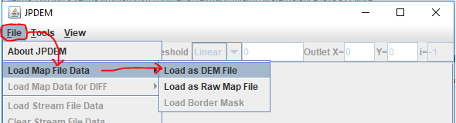

Step 2: Load the Channel/Stream Guide Map

Load the sequential guide map via the File -> “Load Stream File Data”

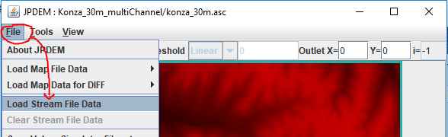

After the sequential guide (a.k.a. Stream File Data) map has been loaded, JPDEM will display the cell from the guide map in green:

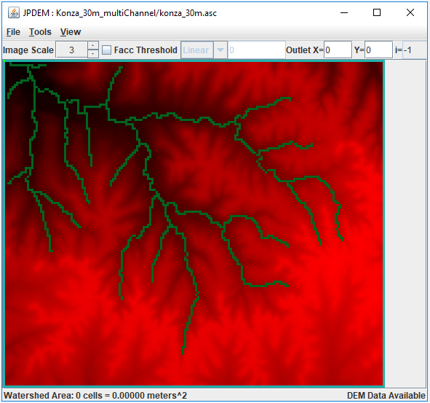

If you find that you have loaded the wrong channel/stream guide data, click the File -> “Clear Stream File Data”, and then “File -> “Load Stream File Data” to load the correct file.

Step 3: Run the Channel Cutter

Perform the actual channel cutting by clicking the Tools -> “Adjust DEM via Sequential Stream Guide Data” menu item.  
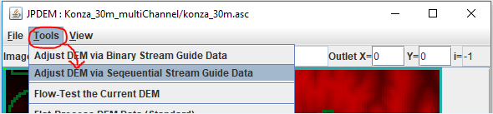

(The Tools -> “Adjust DEM via Binary Stream Guide Data” – is a different, mechanism that is still under development. If you click it by mistake, close JPDEM, then restart it and begin again with Step 1.)

When you click “Adjust DEM via Sequential Stream Guide Data”, the following dialog opens:

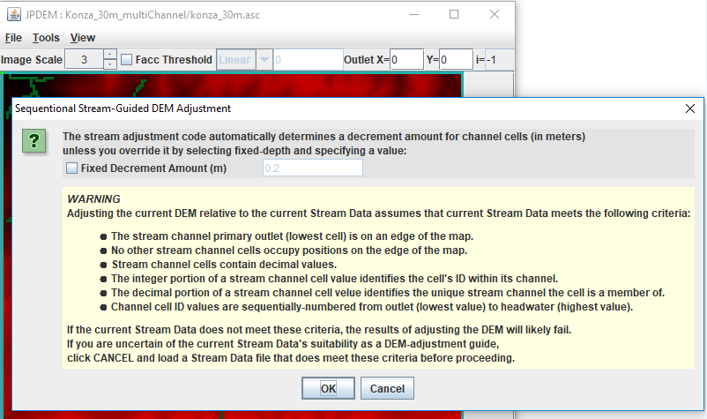

The “WARNING” section provides a condensed overview of the guide map format specified in Appendix A of this document.  
The “Decrement Amount” mentioned at the top of the dialog is the amount that channel cells are lowered relative to their adjacent bank cells. The value is in meters, and is automatically calculated unless you click the “Fixed Decrement Amount” and specify a value.  
Unless you need a very large difference between channel and bank elevations, leave the Fixed Decrement option unchecked, and simply click the OK button at the bottom of the dialog.  
Doing so will start the channel cutter mechanism.

The following message indicates that the channel cutter has completed its work:

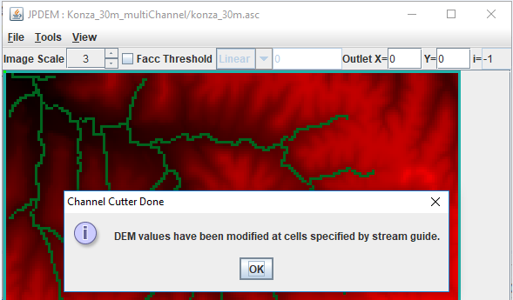

Click the OK button to dismiss it.

When the channel cutter encounters an error, it terminates with the following type of message dialog:

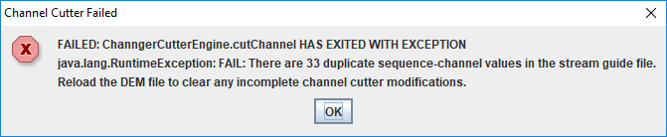

Step 4: Check the Channel Cutter Runtime Messages

As it processes the channels, the cutter echoes a status report for each channel ID it encounters to stdout of the console JPDEM was started from. (Note, if you started JDPEM by double-clicking its application icon, the status report messages are suppressed.)

Here is an extract from channel cutter output for a single channel’s status (the [...] indicate long text lines that were truncated for this document.)

Sequenced Channel #14 : 10024 9849 9674 9675 9500 9501 9326 9151 9152 8977 8802 [...]  
minDecrement=2.000000000066393E-4 bankDecrement=1.026900000000012 maxDecrement=[...]  
 Channel Cells: 10024 9849 9674 9675 9500 9501 9326 9151 9152 8977 [...]  
Channel Cell Elevations: 369.2801 368.8617 368.44329999999997 368.0249 [...]  
 Problem Channel Cells: -none-  
 Bank Cells: 10025 10200 10199 10198 10023 9848 9850 9850 10025 10023 [...]  
 Bank Cell Elevations: 372.6165 376.9927 373.6152 375.6302 375.5685 375.7058 [...]  
 Problem Bank Cells: -none-

Note that the above channel processed cleanly: the “Problem Channel” and “Problem Bank” lines report “-none-“. If either of the “Problem” report lines listed cell indices, that would indicate the channel cutter encountered some ambiguity at those cells. Careful review of the guide map data must then be performed: it may be that the sequencing of the channel is incorrect.

The cutter will fail – and lists to the stdout console – when it encounters one or more duplicate sequence.channel ID values in a single guide map. Here is short example of what the duplicate error message looks like:

At 2018-10-05 14:59:02: Starting Sequential Stream Guide Processor ...  
Cutter depth: Automatic Detection  
Duplicate: iSequence=15 iChannel=9  
Duplicate: iSequence=2 iChannel=2  
Duplicate: iSequence=141 iChannel=1  
Duplicate: iSequence=197 iChannel=1  
FAILED: ChanngerCutterEngine.cutChannel HAS EXITED WITH EXCEPTION  
java.lang.RuntimeException: FAIL: There are 4 duplicate sequence-channel values in the stream guide file.  
Reload the DEM file to clear any incomplete channel cutter modifications.

Step 5: Flat-Process the Channel-Cut Map

You can save the flat-processed channel-cut DEM map immediately after running the cutter, and we recommend you do this, but we also recommend you flat-process the DEM immediately after successfully channel-cutting it. The results of the channel-cutter mechanism are most compatible with the 3 “Experimental …” flat-processing algorithms; choose one of those and run it on the just-cut DEM.  
After the flat-processor is done, save the resulting map to a file (File -> “Save DEM Data As” -> “ASCII Grid”). You may also use the “Facc Threshold” rendering feature to evaluate how well the guide map’s cells correspond to high-flow cells of the flat-processed DEM (see Appendix B for details).

Appendix A:

Channel Cutter Sequential Guide Map Format

For some watersheds, a VELMA user may desire to increase the processing time required to flat process their area of interest or may need to control the representation of the VELMA simulation flow path. Both goals can be met using JPDEM’s advanced feature, the Dredger.

The current state of the dredging tool is beyond “Beta”. Though, currently this method is not as user friendly as JPDEM itself. As of VELMA 2.1, the user must use GIS software to prepare spatial data for an intermediate Java-based tool referred to as the Channel Cutter method (a.k.a Dredger), or by Java file referred to as “JpdemStreamDredgePrepper.jar”.

A channel cutter sequential guide map is an ESRI Grid ASCII (.asc) map file with the same dimensions as the DEM file it is intended to overlay. The contents of the file specify a collection of one or more channels, and the sequence of cells within each channel.

The following cell value details are generated for the user by the JpdemStreamDredgePrepper.jar tool. Understanding the end goal assists with trouble shooting the final stream dredge map provided to JPDEM. Each cell data value within the file must be either:

1. The DEM file’s nodata_value (usually -9999).
   1. Cells with the nodata_value are ignored by the channel cutter mechanism.
2. A decimal number signifying that cell’s stream flow sequence and channel ID numbers.
   1. The whole number portion (left side of decimal) of the number is the cell’s stream flow sequence number within the channel. First stream cell (stream mouth) is always 1 and each flowing cell is a greater number than touching downstream number. Numbers in the sequence can be skipped.
   2. The mantissa or cents portion (right side of decimal) of the number is the stream ID value for each channel that cell is a member. The ranking of each stream channel value dictates the hierarchy of dredging. A stream value of 1 has highest priority. Any stream cell of lower priority is dredged first with a higher priority being dredged later. This allows for proper dredging at stream confluences. The stream that terminates at the confluence should be of lower stream value priority, meaning a larger stream number.

The channel cutter mechanism is inelastic and cannot recover from map data errors. In addition to the above, the following requirements must be met:

* It is an error for the same sequenceID.channelID number value to occur more than once in a single map file.
* A channel’s sequence ID values must increase (lowest to highest) from its outlet to its “headwater” cell.
* A channel’s outlet cell must either terminate at the edge of the DEM grid, or adjacent to a cell of a different channel.
* A channel (and all connecting channels) may touch the edge of the DEM grid at only one cell location – that is, a channel or network of channels must terminate at a single DEM grid edge cell. A sequential guide map *may* contain more than one channel that terminates at a DEM grid edge, but every channel or network of channels that terminates at a DEM grid edge cell must be independent (i.e. not connect) to any other channel or network of channels that terminate at a grid edge cell.

Preparing the channel cutter sequential guide map using the JPDEM Dredger Prepper Tool

Part 1: Preparation of stream data

1. Load into ArcMap your raw DEM in the format VELMA will receive, meaning the extent and final cell resolution are already resolved. Note: the extent is an important here, if you change the DEM extent, you must create a new Dredge map matching the new DEM.
2. Load the polyline shapefile representing your desired dredging pattern.
   1. These data can be existing NHD data or other prepared stream data representations, created from scratch when data does not exist, such as when proposed future flow paths are part of the research.
   2. Two key points on this polyline shapefile.
      1. Each “stream” polyline must be represented as one, meaning in the attribute table an entire stream must contain the same number.
      2. A “stream” in this polyline shapefile is all the line segments together, and these line segments must all be connected to one network.
      3. Each “stream” polyline must have its own unique number. Again, a “stream” can be made up of many line segments, but all the segments representing one “stream” must all have the same number, and that number must be unique to only that “stream”.
      4. The “stream” network must have one, and only one, unique “stream” touching the edge of the map.
      5. The numbers themselves DO NOT have to be in sequence. That is one of several tasks the “JpdemStreamDredgePrepper” accomplishes during initiation.
   3. Clip the “stream” polyline network to match the extent of the raw DEM file.
   4. Check the attribute table to ensure all line segments have the unique ID matching the “stream” that line segment belongs to.
      1. Edit the attribute table as needed to meet this tool requirement. Line segments with missing data will become the terminal end of that “stream” due to the discontinuity. Therefore, the JpdemStreamDredgePrepper tool will stop processing that stream at any point of discontinuity.

Convert the “stream” polyline to a raster with matching extent and matching cell resolution. If using ArcMaps Polyline to Raster conversion tool, be sure the attribute field used is the field representing your “streams” unique stream numbers.

Running the JpdemStreamDredgePrepper

JpdemStreamDredgePrepper is a tool that can be used to simplify the creation of the JPDEM Stream Guide input map. The tool is ran from command line as of 23rd May, 2017. On-going work is being done to streamline this process even further.

Part 2: Running JpdemStreamDredgePrepper Java Tool

Steps for preparing to run the JpdemStreamDredgePrepper tool

1. Fill out the properties file using the JpdemStreamDredgePrepper_DefaultProperties.properties file provided.

Directory and Burn Modification keys.

* 1. Provide a project name. The ProjectName must be filled in when the runForModifiedBurns is set to true. The output modified burn file will be named using this key.
  2. Provide the full file path directory to the location the properties file and input data will be located at.

*** The directory file path can contain double backlashes or a single forward slash to separate folders.

* 1. stream key is the array generated from the Polyline to Raster conversion. Must be an ASCII. Use ArcMap Raster to ASCII tool to accomplish file conversion.
  2. startPtX key is the row dimension of the main stream within the "stream" file, where the dredging would begin against the edge of the area of interest.
  3. startPtY key is the column dimension of the main stream within the "stream" file, where the dredging would begin against the edge of the area of interest.
  4. writeOutData key is used to control the writing out of intermediate files that are not needed by JPDEM, but could be useful for trouble-shooting when the output ""project"_watershedDredgeMap.asc" file is not as expected.

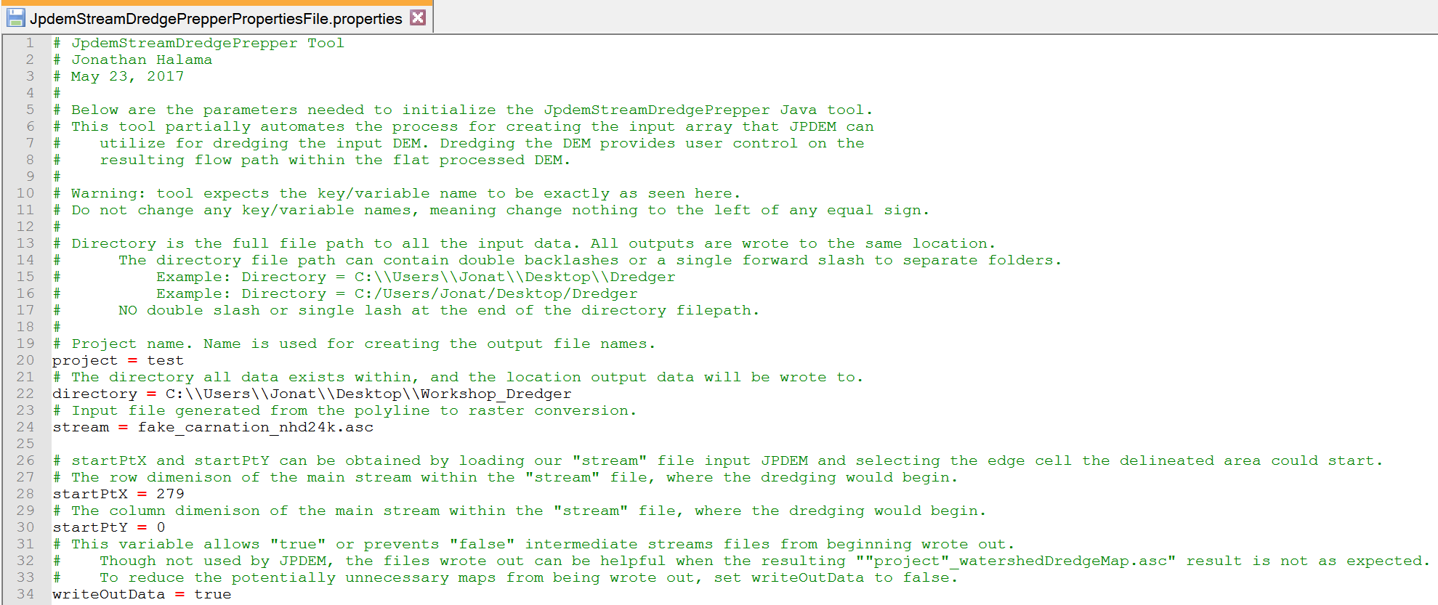

1. Save the Properties file within an accessible folder.
2. Launch PowerShell. Other command line methods will work, but PowerShell has the invaluable feature of drag-n-dropping full filepaths.
3. Type in PowerShell the following: java -jar
   1. There is a space between “java” and “-jar”, as well as a space after -jar
4. Drag-n-drop the “JpdemStreamDredgePrepper.jar” from its full file path location.
5. Add a space by clicking the spacebar.
6. Drag-n-drop the “JpdemStreamDredgePrepper_DefaultProperties.properties” from its full file path location.
   1. Properties file filename can vary, if you renamed it after modifying the variables to fit your study area.
   2. PowerShell should look something like this now:

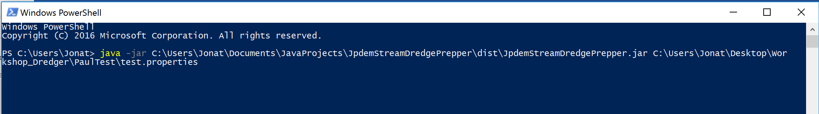

1. Hit enter! If successful, you will see something like this when the tool is complete:

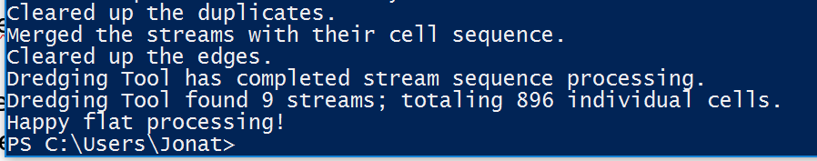

1. Outputs:
   1. The tool generates several output files. This is partly due to the tool not being 100% complete, so some files are used during development. The other reason is these files can be useful for trouble shooting problems when the final map does not match what you expected.

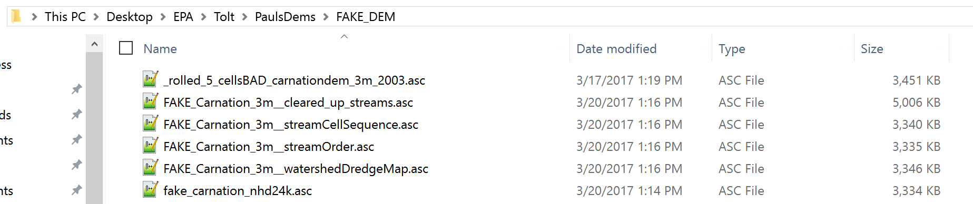

* 1. In the above file structure example:
     + 1. *projectName*_watershedDredgeMap.asc
          1. This is the file one provides to JPDEM. This file is a sorted stream network with the file structure of “sequentialCell.uniqueStream”. Example: “1.1” “2.1” “3.1”
       2. *projectName*_cleared_up_streams.asc
          1. The results of an intermediate processing step. Normally only used for code debugging.
       3. *projectName*_streamOrder.asc
          1. The results from the tool sorting the “streams” per cell for the numbers to the right of the decimal.
       4. *projectName*_streamCellSequence.asc

The results from the tool sorting the values per cell for the numbers to the left of the decimal.

Appendix B:

Viewing Channel Information After Flat-Processing

Assuming you have loaded a valid DEM and associated guide map, successfully run the channel cutter, and flat-process the channel-cut map, you can view how well the channel guide cells correspond to the DEM’s high-flow cells.  
Click the “Facc Threshold” checkbox in JPDEM’s toolbar, and enter an appropriate threshold value.  
The threshold image rendering is “guide-map aware”, and when guide map information is available, the Facc Threshold colors the DEM map’s cells as follows:

|  |  |  |
| --- | --- | --- |
| **Cell Color** | **>= Facc Threshold ?** | **Channel Guide Cell ?** |
| Grayscale | NO | NO |
| Red | YES | NO |
| Dark Green | NO | YES |
| Yellow/Orange | YES | YES |

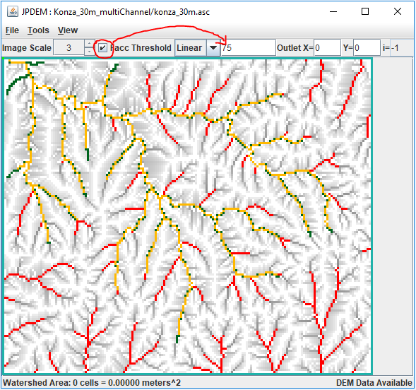

# C.1 | VELMA Reach Mapping

#### Overview (Tutorial C.1 – VELMA Reach Mapping)

Tutorial “*B.9_HowTo_JPDEM Sub-Reach Delineations*” described how to use JPDEM to establish a set of x, y coordinates for user-delineated sub-watershed (sub-reach) outlets, in preparation for running VELMA in parallel mode to simulate daily streamflow for those sub-reach outlets.

The present tutorial, “*Tutorial C.1 – VELMA Reach Mapping*”, describes how to incorporate the x, y sub-reach coordinates developed with JPDEM into VELMA.

Tutorial “*Tutorial C.2 – How To Run VELMA Parallel Mode*” describes how to run VELMA in parallel mode for generating daily streamflow results for the specified sub-watershed (sub-reach) outlets.

Aside from potential gains in computational efficiency, sub-reach delineations for running VELMA in parallel mode can help watershed managers tease apart streamflow responses to local and more distant upstream changes in land cover and land use.

The VELMA simulator engine can be configured to subdivide the watershed specified by the primary outlet (via the outx and outy configuration parameters) into several sub-reaches. Ordinarily, this feature is unnecessary, but it is useful and/or required for certain simulation situations. For example, sub-reaches must be specified when running a simulation via the VelmaParallelCmdLine. For additional details see “How to: Run VELMA in Parallel Mode. [Note: Sub-reaches must also be specified in simulation configuration .xml files that will be used for multi-scale simulation runs via the VelmaSimulatorAltCmdLine. Multi-scale simulations are still under development].

The simulation configuration’s sub-reach behavior and the locations of the sub-reaches are specified by two, separate, but interrelated parameters:

* The enableReachMapping parameter specifies the mode (i.e. behavior) of the VELMA simulator with regard to sub-reach maps.  
  Its value must be the *exact* text representation of one of the four valid modes: AUTO_MODE, LEGACY_MODE, MULTI_MODE or SOLO_MODE.
* The initialReachOutlets parameter specifies the linear cell indices of all of the sub-reaches.  
  When specified, its value must be a whitespace-separated sequence of   
  (The initialReachOutlets parameter value is ignored for some enableReachMapping modes.)

Specify the enableReachMapping mode first, then (depending upon whether the specified mode requires it or not) specify the initialReachOutlets parameter’s list of sub-reach outlets.

|  |  |  |  |
| --- | --- | --- | --- |
| **enableReachMapping value is …** | **initialReachOutlets value is …** | **VELNA Simulator behavior is …** | **Notes** |
| AUTO_MODE | Ignored | Auto-generated sub-reaches. | Seldom required; may generate many sub-reaches |
| LEGACY_MODE | Ignored | No sub-outlets, single watershed. | This mode is deprecated. |
| MULTI_MODE | Required | Sub-outlets specified by initialReachOutlets | Use for Velma Parallel or Alt cmdline runs. |
| SOLO_MODE | Ignored | No sub-outlets, single watershed. | Most common mode for JVelma runs. |

Setting the Reach Mapping Parameters in JVelma GUI

You can set both of the reach mapping parameters in either JVelma’s “Run Parameters” or from the “All Parameters” tab.

In the “Run Parameters” tab, underneath the label “Sub-Reach Mapping Controls” there is a drop-down selector for the enableReachMapping mode value, and a text field for the initialReachOutlets:

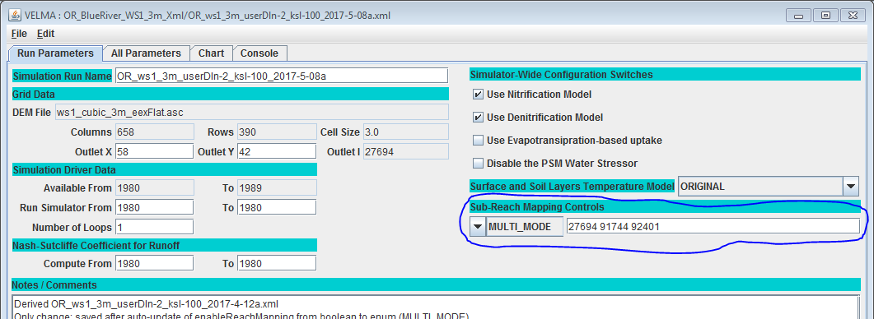

In the image above the enableReachMapping parameter is set to MULTI_MODE, and the initialReachOutlets value is a 3-index sequence of cell indices: 27694 91744 92401.

In the “All Parameters” tab, you can quickly filter-limit the table to the reach mapping parameters by selecting the “Sub-Reach Mapping” topic from the drop-down outline menu as show below:  
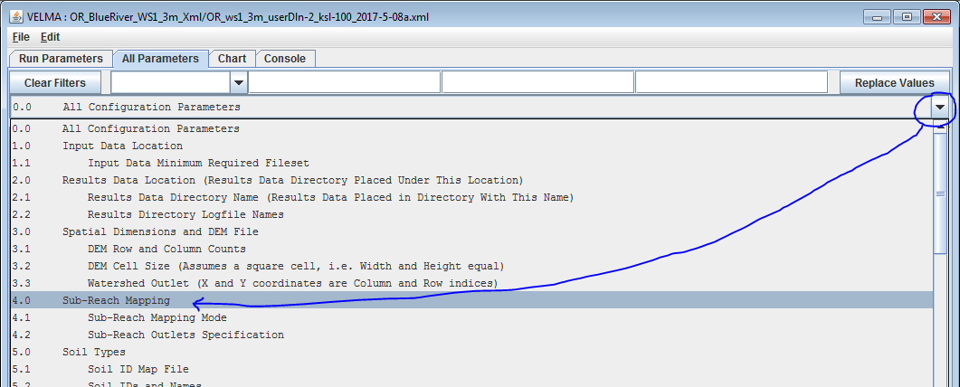

Click-select topic “4.0 Sub-Reach Mapping”, as shown by the blue circle and arrow above, to set the filter for reach mapping, and limit the All Parameters table rows to only reach mapping parameters (as shown in the following image):

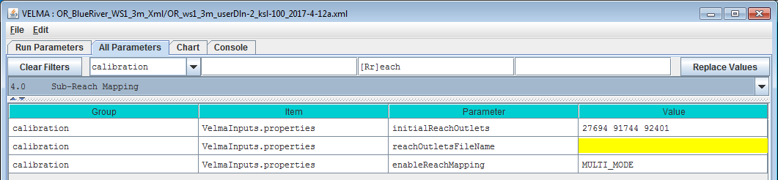

Notice the reachOutletsFileName parameter and blank (yellow) value in the above image. The reachOutletsFileName parameter is a legacy setting that is ignored. If you run JVelma’s Edit -> Remove Unused Parameters function, it will be deleted from the configuration.

Legacy Configurations Will (Mostly) Work Correctly

Earlier VELMA configurations specified Reach Mapping behavior differently.

* enableReachMapping was a boolean value (i.e. either true or false and nothing else).
* The reachOutletsFileName contents were combined with the initialReachOutlets value to form the final list of reach outlets.

When a legacy configuration .xml is loaded into JVelma or one of the VELMA command-line tools, the following updates occur:

* The enableReachMapping value is changed: true = MULTI_MODE, false = LEGACY_MODE.
* The reachOutletsFileName value is ignored.
* The initialReachOutlets value is untouched, and is used as-is if enableReachMapping’s new mode value is MULTI_MODE.

This set of update rules means that most legacy simulations’ Reach Mapping behavior will remain unchanged. The exceptions are configurations that contained reachOutletsFileName parameter values, and configurations that had enableReachMapping == true and initialReachOutlets == “”.

The legacy VELMA simulator engine used enableReachMapping == true and initialReachOutlets == “” as an implicit indication of what is called AUTO_MODE. One of the goals of the new Reach Mapping parameters is making running in AUTO_MODE a very deliberate intention.   
Legacy configurations with enableReachMapping == true and initialReachOutlets == “” now map to MULTI_MODE, but the empty initialReachOutlets value is forced to = the primary (outx, outy) outlet.  
This means that the run will effectively be the same as manually setting SOLO_MODE.

# C.2 | How to Run VELMA in Parallel Mode

**Overview** *(Tutorial C.2 – How To Run VELMA Parallel Mode)*

This tutorial describes how to run VELMA in parallel mode, which splits a simulation run of a single, large watershed into multiple user-designated sub-watersheds, and runs each separately. When running in parallel mode, VELMA is programmed to collect simulated daily streamflow information for each designated sub-reach (sub-watershed) outlet. VELMA uses that information to compute, for each sub-reach outlet, the sum of flow contributions from

* all upstream grid cells draining to the sub-reach outlet, and
* only those cells falling between the sub-reach outlet and the next upstream sub-reach outlet (thereby excluding flow from all other upstream cells).

Thus, aside from potential gains in computational efficiency, sub-reach / sub-watershed delineations for running VELMA in parallel mode can help watershed managers tease apart streamflow responses to local and more distant upstream changes in land cover and land use.

Introduction

Within certain limitations, VELMA can be configured to split the simulation run of a single, large watershed into several sub-watersheds, and running each separately.

The sub-watersheds processes are scheduled such that downstream, dependent watersheds run after upstream contributing sub-watersheds.

For large (in terms of watershed total cell count) areas, splitting the "primary" watershed into sub-watersheds can reduce running time and memory footprint (per sub-process) by a significant amount.

Also, running a simulation in parallel mode is currently the only way to generate “only-my-own-sub-watershed runoff” data (as opposed to “my-sub-watershed-plus-upstream runoff” data) for a simulation.

Running in parallel mode imposes some special requirements and limitations:

* Parallel mode can only be run from a command-line front-end.  
  You cannot launch a parallel mode run from JVelma, and no runtime display is available.
* Parallel mode requires a relatively capable computer.  
  If your computer has a single processor with only 1 or 2 cores, or a limited (4 Gigabytes or less) amount of memory, you may not gain any benefit from running in VELMA parallel mode.
* There is some additional configuration effort involved.  
  You must determine sub-watershed (a.k.a. “sub-reach”) outlets for the primary watershed.  
  You must tweak the simulation configuration .xml (described later in this document).
* Some Disturbance functionality is unavailable.  
  Specifically, Water Drain Disturbances are incompatible with parallel mode runs.
* Parallel Mode runs generate a larger number of results files, some of which may be redundant.
* For small watersheds, the overall running time of a parallel mode run may be greater than running it single-process style (i.e. under JVelma).
* Unlike JVelma or VelmaSimulatorCmdLine, if you want to run a simulation configuration in parallel mode multiple times, you must either manually rename the results directory from the previous run of that simulation configuration, or delete it. The Velma parallel mode tool will not create new “_0”, “_1”, etc. named-suffix results folders automatically.

(continued)

Configuration Steps for A VELMA Parallel Mode Run

Start with a “proven”, single-process configuration – i.e., a simulation configuration .xml file that has the enableReachMapping parameter set to SOLO_MODE, and that has been run successfully (even if only for one simulation year) under JVelma.

Load that simulation configuration .xml file into JVelma, and immediately change its “Simulation Run Name” (i.e. the run_index parameter’s value), then save it. This creates a copy of the original .xml that you can modify for parallel mode, while saving the original .xml for single-process use.

Next:

1. Change the enableReachMapping from SOLO_MODE to MULTI_MODE.  
   *Note: there is also an AUTO_MODE available, but we do not recommend using it at this time.*
2. Enter the linear indices of the sub-reach outlet cells as the whitespace-separated value of the initializeReachOutlets parameter.  
   The tutorial “Tutorial B.9 - JPDEM Sub-Reach Delineations” details how to determine sub-reach locations.  
   Here is a snapshot of the “Run Parameters” tab’s “Sub-Reach Mapping Controls” section showing an example of configuring for MULTI_MODE.  
   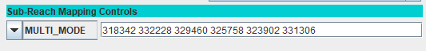  
   The numbers to the right of the MULTI_MODE setting are the sub-reach indices. Entering them into this numeric field assigns them to the initializeReachOutlets parameter.
3. Spatial Data must be output as "trimmed" maps.  
   Set the trimOutputToWatershedBoundary parameter value to true for any and all spatialDataWriter parameter Group(s).  
   Set the trimOutputToWatershedBoundary parameter value to true for any and all disturbance parameter Group(s).
4. All cover and soil results must be reported.  
   Set the parameter reportAllCoverResults value to true.  
   Set the parameter reportAllSoilResults value to true.  
   *(Note: this is so important that VELMA's parallel mechanism will perform it automatically  
   during simulator initialization if it is not done before-hand.)*

Save the changes – the simulation configuration .xml is now ready for use in VELMA Parallel Mode.

Running a Simulation via the VelmaParallelCmdLine

Although you can use JVelma to prepare a simulation configuration for a parallel mode run, you cannot launch the simulation run from JVelma, via its START button. Instead, you must open a Microsoft Powershell command window, and invoke the VelmaParallelCmdLine tool.  
(See Appendix I for how to start a Microsoft Powershell.)

But, before you do that, you should gather the following information:

* Determine the number of processor cores available on your computer.  
  If you know this already, you're done.  
  If you don't, open a Microsoft Powershell (you will need one to run VelmaParallelCmdLine in any case) and run the command highlighted in this example:  
    
  PS C:\> Get-WmiObject Win32_Processor | % {$_.DeviceID + " cores=" + $_.numberOfCores}  
  CPU0 cores=4  
  CPU1 cores=4  
    
  In the above example, the computer reports it has 2 CPUs, and each CPU has 4 processor cores, for a total of 8. As a rule of thumb, try to limit your VelmaParallelCmdLine runs to use less than the total number of available cores. Leaving 1 or 2 cores unused will keep the computer from becoming unresponsive to other processing requirements while your simulation is running.
* Determine the amount of RAM available on your computer.  
  The simplest way to do this is to open the Windows Start -> Settings (the "gear" icon) Window,   
  then click "System", and finally click "About".  
  In the "About" window, look for the "Installed RAM" specification.  
  Example:  
  The Settings icon:  
  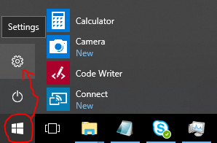  
  Settings -> System -> About:  
  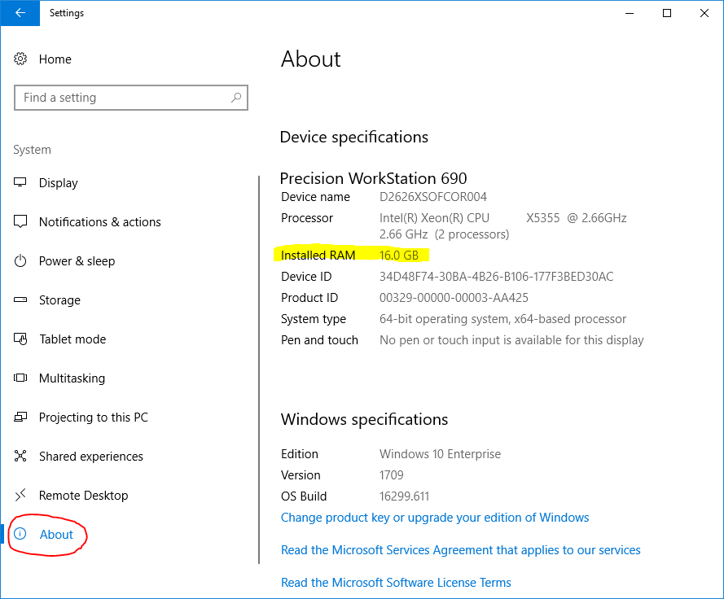  
  Knowing the amount of RAM available is important, because you will probably want to specify an initial heap size (via Java’s -Xmx option), and VelmaParallelCmdLine will request the amount of memory you specify ***for each process starts***. This means that, if you request 6 processors and 4 gigabytes of memory (“-Xmx6g”) VelmaParallelCmdLine may request up to 6 x 6 = 36 gigabytes of memory at a time (if you have 6 or more sub-reaches that it determines can all be run in parallel).

Once you know the number of available processes and memory, you can keep your VelmaParallelCmdLine startup within the limits of what your computer can process.

The VelmaParallelCmdLine front-end is part of the JVelma.jar. To run it, use the following command-line format, within a Powershell window:

java -Xmx<size> -cp “<path/JVelma.jar>” gov.epa.velmasimulator.VelmaParallelCmdLine “<file.xml>” --maxProcesses=<n>

(*The above command should all be entered as one line – it wraps across more than one line in this document.*)

Here is an example of an actual command line:

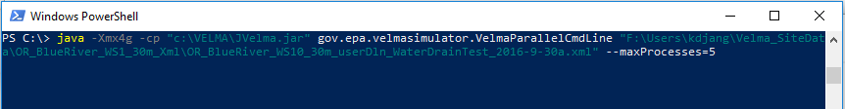

In the above example …

* The <size> of “4g” for the -Xmx argument requests 4 gigabytes per process/sub-reach.
* The <path/JVelma.jar> argument is the full-path to the JVelma.jar on the example computer.
* The <file.xml> argument is the full-path of the simulation configuration .xml file to run.
* The <n> value of 5 asks VelmaParallelCmdLine to use up to 5 processors at a time.
* The <path/JVelma.jar> and <file.xml> are enclosed in double-quotes in case of whitespace characters in the path or file names.

VELMA Parallel Mode Results

Like JVelma, VelmaParallelCmdLine creates a new subdirectory using the .xml configuration file’s simulation run name (i.e. the value of the run_index parameter) underneath the location specified by the initializeOutputDataLocationRoot parameter value. However, unlike JVelma, VelmaParallelCmdLine creates sub-subdirectories under the “root” output subdirectory for each sub-reach:

./<run_index-name>/  
 |  
 +--/Results_<a>/  
 | |  
 | GlobalStateLog.txt  
 | DailyResults.csv  
 | etc ...  
 |  
 +--/Results_<b>/  
 |  
 +--/Results_<c>/  
 |  
 etc ...

Each results directory contains the GlobalStateLog.txt, DailyResults.csv, and other files for that sub-reach’s simulation run. The files in the Results_* directory of the primary watershed outlet are of primary importance when considering the overall watershed results, but the other Results_* folders’ files may be of interest – especially the ReachFlowContributions.csv file which contain runoff values specific to that sub-reach alone.

Finally, again unlike JVelma, VelmaParallelCmdLine writes its own overall running log file during its operation, and leaves it underneath root results directory.  
The file is always named VelmaParallelRunlog.txt, and it contains a meta-level log of the entire simulation run.

Here are the contents of an example:

PS C:\> cat .\VelmaParallelRunlog.txt  
CONFIG 2018-07-20 10:16:43 VelmaParallelCmdLine: STARTING Parallel Processing  
CONFIG 2018-07-20 10:16:43 VelmaParallelCmdLine: Processors: available=8 requested=4 utilized=4  
CONFIG 2018-07-20 10:16:44 VelmaParallelCmdLine: Readying reach {WatershedInfo outlet=3590 dependencies=[] path=""}  
CONFIG 2018-07-20 10:16:44 VelmaParallelCmdLine: Readying reach {WatershedInfo outlet=2434 dependencies=[] path=""}  
CONFIG 2018-07-20 10:16:44 VelmaParallelCmdLine: Pending reach {WatershedInfo outlet=1735 dependencies=[2434, 2263] path=""}  
CONFIG 2018-07-20 10:16:44 VelmaParallelCmdLine: Pending reach {WatershedInfo outlet=3236 dependencies=[3590] path=""}  
CONFIG 2018-07-20 10:16:44 VelmaParallelCmdLine: Pending reach {WatershedInfo outlet=2263 dependencies=[3236] path=""}  
CONFIG 2018-07-20 10:16:44 VelmaParallelCmdLine: Parallel VELMA initial status: reaches pending=3 ready=2 completed=0  
INFO 2018-07-20 10:16:44 VelmaParallelCmdLine: STARTED Reach iOutlet=3590 process=java.lang.ProcessImpl@5e2de80c memory="-Xmx1g"  
INFO 2018-07-20 10:16:44 VelmaParallelCmdLine: STARTED Reach iOutlet=2434 process=java.lang.ProcessImpl@1d44bcfa memory="-Xmx1g"  
INFO 2018-07-20 10:18:26 VelmaParallelCmdLine: TERMINATED Reach iOutlet=3590 process=java.lang.ProcessImpl@5e2de80c status=0  
INFO 2018-07-20 10:18:26 VelmaParallelCmdLine: STARTED Reach iOutlet=3236 process=java.lang.ProcessImpl@266474c2 memory="-Xmx1g"  
INFO 2018-07-20 10:19:48 VelmaParallelCmdLine: TERMINATED Reach iOutlet=2434 process=java.lang.ProcessImpl@1d44bcfa status=0  
INFO 2018-07-20 10:20:39 VelmaParallelCmdLine: TERMINATED Reach iOutlet=3236 process=java.lang.ProcessImpl@266474c2 status=0  
INFO 2018-07-20 10:20:39 VelmaParallelCmdLine: STARTED Reach iOutlet=2263 process=java.lang.ProcessImpl@6f94fa3e memory="-Xmx1g"  
INFO 2018-07-20 10:24:52 VelmaParallelCmdLine: TERMINATED Reach iOutlet=2263 process=java.lang.ProcessImpl@6f94fa3e status=0  
INFO 2018-07-20 10:24:52 VelmaParallelCmdLine: STARTED Reach iOutlet=1735 process=java.lang.ProcessImpl@5e481248 memory="-Xmx1g"  
INFO 2018-07-20 10:27:07 VelmaParallelCmdLine: TERMINATED Reach iOutlet=1735 process=java.lang.ProcessImpl@5e481248 status=0  
CONFIG 2018-07-20 10:27:10 VelmaParallelCmdLine: TERMINATED Parallel Processing finalExitStatus=0  
PS C:\>

An exit status of “0” indicates success – any other value signals an error.

The VelmaParallelRunlog.txt file’s contents are useful for figuring out what went wrong when a VelmaParallelCmdLine run does not complete all the sub-reaches.

Appendix 1: How to Open a Microsoft PowerShell Window

Click the Windows Start button  and start typing “Powershell”.

The Start panel should change to show the following:

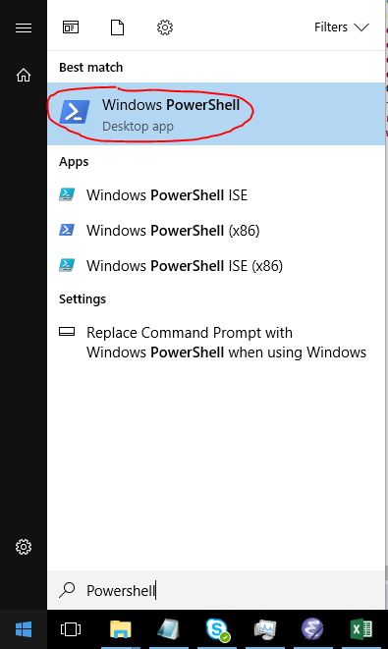

Click the “Windows PowerShell” (Best Match item) as shown above.

# C.3 | Rationale for Parallel Velma and Reach Segmentation

#### Overview (Tutorial C.3 – Rationale for Parallel Velma)

This tutorial provides the rationale for setting up and running VELMA in parallel mode, whereby a large watershed is broken up into smaller subwatersheds that can be run in parallel more efficiently. This requires segmentation of the overall stream network.

VELMA links a hydrological model with a biogeochemical model. The modeling unit is a square grid cell with up to eight adjacent grid cells. Processing of each grid cell includes computing transfers of water and chemicals from adjacent uphill cells, and to adjacent downhill cells. Transfers into or out of a cell can happen from any adjacent uphill or downhill, so a cell may have multiple flow directions. Having multiple flow directions is more realistic in general but is problematic in certain cases. VELMA starts with a set of cells that are delineated from an outlet point and include all cells whose primary flow direction sends water to the given outlet. Cells that are on the edge of this set could have flow into cells that are not included in the set, and cells outside the set may have flow into the set. This is a problem for a couple reasons. Cells on the edge of the delineated watershed behave differently from cells within the watershed in that a pair of cells with the downhill cell in the watershed and the uphill cell not in the watershed does not contribute water from the uphill cell to the downhill cell, whereas a pair of cells with the same configuration inside the watershed would have water contributed from the uphill to the downhill cell.

A desirable property of VELMA watershed processing is to get identical results for a cell whether the cell is being processed as an edge cell or as an interior cell. This property would then extend to say that a sub-watershed processed independently should get identical results when processed as part of a larger watershed.

In VELMA we get this property by selecting a set of sub-outlets that divide the watershed into a set of catchments and then require that water transfer occur only when adjacent cells are in the same catchment or if the upper cell is one of the designated outlets. This produces several desirable behaviors. First, given a set of outlets, processing a cell or catchment independently will produce the same results if the cell or catchment is processed as part of a larger watershed. In addition, communication between catchments is only through the set of outlets, further streamlining processing. This allows catchments to be processed by VELMA independently, either serially or in parallel, allowing for faster processing and allowing for the processing of much larger watersheds. It produces a less desirable behavior though. The overall results depend on the assignment of outlets. Adding an outlet changes the water flow from cells that are now considered to be outside the catchment delineated by the new outlet. Differences are small but significant.

Another way to get identical behavior would be to include in processing all cells uphill from a given outlet. This ensures that for each cell, whether interior or edge, processing will be identical. However, in many cases, the additional number of cells can be quite large. For processing in parallel, the communication between catchments now many include all border cells, not just the outlets. The redundancy of processing plus the cost of communication between catchments makes parallel processing effectively worthless. Even in the purely serial case the amount of extra processing is significant.

Using square grid cells will always be a compromise. For channel cells we don’t account for how much of the cell is the stream and how much is riparian boundary. For ridge cells we don’t account for where the high point is within the cell. Adding an additional convention to ridge cells, that all water and chemicals flow into only one of the catchments divided by the cell, seems like a small cost to pay for the benefit of being about to subdivide a watershed and process catchments individually.

# D.1 | Acquisition & Generation of VELMA Input Data

**Overview***(Tutorial D.1 – Basic Acquisition and Generation of VELMA Input Data)*

This tutorial describes the minimum data input files required to run the VELMA simulator, where to acquire them, and steps to prepare them for a VELMA simulation.

The following data files must be complete and available for the VELMA Simulator to run:

|  |  |  |
| --- | --- | --- |
| **FILE** | **TYPE** | **CONTAINS** |
| Flat-Processed DEM | Spatial / Grid ASCII (.asc) | Elevation in meters |
| Cover Species ID Map | Spatial / Grid ASCII (.asc) | Cover Species ID integers |
| Cover Species Age Map | Spatial / Grid ASCII (.asc) | Cover Species age in years |
| Soil Parameters ID Map | Spatial / Grid ASCII (.asc) | Soil Parameterization ID integers |
| Precipitation Driver Data | Temporal / (.csv or .txt) | Precipitation per in mm |
| Air Temperature Driver Data | Temporal / (.csv or .txt) | Air Temperature in degrees C |

Digital Elevation Model and Soils

Elevation and other common GIS data can be retrieved from many local, state, and federal GIS repository libraries. The USDA’s “Geospatial Data Gateway” provides easy access to multi resolution USGS National elevation data along with many other types of natural resource data. Higher resolution data, like LiDAR can many times be found from alternative public and private stakeholders such as the “Puget Sound Lidar Consortium”. Other popular data, such as STATSGO and newer 10m gridded SSURGO soils GIS layers can also be acquired from the “Geospatial Data Gateway”.

References

Geospatial Data Gateway - <https://datagateway.nrcs.usda.gov/>

Puget Sound Lidar Consortium - <http://pugetsoundlidar.ess.washington.edu/>

Weather Data

Daily meteorological summaries driver data can most easily be acquired from both observational and modeled sources such as:

* NOAA - <https://www.ncdc.noaa.gov/cdo-web/>
* SNOTEL - <https://www.wcc.nrcs.usda.gov/snow/>
* PRISM – <http://www.prism.oregonstate.edu/>
* DAYMET - <https://daymet.ornl.gov/>

Care needs to be taken with all weather data drivers to ensure completeness of temporal coverage and accuracy of values. Consistently, observational data will have “not available” (NA’s) or gaps in coverage, false readings from equipment malfunction, and user input errors. Modeled data tends to bring with it other types of errors or consistency gaps, which will need to be accounted for. For instance, DAYMET estimates are updated yearly, currently only available for 1980 – 2017, and uniformly truncate leap years to 365 days, where the VELMA model accounts for leap days. Benhnke et al. 2016 highlight the general comparison of observational versus modeled errors, as well as the regional variations of the various popular downscale gridded meteorological data. Appended tools and alternative weather models were created to deal with these and other inconsistencies in daily diver data.

References

Behnke, R., Vavrus, S., Allstadt, A., Albright, T., Thogmartin, W. E., & Radeloff, V. C. (2016). Evaluation of downscaled, gridded climate data for the conterminous United States. Ecological Applications.

PRISM Climate Group, Oregon State University, http://prism.oregonstate.edu

Thornton, P.E., M.M. Thornton, B.W. Mayer, Y. Wei, R. Devarakonda, R.S. Vose, and R.B. Cook. 2016. Daymet: Daily Surface Weather Data on a 1-km Grid for North America, Version 3. ORNL DAAC, Oak Ridge, Tennessee, USA. http://dx.doi.org/10.3334/ORNLDAAC/1328

Cover Species and Land Cover

Species and land cover data can be either custom generated or retrieved from data libraries. There are several national and regional scale land cover and species type data sets to be chosen from. The popular remotely sensed National Land Cover Data for the years 2006 and 2011 can be acquired from either the “Multi-Resolution Land Characteristics consortium” or “Geospatial Data Gateway”. The Gap Analysis Program (GAP) has create a national scale vegetation inventory, which was also combined with LANDFIRE, another national GIS data set, to help with both ecosystem management and fire resource management. For Pacific coast states, gradient analysis and nearest neighbor imputation (GNN) techniques were used to create more accurate forested species cover maps. Since cover species is site specific, general reductions can be made from national data sets to meet the user’s needs.

References

NLCD - <https://www.mrlc.gov/nlcd2011.php>

GAP - <https://gapanalysis.usgs.gov/gaplandcover/>

LANDFIRE - <https://www.landfire.gov/>

GNN – <https://lemma.forestry.oregonstate.edu/data/structure-maps>

Gergely, K.J., and McKerrow, A., 2016, Terrestrial ecosystems—National inventory of vegetation and land use (ver. 1.1, August 2016): U.S. Geological Survey Fact Sheet 2013–3085, 1 p., https://pubs.usgs.gov/fs/2013/3085/.

Homer, C.G., Dewitz, J.A., Yang, L., Jin, S., Danielson, P., Xian, G., Coulston, J., Herold, N.D., Wickham, J.D., and Megown, K., 2015, Completion of the 2011 National Land Cover Database for the conterminous United States-Representing a decade of land cover change information. Photogrammetric Engineering and Remote Sensing, v. 81, no. 5, p. 345-354

LANDFIRE, LANDFIRE: Existing Vegetation Type, U.S. Department of Agriculture and U.S. Department of the Interior.

Ohmann, Janet L.; Gregory, Matthew J. 2002. Predictive mapping of forest composition and structure with direct gradient analysis and nearest neighbor imputation in coastal Oregon, U.S.A. Canadian Journal of Forest Research. 32: 725-741

Cover Species Age

In some instances, stand ages maps might exist, but generally cover species age maps are custom made for each VELMA area of interest (AOI) model run. Age maps may be developed from remotely sensed data, surveys, land ownership maps, expert knowledge, or some combination of these methods. Below is an example of a custom species age creation process.

The Winant AOI, is a small tidally influence watershed that drains into the Yaquina bay along the Oregon coast. Modeling efforts are being made to quantify and qualify how nutrients are transport and cycled through a salt marsh whose headwaters are drainages of typical coastal conifer species and high nitrogen fixing hardwoods. It was there for necessary to model both types of unique biogeochemistry of the contributing Alder and Conifer forests, and their ages.

(continued)

Cover species maps were developed for the Winant AOI from a combination of ortho-imagery, aerial imagery, and on-site ground surveys (Figure 1).

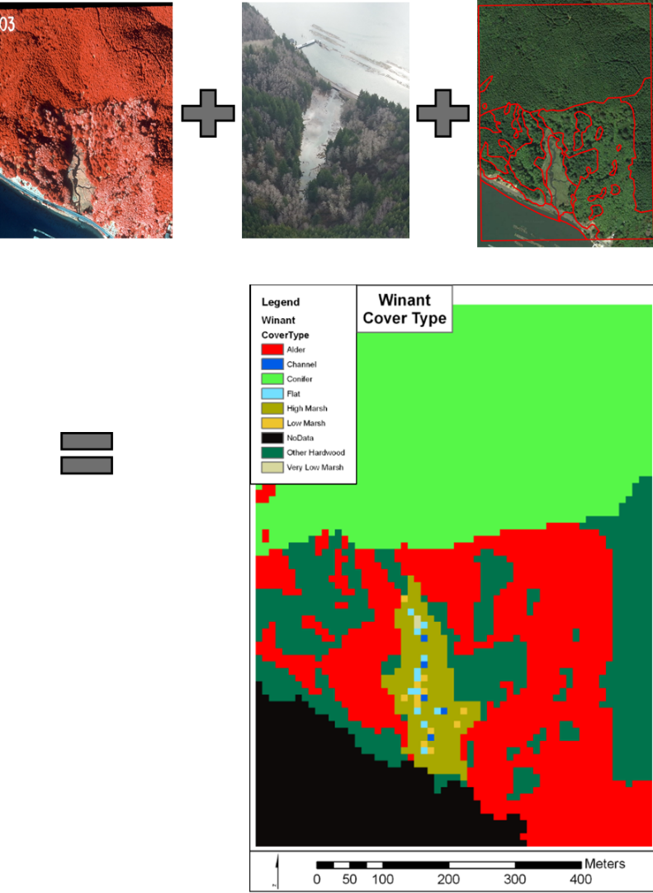

Figure 1. From Top left to right to bottom, ortho-imagery, aerial imagery, and site survey were combined to create cover type raster maps.

To generate species specific age maps, Michaelis-Menten curves we developed using literature data to produce functions that related species specific age to height. LiDAR height values were used to run the fitted curves of a particular species and derive its appropriate age cell value (Figure 2 and 3). Similar techniques can be used to develop relationships between above ground biomass or above ground carbon and vegetation age. Woods Hole has produced a national data set which include estimates of above ground carbon and vegetation height (Kellndorfer et al, 2012).

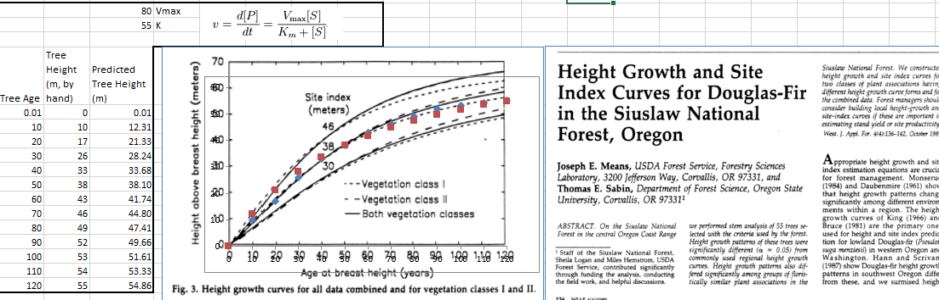

Figure 2. Height to age index curve calculation for Douglas-Fir.

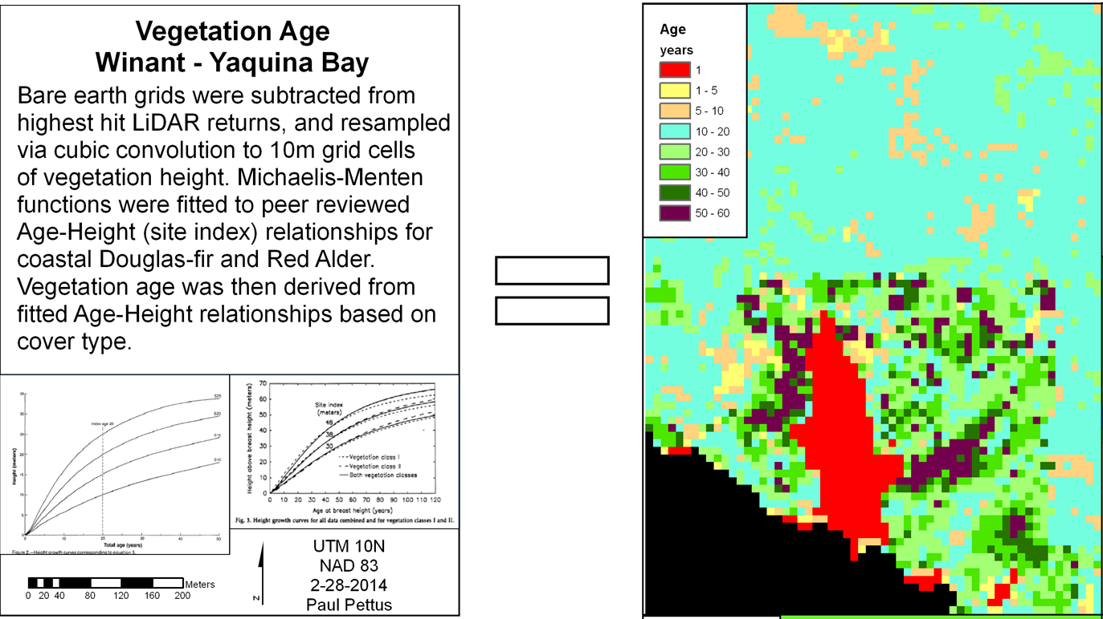

Figure 3. Site index and curve fitted relationships species age and tree height.

References

Kellndorfer, J., Walker, W., LaPoint, E., Bishop, J., Cormier, T., Fiske, G., Hoppus, M., Kirsch,

K., and Westfall, J. 2012. NACP Aboveground Biomass and Carbon Baseline Data (NBCD

2000), U.S.A., 2000. Data set. Available on-line [http://daac.ornl.gov] from ORNL DAAC,

Oak Ridge, Tennessee, U.S.A. <http://dx.doi.org/10.3334/ORNLDAAC/1081>

# D.2 | Soil Data Mapping and Parameter Initialization

#### **Overview** (Tutorial D.2 – Soil Data Mapping and Parameter Initialization)

This tutorial describes the minimum data input files required to run the VELMA simulator, where to acquire them, and steps to prepare them for a VELMA simulation.

Soil Data Sources

* gSSURGO - <https://gdg.sc.egov.usda.gov/>
  + gSSURGO User Guide (PDF; 10.7 MB) Soil Survey Staff. Gridded Soil Survey Geographic (gSSURGO) Database for Washington. United States Department of Agriculture, Natural Resources Conservation Service.
* STATSGO2 - <https://gdg.sc.egov.usda.gov/>
  + Soil Survey Staff. Gridded Soil Survey Geographic (STATSGO2) Database for Washington. United States Department of Agriculture, Natural Resources Conservation Service.

Soil Data Pre-Processing

To create a thematic soil texture map for either the gSSURGO, SSURGO, or STATSGO2 data sets the one too many to many hierarchies of relationships must be resolved with spatial map units and tabular data. Both soil tabular and spatial data tables are included when any of the data sets are downloaded from the USDA. For a complete overview of relationships, refer to the SSURGO/STATSGO2 documentation “SSURGO 2.2 Data Model – Diagram 1 of 2”. To link the spatial map units to their textures a series of joins must be made between the tabular text file and the Shapefiles (Figure 1).

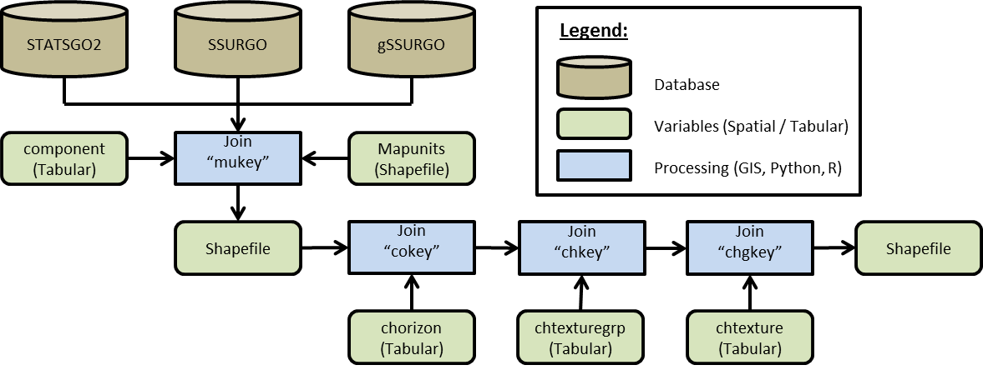

**Figure 1. Spatial join process**

***Example: Tolt River Watershed Soil Data Pre-Processing***

1. Within ArcGIS, load the STATSGO2 shapefile “gsmsoilmu_a_wa.shp”
2. Using the “Join Field” (Data Management) tool set:
   * Input Table = “gsmsoilmu_a_wa.shp”
   * Input Join Field = “MUKEY”
   * Join Table = PATH + “component”
   * Output Join Field = “mukey”
   * Join Fields (optional) = CHECK “cokey”
3. Repeat “Join Field” for the C horizon, chtexturegrp, and chtexture tables to the final texture column.

* Dataset 1.
  + In cases where the gSSURGO soil textures were initially classified under subclass, the soil textures need to be re-classified to their parent class of the USDA Soil Survey Manual, Chapter 3 (USDA, 2017) of the soil triangle textures that are used by VELMA (Figure 2).
    - Sands <- Coarse Sand, Sand, Fine Sand, Very Fine Sand
    - Loamy Sand <- Loamy Coarse Sand, Loamy Sand, Loamy Fine Sand, Loamy Very Find Sand
    - Sandy Loams <- Coarse Sandy Loam, Sandy Loam, Fine Sandy Loam, Very Fine Sandy Loam
    - Silt Loam = Silt

(continued)

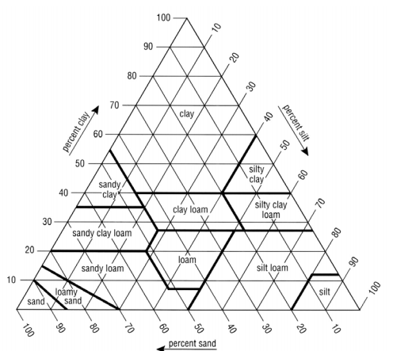

**Figure 2. USDA Soil texture triangle**

* + Replaced all missing gSSURGO soils texture cells with STATSGO soil textures, creating a merged high- and low-resolution soils data layer (Table 1, Figure 4, Figure 5, and Figure 6).

**Table 1. Soil texture key for VELMA**

|  |  |  |
| --- | --- | --- |
| File Name | |  |
| tolt_ssurgo_statsgo_soil.tif | | |
|  | Key | Value |
|  | 1 | sand |
|  | 2 | loamy sand |
|  | 3 | sandy loam |
|  | 4 | loam |
|  | 5 | silt loam |
|  | 6 | sandy clay loam |
|  | 7 | clay loam |
|  | 8 | silty clay loam |
|  | 9 | sandy clay |
|  | 10 | silty clay |
|  | 11 | clay |

Software Requirements and Processing

To run and produce the merged soil texture map (ASCII), you will need the following:

1. Python version 2.x: Current release is 2.7.11
   1. Python comes pre-packaged within ArcGIS, so it is likely you already have it installed on your computer. For example, a default install is currently here: C:\Python27\ArcGIS10.2\python.exe. Check to see if you have Python installed before installing a new version. If Python is not installed, you can obtain a copy here: <https://www.python.org/download/releases/2.7/> *Note that Python 2.7 is currently considered safe for use on U.S. EPA network and non-network computers.*
2. ASCII Map requirements:
   1. gSSURGO ASCII format (.asc) for the AOI and a STATSGO2 ASCII format (.asc) for the AOI.
      * Cell values set to match the soil texture key for VELAM (Table 1).
      * No-data cells values set to -9999, which is the default ERSI ASCII no data value.
      * These map(s) should match the exact extent and resolution of the AOI / DEM ASCII regardless if they are higher resolution.
   2. Output filename to be determined by the user, ASCII format (.asc).
3. “**Soil_merger.py**” and can be run on the Command Prompt line with Python. This script requires at a minimum a gSSURGO map, one STATSGO2 map, and one output file name. The script will output an intermediate merged file map with No-data values. The merged soil texture values will assign values to the output map from the higher resolution gSSURGO map first and then from the STATSGO2 map. The final output map will fill No-data values with soil texture values. The technique uses a nearest neighbor search algorithm that will radiate out in one cell radius increments searching for the nearest cell with a valid texture value which will then be assigned to the No-data cell.

**Command prompt input example:**“python .\soils_merger.py -SUR D:\Temp\ssurgo_aoi_texture_reclass.asc -STA D:\Temp\statsgo_aoi_texture_reclass.asc -OUT D:\Temp\Merged_output.asc”  
“python C:\Path\To\soils_merger.py –help” for exact arguments (Figure 4).

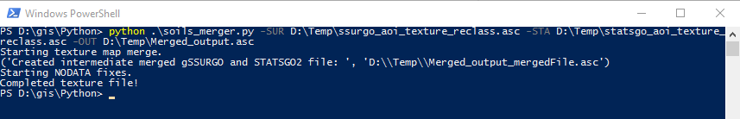

**Figure 3. Windows PowerShell python example**

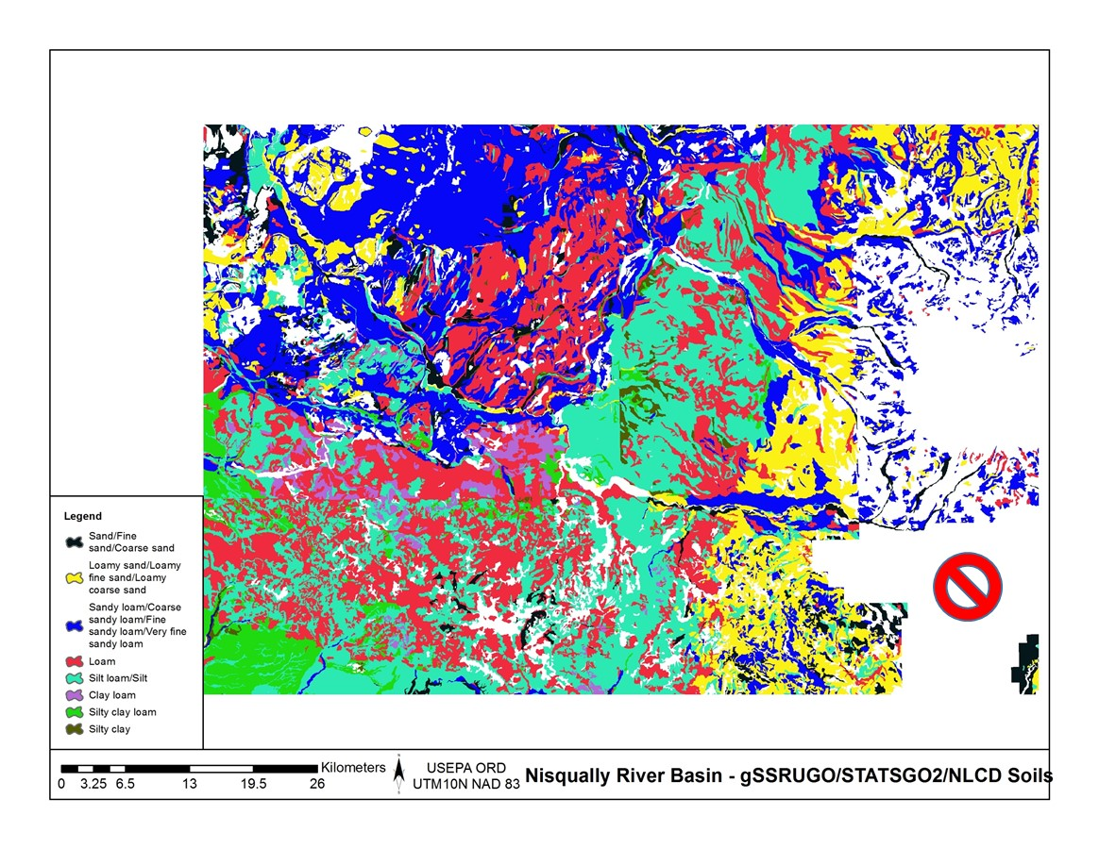

**Figure 4. gSSURGO Soils texture and NODATA**

(continued)

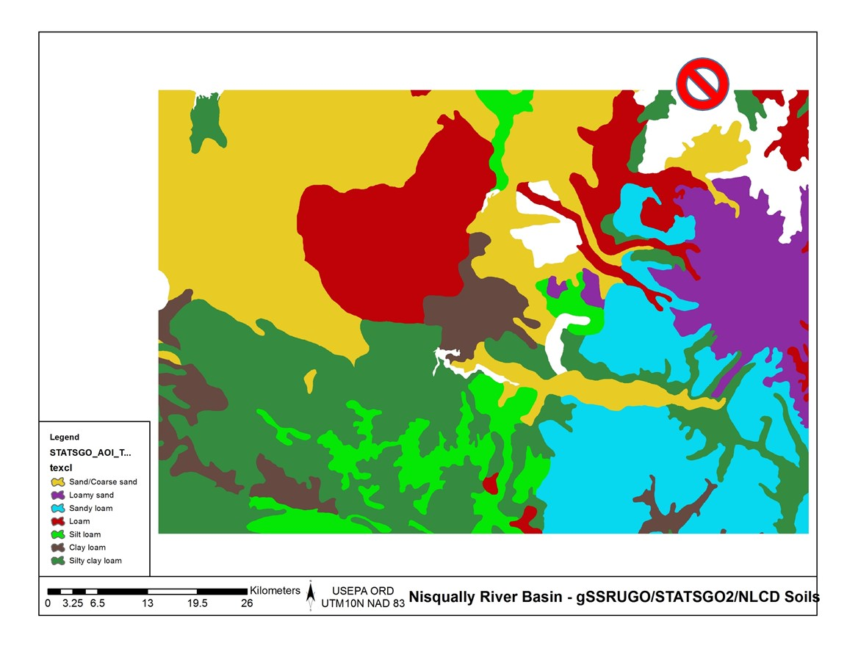

**Figure 5. STATSGO Soils texture and NODATA**

(continued)

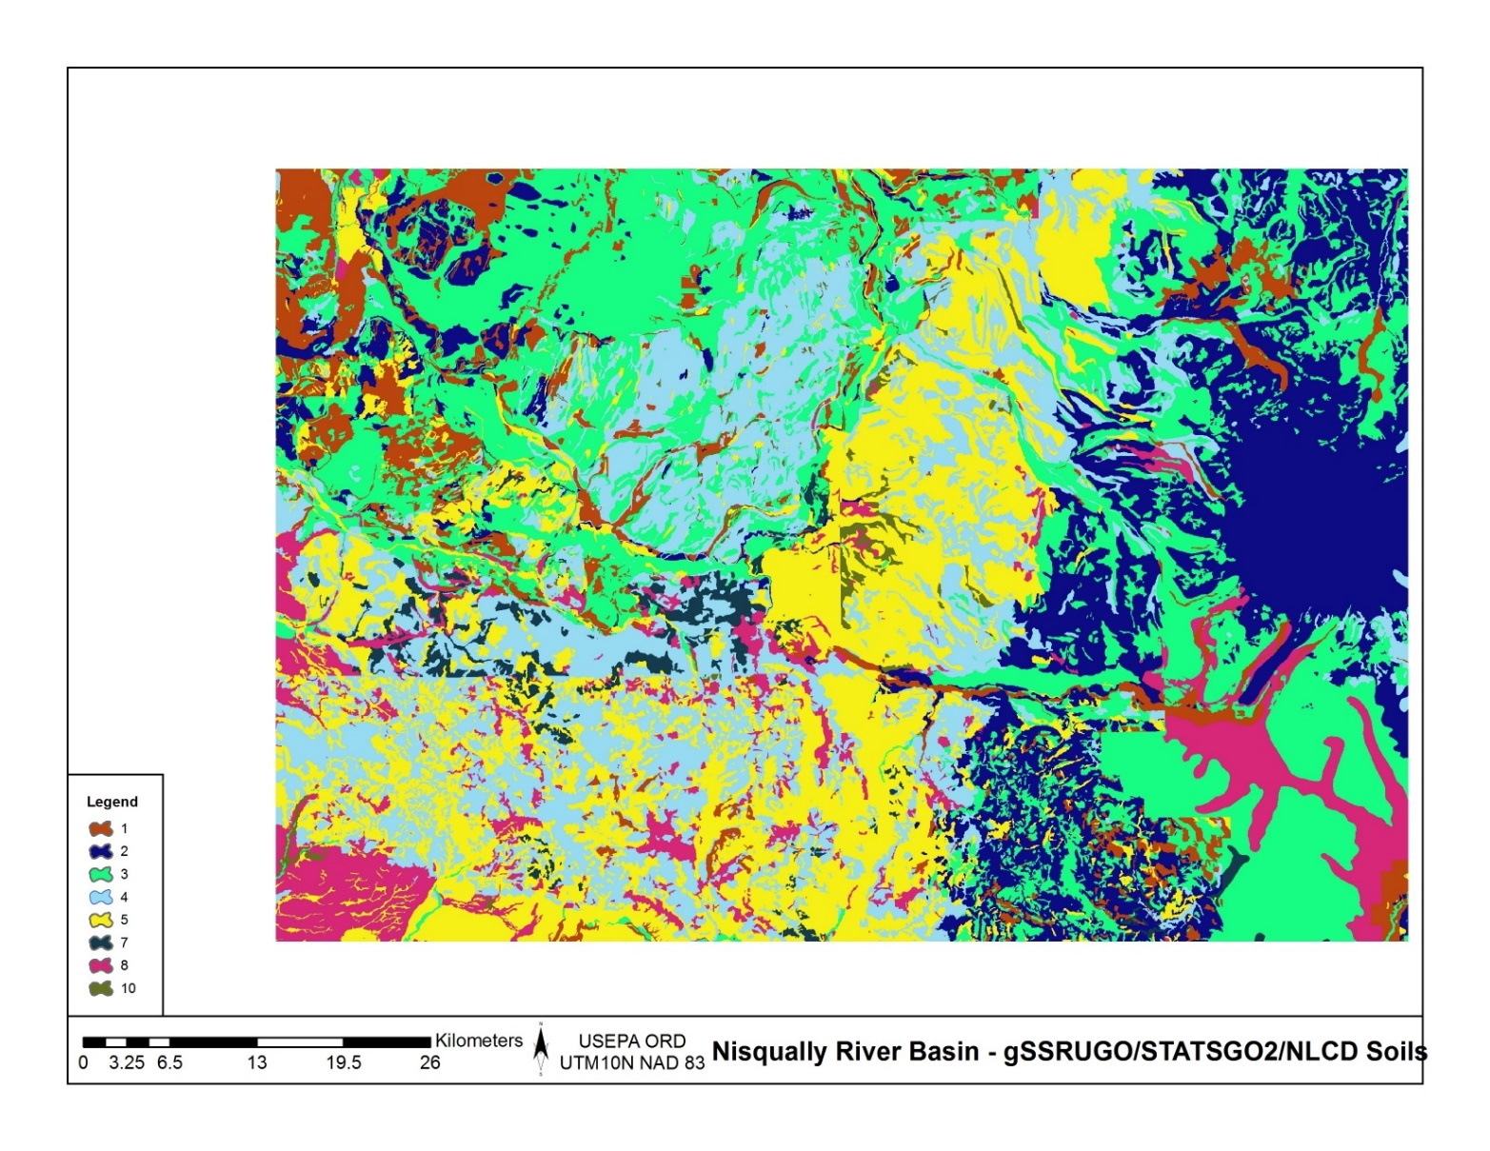

**Figure 6. Merged soils, gSSURGO and STATSGO.**

References

Soil Science Division Staff. 2017. Soil survey manual. C. Ditzler, K. Scheffe, and H.C. Monger (eds.). USDA Handbook 18. Government Printing Office, Washington, D.C.

Scripts

# soils_merger.py

# Author: Paul Pettus

# Date: 10-20-2017

# Description: Merge STATSGO2 and gSSURGO soil texture ASCII Maps

#

# Output is a single ASCII map that will have an assigned soil texture value

# for every cell

#

# By default, cell values will be first assigned the value of the higher

# resolution gSSURGO and if no data exists in the gSSURGO map values

# will be assigned to the output from the lower resolution STATSGO2.

#

# If no values are found in either soil input maps, nodata cells will

# be assigned a nearest neighbor value from a circling radial stepping

# algorithm. The stepping algorithm steps one cell radius per iteration until

# it finds a soil texture cell value. The algorithm ignores border cells.

#

# Last updated: 11-16-2017

import os, sys, numpy, re, argparse, itertools

# ------------------------------------------------------------------------------------------------

# Error message class

class Usage(Exception):

def __init__(self, msg):

self.msg = msg

def main(argv=None):

if argv is None:

argv = sys.argv

try:

parser = argparse.ArgumentParser(description='Output is a single ASCII map that will'+

' have an assigned soil texture value for every cell')

parser.add_argument('-SUR', action='store', dest='surFILE',default='D:/GIS/Nisqually/Soil/ssurgo_aoi_texture_reclass.tif.asc',

help='Fully-qualified path + name of ".asc" gSSURGO soil texture file.')

parser.add_argument('-STA', action='store', dest='staFILE',default='D:/GIS/Nisqually/Soil/statsgo_aoi_texture_reclass.asc',

help='Fully-qualified path + name of ".asc" STATSGO2 soil texture file.')

parser.add_argument('-OUT', action='store', dest='outFILE',default='D:/GIS/Nisqually/Soil/build_old_timey_mudButt_6.asc',

help='Fully-qualified path + name of ".asc" output file.')

args = parser.parse_args()

# args parsing

ssurgoAsc = os.path.abspath(args.surFILE)

statsgoAsc = os.path.abspath(args.staFILE)

buildFile = os.path.abspath(args.outFILE)

# Check that files exists

if not os.path.exists(ssurgoAsc):

raise Usage('Cannot find AOI file "' + ssurgoAsc + '"')

if not os.path.exists(statsgoAsc):

raise Usage('Cannot find AOI file "' + statsgoAsc + '"')

# do the work

mergeSoils(ssurgoAsc,statsgoAsc,buildFile)

except Usage as e:

print(e.msg)

return 2

except Exception as e:

# STUB exception handler

# Warning: poor programming style.

# Catches almost any exception (but not KeyboardInterrupt -- which is a Good Thing)

raise e

# ------------------------------------------------------------------------------------------------

# Return an ascii file header

def readHeader(asciiFile):

if not os.path.exists(asciiFile):

raise Usage('Cannot find ASCII "' + asciiFile + '"')

# Open file and read in header info

readFile = open(asciiFile)

header = readFile.readline() #ncols

header += readFile.readline() #nrows

header += readFile.readline() #xllcorner

header += readFile.readline() #yllcorner

header += readFile.readline() #cellsize

header += readFile.readline() #NODATA_value

readFile.close()

return header

# ------------------------------------------------------------------------------------------------

# Loop by one + one cell radius of surrounding cells to find nearest neighbor cell value

def lookAround(passRow,passCol,inArray):

inRow, inCol = inArray.shape

# Initial search radius at one cell

radius = 1

found = False # found a value

# Loop by one + one cell radius of surrounding cells to find nearest neighbor cell value

while found != True:

rowList = [0] #

colList = [0]

# Create search box of one cell distance

if radius == 1:

for i in xrange(radius):

for j in xrange(radius):

rowList.append((i + 1) * -1)

rowList.append(i + 1)

colList.append((i + 1) * -1)

colList.append(i + 1)

# creates a list of the relative coordinates which to search around the missing value cell

setList = list(itertools.product(rowList, colList))

# Else cell radius is larger than one cell

else:

rowList = [0]

colList = [0]

# Create an inner one radius cell shorter search box

# Keeps track of already searched cells in radius

for i in xrange((radius-1)):

for j in xrange((radius-1)):

rowList.append((i + 1) * -1)

rowList.append(i + 1)

colList.append((i + 1) * -1)

colList.append(i + 1)

minusList = list(itertools.product(rowList, colList))

rowList = [0]

colList = [0]

# Create an full radius cell search box around the missing value cell

for i in xrange(radius):

for j in xrange(radius):

rowList.append((i + 1) * -1)

rowList.append(i + 1)

colList.append((i + 1) * -1)

colList.append(i + 1)

fullList = list(itertools.product(rowList, colList))

# Select only the out radius cells from full box list

setList = list(set(fullList) - set(minusList))

for item in setList:

# Check that searched cells are not out of array bounds

if ((passRow + item[0]) >= 0) and ((passRow + item[0]) < inRow) and ((passCol + item[1]) >= 0) and ((passCol + item[1]) < inCol):

# nearest neighbor cell value and return it

value = inArray[(passRow + item[0]),(passCol + item[1])]

if value != -9999:

found = True

return value

# Increase radius by a cell if NA / no values are found

radius = radius + 1

# ------------------------------------------------------------------------------------------------

# Merge SSUGO STATSGO Soils, then replace nodata values

def mergeSoils(ssurgoAsc,statsgoAsc,buildFile):

# Load ssrgo array file

ssgoArray = numpy.loadtxt(ssurgoAsc, skiprows=6)

# Load statsgo array file

statsArray = numpy.loadtxt(statsgoAsc, skiprows=6)

row, col = ssgoArray.shape

# Create new merge array

mergeArray = numpy.zeros((row,col))

print("Starting texture map merge.")

for i in xrange(row):

for j in xrange(col):

# Get soil values

ssgoValue = ssgoArray[i,j]

statsValue = statsArray[i,j]

# Assign higher resolution ssurgo values first

if ssgoValue != -9999:

mergeArray[i,j] = ssgoValue

# Assign lower resolution statsgo next

elif statsValue != -9999:

mergeArray[i,j] = statsValue

# Assign no data value if neither has a set has a value

else:

mergeArray[i,j] = -9999

# Merged ssurgo statsgo, export complete ascii

fileName, fileExtension = os.path.splitext(buildFile)

mergeFile = fileName + "_mergedFile" + fileExtension

header = readHeader(ssurgoAsc)

f = open(mergeFile, "w")

f.write(header)

numpy.savetxt(f, mergeArray, fmt="%i")

f.close()

print("Created intermediate merged gSSURGO and STATSGO2 file: ", mergeFile)

reloadArray = numpy.loadtxt(mergeFile, skiprows=6)

noDataArray = numpy.zeros((row,col))

print("Starting NODATA fixes.")

# Replace nodata cells with search radius algorythm

for i in xrange(row):

for j in xrange(col):

mergeValue = reloadArray[i,j]

# if nodata, send to search algorythm

if mergeValue == -9999:

newValue = lookAround(i,j,reloadArray)

noDataArray[i,j] = newValue

# else keep merged data value

else:

noDataArray[i,j] = mergeValue

# Merged ssurgo statsgo and nodata filled, export complete ascii

header = readHeader(ssurgoAsc)

outputFile = buildFile

f = open(outputFile, "w")

f.write(header)

numpy.savetxt(f, noDataArray, fmt="%i")

f.close()

print("Completed texture file!")

if __name__ == "__main__":

sys.exit(main())

# ------------------------------------------------------------------------------------------------

# Old code for internal testing only

################################################################################################

### Modify files and locations

################################################################################################

### SSURGO ASCII file

##ssurgoAsc = "D:/GIS/Nisqually/Soil/ssurgo_aoi_texture_reclass.tif.asc"

### STATSGO ASCII file

##statsgoAsc = "D:/GIS/Nisqually/Soil/statsgo_aoi_texture_reclass.asc"

### SSURGO and STATSGO merged ASCII file, intermediate

##mergeFile = "D:/GIS/Nisqually/Soil/merged_soils_5.asc"

### SSURGO and STATSGO merged ASCII file with nodata fixed, final output

##buildFile = "D:/GIS/Nisqually/Soil/build_old_timey_mudButt_5.asc"

################################################################################################

##

### Call main function to merge and replace nodata values

##mergeSoils(ssurgoAsc,statsgoAsc,buildFile)

# D.3 | Initialize a Spatial Data Pool Using an Ascii Grid

#### **Overview** (Tutorial D.3 – Initialize a Spatial Data Pool Using an Ascii Grid)

VELMA is a spatially-distributed model, with each grid cell within a watershed representing a soil column and vegetation with characteristics that can vary greatly in space, reflecting variations in geology, land cover, land use and many other factors.

Before VELMA can reasonably simulate cell-to-cell transfers of water and chemicals within a real-world watershed, all supporting soil and vegetation spatial data must be initialized for day 1 of the simulation.

This tutorial describes the basic procedure for initializing soil and vegetation spatial data pools that use an Ascii grid of the same size and georeferencing as the DEM.

General Procedure

VELMA Simulator spatial data pools may be initialized by specifying “Set Spatial Data By Map” disturbances as part of a simulator run’s simulation configuration. Each spatial data pool (and each layer of that pool for multi-layer pools) that is initialized must have a separate disturbance specified for it, and its own Grid Ascii (.asc) map file available for the disturbance to use as a data source[1].

Assuming an otherwise already configured VELMA application, load the configuration (XML file) into JVelma. To initialize a spatial data pool (using the leaf biomass pool as our example), add a “Set Spatial Data By Map” disturbance event to the configuration:

***Note***It’s assumed that before configuring the simulation, you’ve already created a Grid Ascii map file (.asc) for the disturbance to use. How you create the map is up to you, but it must in standard Grid Ascii format, and have the same dimensions as the Grid Ascii map of DEM data that the simulation will use.  
For this example, each cell value in the Grid Ascii map file is assumed to be an amount of leaf biomass (in grams per square meter).

Add the New Disturbance Parameters to the Simulation Configuration

1. In JVelma, with the simulation configuration loaded, Click/open the “Edit” menu and Click/Select “Disturbances “ -> “Add a Disturbance”.
2. In the Disturbance Model Selector dialog, use the drop-down selector to find the “SetSpatialDataByMapDisturbanceModel” and Click/Set it as the Disturbance Type.
3. In the text box next to the “DisturbanceName” prompt, type in a name for this particular disturbance. The name should be unique (the dialog will warn you if you enter a name already in use) and it is better to avoid whitespace and non-alphanumeric characters.  
   For this is example, the name will be “Init_Leaf_Biomass”.
4. Click the “OK” button. The dialog closes, the parameters for a new Set Spatial Data By Map disturbance are added to the simulation configuration, and the view should shift to these new parameters in JVelma’s “All Parameters” tab window.

Configure the New Disturbance Parameters

The parameters for the Set Spatial Data By Map disturbance tell the disturbance when it should occur, What its data source is, and Which Spatial Data Pool to apply that data source to.

The initializeActiveLoops, initializeActiveYears” and initializeActiveJdays parameters, plus the occursAtStepStart parameter specify when this disturbance should occur. To initialize the leaf biomass pool before any simulation steps, set them as follows:

|  |  |  |
| --- | --- | --- |
| **Parameter Name** | **Set Value As …** | **Comment** |
| initializeActiveLoops | 1 | Occurs during the first loop |
| initializeActiveYears | 2000 | Assumes 2000 is the simulation’s start year |
| initializeActiveJdays | 1 | Occurs during the first Julian day |
| occursAtStepStart | true | Disturbance will occur before any simulation work is performed on the day when it occurs |

Set the spatialDataFileFullName parameter to the fully-qualified path and name of the Grid Ascii file that you plan to use as the input data source for biomass leaf values.  
For this example, suppose that file is named “LeafBiomassData.asc” and resides in directory “C:\My Data\”. The spatialDataFileName value should then be set to: “C:/My Data/LeafBiomassData.asc” (without the double-quotes).   
***Note***  
Instead of Windows backslash “\” path separators, use forward slash “/” characters as path separators.  
Also, be very careful with whitespace; if there is any, it must *exactly* match whatever whitespace is present in the actual path and filename.

Set the spatialDataName parameter to the Spatial Data Pool that will receive data from the file.   
For our example of leaf biomass, the pool name is “BIOMASS_LEAF_N” (without the double-quotes).  
***Note***  
A table containing the names of the Velma Simulator’s spatial data pools is available at the end of this document.

Set the spatialDataLayer parameter to the (one-based) layer index number of the spatial data pool layer that will receive data from the file.   
For single-layer spatial data pools this value MUST be set to “1” see the table of spatial data at the end of this document for a summary of how many layers each pool has.

In summary, here is the full parameterization for our example Set (Leaf Biomass) Spatial Data Pool By Map disturbance:

|  |  |
| --- | --- |
| **ID Key** | **Value** |
| /disturbance/Init_Leaf_Biomass/initializeActiveJdays | 1 |
| /disturbance/Init_Leaf_Biomass/initializeActiveLoops | 1 |
| /disturbance/Init_Leaf_Biomass/initializeActiveYears | 2000 |
| /disturbance/Init_Leaf_Biomass/modelClass | SetSpatialDataByMapDisturbanceModel |
| /disturbance/Init_Leaf_Biomass/occursAtStepStart | true |
| /disturbance/Init_Leaf_Biomass/spatialDataFileFullName | C:/My Data/LeafBiomassData.asc |
| /disturbance/Init_Leaf_Biomass/spatialDataLayer | 1 |
| /disturbance/Init_Leaf_Biomass/spatialDataName | BIOMASS_LEAF_N |

Configured as specified by the parameters above, this SetSpatialDataByMapDisturbanceModel disturbance occurs once during the simulation; in the first loop, on the first day of 2000 (assumed to be the first year of simulation for our example) and before any simulation work is done on that day.  
When the disturbance occurs, it will open the Grid Ascii spatial data file  
 “C:/My Data/LeafBiomassdata.asc”, and set each cell of the BIOMASS_LEAF_N spatial data pool in layer 1 to the value for that cell read from the .asc spatial data file.

That’s all there is to it!  
Although SetSpatialDataByMapDisturbanceModel disturbances may be used for other purposes, by varying when they occur, this example shows the commonest use-case; initializing specific non-uniform values into a spatial data pool at the start of a simulation.

Caveat  
There is no cross-checking of user-specified SetSpatialDataByMapDisturbanceModel disturbances. This means that it is possible to configure a simulation with multiple SetSpatialDataByMapDisturbanceModel disturbances targeting a single spatial data pool. In such circumstances, all multiple maps’ values are applied to a single pool in succession, and the last map’s values are the pool’s “initialization”. However, it is not possible to specify the sequence for the application of the multiple maps; hence what the pool is actually initialized to is ill-defined.

Cross-checking is automatically performed when the simulator’s setStartStateSpatialDataFullDir parameter is specified, but under no other conditions.

The user, is therefore responsible for confirming that a collection of SetSpatialDataByMapDisturbanceModel distrubances do not “step on each other” with regard to the spatial data pools they modify.

A Partial List of Velma Simulator Spatial Data Pools

(*see Tutorial D.8 for full list*)

|  |  |  |
| --- | --- | --- |
| **Spatial Data Pool Name** | **Layers** | **Unit Type** |
| BIOMASS_AG_STEM_N | 1 | N g/m^2 |
| BIOMASS_BG_STEM_N | 1 | N g/m^2 |
| BIOMASS_DELTA_AG_STEM_N | 1 | N g/m^2 |
| BIOMASS_DELTA_BG_STEM_N | 1 | N g/m^2 |
| BIOMASS_DELTA_LEAF_N | 1 | N g/m^2 |
| BIOMASS_DELTA_ROOT_N | 1 | N g/m^2 |
| BIOMASS_HARVESTED_TO_OFFSITE_C | 1 | C g/m^2 |
| BIOMASS_LEAF_N | 1 | N g/m^2 |
| BIOMASS_ROOT_N | 4 | N g/m^2 |
| CO2 | 4 | Carbon |
| DENITRIFICATION | 4 | N g/m^2 |
| DETRITUS_AG_STEM_N | 1 | N g/m^2 |
| DETRITUS_BG_STEM_N | 4 | N g/m^2 |
| DETRITUS_BURNED_C | 1 | C g/m^2 |
| DETRITUS_LEAF_N | 1 | N g/m^2 |
| DETRITUS_ROOT_N | 4 | N g/m^2 |
| DOC | 4 | C g/m^2 |
| DON | 4 | N g/m^2 |
| GROUND_SURFACE_TEMPERATURE | 1 | Degrees C |
| GROUND_TEMPERATURE_LAYERS | 4 | Degrees C |
| HUMUS | 4 | N g/m^2 |
| NH4 | 4 | N g/m^2 |
| NITRIFICATION | 4 | N g/m^2 |
| NO3 | 4 | N g/m^2 |
| NPP_C | 1 | C g/m^2 |
| NPP_N | 1 | N g/m^2 |
| UPTAKE_N | 4 | N g/m^2 |

# D.4 | Create Initial Soil and Plant Chemistry Spatial (ASCII Grid) Data Pools

#### **Overview** (Tutorial D.4 – Create Initial Spatial Soil and Plant Chemistry Pools)

VELMA simulates responses of 58 soil and plant chemistry pools to changes in climate, land use and land cover. This document explains how to initialize the sizes (nitrogen or carbon grams/m2) of these pools to reflect conditions at the beginning of a simulation. It is up to the user to obtain the spatial data describing those initial conditions. For example, data describing the amount of forest aboveground biomass across a landscape 30-meter grid can be obtained from remote sensing sources such as <http://geotrendr.ceoas.oregonstate.edu/landtrendr/>, or <http://whrc.org/woods-hole-research-center-debuts-detailed-maps/>.

Initial chemistry or nutrient pools are created through a series of transformations of above ground biomass to each of the respective spatial and chemistry data pools. These transformations are defined by relationship ratios (fractions) each pool has to “real” or estimated measurements of above ground carbon, gC/m² for the study area. Optionally, a cover age file can be used to create these same chemistry pool ASCII rasters from the ratio lookup table.

58 VELMA Simulator spatial data pools will be created from this one raster grid biomass layer (Table 1 & 2). See Table 1 for the complete list of initial layers that will be created, and Table 2 for the C:N ratio pools created. Each spatial data pool layer will have its own corresponding Grid Ascii (.asc) map file upon completion of the Python script. These Grid Ascii (.asc) map files will be used as inputs to VELMA for initializing the map disturbance events.

Software Requirements

To run and produce the processed permeability fraction map (ASCII) from the “roads” or impervious surface layer (ASCII), you will need the following:

1. Python version 2.7: Current release is 2.7.11
   1. Python comes pre-packaged within ArcGIS, so it is likely you already have it installed on your computer. For example, a default install is currently here: C:\Python27\ArcGIS10.2\python.exe. Check to see if you have Python installed before installing a new version. If Python is not installed, you can obtain a copy here: <https://www.python.org/download/releases/2.7/> *Note that Python 2.7 is currently considered safe for use on U.S. EPA network and non-network computers.*
   2. NumPy package installed, for the Python version

File Requirements for Data Processing

1. ASCII Map requirements:
   * Above ground carbon g / m² ASCII (.asc) raster that matches the VELMA modeling DEM to the exact extent, row and column count, and cell size. (Optional, if using an age map)
   * Age ASCII raster that matches the VELMA modeling DEM to the exact extent, row and column count, and cell size. (Optional, if using a biomass map)
2. Biomass ratio look up file which contains all the pool attributes seen in table 1.
   * Pool ratios values in subsequent columns (quantity 37) (Table 1).
   * Biomass values (stand age / mass) is in the first column (Figure 1).
   * Header and Column arrangement must match order in Table 1.
   * Saved in “.csv” comma delaminate format
3. Conversion driver file that relates ratio look up file column inputs to output names and additional C:N nitrogen conversion pools.
   * Pool ratios values in subsequent columns (quantity 37) (Table 1) and the nitrogen conversion pools (quantity 21) (Table 2)
   * Column descriptions (Figure 2 and 3):
     1. Outfile_Pool = The output file name for the ratio pool
     2. Biomass_Ratio_Type = Spatial data pool type
     3. Column_Number = The column number associate with the spatial data pool type.
     4. Conversion_output = “FALSE” if the spatial data pool type is initial pool, “TRUE” if it a C:N nitrogen conversion.
     5. C_to_N_Associate_File = The filename of the spatial pool type to be converted to the nitrogen spatial pool by the C:N ratio.
     6. C_to_N_Ratio = The C:N ratio that is divided into the carbon spatial pool to create the nitrogen pool
   * Header and Column arrangement must match the order in Figure 2 and 3.
   * Saved in “.csv” comma delaminate format
4. Maximum age (years) or above ground (gC / m²) (Optional, default to 400 years or 62000 gC / m²)
5. Minimum age (years) or above ground (gC / m²) (Optional, default to 1 years or 400 gC / m²)





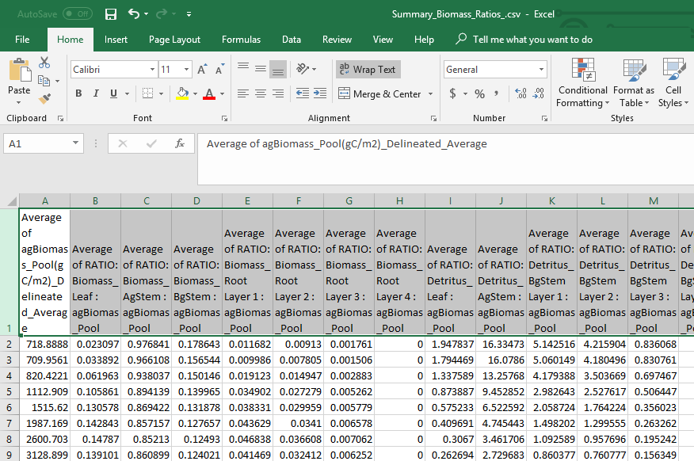

Figure 1. Summary Biomass Ratio Look up file, .csv

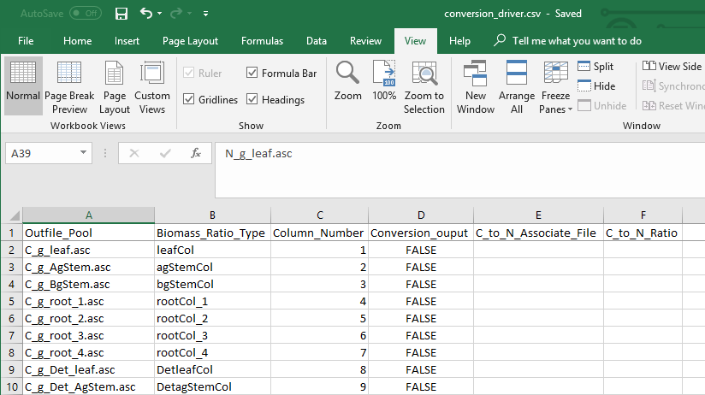

Figure 2. Conversion diver file

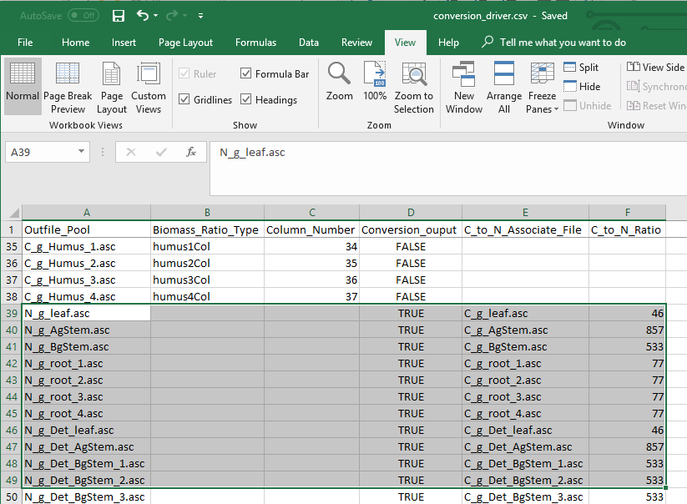

Figure 3. Conversion driver file

Processing

Conversion of biomass (g / m²) to the final spatial pools and nitrogen pools (g / m²) are made through an intermediate step of converting mass to carbon (g / m²) pools, and then using the conversion driver file, different C to N ratios for each pool are used to calculate the final nitrogen pools. Fractions (ratios) of spatial pools change both in the positive and negative direction as a forest ages or increases in total biomass. Ratio pools can increase or decrease between stand age increments, and the calculations of these intermediate biomass observational values must reflect this dynamic nature of changing ratios between time steps. Intermediate values of biomass, those that land in between time step years, were therefore linearly interpolated between the time point bounds. Spatial map ascii grid values for each of the 37 pools should then backward match ratio conversions and final C to N calculations to the original “observed” above ground biomass. (Only a partial list of pools is displayed here).

When using age maps instead of carbon biomass maps, spatial pools are created from the year and row number each cell corresponds too. If a cell is 1 year old, row 1 values would be used, while a 400-year-old cell relates to row 400.

*Example:* A mid biomass cell value at B10 = 3276 (g / m²) and is part way between stand age values at L9 and L10. It’s above ground stem carbon mass fraction increases from 0.8609 (D9) to 0.8642 (D10). So, its fraction stem mass (column D) should increase as its percentage difference moves from L9 towards LD10. Conversely, for all the other pool attributes, its percentage difference would increase as its fraction moves the opposite direction from rows 10 to rows 9.

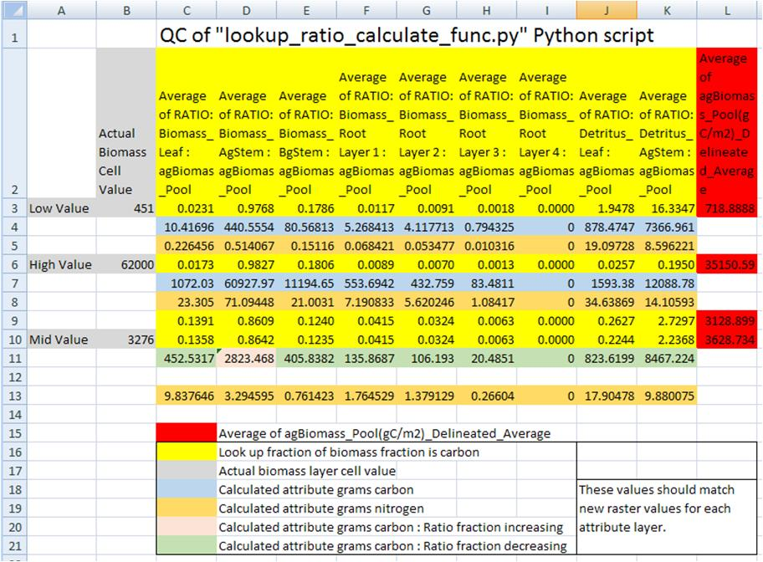

Figure 4. Quality control check of Python script’s dynamic conversions of “observed” above ground biomass (g / m²) to the final nitrogen (g / m²) spatial data pools.

The “**Spatial_Pools_CommandLine.py**” and can be run on the Command Prompt line with Python. This script requires at a minimum, one biomass or one age surface map, a ratio look up file, a conversion driver file, and one output directory name. Optionally, a minimum and maximum age or grams carbon value can be provided.   
  
Windows PowerShell Command prompt input example:   
“python C:\Path\To\Spatial_Pools_CommandLine.py -Rat C:\Temp\Chem_Pools\Summary_Biomass_Ratios_.csv -Bio C:\Temp\Chem_Pools\randomBiomass.asc -Con C:\Temp\Chem_Pools\conversion_driver.csv -Max 62000 -Min 400 -Out C:\Temp\Chem_Pools\Output”  
“python C:\Path\To\Spatial_Pools_CommandLine.py –help” for exact arguments (Figure 5).

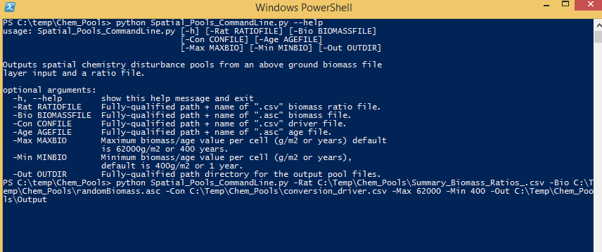

Figure 5 Window PowerShell

Note  
Processing time is very dependent on processing power and the size of your study area. For example, the Blue River, in Oregon, had a study grid of ~350,000 cells and took ~10 minutes for each of the 37 pools, for a total of 6-8 hours. The Python shell will print updates of pool processing steps, and say “All Done!” when it’s done.

* Creating a notepad text file may make coping and pasting the prompt input easier.

Scripts

# Command line for gathering info for processing and generating initial spatial pools

# 9-11-2018

# Author: Paul Pettus

# Spatial_Pools_CommandLine.py

#

import time

import csv

import os, sys, argparse

import numpy

import linecache

# Error message class

class Usage(Exception):

def __init__(self, msg):

self.msg = msg

# Main class

def main(argv=None):

if argv is None:

argv = sys.argv

try:

# Describe the tool and required aruments

parser = argparse.ArgumentParser(description='Outputs spatial chemistry disturbance pools from an'+

' above ground biomass file layer input and a ratio file.')

# Ratio file input

parser.add_argument('-Rat', action='store', dest='ratioFILE',

help='Fully-qualified path + name of ".csv" biomass ratio file.')

# Biomass ascii file input

parser.add_argument('-Bio', action='store', dest='biomassFILE',

help='Fully-qualified path + name of ".asc" biomass file.')

# Biomass ascii file input

parser.add_argument('-Con', action='store', dest='conFILE',

help='Fully-qualified path + name of ".csv" driver file.')

# Age ascii file input

parser.add_argument('-Age', action='store', dest='ageFILE',

help='Fully-qualified path + name of ".asc" age file.')

# Maximum biomass value per cell

parser.add_argument('-Max', action='store', dest='maxBio',

help='Maximum biomass/age value per cell (g/m2 or years) default is 62000g/m2 or 400 years.')

# Minimum biomass value per cell

parser.add_argument('-Min', action='store', dest='minBio',

help='Minimum biomass/age value per cell (g/m2 or years), default is 400g/m2 or 1 year.')

### Minimum biomass value per cell

## parser.add_argument('-Min', action='store', metavar='minBio',

## type=int,

## help='Minimum biomass/age value per cell (g/m2 or years), default is 400g/m2 or 1 year.')

# Output dir for spatial chemistry pools

parser.add_argument('-Out', action='store', dest='outDIR',

help='Fully-qualified path directory for the output pool files.')

args = parser.parse_args()

# args parsing

if args.ratioFILE == None:

ratioFile = args.ratioFILE

else:

ratioFile = str(os.path.abspath(args.ratioFILE))

if args.biomassFILE == None:

biomassFile = args.biomassFILE

else:

biomassFile = str(os.path.abspath(args.biomassFILE))

if args.conFILE == None:

conFile = args.conFILE

else:

conFile = str(os.path.abspath(args.conFILE))

if args.ageFILE == None:

ageFile = args.ageFILE

else:

ageFile = str(os.path.abspath(args.ageFILE))

outDir = str(os.path.abspath(args.outDIR)) + "\\"

if args.minBio == None:

minValArg = args.minBio

else:

minValArg = int(args.minBio)

if args.maxBio == None:

maxValArg = args.maxBio

else:

maxValArg = int(args.maxBio)

# Print all input arguments

print('\n' + '\n' + "Echo inputs" + '\n')

## print(args)

## print('\n')

print(outDir, ratioFile, biomassFile, conFile, ageFile, minValArg, maxValArg)

# do the work function

buildRatios(outDir, ratioFile, biomassFile, conFile, ageFile, minValArg, maxValArg)

except Usage as e:

print(e.msg)

return 2

except Exception as e:

# STUB exception handler

# Warning: poor programming style.

# Catches almost any exception (but not KeyboardInterrupt -- which is a Good Thing)

raise e

## Return an numpy array from an ascii raster

def ascii2array(asciifn):

#### GDAL version

## dsAscii = gdal.Open(asciifn,gdalconst.GA_ReadOnly)

## cols = dsAscii.RasterXSize

## rows = dsAscii.RasterYSize

## bands = dsAscii.RasterCount

## band = dsAscii.GetRasterBand(1)

array = numpy.loadtxt(asciifn, skiprows=6, dtype= numpy.float32)

return array

## Return and ascii raster file from an numpy array, output file name

## (optional inputs are an alternative ascii area of interest and or

## an optional header text: these are not used in the script

def array2ascii(array, asciiOutfn, asciiaoi = None, headerList = None):

# set up header text for the output ascii raster

if asciiaoi == None:

## for i in headerList:

header = headerList

else:

header = linecache.getline(asciiaoi,1)

header += linecache.getline(asciiaoi,2)

header += linecache.getline(asciiaoi,3)

header += linecache.getline(asciiaoi,4)

header += linecache.getline(asciiaoi,5)

header += linecache.getline(asciiaoi,6)

# open the output file and write the header text and numpy array

# and save the output file

f = open(asciiOutfn, "w")

f.write(header)

numpy.savetxt(f, array, fmt="%f")

f.close()

## return the header information of an ascii raster

def readHeader(asciiFile):

# return error if the ascii is not found

if not os.path.exists(asciiFile):

raise Usage('Cannot find ASCII "' + asciiFile + '"')

# Open file and read in header info

readFile = open(asciiFile)

header = readFile.readline() #ncols

header += readFile.readline() #nrows

header += readFile.readline() #xllcorner

header += readFile.readline() #yllcorner

header += readFile.readline() #cellsize

header += readFile.readline() #NODATA_value

readFile.close()

return header

# Do the work class, build the ratio files

def buildRatios(finalPoolDir, ratioFile, biomassFile, conFile, ageFile, minValArg, maxValArg):

##################################################################################

# Start preprocess code block

##################################################################################

# return error if the ratio file is not found

if not os.path.exists(ratioFile):

raise Usage('Cannot find ratio file "' + ratioFile + '"')

# return error if both the age or biomass asciis are arguments

if ageFile != None and biomassFile != None:

print(ageFile)

print(biomassFile)

raise Usage('Please choose either a biomass or an age ASCII raster, not both.')

# return error if the age or biomass ascii is not found

if ageFile == None:

# return error if the biomass ascii is not found

print("Calculating chemistry pool rasters from biomass raster."+ '\n')

## print("hello")

## print(biomassFile)

if not os.path.exists(biomassFile):

raise Usage('Cannot find biomass ASCII "' + biomassFile + '\n')

else:

print("Calculating chemistry pool rasters from age raster."+ '\n')

if not os.path.exists(ageFile):

raise Usage('Cannot find age ASCII "' + ageFile + '"')

## # return error if the biomass ascii is not found

## if not os.path.exists(biomassFile):

## raise Usage('Cannot find conversion driver file "' + conFile + '"')

# create the output dir if it doesn't exist

if not os.path.exists(os.path.dirname(finalPoolDir)):

print("Final outpur dir not found, creating it."+ '\n')

# Safety bachslash to slash replacement

finalPoolDir.replace("\\",'/')

os.makedirs(os.path.dirname(finalPoolDir))

# Set maximum and minimum biomass value

if biomassFile != None:

print(biomassFile)

# Set default maximum and minimum biomass value

if maxValArg == None:

maxValue = 62000

else:

maxValue = maxValArg

if minValArg == None:

minValue = 400

else:

minValue = minValArg

# Set maximum and minimum age value

if ageFile != None:

# Set default maximum and minimum age value

if maxValArg == None:

maxValue = 400

else:

maxValue = maxValArg

if minValArg == None:

minValue = 0

else:

minValue = minValArg

# Check to that maxValue isn't larger than length of ratio lookup

ratioLookupArray = numpy.genfromtxt(ratioFile,skip_header=1, dtype=float, delimiter=',')

rCount, cCount = ratioLookupArray.shape

if int(maxValue) > int(rCount):

raise Usage('Max age is larger than ratio file rows ' + str(rCount))

print(maxValue)

print(minValue)

# numpy method to read .csv to array

ratioLookupArray = numpy.genfromtxt(ratioFile,skip_header=1, dtype=float, delimiter=',')

# Read biomass or age raster to array

if ageFile != None:

# Read age raster to array

ageArray = ascii2array(ageFile)

# get the ascii raster header information

buildRatios.header = readHeader(ageFile)

else:

# Read biomass to array

biomassArray = ascii2array(biomassFile)

# get the ascii raster header information

buildRatios.header = readHeader(biomassFile)

# read through ratio conversion driver file

datafile = open(conFile, 'r')

next(datafile,None)

myreader = csv.reader(datafile)

# create ratio conversion to a list

driverList = list(myreader)

# close file

datafile.close()

##################################################################################

# End preprocess code block

##################################################################################

##################################################################################

# Start functions block

##################################################################################

# Function: Returns grams of carbon for the upper and lower most

# biomass lookup cells. These two cells do not need to dynamically

# calculated.

# Inputs:

# upval = the lookup ratio

# cellmass = biomass cell value

# Output:

# gramsC = grams of carbon

def calLowHighper(upval,cellmass):

gramsC = upval*cellmass

return gramsC

# Function: Dynamically returns grams of carbon from the larger and smaller

# biomass lookup cells. Creates fraction difference between a larger

# and smaller biomass value in the biomass lookup table, then applies that

# fraction value difference to the lookup attribute.

# Inputs:

# smallMass = smaller biomass from the velma attribute array

# largeMass = larger biomass from the velma attribute array

# upval = the lookup ratio that corresponds to the largeMass value

# lowval= the lookup ratio that corresponds to the smallMass value

# cellmass = biomass cell value

# Output:

# gramsC = grams of carbon

# Variables:

# difmass = difference bewteen the large and small biomass

# permass = fraction of cellmass that is over the smallMass

# difval = difference between upval and lowval

# deltaRatioValue = corresponding fraction of the lookup value

# newValue = the correct ratio of the the lookup value

# gramsC = grams of carbon

def calMidper(upval,lowval,largeMass,smallMass,cellmass):

difmass = (largeMass-smallMass)

permass = (cellmass-smallMass)/difmass

difval = (upval-lowval)

# If the difval is negative then lowval is larger than upval.

if difval < 0:

difval = (lowval-upval)

deltaRatioValue = permass*difval

newValue = (lowval-deltaRatioValue)

gramsC = cellmass*newValue

return gramsC

elif difval == 0:

gramsC = cellmass*upval

return gramsC

# Else: upval is larger than lowval

else:

deltaRatioValue = permass*difval

newValue = deltaRatioValue+lowval

gramsC = cellmass*newValue

return gramsC

# Function: For each cell in biomass raster, lookup its biomass in the biomass ratio lookup

# table and calculate a new grams of carbon value. Returns an array that can be turned back

# into a new raster for any inputed velma attribute.

# Inputs:

# biomassArray = input biomass array, from biomass raster

# ratioLookupArray = input biomass lookup array, attribute table

# column = column number of the attribute of interest

# Output:

# outArray = array with corresponding values of attribute calculated from biomass

# Variables:

# i = current row of biomass array

# j = current column of biomass array, from biomass raster

# row = current row of biomass lookup array, attribute table

# rowPlus = one row ahead of item or current row

# cellValue = value of the current cell in the biomass array, from biomass raster

# returnCell = grams of carbon returned from function call

def biomassConverter(biomassArray,ratioLookupArray,column,maxValue,minValue):

#creates numpy array with zeros numpy.zeros()

#array is the same size as biomass raster array

rowArraySize, colArraySize = biomassArray.shape

# create empty output array

outArray = numpy.zeros( (rowArraySize,colArraySize) )

rowRatioArray, colRatioArray = ratioLookupArray.shape

# Loop through all the biomass raster values

for i in xrange(rowArraySize):

for j in xrange(colArraySize):

# Loop through all of the biomass values in the lookup chem ratios

for row in xrange(rowRatioArray):

# index for the next row

rowPlus = row + 1

cellValue = float(biomassArray[i,j])

# Makes sure no cell value is over the maximum biomass allowed

if cellValue > maxValue:

cellValue = float(maxValue)

# Make sure no cell value is under the minimum biomass allowed

if cellValue < minValue:

cellValue = float(minValue)

# Breaks loop if first element is in lookup chem ratios

if cellValue <= ratioLookupArray[row,0]:

returnCell = calLowHighper(ratioLookupArray[row,column],cellValue)

outArray[i,j] = returnCell

break

# Breaks loop if last element in lookup chem ratios

if row == (rowRatioArray-1):

returnCell = calLowHighper(ratioLookupArray[row,column],cellValue)

outArray[i,j] = returnCell

break

# Looks to see if the biomass cellvalue is inbetween the current lookup chem ratio

# item and the next row lookup item

if cellValue > ratioLookupArray[row,0] and cellValue <= ratioLookupArray[rowPlus,0]:

# Return value that is between the two lookup chem ratio rows

returnCell = calMidper(ratioLookupArray[rowPlus,column],ratioLookupArray[row,column],

ratioLookupArray[rowPlus,0],ratioLookupArray[row,0],cellValue)

outArray[i,j] = returnCell

# Return the chem pool array

return outArray

#creates numpy array with zeros numpy.zeros()

#array is the same size as biomass raster array

def ageConverter(ageArray,ratioLookupArray,column,maxValue,minValue):

clockStartBiomass = time.clock()

rowArraySize, colArraySize = ageArray.shape

outArray=numpy.zeros( (rowArraySize,colArraySize) )

for i in xrange(rowArraySize):

for j in xrange(colArraySize):

yearRow = int(ageArray[i,j])

# Change to the year to a max of 400 yo

if yearRow > maxValue:

yearRow = maxValue

if yearRow < minValue:

yearRow = minValue

# the row number in the lookup ratio file corisponds to age (yr)

biomassValue = ratioLookupArray[yearRow,0]

ratioValue = ratioLookupArray[yearRow,column]

cellValue = biomassValue * ratioValue

outArray[i,j] = cellValue

return outArray

##################################################################################

# End functions block

##################################################################################

print("Starting the 37 Biomass Ratio convertions!"+'\n')

##################################################################################

# Processing block code

##################################################################################

# Loop once through the driver list to create the carbon ratio ascii rasters first

for i in driverList:

# Get output file name

outName = i[0]

# Get column name, Unused

colName = i[1]

# Get ratio column number, check that it is not empty first

# biomass ratio file column number associated with the attribute.

# Empty sets are nitrogen conversion completed next step

if i[2] != '':

ratioCol = int(i[2])

# Get conversion boolean, FALSE equals file is not a ratio conversion

conversionOut = i[3]

# Function call to calculate each of the attributes and create

# a raster from the returned array

if conversionOut == 'FALSE':

# start time clock

clockStartBiomass = time.clock()

if ageFile != None:

# For each ratio attribute column determin the ratio of biomass

# associated with that particular chemestry pool and return an

# array used to create chem pool raster

ratioArray = ageConverter(ageArray,ratioLookupArray,ratioCol,maxValue,minValue)

else:

# For each ratio attribute column determin the ratio of biomass

# associated with that particular chemestry pool and return an

# array used to create chem pool raster

ratioArray = biomassConverter(biomassArray,ratioLookupArray,ratioCol,maxValue,minValue)

# Concatinate output dir with output file name

outName = finalPoolDir + outName

# Create the chem pool raster

array2ascii(ratioArray, outName, asciiaoi = None, headerList = buildRatios.header)

# end time clock

clockFinishBiomass = time.clock()

biomassTime = round((clockFinishBiomass-clockStartBiomass)/60,2)

print("Completed: " + outName + " in " + str(biomassTime)+" minutes!"+'\n')

print("Starting the C to N convertions!" + '\n')

# Second time through the driver list to complete nitrogen ratios last

# Create Nitrogen grams per square meter from carbon layers

# Values are carbon to nitrogen ratios from Bob ratio chem file

for i in driverList:

# Get output file name

outName = i[0]

# Get conversion boolean, TRUE equals file is a nitrogen ratio conversion

conversionOut = i[3]

# Carbon filename associated with the nitrogen ratio conversion

cToNassociateFile = i[4]

# Get ratio conversion, check that it is not empty first.

# Empty set are files that don't have a conversion n to c ratio

if i[5] != '':

cToNratio = float(i[5])

if conversionOut == 'TRUE':

# start time clock

clockStartBiomass = time.clock()

# Concatinate output dir with input file name

associateFile = finalPoolDir + cToNassociateFile

# Get array from ascii raster values from associate carbon raster

associateArray = ascii2array(associateFile)

# Create the associated c to n array chemestry pool and return an

# array used to create chem pool raster

ratioArray = numpy.divide(associateArray,cToNratio)

# Concatinate output dir with output file name

outName = finalPoolDir + outName

# Create the chem pool raster

array2ascii(ratioArray, outName, asciiaoi = None, headerList = buildRatios.header)

# end time clock

clockFinishBiomass = time.clock()

biomassTime = round((clockFinishBiomass-clockStartBiomass)/60,2)

print("Completed: " + outName + " in " + str(biomassTime)+" minutes!"+'\n')

print("Done!"+'\n')

##################################################################################

# End Processing block

##################################################################################

if __name__ == "__main__":

sys.exit(main())

# D.5 | Create Land-zoning Maps for a VELMA Application

#### **Overview** (Tutorial D.5 – Create Land-zoning VELMA Input Data)

This document describes how to set up a land-zoning map, which includes the same integer code for all pixels in a particular zone. Once a land-zoning map is established, a VELMA user can apply a disturbance (harvest, fertilization, etc.) to a specified zone. Land-zoning maps can be used to define boundaries for land management units, land ownership, cover types, and so on.

Note: Detailed instructions for setting up and applying disturbances to land-zoning maps are provided in section 24.0 in the VELMA 2.0 User Manual (<https://www.epa.gov/water-research/visualizing-ecosystem-land-management-assessments-velma-model-20>).

*The DEM file is the “master” layer for a simulation run: all other spatially-explicit data is assumed to have the same row, column, cell size and x, y offset values as the DEM file. Spatial data is nearly always input from files in ESRI Grid ASCII format (.asc), therefor all spatial data inputs including the Land-zoning maps must match the DEM file (.asc.).*

Shapefile Conversions

Forest practices, land ownership, and other land parcel maps are typical packaged as shapefiles in various State projections and need to be converted into VELAM compatible spatial inputs.

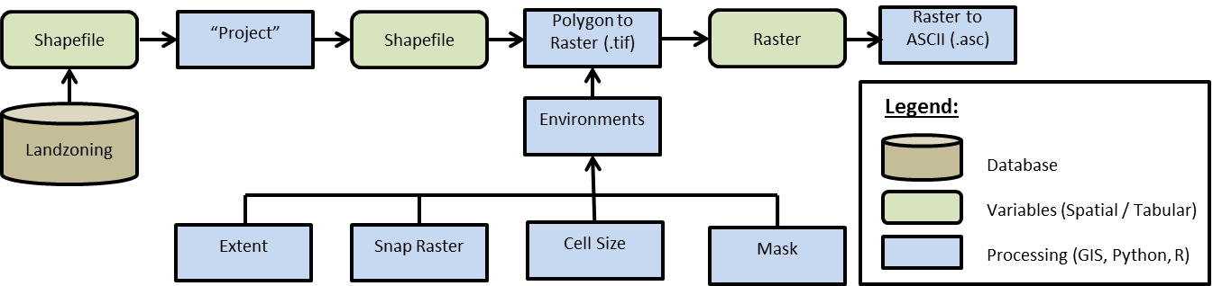

Figure 1 GIS Processing

Using a common GIS package such as ArcMap the process flow would be as follows (figure 1):

1. Initial data acquisition from a database -> Shapefile
2. Reproject the Shapefile to match the VELAM DEM projection.
   * “Project” Data Management
3. Convert the Shapeflie to Raster.
   * “Polygon to Raster” (.tif) Conversion
   * While using the “Polygon to Raster” tool the user must define the “Environments settings” to ensure correct extent, cell size, and snapping to the DEM.
     + “Processing Extent”
       1. “Extent” -> to match DEM file
       2. “Snap Raster” -> to match DEM file
     + “Raster Analysis”
       1. “Cell Size” -> to match DEM file
       2. “Mask” -> to match DEM file
4. Convert Raster to ASCII
   * “ASCII to Raster” (.asc)

GIS Examples

JPDEM Delineation of the 209 km2 Mashel River Watershed, WA.

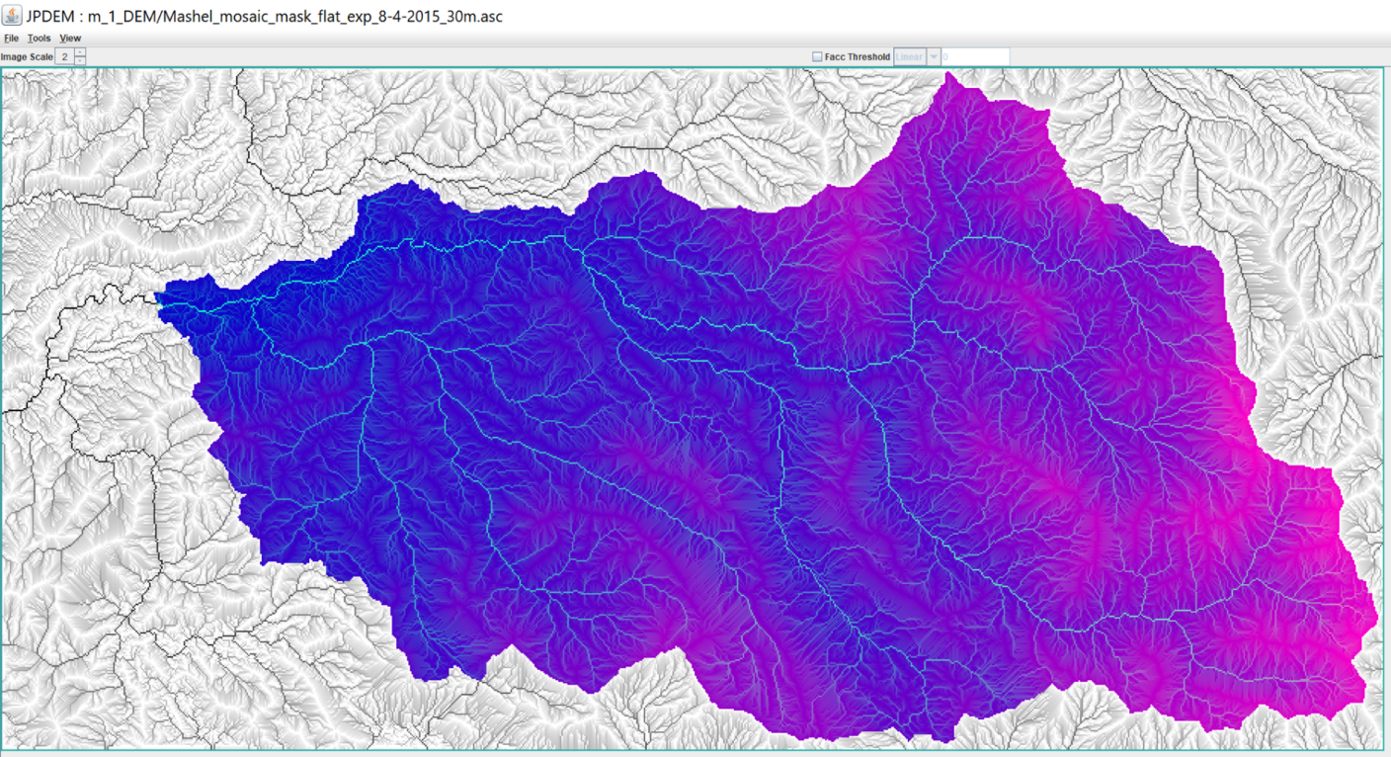

(continued)

Hill-shade view of 4 km2 Busy Wild Creek subwatershed (red) within Mashel River Watershed (209 km2)

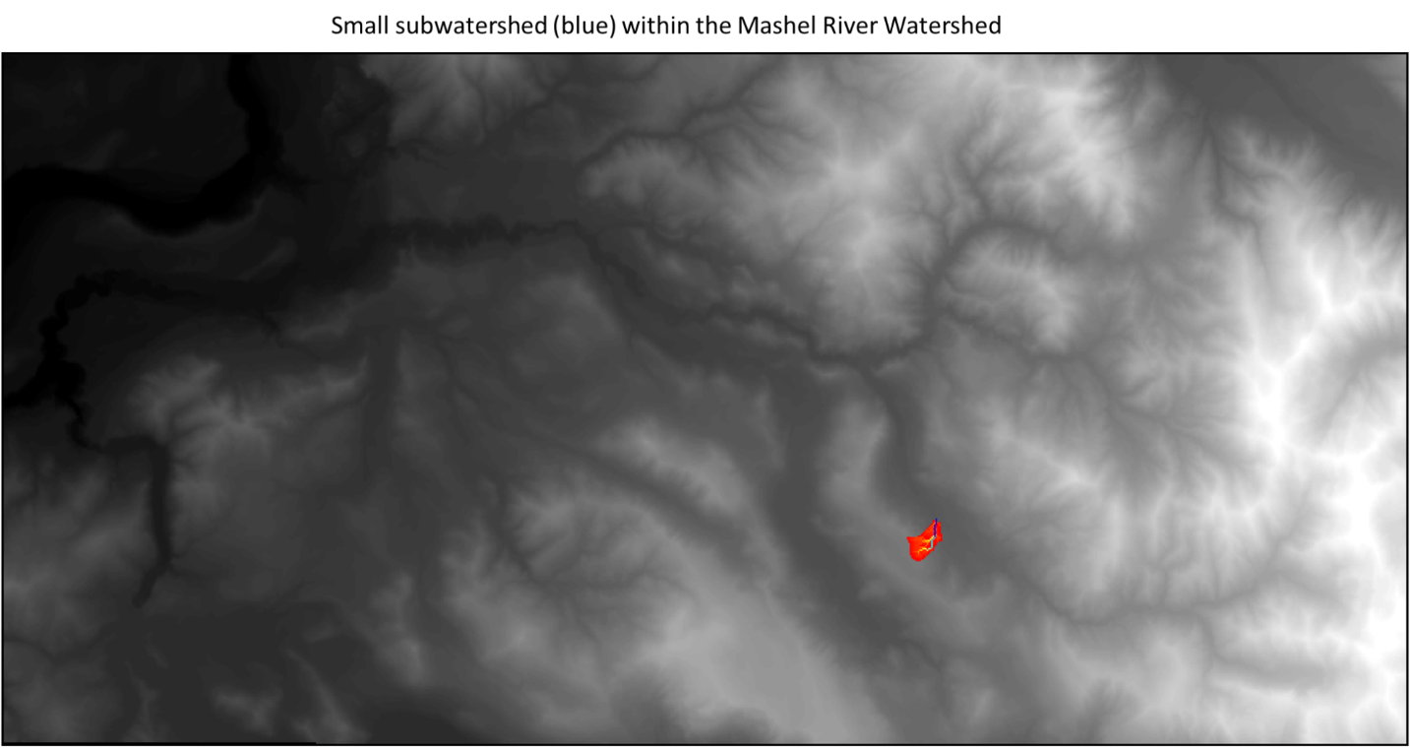

Flow-path view of 4 km2 Busy Wild Creek subwatershed (blue) within Mashel River Watershed (209 km2)

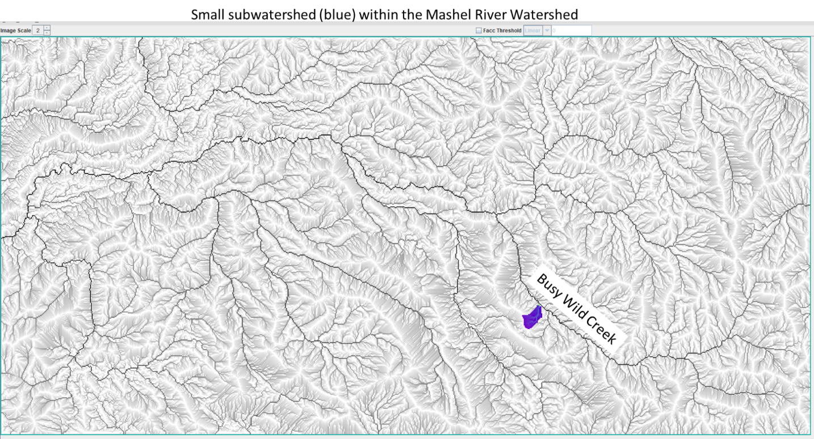

Zoomed-in view of the 4 km2 Busy Wild Creek subwatershed shown on page 5.

This view shows individual 30-meter pixels with coloration indicating flow path

intensity (blue = highest flow; red = lowest flow).

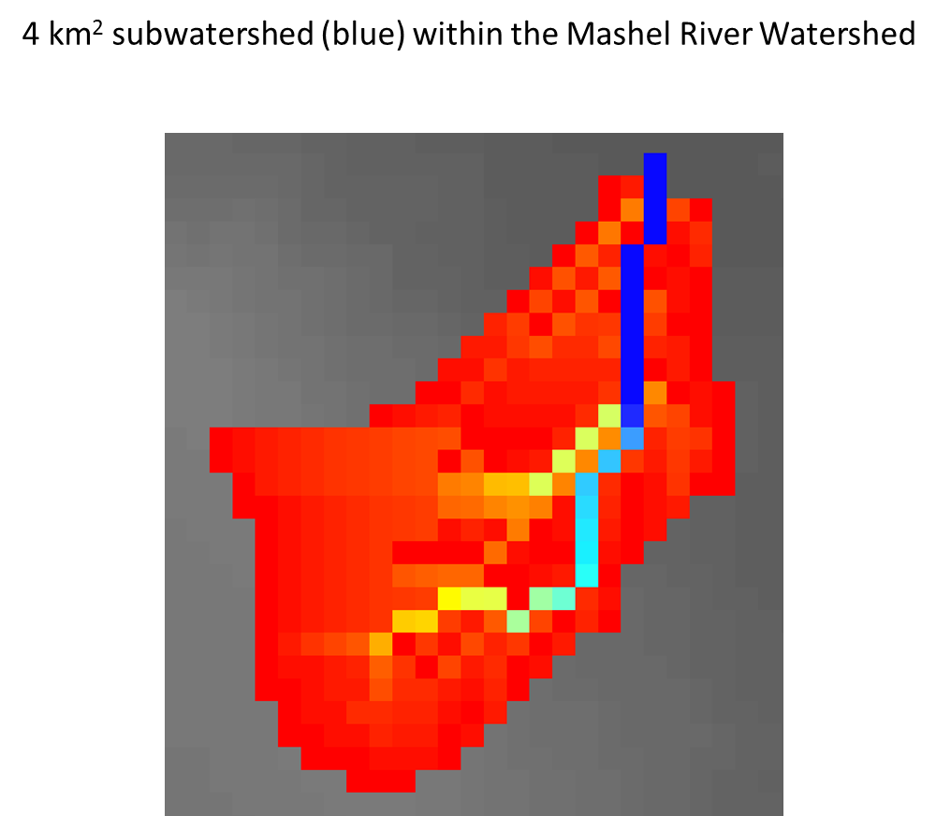

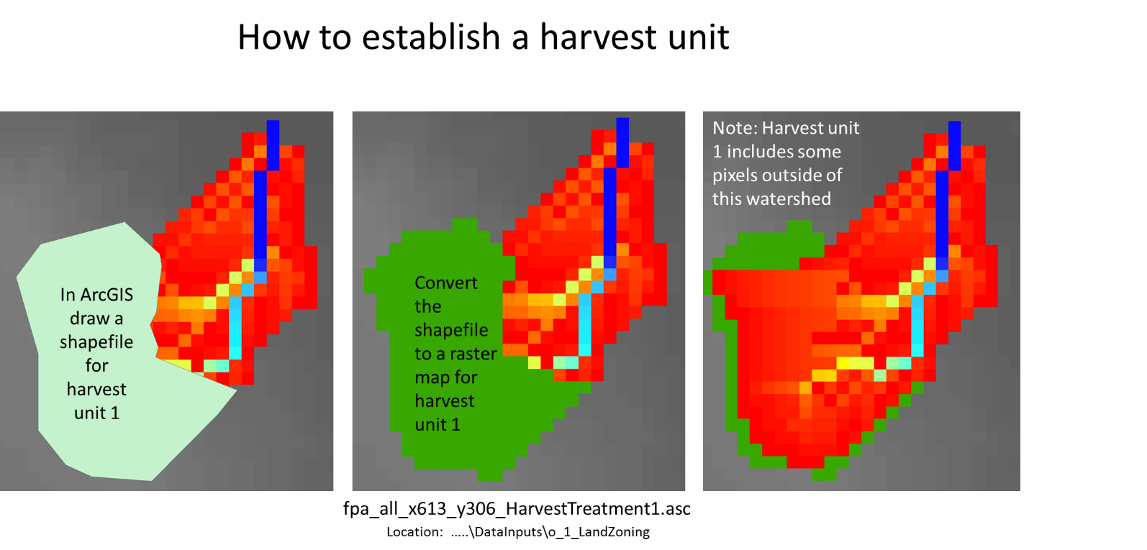

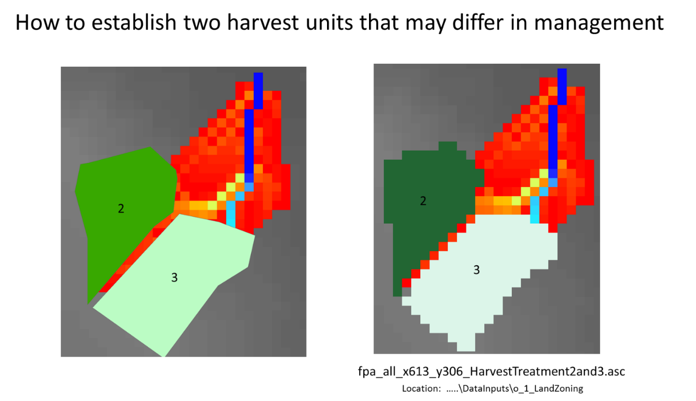

**To apply a forest harvest or other disturbance to these units**, the VELMA user will need to assign a single, unique value to each unit. For this example, all pixels falling within map unit 2 would need to be labeled 2, and all pixels in map unit 3 would need to be labeled 3. Separate disturbances could then be designed for each unit, for example, unit 2 = clearcut; unit 3 = 50% thinning.

**For details on how to set up and apply disturbances, see Section 24, page 102, of the VELMA Version 2.0 User Manual** *(McKane, R.; Brookes, A.; Djang, K.; Stieglitz, M.; Abdelnour, A.; Pan, F.; Halama, J.; Pettus, P.; Phillips, D. 2014. Velma User Manual and Technical Documentation. U.S. Environmental Protection Agency Office of Research and Development National Health and Environmental Effects Research Laboratory: Corvallis, OR, USA. Link:* [*https://www.epa.gov/water-research/visualizing-ecosystem-land-management-assessments-velma-model-20*](https://www.epa.gov/water-research/visualizing-ecosystem-land-management-assessments-velma-model-20)

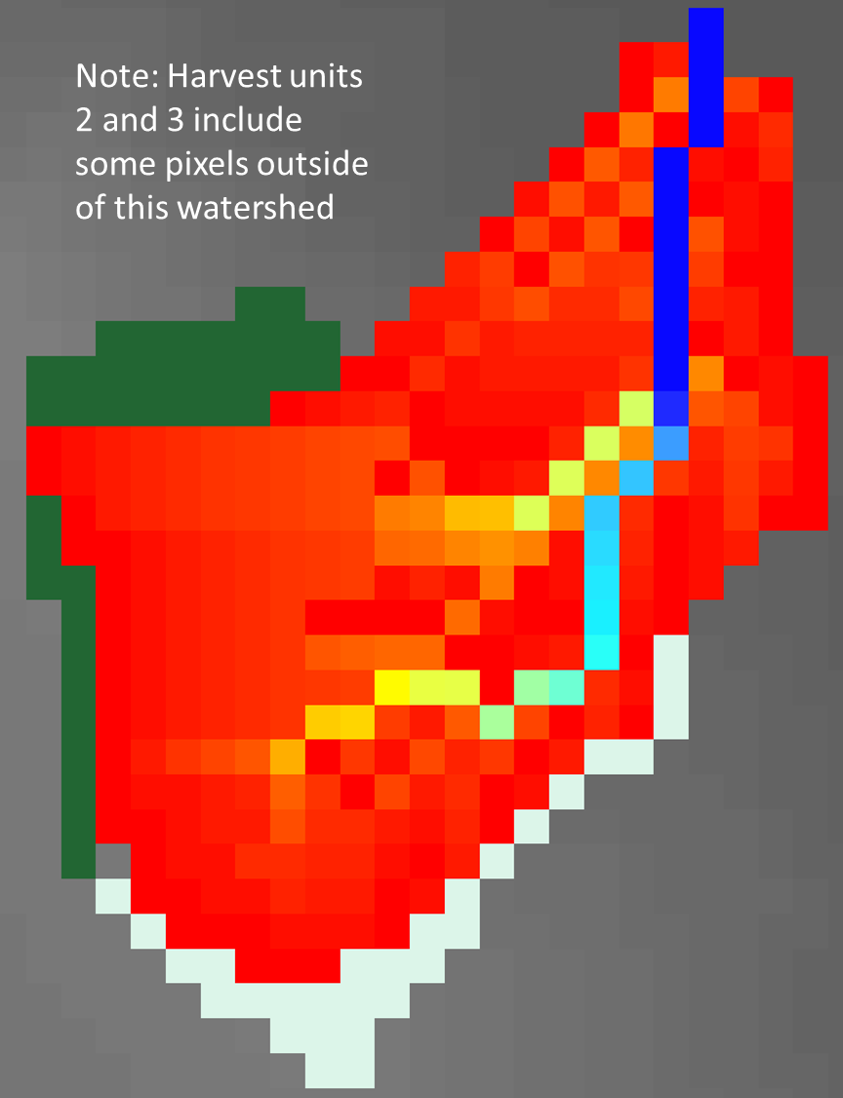

# D.6 | Add Georeferenced Projection Information to VELMA Output ASCII Maps

#### **Overview** (Tutorial D.6 – Add Georeferenced Projection Info to VELMA Output ASCII Maps)

This document describes how to add georeferenced projection information to VELMA’s spatial output files so that the outputs can be correctly displayed in space with reference to other geospatial data.

Very important when using ArcGIS, VISTAS or other visualization software to compare VELMA outputs with other geospatial data.

Note: Instructions for creating VELMA spatial output files can be found in section “23.0 – Spatial Data Items” in the VELMA 2.0 User Manual (<https://www.epa.gov/water-research/visualizing-ecosystem-land-management-assessments-velma-model-20>).

VELMA output maps are by default produced without adjoining projection files. This script will create the corresponding projection information for each output map so that the user can properly geolocate the ASCII maps in a GIS software, such as ArcGIS or QGIS. The user will have to create or provide a single projection file from which all other maps will be referenced to.

Software Requirements and Processing

To run and produce the adjoining projection files for a set of VELMA ASCII map outputs you will need the following:

1. Python version 2.x: Current release is 2.7.12
   1. Python comes pre-packaged within ArcGIS and QGIS, so it is likely you already have it installed on your computer. For example, a default install is currently here: C:\Python27\ArcGIS10.2\python.exe. Check to see if you have Python installed before installing a new version. If Python is not installed, you can obtain a copy here: <https://www.python.org/download/releases/2.7/> *Note that Python 2.7 is currently considered safe for use on U.S. EPA network and non-network computers.*
2. ASCII Maps requirements: VELMA ASCII raster outputs.
3. A single projection (.prj) file that matches the projection of raster outputs.
4. “**Add_Projection.py**” and can be run with Command Prompt line with Python.

Command prompt input example:   
“python Add_Projection.py -FOLDER C:\Temp\Test -PRJ mypojectionFile.prj”  
“python Add_Projection.py -–help” for exact arguments (Figure 1).

(continued)

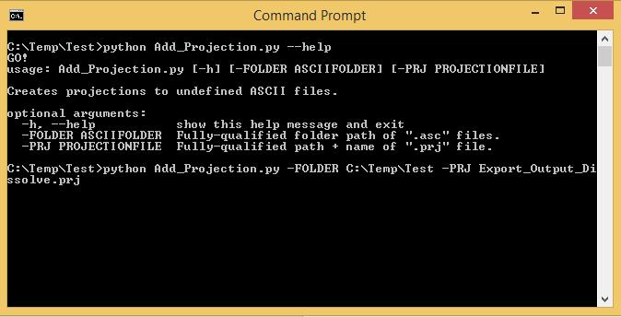

Figure 1. Command line example of running the projection adding script.

Scripts

# Add_Projection.py

# Author: Paul Pettus

# Date: 5-1-2017

# Description: Adds projections to raw ASCII VELMA file outputs

#

# VELMA Output files are created without projection. This script creates

# projections for those output files from a single projection file.

#

# Last updated: 5-2-2017

import os, sys, argparse

# ------------------------------------------------------------------------------------------------

# Error message class

class Usage(Exception):

def __init__(self, msg):

self.msg = msg

def main(argv=None):

if argv is None:

argv = sys.argv

try:

print("GO!")

parser = argparse.ArgumentParser(description='Creates projections to undefined ASCII files.'

)

parser.add_argument('-FOLDER', dest='asciiFolder',

help='Fully-qualified folder path of ".asc" files.')

parser.add_argument('-PRJ', dest='projectionFile',

help='Fully-qualified path + name of ".prj" file.')

args = parser.parse_args()

# args parsing

prjFile = os.path.abspath(args.projectionFile)

inFolder = os.path.abspath(args.asciiFolder)

print (prjFile)

print (inFolder)

# do the work

addProjections(prjFile, inFolder)

except Usage as e:

print(e.msg)

return 2

except Exception as e:

# STUB exception handler

# Warning: poor programming style.

# Catches almost any exception (but not KeyboardInterrupt -- which is a Good Thing)

raise e

def addProjections(prjFile, inFolder):

# Check that projection file exists

if not os.path.exists(prjFile):

raise Usage('Cannot find projection file "' + prjFile + '"')

# Check that ASCII folder exists

if not os.path.exists(inFolder):

raise Usage('Cannot find folder "' + inFolder + '"')

print ("Starting projection definitions.")

# read in projection file text

prjF = open(prjFile,'r')

prjText = prjF.readlines()

prjF.close()

# read in ASCII files

asciiList = []

for files in os.listdir(inFolder):

if files.endswith(".asc"):

print(files)

asciiList.append(files)

# Loop through files and create new projections

for files in asciiList:

fileName, fileExtension = os.path.splitext(files)

outFile = fileName + ".prj"

print(outFile)

f = open(outFile, "w")

for item in prjText:

f.write(item)

f.close()

print("Done!")

if __name__ == "__main__":

sys.exit(main())

# D.7a | Create Multiple-Location Weather Drivers – Alternate Methods Using Pseudo Weather Stations

#### Overview (Tutorial D.7a – Create Multiple-Location Weather Drivers)

Daily temperature and precipitation data for multiple weather stations can help VELMA to more accurately simulate climatic effects on streamflow and ecosystem dynamics. However, weather stations are often not optimally located or in sufficient density to support accurate model predictions.

This document describes how to add and locate pseudo-climate stations to a VELMA simulation, based upon daily climate data grids produced by sophisticated national climate models such as PRISM and Daymet. The added pseudo-stations can greatly improve VELMA’s interpolation of climate drivers across the landscape, thereby improving model performance.

The Multiple-Location Weather Model Configuration requires multiple observed weather stations data within the area of interest (AOI), and these data are not always available for the AOI. Alternatively, “station” driver data can be provided to VELMA from other forms of spatially derived daily precipitation and air temperature values for cells in a simulation’s delineated AOI. Unlike actual observed weather station data, these pseudo-station climate data are developed from sophisticated spatial climate models’ datasets such as PRISM (PRISM, 2013) or Daily Gridded Weather Data (Daymet). Both data sets are publicly available daily national climate data, gridded at 1 km x 1 km spatial resolution for Daymet, compared to the 4 km x 4 km resolution data from PRISM. Daily gridded data can be extracted as input climate driver data for a VELMA simulation, by probing latitude and longitude positions for single or multiple locations within an AOI. (Figure 1.)

(continued)

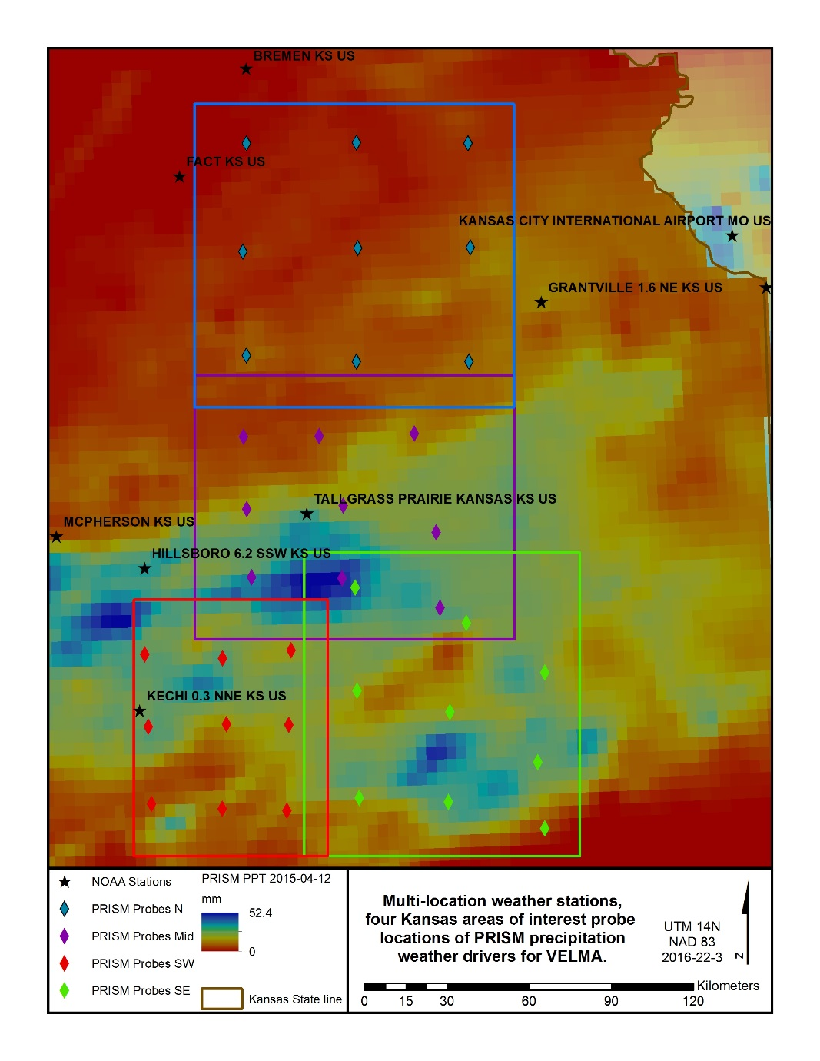

Figure 1 Pseudo weather station example, Flint hills Kansas.

Example Procedure –PRISM, Daymet, or, Observed?

Multiple weather station driver data allows VELMA to more dynamically apply spatially explicit climate drivers to a simulation. For a series of AOI’s in the Kansas’s Flint hills, there are publicly available NOAA observed weather station data that reside across the study region (Figure1). Only two of the simulated AOI’s has a single observation station that resides with its study area, while many observation stations are nearby but are outside these study areas. In this example, many of these NOAA stations had missing data for either precipitation or air temperature, as well as being located out of the AOI’s. Pseudo stations or probes of modeled climate data can, in some effect, cover the spatial dynamic of the daily climate by nearest neighbor assignment to probe station. In these study areas, nine stations were created for each AOI to fit Multi-station data from a combination of PRISM and Daymet daily modeled precipitation and air temperature data (Appendix).

In the Kansas example, the simulation was ran for the years 1998 – 2015. Higher resolution Daymet data was available for the years 1998 – 2014. While PRISM data was available for the year 2015. No continuous data were observed by NOAA in the AOI’s. Daymet data was then supplemented with PRISM data for the missing years, and formatted as required by the “Multiple-Location Weather Configuration” (Figure 2) (Appendix).

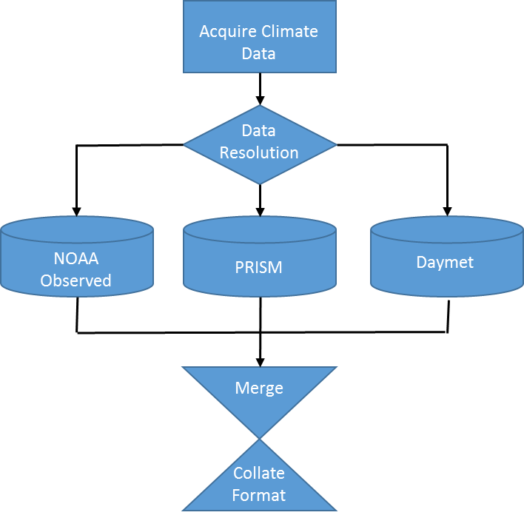

Figure 2 Process flow for multi-station climate data.

Within VELMA there are two choices for the Multi-Location models, “Multiple-Location Weather Model” and “Multiple-Weighted-Locations Weather Model” (Figure 3).

(continued)

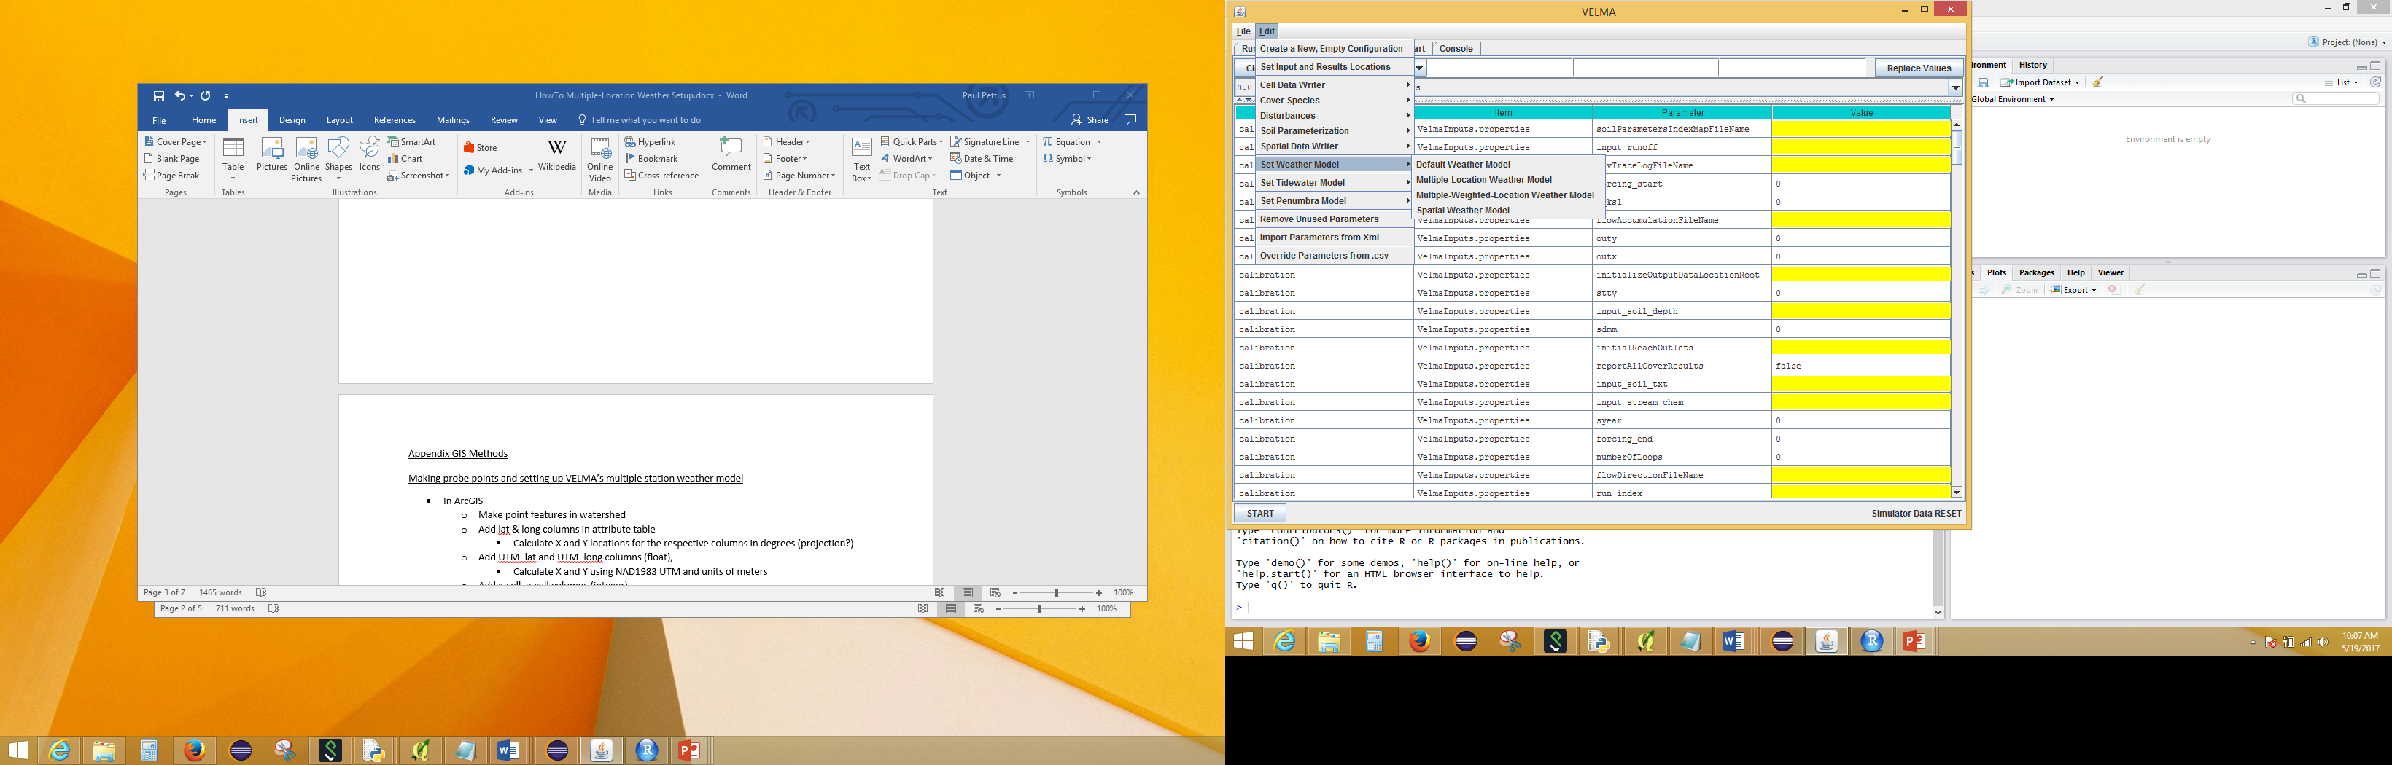

Figure 3 Multi-Location Weather Model options with in VELMA simulator.

(continued)

Multiple-Location Weather Model

The “Multiple-Location Weather Model” creates Thiessen Polygons around each of the probe stations Figure 4). This is a very common method used in hydrometeorology for creating a weighted mean from multiple measurement spots in a watershed area.

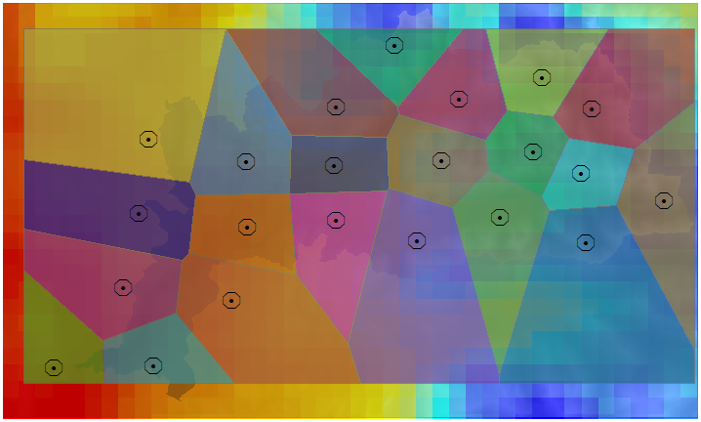

Figure 4 Thiessen Polygons around pseudo station probes.

(continued)

Multiple-Weighted-Locations Weather Model

The second method “Multiple-Weighted-Locations Weather Model” is a nonlinear interpolation or inverse distance weighting technique. The weight a sample point assigns to the averaging calculation value to a cell is based on its distance or closeness it is to the cell. This weighting creates a moving surface, based on inverse distance squared relationship instead of simple inverse (Figure 5).

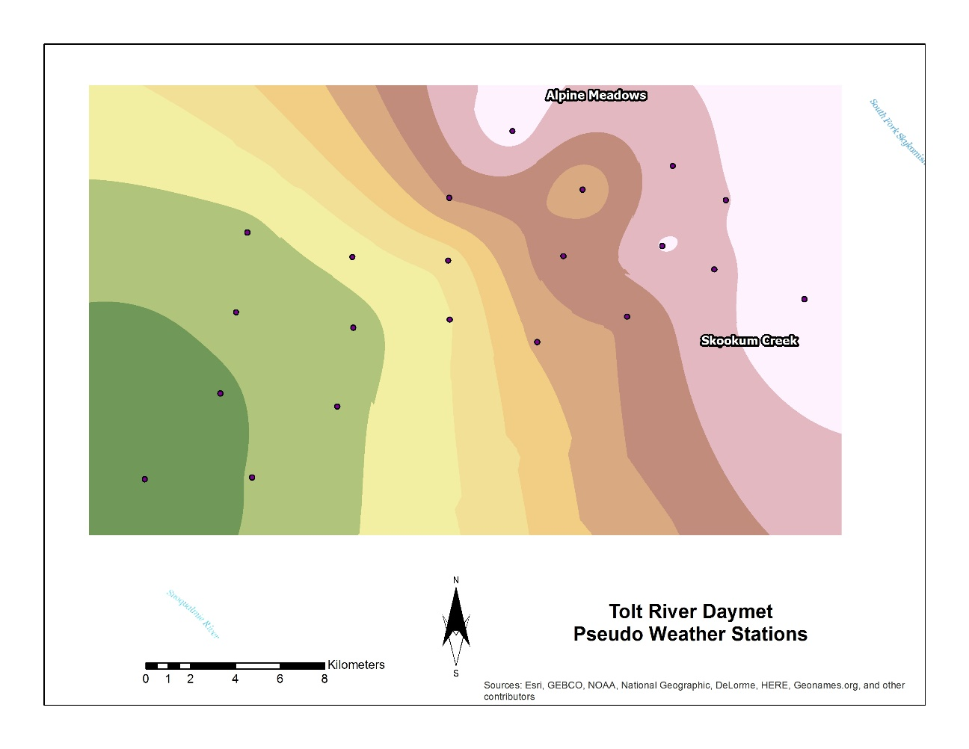

Figure 5 Inverse distance weighted influence of pseudo weather station.

***You Must Provide the Weather Model with Location and Driver Data for One or More Weather Locations***

The Multiple-Location Weather Model needs the location and driver data file name for each “Weather Location” it will use. A “Weather location” is simply the x and y coordinates of a cell within the bounds of the DEM grid specified for the simulation configuration, plus a file of daily driver values that specifies the precipitation and air temperature at that cell.

The value for the weatherLocationDataFileName parameter must be the name (or fully-qualified path + name) of a comma-separated (.csv) file with one or more rows. Each row specifies the location and driver data for a specific cell and has the following field layout:

x-coordinate, y-coordinate, uniqueName, driverFileName

The x-coordinate and y-coordinate must specify a location within the bounds of the simulation configuration’s DEM grid. (I.e. they must be in the ranges [0, (ncol – 1)] and [0, (nrow – 1)] respectively.  
(Recall that ncol and nrow are the DEM grid’s number-of-columns and number-of-rows values – and they must be set to match the ncols and nrows values of the DEM grid’s input_dem (.asc) file.)

As with the weatherLocationDataFileName, the driverFileName may be either a fully-qualified path + name, or simply a file name. In both cases, when presented with a file name without a path, the VELMA simulation engine’s initialization code will assume the file is located in the directory specified by the inputDataLocationRootName/inputDataLocationDirName path.

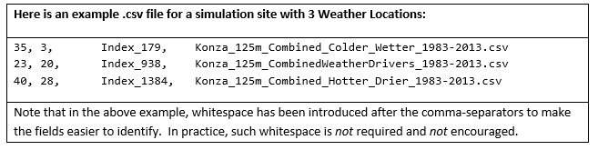

Note: Currently, the weatherLocationDataFileName file **cannot** contain a header row.

***You Must Provide a Driver Data .csv File Corresponding to Each driverFileName Listed in the Weather Locations Data File.***

Each driverFileName specifies a comma-separated (.csv) with one row of data per simulation day. Currently, the number of rows must exactly match the number of days implied by the simulation configuration’s forcing_start and forcing_end parameters. (E.g. if forcing_start = 1999 and forcing_end = 2000, then there must be 365 + 366 = 731 rows of driver data in each specified driverFileName file.)

Each row of a driverFileName file as the following field layout:

Year, Julian Day, Day’s Precipitation (mm), Average Day’s Air Temperature (degrees C)

Here is an example of a few rows from a driver file (these rows are not the first rows in the file):

1983, 28, 0, 3.23  
1983, 29, 9.6, 1.94  
1983, 30, 3.3, -0.95  
1983, 31, 12.5, -4.6  
1983, 32, 12.5, -4.6  
1983, 33, 0, -5.53  
1983, 34, 0, -9.51  
1983, 35, 0.5, -9.36

Again, whitespace has been added above to make the data easier to read. Do *not* include such whitespace in actual data files.

Note: Currently, driverFileName files ***cannot*** contain header rows.

Appendix: GIS Methods

Making probe points and setting up VELMA’s multiple station weather model

* In ArcGIS
  + Make point features in watershed
  + Add lat & long columns in attribute table
    - Calculate X and Y locations for the respective columns in degrees (projection?)
  + Add UTM_lat and UTM_long columns (float),
    - Calculate X and Y using NAD1983 UTM and units of meters
  + Add x-cell, y-cell columns (integer)
    - Look up top limit of AOI and left limit
    - Using field calculator:
      * x-cell = (UTM_long-AOI_left)/(cell size)
      * y-cell = (AOI_top-UTM_lat)/(cell size)
  + Export attribute table as .txt, then change to .csv
* Using R Scripts
  + Enter lat-lon values into ‘daymetR’ R script to download data from Daymet for each station
    - May need to change some parts of script like directories/filenames
    - SNOTEL locations will need to be updated when exact locations are found
      * Bob can identify from satellite imagery
  + Use ‘fix_daymet’ R script to account for Daymet lack of leap year (averages first and last day of year)
    - Some things in script like file names, directories, and years need to be altered
* Creating VELMA set up files for Multiple-location Weather Configurations (this tutorial)
  + Need to make .csv set up file in Excel for VELMA for multiple weather stations with x, y, cell_index , weather station file name
  + ‘fix_daymet’ R script gives an output of created file names, can be copied into this
  + for cell_index column can use any unique identifier, we just used ‘x_XXXX_y_YYYY’ with XXXX and YYYY being the x and y cords
* VELMA set up
  + Edit -> Set Weather Model -> Multiple-Location Weather Model

‘weatherLocationsdatafilename’ variable is the configuration file made above

(continued)

Appendix (Example R code):

DaymetR_KS.r

# Author: Paul Pettus

# Purpose: Download Daymet climate data via lat long probe method

install.packages("rgeos")

install.packages("DaymetR")

library("DaymetR")

setwd("d:/temp/netCDF/")

# Download a probe site by latitude and longitude

download.daymet(site="Northern_KS_1998-2014_X_478_Y_427",lat=39.3031,lon=-96.3158,start_yr=1998,end_yr=2014,internal=FALSE)

download.daymet(site="Northern_KS_1998-2014_X_474_Y_759",lat=38.9298,lon=-96.3348,start_yr=1998,end_yr=2014,internal=FALSE)

download.daymet(site="Northern_KS_1998-2014_X_474_Y_119",lat=39.65,lon=-96.3074,start_yr=1998,end_yr=2014,internal=FALSE)

download.daymet(site="Northern_KS_1998-2014_X_153_Y_121",lat=39.658,lon=-96.7758,start_yr=1998,end_yr=2014,internal=FALSE)

download.daymet(site="Northern_KS_1998-2014_X_142_Y_437",lat=39.3019,lon=-96.8018,start_yr=1998,end_yr=2014,internal=FALSE)

download.daymet(site="Northern_KS_1998-2014_X_153_Y_741",lat=38.9604,lon=-96.7978,start_yr=1998,end_yr=2014,internal=FALSE)

download.daymet(site="Northern_KS_1998-2014_X_800_Y_121",lat=39.6361,lon=-95.8344,start_yr=1998,end_yr=2014,internal=FALSE)

download.daymet(site="Northern_KS_1998-2014_X_806_Y_426",lat=39.2931,lon=-95.8401,start_yr=1998,end_yr=2014,internal=FALSE)

download.daymet(site="Northern_KS_1998-2014_X_803_Y_759",lat=35.8617,lon=-95.8617,start_yr=1998,end_yr=2014,internal=FALSE)

download.daymet(site="Southern_KS_1998-2014_X_258_Y_621",lat=37.4711,lon=-96.9415,start_yr=1998,end_yr=2014,internal=FALSE)

download.daymet(site="Southern_KS_1998-2014_X_51_Y_607",lat=37.4914,lon=-97.2331,start_yr=1998,end_yr=2014,internal=FALSE)

download.daymet(site="Southern_KS_1998-2014_X_447_Y_626",lat=37.4599,lon=-96.6753,start_yr=1998,end_yr=2014,internal=FALSE)

download.daymet(site="Southern_KS_1998-2014_X_32_Y_170",lat=37.9838,lon=-97.249,start_yr=1998,end_yr=2014,internal=FALSE)

download.daymet(site="Southern_KS_1998-2014_X_42_Y_381",lat=37.7462,lon=-97.2408,start_yr=1998,end_yr=2014,internal=FALSE)

download.daymet(site="Southern_KS_1998-2014_X_271_Y_374",lat=37.7487,lon=-96.9161,start_yr=1998,end_yr=2014,internal=FALSE)

download.daymet(site="Southern_KS_1998-2014_X_452_Y_375",lat=37.7423,lon=-96.6586,start_yr=1998,end_yr=2014,internal=FALSE)

download.daymet(site="Southern_KS_1998-2014_X_459_Y_157",lat=37.9872,lon=-96.6409,start_yr=1998,end_yr=2014,internal=FALSE)

download.daymet(site="Southern_KS_1998-2014_X_259_Y_181",lat=37.966,lon=-96.9258,start_yr=1998,end_yr=2014,internal=FALSE)

download.daymet(site="Middle_North_KS_1998-2014_X_172_Y_594",lat=38.2307,lon=-96.7979,start_yr=1998,end_yr=2014,internal=FALSE)

download.daymet(site="Middle_North_KS_1998-2014_X_157_Y_396",lat=38.4546,lon=-96.812,start_yr=1998,end_yr=2014,internal=FALSE)

download.daymet(site="Middle_North_KS_1998-2014_X_148_Y_185",lat=38.6926,lon=-96.8179,start_yr=1998,end_yr=2014,internal=FALSE)

download.daymet(site="Middle_North_KS_1998-2014_X_368_Y_183",lat=38.6883,lon=-96.5013,start_yr=1998,end_yr=2014,internal=FALSE)

download.daymet(site="Middle_North_KS_1998-2014_X_722_Y_684",lat=38.113,lon=-96.0174,start_yr=1998,end_yr=2014,internal=FALSE)

download.daymet(site="Middle_North_KS_1998-2014_X_436_Y_598",lat=38.2189,lon=-96.4213,start_yr=1998,end_yr=2014,internal=FALSE)

download.daymet(site="Middle_North_KS_1998-2014_X_439_Y_385",lat=38.4586,lon=-96.4075,start_yr=1998,end_yr=2014,internal=FALSE)

download.daymet(site="Middle_North_KS_1998-2014_X_647_Y_176",lat=38.6873,lon=-96.101,start_yr=1998,end_yr=2014,internal=FALSE)

download.daymet(site="Middle_North_KS_1998-2014_X_711_Y_463",lat=38.3613,lon=-96.0229,start_yr=1998,end_yr=2014,internal=FALSE)

download.daymet(site="Southeastern_KS_1998-2014_X_154_Y_414",lat=37.848,lon=-96.3725,start_yr=1998,end_yr=2014,internal=FALSE)

download.daymet(site="Southeastern_KS_1998-2014_X_161_Y_727",lat=37.4954,lon=-96.3756,start_yr=1998,end_yr=2014,internal=FALSE)

download.daymet(site="Southeastern_KS_1998-2014_X_149_Y_112",lat=38.1875,lon=-96.3673,start_yr=1998,end_yr=2014,internal=FALSE)

download.daymet(site="Southeastern_KS_1998-2014_X_422_Y_738",lat=37.4738,lon=-96.0081,start_yr=1998,end_yr=2014,internal=FALSE)

download.daymet(site="Southeastern_KS_1998-2014_X_703_Y_360",lat=37.8888,lon=-95.5907,start_yr=1998,end_yr=2014,internal=FALSE)

download.daymet(site="Southeastern_KS_1998-2014_X_426_Y_476",lat=37.7686,lon=-95.9892,start_yr=1998,end_yr=2014,internal=FALSE)

download.daymet(site="Southeastern_KS_1998-2014_X_474_Y_216",lat=38.0601,lon=-95.9096,start_yr=1998,end_yr=2014,internal=FALSE)

download.daymet(site="Southeastern_KS_1998-2014_X_703_Y_815",lat=37.3764,lon=-95.6141,start_yr=1998,end_yr=2014,internal=FALSE)

download.daymet(site="Southeastern_KS_1998-2014_X_682_Y_622",lat=37.5948,lon=-95.6343,start_yr=1998,end_yr=2014,internal=FALSE)

fix_Daymet_LeapYear_PPT_TMEAN.r

# Author: Paul Pettus

# Purpose: Format Daymet data, fix leap years, create air temp mean.

# Daymet data does not create daily files for leap day on leap years, it drops Dec 31

# data on leap years. VELMA requires leap days, solution is to average both mean

# air temp and precipitation of julian day 365 and 1 -> julian day 366

# For data sets ending in a leap year, such as 2016, julian day 365 data

# is repeated for julian day 366.

#install.packages("miscTools")

library("miscTools")

library(plyr)

###########################################################################################

# Modify setwd (working directory)

# Modify outDir (output file directory)

setwd("C:/Temp/VELMA_Mobile_Bay/Climate/")

outDir<-"C:/Temp/VELMA_Mobile_Bay/Climate/Output/"

# Modify station output processed list file name (.csv)

stationsFile<-"C:/Temp/VELMA_Mobile_Bay/Climate/Output/Mobile_Stations.csv"

###########################################################################################

# Expected input is "download_daymet" from "daymetr" package

# or "download.daymet" from "DaymetR" package

inFiles <- list.files(pattern="*.csv")

nFiles <- length(inFiles)

# For multiple probe station files

# For each leap year in the study range input a mean value for julian day 366

for (name in inFiles)

{

print(name)

# test file

# myfile<-"C:/Temp/VELMA_Mobile_Bay/Climate/Daphne_0.4_SW_AL_US_2012-2016_X_989_Y_-7027_2012_2016.csv"

# will overwrite test file with listed file

myfile<-name

# read in raw daymet file

df = read.csv(myfile,skip=8,header=FALSE,sep=",",col.names=c("year","yday","tday",

"ppt","srad","swe",

"tmax","tmin","vp"))

# remove unnecessary Daymet climate columns

# keep ppt, tmax, tmin

parseFile<-df[-c(3,5,6,9)]

head(parseFile)

# add tmean column

parseFile["tmean"]<- NA

# create a mean air temp from max and min daily temp

parseFile$tmean <- (parseFile$tmax+parseFile$tmin)/2

# remove tmax, tmin columns

modDaymet <- parseFile[-c(4,5)]

head(modDaymet)

# return a vector of all unique years in the Daymet file

listYears=unique(modDaymet$year)

# A function to determin if a year is a leap year

# http://en.wikipedia.org/wiki/Leap_year

# A leap year is every 4 years, but not every 100 years, yet then again every 400 years

is.leapyear=function(year){

return(((year %% 4 == 0) & (year %% 100 != 0)) | (year %% 400 == 0))

}

# empty vector for leap years

leapYears <- c()

# Loop through all the years looking for the leap years and add them to a list of leap years

for (yearNumber in listYears) {

# Using the is.leapyear function return and add a leap year to the yeap year list

if (is.leapyear(yearNumber) == TRUE) {

leapYears <- c(leapYears,yearNumber)

}

}

# Create a new data.frame that matches the raw Dayment frame input

# this will be filled with the output data.frame and leap day additions

newFrame <- data.frame(year= integer(0), yday=integer(0), ppt=numeric(0), tmean=numeric(0))

# track position of rows processed, start at the end of first year

rowsProcessed <- 0

# Loop through all the years to process

for (yearNumber in listYears) {

print (yearNumber)

# check to see if year is a leap year and leap year is not the last year to process

if (is.element(yearNumber, leapYears) && yearNumber < listYears[length(listYears)] ){

# Get values of 1 to 365 Julian day of the year

yearSubset<-subset(modDaymet, year == yearNumber)

# bind subset of year to newFrame

newFrame<-rbind(newFrame,yearSubset)

# increment rows processed position pointer to the end of year (365) on the original raw Daymet frame

rowsProcessed<-rowsProcessed + 365

# Get values of Julian day 365

value_J_365<-modDaymet[rowsProcessed,]

# Get values of next years Julian day 1

value_J_1<-modDaymet[rowsProcessed+1,]

# Average the first and last day

value_J_366<-(value_J_365+value_J_1)/2

# copy the year number

value_J_366[1]=yearNumber

# create a new 366 Julian day

value_J_366[2]=366

# File new data frame with new Julian 366 data

newFrame<-rbind(newFrame,value_J_366)

}

# check if the year is the last year in the listYears and that it is also

# a leap year

else if (yearNumber == listYears[length(listYears)] && yearNumber == leapYears[length(leapYears)] ){

# Get values of 1 to 365 Julian day of the year

yearSubset<-subset(modDaymet, year == yearNumber)

# bind subset of year to newFrame

newFrame<-rbind(newFrame,yearSubset)

# increment rows processed position pointer to the end of year (365) on the original raw Daymet frame

rowsProcessed<-rowsProcessed + 365

# copy the last day of the year to Julian 365

value_J_365<-modDaymet[rowsProcessed,]

# copy the last day of the year to Julian 366

value_J_366<-value_J_365

# copy the year number

value_J_366[1]=yearNumber

# create a new 366 Julian day

value_J_366[2]=366

# File new data frame with new Julian 366 data

newFrame<-rbind(newFrame,value_J_366)

}

# All other years are not leap years, so just add their data to the new frame

else{

# Get values of 1 to 365 Julian day of the year

yearSubset<-subset(modDaymet, year == yearNumber)

# bind subset of year to newFrame

newFrame<-rbind(newFrame,yearSubset)

# increment rows processed position pointer to the end of year (365) on the original raw Daymet frame

rowsProcessed<-rowsProcessed + 365

}

}

print("Processed Psuedo Station File")

print(name)

# Define output file name

outFile<-paste(outDir,name,sep="")

# convert data.frame to data.matrix for easier file writing

matClimate<-data.matrix(newFrame)

# Create the output file of processed weather data

write.table(matClimate,outFile,row.names=FALSE,col.names=FALSE,sep=",")

}

# Write out a list of stations processed

write.table(inFiles,stationsFile,row.names=FALSE,col.names=FALSE,sep=",")

print("We did it, time for a coffee break!")

Daymet_prism_blender_2-25-2016.r

# Author: Paul Pettus

# Date: 2-29-2016

# Purpose:

# Blend Daymet and PRISM probe weather station data into VELMA ready driver input

#

install.packages("prism")

install.packages("zoo")

#updateR()

library("prism")

library("zoo")

# set working dir

setwd("c:/Temp/PRISM/")

mydir<-"c:/Temp/PRISM/"

# check path for prism package

path_check()

# Download study dates for precipitation and mean air temperature, PRISM

get_prism_dailys(type="tmean", minDate = "2015-01-01", maxDate = "2016-2-22", keepZip=FALSE)

get_prism_dailys(type="ppt", minDate = "2015-01-01", maxDate = "2016-2-22", keepZip=FALSE)

# Set input dir of probe data, this data was created from Daymet probes

baseInDir<-"C:/temp/Output/"

# Set output dir for final files

baseOutDir<-"C:/temp/New_Output/"

# CSV file containing the station file names and lat and long of stations

stationCSV<-"C:/temp/kansas_stations.csv"

headNames<-c("filename","lat","long")

stations <- read.csv(stationCSV,header=FALSE,sep=",",col.names=headNames)

# Determine the number of stations

nFiles <- nrow(stations)

for (i in 1:nFiles)

{

# Get latitude, longitude, and filename

lat<-stations$lat[i]

long<-stations$long[i]

filename<-stations$filename[i]

location<-c(long,lat)

# Define the Daymet input file name

fullPathFile<-paste(baseInDir,filename,"_1998_2014",".csv",sep='')

headNames<-c("year","yday","ppt","tmean")

# Read in Daymet probe station file

wData<-read.csv(fullPathFile,header=FALSE,sep=",",col.names=headNames)

# Slice prism cell data by location of cell

curStation <- prism_slice(location,ls_prism_data()[,1])

# Retrive precip and mean air temp

rain<-curStation$data[grep("ppt",rownames(curStation$data)),]

temp<-curStation$data[grep("tmean",rownames(curStation$data)),]

rownames(rain)<-c() #remove rownames

rownames(temp)<-c() #remove rownames

addLength<-nrow(rain)

# create a new data frame for the output data

outFrame <- data.frame(year=integer(addLength),yday=integer(addLength),ppt=double(addLength),tmean=double(addLength))

# modify the date field to julian day and year

outFrame$yday<-as.numeric(format(rain$date, "%j"))

outFrame$year<-as.numeric(format(rain$date, "%Y"))

outFrame$ppt<-rain$data

outFrame$tmean<-temp$data

# combined Daymet frame with PRISM frame climate data

finalFrame<-rbind(wData,outFrame)

# Fixing file name of input files

newFN<-gsub("2014","2015",filename)

# Define the output file name

outPathFile<-paste(baseOutDir,newFN,".csv",sep='')

# write output file to final output dir.

matClimate<-data.matrix(finalFrame)

write.table(matClimate,outPathFile,row.names=FALSE,col.names=FALSE,sep=",") }

# D.7b | Statistical Climate Addendum: Development of Statistical Models Based on Monthly PRISM / Daymet Data

#### Overview (Tutorial D.7b – Addendum to Spatial Climate Statistics)

VELMA requires daily temperature and precipitation climate data to accurately simulate hydrologic processes in watersheds, such as runoff and soil moisture dynamics. Therefore, the accuracy of hydrologic predictions will largely depend upon the proximity of climate a station(s) to the simulated watershed or portions therein. Especially for large watersheds having steep climatic gradients – mountains and coastal areas, for example – climate data need to be at relatively fine spatial resolution (e.g., 1 km2) to accurately capture snow dynamics, runoff and other processes.

This document describes methods for dealing with sparse climate station data. New methods are introduced for improving the estimation of statistical parameters for the VELMA Spatial Weather Model previously described in Appendix 5 of McKane et al. (2014). These new methods include generating daily pseudo weather station driver data for areas of interest that lack ground-based weather stations.

Reference:

McKane, R.; Brookes, A.; Djang, K.; Stieglitz, M.; Abdelnour, A.; Pan, F.; Halama, J.; Pettus, P.; Phillips, D. (2014)

Velma User Manual and Technical Documentation, 2nd ed.; U.S. Environmental Protection Agency Office of

Research and Development National Health and Environmental Effects Research Laboratory: Corvallis, OR.

Procedure 1 – Generate statistical parameters

Following the Spatial Weather Model methodology, correlation coefficients were generated from 800m resolution PRISM 30-year monthly temperature and precipitation normals for 1981-2010 (PRISM, 2013). Correlation models were build based on a single independent variable, elevation. Gridded PRISM data were downscaled to match the 30m digital elevation modeled data. Relational models were then generated for each 30 year normal month cell to its corresponding elevation cell of the AOI. Monthly models were developed for both mean air temperature and precipitation, for each AOI. Revised intercept and slope values were used to complete both the “Air Temperature Coefficients File” and the “Precipitation Coefficients File“, which are needed for the VELMA Spatial Weather Configuration. Unfitted parameters such as heat index and flow accumulation were set to zero, since they were unmodeled. The results are summarized in Table 1 and Table 2. All regression equations were created using R statistics package (Appendix 1).

 

Procedure 2 – Daily weather drivers

Pseudo weather stations were created to solve the problem of when there is no ground observational climate data within AOI. These data are also need to properly parametrize the regression driver data of the VELMA spatial weather model. Daily Gridded Weather Data (Daymet) is a national climate data set that was developed in part from NASA funding, for the years of 1980 – 2014, and is widely used in the scientific community (Thorton et al., 2014). It models daily air temperature and precipitation at a higher 1 km x 1 km spatial resolution, compared to the 4 km x 4 km spatial resolution climate data that is publicly available from the PRISM group (PRISM, 2013).

Pseudo weather stations were created by choosing a semi homogenous elevation area within the AOI that was overlaid by one 1 km Daymet cell. Using the latitude and longitude of the cell, daily precipitation and air temperature data was downloaded for the temporal period of interest. This daily Daymet modeled data was then used as an observed “weather station” within the AOI. This cell location would be used as the “Prime Cell” by its center DEM cell x-and-y coordinates as part of the Spatial Weather Model’s parameterization.

As an example, the Mowich SNOTEL weather station that is several KM north and east of the Mashel river basin in Washington was used to explore the effectiveness of this process. 1998 – 2014 SNOTEL from this station along with Daymet modeled climate for these days was plotted to explore fit ground observations vs modeled climate. Results are summarized in Figure 1 and Figure 2.

Figure 1 Daymet modeled air temperature vs overserved Mowich, WA SNOTEL data.

Figure 2. Daymet modeled precipitation vs overserved Mowich, WA SNOTEL data.

Addendum - Procedure 2 – Daily weather drivers

Pseudo station Daymet climate data for water years 1995 and 1999 were compared to two observed SNOTEL climate sites in the Tolt river basin, Alpine Meadows and Skookum. Daily observations of precipitation (mm / day) were accumulated over the water year starting at October 1st and plotted out against Daymet model data at Longitude and Latitudes 1km cells at the location each SNOTEL site. 10 day moving average lines were added to daily comparisons of mean air temperature observations and Daymet models temperatures at those locations. The same mean daily average temperature and precipitation comparison were made between the two SNOTEL sites.

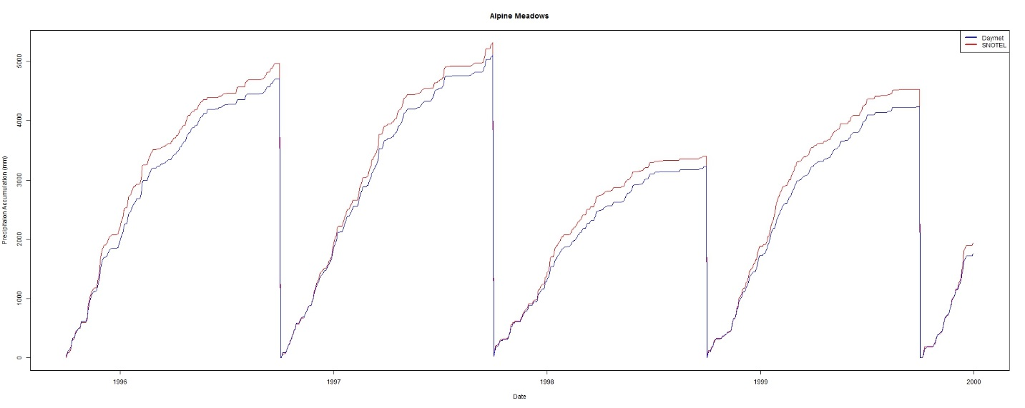

Figure 3 Accumulated precipitation, Daymet vs Alpine Meadows SNOTEL.

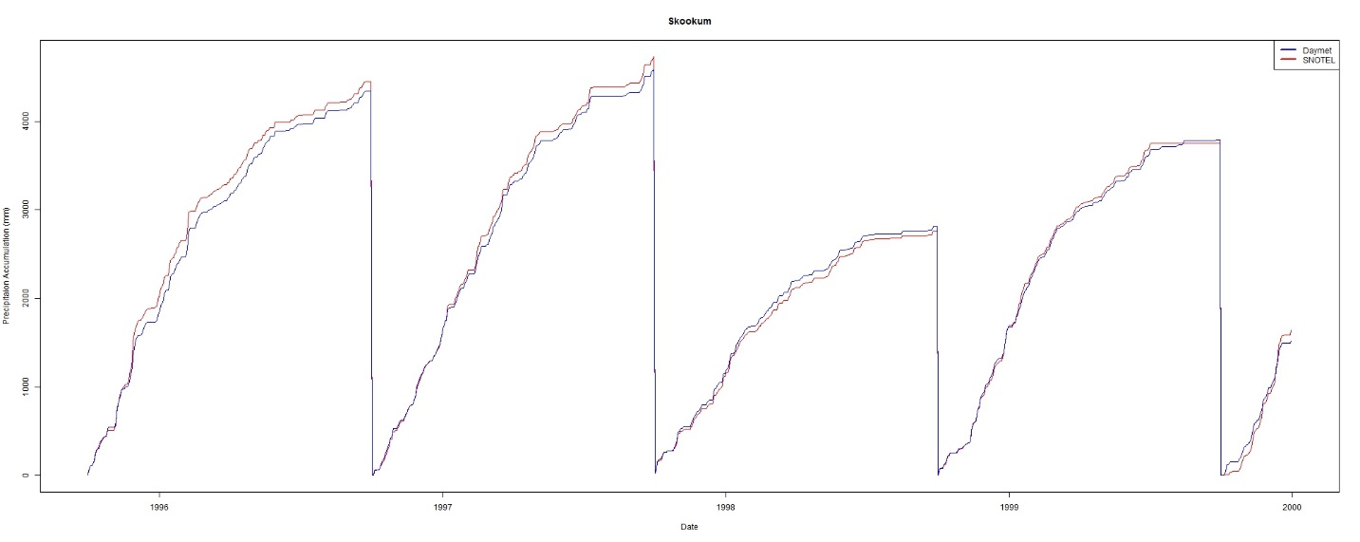

Figure 4 Accumulated precipitation, Daymet vs Skookum SNOTEL.

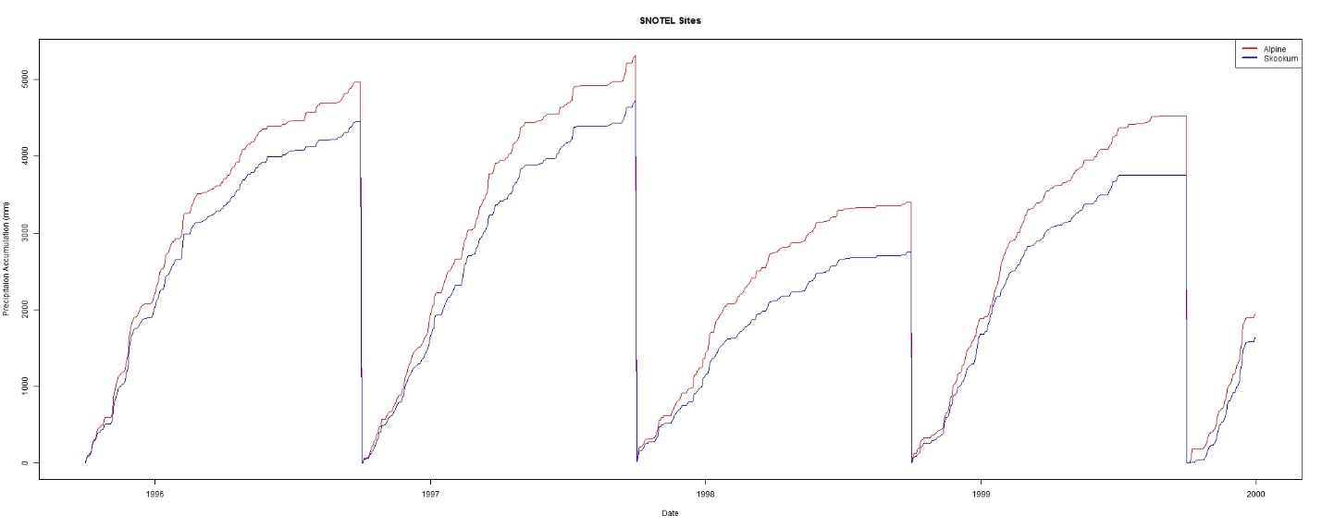

Figure 5 Accumulated precipitation, Alpine Meadows vs Skookum SNOTEL

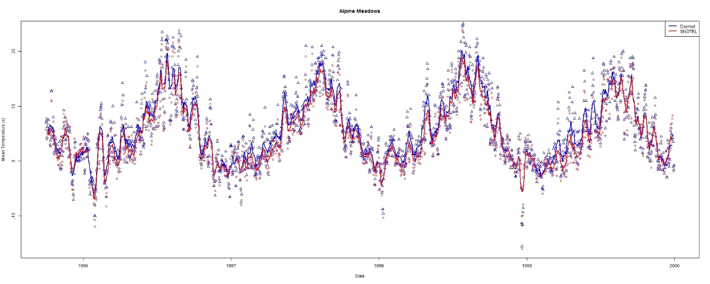

Figure 6 Daily air temperature, Daymet vs Alpine Meadows

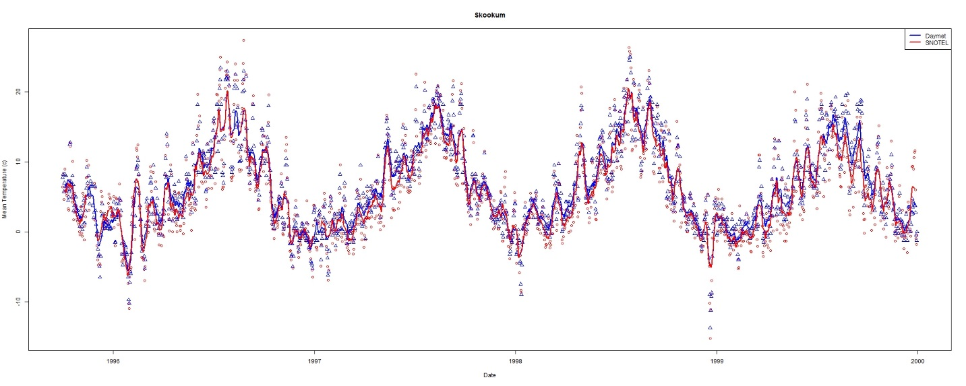

Figure 7 Daily air temperature, Daymet vs Skookum

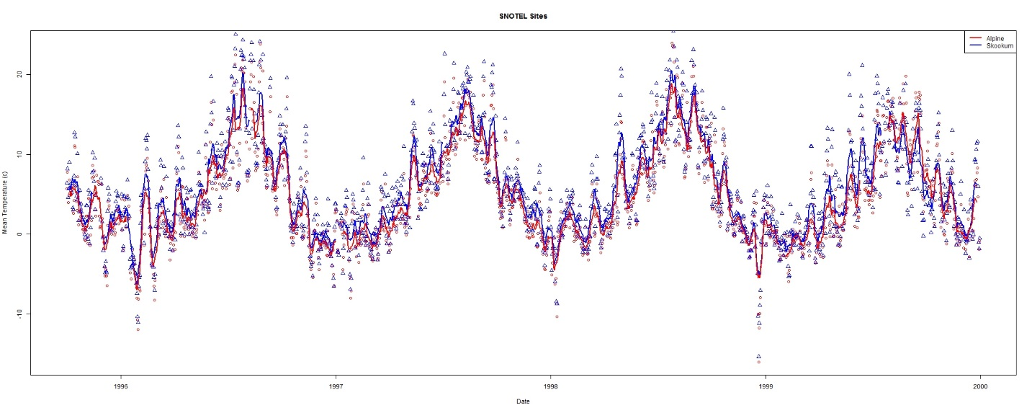

Figure 8 Daily air temperature, Skookum vs Alpine Meadows SNOTEL

References

PRISM Climate Group (2013) Descriptions of PRISM Spatial Climate Datasets for the Conterminous United States. In. PRISM Climate Group, Oregon State University, Corvallis, Oregon, http://prism.oregonstate.edu/documents/PRISM_history_jun2013.pdf

Thornton, P.E., M.M. Thornton, B.W. Mayer, N. Wilhelmi, Y. Wei, R. Devarakonda, and R.B. Cook. 2014. Daymet: Daily Surface Weather Data on a 1-km Grid for North America, Version 2. Data set. Available on-line [https://daac.ornl.gov] from Oak Ridge National Laboratory Distributed Active Archive Center, Oak Ridge, Tennessee, USA.

United States Department of Agriculture, National Water and Climate Center. SNOTEL Precipitation Products. http://www.wcc.nrcs.usda.gov/snow/snotel-precip-reports.html

Appendix

# Regression model between the weather variables (temperature and precipitation) and the

# physiographic variables

climate<-read.csv("D:/Temp/Tolt/ToltClimate.csv",header=TRUE)

climVar<-names(climate)

# Retrieve the site names

for (i in climVar) {

print(i)

}

ln<-length(names(climate))

# Simple plotting of each site, temp vs date

# Modify output/create output directory for plots

m <- list()

for (i in 1:ln) {

fit <- lm(climate[,i] ~ climate[,25])

fit <- lm(X01_ppt~ele, data = climate)

fitAtt<-summary(fit)

models$climVar[i]<-fitAtt

directory="D:/Temp/Tolt/"

r2<- = round(fitAtt$adj.r.squared)

outname<-paste(directory,climVar[i],".jpg",sep="")

jpeg(filename=outname,width=675,height=675,quality=100)

#newdata<-subset(wqdata, Site==i)

ylabel <- paste(climVar[i]," (mm)", sep="")

plot(climate[,i] ~ climate[,25],ylab=ylabel,xlab="Elevation (m)")

abline(coef(fit)[1:2],col="red")

## rounded coefficients for better output

cf <- round(coef(fit), 3)

## sign check to avoid having plus followed by minus for negative coefficients

eq <- paste0(climVar[i], " = ", cf[1],

ifelse(sign(cf[2])==1, " + ", " - "), abs(cf[2]), " ele R^2: ", round(r2,3)

mtext(eq, 3, line=1)

dev.off()

}

# SNOTEL_Daymet_Climate_Comparison.r

# Author: Paul Pettus

# Purpose:

# Compare Daymet modeled and SNOTEL ground station

# observations of precipitation and mean air temperature

#

################################################################

# Plots 1995 1999

# Skookum

inFile<-"E:/SNOTEL/NRCS_Daymet_Daily_Skookum_Alpine_1995_1999.csv"

dfdmNRCS = read.csv(inFile,header=TRUE,sep=",")

dfdmNRCS$Date <- as.Date(dfdmNRCS$Date, format="%m/%d/%Y")

jpegFile<-"E:/SNOTEL/Plots/SNOTEL_Skookum_Daymet_Daily_TAVG_1995_1999.jpg"

jpeg(filename=jpegFile,width=2000,height=800,quality=100)

yLab <- "Mean Temperature (c)"

xLab <- "Date"

mainTitle <- "Skookum"

plot(dfdmNRCS$Date,dfdmNRCS$TAVG_c_Skook_SN,type="p",col="red",pch=1,xlab=xLab, ylab=yLab,main=mainTitle)

points(dfdmNRCS$Date,dfdmNRCS$TAVG_c_Skook_DM,type="p",col="blue",pch=2)

f21 <- rep(1/11,11)

y_sym2 <- filter(dfdmNRCS$TAVG_c_Skook_DM, f21, sides=2)

lines(dfdmNRCS$Date, y_sym2, col="blue",lwd=2)

y_sym <- filter(dfdmNRCS$TAVG_c_Skook_SN, f21, sides=2)

lines(dfdmNRCS$Date, y_sym, col="red",lwd=2)

legend('topright', legend=c("Daymet","SNOTEL"), lwd=c(2.5,2.5), col=c("blue","red"))

dev.off()

jpegFile <- "E:/SNOTEL/Plots/SNOTEL_Daymet_Skookum_PPT_Accumulation_1995_1999.jpg"

jpeg(filename=jpegFile,width=2000,height=800,quality=100)

yLab <- "Precipitaion Accumulation (mm)"

xLab <- "Date"

mainTitle <- "Skookum"

plot(dfdmNRCS$Date,dfdmNRCS$acc_PPT_mm_Skook_SN,type="l",col="red",pch=1, xlab=xLab, ylab=yLab,main=mainTitle)

lines(dfdmNRCS$Date,dfdmNRCS$acc_PPT_mm_Skook_DM,type="l",col="blue",pch=2)

legend('topright', legend=c("Daymet","SNOTEL"), lwd=c(2.5,2.5), col=c("blue","red"))

dev.off()

# Alpine Meadows

jpegFile<-"E:/SNOTEL/Plots/SNOTEL_Alpine_Daymet_Daily_TAVG_1995_1999.jpg"

jpeg(filename=jpegFile,width=2000,height=800,quality=100)

yLab <- "Mean Temperature (c)"

xLab <- "Date"

mainTitle <- "Alpine Meadows"

plot(dfdmNRCS$Date,dfdmNRCS$TAVG_c_Alp_SN,type="p",col="red",pch=1,xlab=xLab, ylab=yLab,main=mainTitle)

points(dfdmNRCS$Date,dfdmNRCS$TAVG_c_Alp_DM,type="p",col="blue",pch=2)

f21 <- rep(1/11,11)

y_sym2 <- filter(dfdmNRCS$TAVG_c_Alp_DM, f21, sides=2)

lines(dfdmNRCS$Date, y_sym2, col="blue",lwd=2)

y_sym <- filter(dfdmNRCS$TAVG_c_Alp_SN, f21, sides=2)

lines(dfdmNRCS$Date, y_sym, col="red",lwd=2)

legend('topright', legend=c("Daymet","SNOTEL"), lwd=c(2.5,2.5), col=c("blue","red"))

dev.off()

jpegFile <- "E:/SNOTEL/Plots/SNOTEL_Daymet_Alpine_PPT_Accumulation_1995_1999.jpg"

jpeg(filename=jpegFile,width=2000,height=800,quality=100)

yLab <- "Precipitaion Accumulation (mm)"

xLab <- "Date"

mainTitle <- "Alpine Meadows"

plot(dfdmNRCS$Date,dfdmNRCS$acc_PPT_mm_Alp_SN,type="l",col="red",pch=1, xlab=xLab, ylab=yLab,main=mainTitle)

lines(dfdmNRCS$Date,dfdmNRCS$acc_PPT_mm_Alp_DM,type="l",col="blue",pch=2)

legend('topright', legend=c("Daymet","SNOTEL"), lwd=c(2.5,2.5), col=c("blue","red"))

dev.off()

# Apline Meadows vs Skookum

jpegFile<-"E:/SNOTEL/Plots/SNOTEL_Skookum_Alpine_Daily_TAVG_1995_1999.jpg"

jpeg(filename=jpegFile,width=2000,height=800,quality=100)

yLab <- "Mean Temperature (c)"

xLab <- "Date"

mainTitle <- "SNOTEL Sites"

plot(dfdmNRCS$Date,dfdmNRCS$TAVG_c_Alp_SN,type="p",col="red",pch=1,xlab=xLab, ylab=yLab,main=mainTitle)

points(dfdmNRCS$Date,dfdmNRCS$TAVG_c_Skook_SN,type="p",col="blue",pch=2)

f21 <- rep(1/11,11)

y_sym2 <- filter(dfdmNRCS$TAVG_c_Skook_SN, f21, sides=2)

lines(dfdmNRCS$Date, y_sym2, col="blue",lwd=2)

y_sym <- filter(dfdmNRCS$TAVG_c_Alp_SN, f21, sides=2)

lines(dfdmNRCS$Date, y_sym, col="red",lwd=2)

legend('topright', legend=c("Alpine","Skookum"), lwd=c(2.5,2.5), col=c("red","blue"))

dev.off()

jpegFile <- "E:/SNOTEL/Plots/SNOTEL_Skookum_Alpine_PPT_Accumulation_1995_1999.jpg"

jpeg(filename=jpegFile,width=2000,height=800,quality=100)

yLab <- "Precipitaion Accumulation (mm)"

xLab <- "Date"

mainTitle <- "SNOTEL Sites"

plot(dfdmNRCS$Date,dfdmNRCS$acc_PPT_mm_Alp_SN,type="l",col="red",pch=1, xlab=xLab, ylab=yLab,main=mainTitle)

lines(dfdmNRCS$Date,dfdmNRCS$acc_PPT_mm_Skook_SN,type="l",col="blue",pch=2)

legend('topright', legend=c("Alpine","Skookum"), lwd=c(2.5,2.5), col=c("red","blue"))

dev.off()

#######################################################3

# Plots 1994 2015

inFile<-"E:/SNOTEL/NRCS_Daymet_Daily_Skookum_Alpine_1995_2015.csv"

dfdmNRCS = read.csv(inFile,header=TRUE,sep=",")

dfdmNRCS$Date <- as.Date(dfdmNRCS$Date, format="%m/%d/%Y")

jpegFile<-"E:/SNOTEL/Plots/SNOTEL_Skookum_Daymet_Daily_TAVG_1995_2015.jpg"

jpeg(filename=jpegFile,width=2000,height=800,quality=100)

yLab <- "Mean Temperature (c)"

xLab <- "Date"

mainTitle <- "Skookum"

plot(dfdmNRCS$Date,dfdmNRCS$TAVG_c_Skook_SN,type="p",col="red",pch=1,xlab=xLab, ylab=yLab,main=mainTitle)

points(dfdmNRCS$Date,dfdmNRCS$TAVG_c_Skook_DM,type="p",col="blue",pch=2)

f21 <- rep(1/11,11)

y_sym2 <- filter(dfdmNRCS$TAVG_c_Skook_DM, f21, sides=2)

lines(dfdmNRCS$Date, y_sym2, col="blue",lwd=2)

y_sym <- filter(dfdmNRCS$TAVG_c_Skook_SN, f21, sides=2)

lines(dfdmNRCS$Date, y_sym, col="red",lwd=2)

legend('topright', legend=c("Daymet","SNOTEL"), lwd=c(2.5,2.5), col=c("blue","red"))

dev.off()

jpegFile <- "E:/SNOTEL/Plots/SNOTEL_Daymet_Skookum_PPT_Accumulation_1995_2015.jpg"

jpeg(filename=jpegFile,width=2000,height=800,quality=100)

yLab <- "Precipitaion Accumulation (mm)"

xLab <- "Date"

mainTitle <- "Skookum"

plot(dfdmNRCS$Date,dfdmNRCS$acc_PPT_mm_Skook_SN,type="l",col="red",pch=1, xlab=xLab, ylab=yLab,main=mainTitle)

lines(dfdmNRCS$Date,dfdmNRCS$acc_PPT_mm_Skook_DM,type="l",col="blue",pch=2)

legend('topright', legend=c("Daymet","SNOTEL"), lwd=c(2.5,2.5), col=c("blue","red"))

dev.off()

# Alpine Meadows

jpegFile<-"E:/SNOTEL/Plots/SNOTEL_Alpine_Daymet_Daily_TAVG_1995_2015.jpg"

jpeg(filename=jpegFile,width=2000,height=800,quality=100)

yLab <- "Mean Temperature (c)"

xLab <- "Date"

mainTitle <- "Alpine Meadows"

plot(dfdmNRCS$Date,dfdmNRCS$TAVG_c_Alp_SN,type="p",col="red",pch=1,xlab=xLab, ylab=yLab,main=mainTitle)

points(dfdmNRCS$Date,dfdmNRCS$TAVG_c_Alp_DM,type="p",col="blue",pch=2)

f21 <- rep(1/11,11)

y_sym2 <- filter(dfdmNRCS$TAVG_c_Alp_DM, f21, sides=2)

lines(dfdmNRCS$Date, y_sym2, col="blue",lwd=2)

y_sym <- filter(dfdmNRCS$TAVG_c_Alp_SN, f21, sides=2)

lines(dfdmNRCS$Date, y_sym, col="red",lwd=2)

legend('topright', legend=c("Daymet","SNOTEL"), lwd=c(2.5,2.5), col=c("blue","red"))

dev.off()

jpegFile <- "E:/SNOTEL/Plots/SNOTEL_Daymet_Alpine_PPT_Accumulation_1995_2015.jpg"

jpeg(filename=jpegFile,width=2000,height=800,quality=100)

yLab <- "Precipitaion Accumulation (mm)"

xLab <- "Date"

mainTitle <- "Alpine Meadows"

plot(dfdmNRCS$Date,dfdmNRCS$acc_PPT_mm_Alp_SN,type="l",col="red",pch=1, xlab=xLab, ylab=yLab,main=mainTitle)

lines(dfdmNRCS$Date,dfdmNRCS$acc_PPT_mm_Alp_DM,type="l",col="blue",pch=2)

legend('topright', legend=c("Daymet","SNOTEL"), lwd=c(2.5,2.5), col=c("blue","red"))

dev.off()

# Apline Meadows vs Skookum

jpegFile<-"E:/SNOTEL/Plots/SNOTEL_Skookum_Alpine_Daily_TAVG_1995_2015.jpg"

jpeg(filename=jpegFile,width=2000,height=800,quality=100)

yLab <- "Mean Temperature (c)"

xLab <- "Date"

mainTitle <- "SNOTEL Sites"

plot(dfdmNRCS$Date,dfdmNRCS$TAVG_c_Alp_SN,type="p",col="red",pch=1,xlab=xLab, ylab=yLab,main=mainTitle)

points(dfdmNRCS$Date,dfdmNRCS$TAVG_c_Skook_SN,type="p",col="blue",pch=2)

f21 <- rep(1/11,11)

y_sym2 <- filter(dfdmNRCS$TAVG_c_Skook_SN, f21, sides=2)

lines(dfdmNRCS$Date, y_sym2, col="blue",lwd=2)

y_sym <- filter(dfdmNRCS$TAVG_c_Alp_SN, f21, sides=2)

lines(dfdmNRCS$Date, y_sym, col="red",lwd=2)

legend('topright', legend=c("Alpine","Skookum"), lwd=c(2.5,2.5), col=c("red","blue"))

dev.off()

jpegFile <- "E:/SNOTEL/Plots/SNOTEL_Skookum_Alpine_PPT_Accumulation_1995_2015.jpg"

jpeg(filename=jpegFile,width=2000,height=800,quality=100)

yLab <- "Precipitaion Accumulation (mm)"

xLab <- "Date"

mainTitle <- "SNOTEL Sites"

plot(dfdmNRCS$Date,dfdmNRCS$acc_PPT_mm_Alp_SN,type="l",col="red",pch=1, xlab=xLab, ylab=yLab,main=mainTitle)

lines(dfdmNRCS$Date,dfdmNRCS$acc_PPT_mm_Skook_SN,type="l",col="blue",pch=2)

legend('topright', legend=c("Alpine","Skookum"), lwd=c(2.5,2.5), col=c("red","blue"))

dev.off()

# tolt_plot_8-11-2016.r

# Author: Paul Pettus

# Purpose:

# Create Daymet 30 year normal regressions of Mean air temperature

# and precipitaion in the Greater Tolt river basin, WA

#

#climate<-read.csv("D:/Temp/Mashel/MashelClimate.csv",header=TRUE)

climate<-read.csv("C:/Temp/Daymet_Tolt/Tolt_Beyond_Climate.csv",header=TRUE)

#climate<-read.csv("C:/Temp/Daymet_Tolt/Tolt_Beyond_Climate_Mean_Elevation.csv",header=TRUE)

#directory="C:/Temp/Daymet_Tolt/Daymet_Regressions_Beyond_Over_1000m/"

#directory="C:/Temp/Daymet_Tolt/Daymet_Regressions_Beyond_Under_1000m/"

#directory="C:/Temp/Daymet_Tolt/Daymet_Regressions_Elevation_Mean_Over_500m/"

#directory="C:/Temp/Daymet_Tolt/Daymet_Regressions_Elevation_Mean_Under_500m/"

directory="C:/Temp/Daymet_Tolt/Daymet_Regressions_Beyond/"

#directory="C:/Temp/Daymet_Tolt/Daymet_Regressions_Elevation_Mean/"

climVar<-names(climate)

head(climate)

##################################################################

# Climate subsets

#climate <- subset(climate, ele >= 1000)

#climate <- subset(climate, ele < 1000)

#climate2 <- subset(climate, ele >= 500)

#climate2 <- subset(climate, ele < 500)

head(climate)

# Calapooia site temperature date times

# Retrieve the site names

for (i in climVar) {

print(i)

}

ln<-length(names(climate))

# Simple plotting of each site, temp vs date

# Modify output/create output directory for plots

#################################################

models <- list()

for (i in 1:ln) {

fit <- lm(climate[,i] ~ climate[,25])

#fit <- lm(X01_ppt~ele, data = climate)

val<-climVar[i]

models[[val]]<-fit

fitAtt<-summary(fit)

#directory="C:/Temp/Daymet_Tolt/Daymet_Regressions/"

r2<- round(fitAtt$adj.r.squared,3)

#print(r2)

#

outname<-paste(directory,climVar[i],".jpg",sep="")

jpeg(filename=outname,width=675,height=675,quality=100)

#newdata<-subset(wqdata, Site==i)

ylabel <- paste(climVar[i]," (mm)", sep="")

xlabel<- "Elevation (m)"

plot(climate[,i] ~ climate[,25],ylab=ylabel,xlab=xlabel)

abline(coef(fit)[1:2],col="red")

## rounded coefficients for better output

cf <- round(coef(fit), 3)

# r2 <- round(r2, 2)

## sign check to avoid having plus followed by minus for negative coefficients

eq <- paste0(climate[i], " = ", cf[1],

ifelse(sign(cf[2])==1, " + ", " - "), abs(cf[2]), " ele R^2: ", r2)

eq

mtext(eq, 3, line=1)

dev.off()

}

#outFile2<-"C:/Temp/Daymet_Tolt/Daymet_Regressions_Beyond_Over_1000m/Tolt_Model_Summary_Beyond_Over_1000m.csv"

#outFile2<-"C:/Temp/Daymet_Tolt/Daymet_Regressions_Beyond_Under_1000m/Tolt_Model_Summary_Beyond_Under_1000m.csv"

#outFile2<-"C:/Temp/Daymet_Tolt/Daymet_Regressions_Elevation_Mean_Over_500m/Tolt_Model_Summary_Elevation_Mean_Over_500m.csv"

#outFile2<-"C:/Temp/Daymet_Tolt/Daymet_Regressions_Elevation_Mean_Under_500m/Tolt_Model_Summary_Elevation_Mean_Under_500m.csv"

outFile2<-"C:/Temp/Daymet_Tolt/Daymet_Regressions_Beyond/Tolt_Model_Summary_Beyond.csv"

#outFile2<-"C:/Temp/Daymet_Tolt/Daymet_Regressions_Elevation_Mean/Tolt_Model_Summary_Beyond_Elevation_Mean.csv"

for (i in 1:length(models)) {

modname <-names(models[i])

cf<-coef(models[[i]])

rsq<-summary(models[[i]])$adj.r.squared

cat(

paste(modname,cf[1],cf[2],rsq,sep=',')

,'\n',file=outFile2,append=TRUE)

}

# D.8 | Cell Data Writer Configuration

#### Overview (Tutorial D.8 – Cell Data Writer Configuration)

This document explains how to add optional Cell Data Writers to a VELMA simulation. Cell Data Writers allow you to gather daily simulation results for a specific cell. For example, this is useful if need to compare VELMA soil moisture predictions to observed data recorded by a soil moisture sensor at a particular location.

Cell Data Writers Allow You to Gather and Report Simulation Results for a Specific Grid Location

The VELMA simulator automatically provides daily simulation results for various values (e.g. Leaf Biomass), however these daily results are values that are computed by summing individual cell values and then dividing the sum by the number of cells in the simulation’s delineated watershed.

To gather and report daily simulation results for a single, specific cell, you need to add a Cell Data Writer parameterization for that cell to the simulation configuration.

Adding a Cell Data Writer to a Simulation Configuration

Cell Data Writers are optional. Simulation configurations contain zero instances of them by default. When added, they do not change the simulation computations – they are only involved in reporting results.

To add a Cell Data Writer to your simulation configuration:  
Click the “Edit” 🡪 “Cell Data Writer” 🡪 “Add a New Cell Writer” menu item.

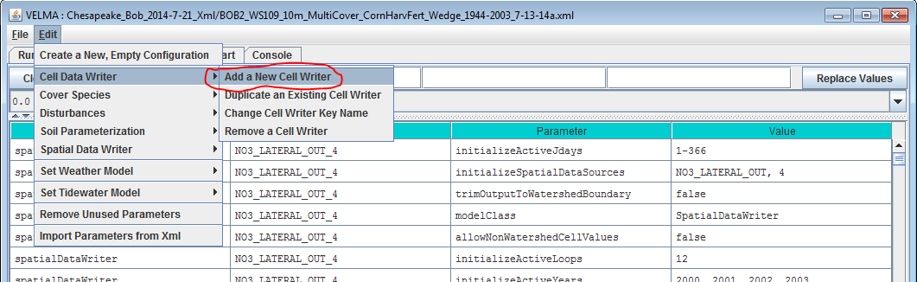

Clicking “Add a New Cell Writer” opens the Cell Writer Name dialog, which looks like this:

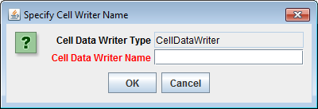

Enter a name for your new Cell Data Writer and click “OK”.  
The name must be unique (i.e. no other Cell Data Writer already specified for this simulation configuration can share the name you specify) and we recommend avoiding whitespace and punctuation characters (e.g. “(“ and “)”). An acceptable example name (assuming it’s not already in use by another Cell Data Writer might be “Probe_Point_1” or maybe “Outlet_Cell”.

Configuring a Cell Data Writer’s Parameters

After you click OK in the Cell Data Writer’s naming dialog, the VELMA GUI adds the Cell Data Writer to the simulation configuration, and sets the All Parameters tab’s filters to display only the parameters of the newly-added Cell Data Writer.  
Assuming we named our new Cell Data Writer “Probe_Point_1” and clicked OK, the VELMA GUI would look like this afterwards:

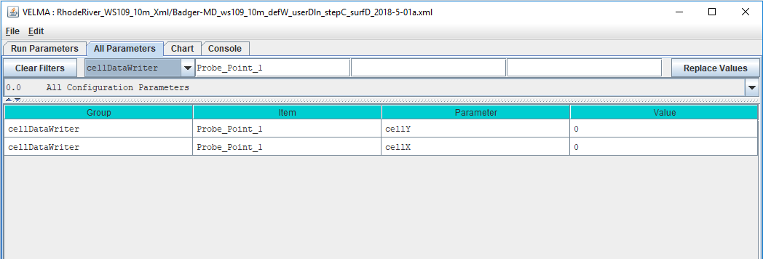

Notice, in passing, that the configuration outline does *not* automatically get set by the GUI. In the example screen capture above, it displays “0.0 All Configuration Parameters” – which is not what is being displayed in the parameterization table. This behavior is harmless.

A Cell Data Writer has only 2 parameters, but they must both be set correctly: *none are optional*.

Set the cellX parameter’s value to the X-coordinate (i.e. column value) of the cell you want data reported for. The valid range is from 0 (the leftmost column) to (number of columns – 1).

Set the cellY parameter’s value to the Y-coordinate (i.e. row value) of the cell you want data reported for. The valid range is from 0 (the topmost row) to (number of rows – 1).

Cell Data Writers Report Cell-Specific Results for Every Simulation Step

Previous versions of JVelma required each Cell Data Writer parameterization to explicitly state which Julian Days of the year the Cell Data Writer instance should report data for. The parameter that specified this (“initializeActiveJdays”) has been removed. Each Cell Data Writer instance parameterized for a simulation now implicitly “knows” to report data for each step of the simulation.

Cell Data Writer Output is A Comma-Separated Values File

The VELMA simulator creates 1 .csv file for each valid Cell Data Writer parameterization in the simulation configuration .xml file.  
  
Cell Data Writer output files are written to the Results Data Location folder. Their filenames always begin with the prefix “Cell_” and contain the linear index, x-coordinate and y-coordinate of the cell they contain data for (e.g. Cell_i2873_x35_y33.csv).

Each row of a Cell Data Writer output file contains results data for a specific loop, year and Julian day during the simulation run. The file’s columns contain the specific results. The header row of the file specifies the contents of each column. Note that some columns contain data that never varies (e.g. the DEM_Elevation(m) column reports the cell’s elevation – which is always the same value.)

Cell Data Writers and Spatial Data Writers are Different, but Complementary

A Cell Data Writer reports all the results data available for a specific cell on user-specified days.  
A Spatial Data Writer reports a specific result for all the cells in the simulation watershed on user-specified days. Both are optional for simulation runs.

# D.9 | Set Up VELMA biomass Outputs as Inputs to BlueSky

**Overview** *(Tutorial D.9 – Set Up VELMA biomass Outputs as Inputs to Bluesky)*

Bluesky is a smoke emissions simulator that is designed to predict the direction and chemistry of smoke produced by forest and rangeland fires. To do this, Bluesky requires spatially-explicit inputs describing the quantity and quality of fuel loads. VELMA is designed to provide this information.

This document describes how to convert VELMA spatial fuel load output to input for BlueSky.

Software Requirements

To run the algorithm that converts VELMA output to input for the Bluesky smoke emissions simulator, you will need the following:

1. **Python version 2.x: Current release is 2.7.11**
2. **Python package ‘ArcPy’ (Requires ArcGIS license)**
3. **Velma2Bluesky Python Algorithm**
4. Python comes pre-packaged within ArcGIS, so it is likely you already have it installed on your computer. For example, mine is installed currently here: C:\Python27\ArcGIS10.2\python.exe. Check to see if you have Python installed before installing a new version. If Python is not installed, you can obtain a copy here: <https://www.python.org/download/releases/2.7/> Note that Python 2.7 is currently considered safe for use on U.S. EPA network and non-network computers.
5. ArcPy is a python package that comes pre-installed with ArcGIS. You can test that you have access to ArcPy by opening your Python executable and typing ‘import arcpy’ into the command line. If you receive no error, then you have ArcPy installed appropriately.

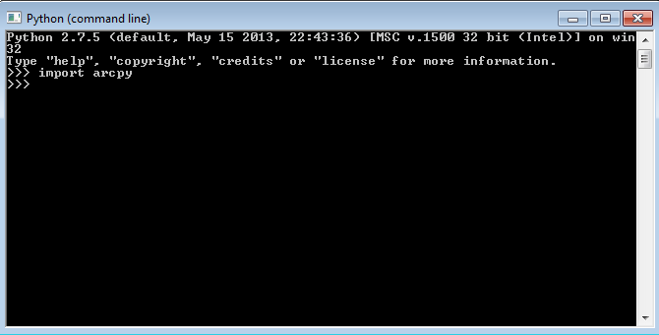

If you have problems importing ArcPy, visit <http://pro.arcgis.com/en/pro-app/arcpy/get-started/importing-arcpy.htm>

1. **Velma2Bluesky Python Algorithm:** This file is called VELMA2BLUESKY.py and can be run using a command line command: “python C:\Path\To\VELMA2BLUESKY.py”. It can also be edited directly with any text editor (e.g., Notepad, EMACS)

Steps for running the VELMA2BLUESKY.py script

1. First, navigate to the directory that contains the Bluesky script. In this example, the script is called VELMA2BLUESKY_2016-10-11.py, but you can rename it if you would like.

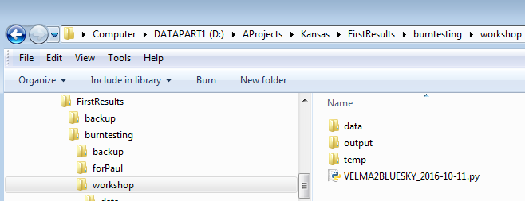

1. You can open the file with any text editor, as shown here: 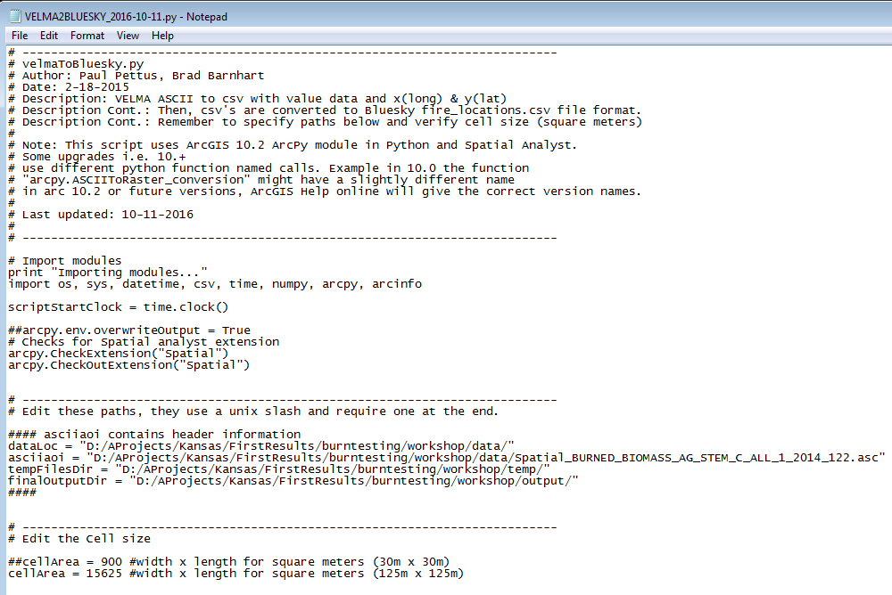
2. You will need to change the paths within the script to make it work on your system.

* dataLoc = This should be the path to your data directory that contains VELMA output files.
* asciiaoi = This path points to any single .asc file in the output data directory. The script uses the header of this file to geo-locate the positions of burns.
* tempFilesDir = This directory must be created to store temporary processing files.
* finalOutputDir = This directory will hold the Bluesky inputs after the script is run.

**NOTE: The tempFilesDir and finalOutputDir must exist and they must be empty for the script to work properly. If you receive an error, make sure that these paths are correct and that there are no files in the tempFilesDir or finalOutputDir.**

Below is an example of a proper specification of paths:

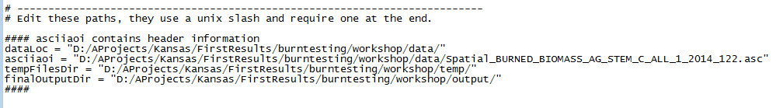

1. You will also need to set the cellArea in the script. You obtain the cellArea variable by squaring the original size of your VELMA cell. That is, if you have a 30m grid, you will input a cellArea = 30x30 = 900.

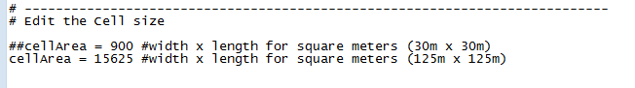

1. To run the script, start by opening a command window. You can also open the script file in IDLE or another Python user environment if you know how to do this.

For the command line method, on Windows, click Start -> Search for Programs or Files -> type in “cmd” and click on cmd.exe.

Then, navigate to the directory where you have your VELMA files using the ‘cd’ command.

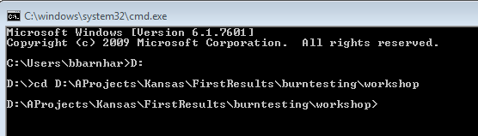

1. Finally, use your python.exe file to run the script using the following command:

C:\path\to\python.exe D:\Path\to\VELMA2BLUESKY_2016_10-11.py

An example is shown below. Note that my python.exe program is located at C:\Python27\ArcGIS10.2\python.exe

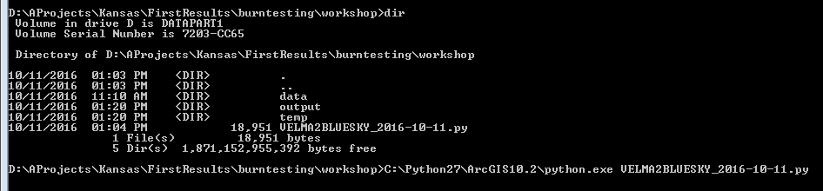

The program will begin and will display the following output. If you receive an error, check the error carefully and determine whether or not you have properly configured your paths and made sure that you have the proper software configuration (ArcGIS with Spatial Analyst, ArcPy, etc.)

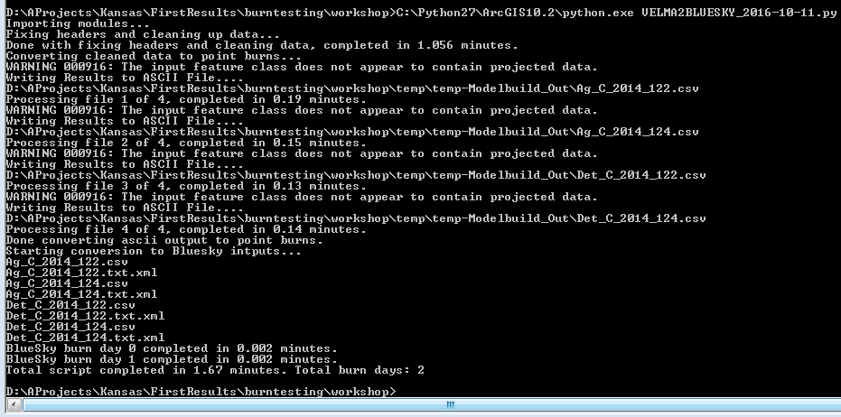

1. Check your output directory for output files.

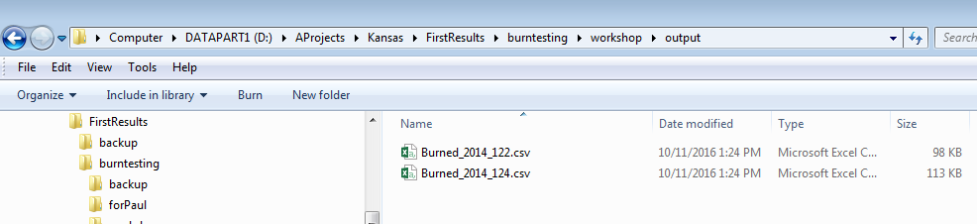

1. You can view the output files using a text or spreadsheet editor.

Scripts

# ---------------------------------------------------------------------------

# velmaToBluesky.py

# Author: Paul Pettus, Brad Barnhart

# Date: 2-18-2015

# Description: VELMA ASCII to csv with value data and x(long) & y(lat)

# Description Cont.: Then, csv's are converted to Bluesky fire_locations.csv file format.

# Description Cont.: Remember to specify paths below and verify cell size (square meters)

#

# Note: This script uses ArcGIS 10.2 ArcPy module in Python and Spatial Analyst.

# Some upgrades i.e. 10.+

# use different python function named calls. Example in 10.0 the function

# "arcpy.ASCIIToRaster_conversion" might have a slightly different name

# in arc 10.2 or future versions, ArcGIS Help online will give the correct version names.

#

# Last updated: 01-31-2017

#

# ---------------------------------------------------------------------------

# Import modules

print "Importing modules..."

import os, sys, datetime, csv, time, numpy, arcpy, arcinfo

scriptStartClock = time.clock()

##arcpy.env.overwriteOutput = True

# Checks for Spatial analyst extension

arcpy.CheckExtension("Spatial")

arcpy.CheckOutExtension("Spatial")

# ---------------------------------------------------------------------------

# Edit these paths, they use a unix slash and require one at the end.

#### asciiaoi contains header information

dataLoc = "L:/Priv/CORFiles/Projects/Velma/Kansas_Project/VELMA_SETUPS_WORKSHOP/Velma_Outputs/KS_Flint_Central_Small_125m_wbFixup_AST2_2017-01-30_historicBurnPlusGraze/"

asciiaoi = "L:/Priv/CORFiles/Projects/Velma/Kansas_Project/VELMA_SETUPS_WORKSHOP/Velma_Outputs/KS_Flint_Central_Small_125m_wbFixup_AST2_2017-01-30_historicBurnPlusGraze/Spatial_BURNED_BIOMASS_AG_STEM_C_ALL_1_2000_88.asc"

tempFilesDir = "L:/Priv/CORFiles/Projects/Velma/Kansas_Project/VELMA_SETUPS_WORKSHOP/Velma_Outputs/temp/"

finalOutputDir = "L:/Priv/CORFiles/Projects/Velma/Kansas_Project/VELMA_SETUPS_WORKSHOP/Velma_Outputs/toolOutput/"

####

# ---------------------------------------------------------------------------

# Edit the Cell size

##cellSize = 900 #width x length for square meters (30m x 30m)

cellSize = 15625 #width x length for square meters (125m x 125m)

#------------------------------------------------------------------------------

print "Starting data clean up..."

outDirStep1 = tempFilesDir + "temp-HeaderFixed/"

# ---------------------------------------------------------------------------

# Read in DEM file, and pull out header

# ---------------------------------------------------------------------------

readFile = open(asciiaoi)

header = readFile.readline() #ncols

header += readFile.readline() #nrows

header += readFile.readline() #xllcorner

header += readFile.readline() #yllcorner

header += readFile.readline() #cellsize

header += readFile.readline() #NODATA_value

readFile.close()

# ---------------------------------------------------------------------------

# ---------------------------------------------------------------------------

# Create temporary directory in tempFilesDir to store fixed headers.

# ---------------------------------------------------------------------------

startClock = time.clock()

## Create a list of all input files

asciiList = []

for files in os.listdir(dataLoc):

if files.endswith(".asc"):

testBit = files in asciiList

if testBit == False:

asciiList.append(files)

for files in asciiList:

filename = dataLoc + files

filesLower = files.lower()

## Load in all four above ground biomass files

if "biomass_ag" in filesLower:

fileName, fileExtension = os.path.splitext(files)

Next_poolName, Next_yearID, Next_julianID = fileName.rsplit('_',2)

stemAgArray = numpy.loadtxt(filename, skiprows=6, dtype= numpy.float64)

leafAgName = dataLoc+"Spatial_BURNED_BIOMASS_LEAF_C_ALL_1_" + Next_yearID + "_" + Next_julianID +".asc"

leafAgArray = numpy.loadtxt(leafAgName, skiprows=6, dtype= numpy.float64)

stemDetName = dataLoc+"Spatial_BURNED_DETRITUS_AG_STEM_C_ALL_1_" + Next_yearID + "_" + Next_julianID +".asc"

stemDetArray = numpy.loadtxt(stemDetName, skiprows=6, dtype= numpy.float64)

leafDetName = dataLoc+"Spatial_BURNED_DETRITUS_LEAF_C_ALL_1_" + Next_yearID + "_" + Next_julianID +".asc"

leafDetArray = numpy.loadtxt(leafDetName, skiprows=6, dtype= numpy.float64)

row, col = stemAgArray.shape

sumAgArray = numpy.zeros((row,col))

sumDetArray = numpy.zeros((row,col))

## Data clean-up: This section ensures that near-zero VELMA output is

## properly accounted for.

for i in xrange(row):

for j in xrange(col):

cellStem = stemAgArray[i,j]

cellLeaf = leafAgArray[i,j]

cellDetStem = stemDetArray[i,j]

cellDetLeaf = leafDetArray[i,j]

# Check for negative values -> to 0

if cellStem < 0 and cellStem != -9999:

cellStem = 0

if cellLeaf < 0 and cellLeaf != -9999:

cellLeaf = 0

if cellDetStem < 0 and cellDetStem != -9999:

cellDetStem = 0

if cellDetLeaf < 0 and cellDetLeaf != -9999:

cellDetLeaf = 0

# Check for values less than 0.001 -> to 0.001

if cellStem <= 0.001 and cellStem != 0 and cellStem != -9999:

cellStem = 0.001

if cellLeaf <= 0.001 and cellLeaf != 0 and cellLeaf != -9999:

cellLeaf = 0.001

if cellDetStem <= 0.001 and cellDetStem != 0 and cellDetStem != -9999:

cellDetStem = 0.001

if cellDetLeaf <= 0.001 and cellDetLeaf != 0 and cellDetLeaf != -9999:

cellDetLeaf = 0.001

# Check if one cell has a value then all cells must have a value

if cellStem >= 0.001 or cellLeaf >= 0.001 or cellDetStem >= 0.001 or cellDetLeaf >= 0.001:

if cellStem < 0.001:

cellStem = 0.001

if cellLeaf < 0.001:

cellLeaf = 0.001

if cellDetStem < 0.001:

cellDetStem = 0.001

if cellDetLeaf < 0.001:

cellDetLeaf = 0.001

if cellStem == -9999:

sumAgArray[i,j] = -9999.0

sumDetArray[i,j] = -9999.0

else:

# Multiply by 1000 because ArcGIS converts raster to shapefile as int not float

sumAgArray[i,j] = (1000*(cellStem + cellLeaf))

sumDetArray[i,j] = (1000*(cellDetStem + cellDetLeaf))

# Writes out live and dead biomass files

asciiOutAgfn = outDirStep1 + "Ag_C_" + Next_yearID + "_" + Next_julianID +".asc"

asciiOutDetfn = outDirStep1 + "Det_C_" + Next_yearID + "_" + Next_julianID +".asc"

if not os.path.exists(os.path.dirname(asciiOutAgfn)):

os.makedirs(os.path.dirname(asciiOutAgfn))

f = open(asciiOutAgfn, "w")

f.write(header)

numpy.savetxt(f, sumAgArray, fmt="%f")

f.close()

f2 = open(asciiOutDetfn, "w")

f2.write(header)

numpy.savetxt(f2, sumDetArray, fmt="%f")

f2.close()

endClock = time.clock()

totalTime = round(((endClock - startClock)/60),3)

print("Done with fixing headers and zero biomass, completed in " + str(totalTime) + " minutes.")

# ---------------------------------------------------------------------------

# Done with fixing headers.

# ---------------------------------------------------------------------------

# ---------------------------------------------------------------------------

# Do not edit these paths. These are temporary directories that

# will be created within the tempFilesDir specified above.

# ---------------------------------------------------------------------------

inDirStep2 = outDirStep1

filesDir = tempFilesDir + "temp-GisFiles/"

outDirStep2 = tempFilesDir + "temp-Modelbuild_Out/"

# ---------------------------------------------------------------------------

print "Starting ascii's to point burn conversions..."

# Process ascii's into point burn data needed for BlueSky input

## Create a list of all input files

asciiList = []

for files in os.listdir(inDirStep2):

if files.endswith(".asc"):

testBit = files in asciiList

if testBit == False:

asciiList.append(files)

count = 0

for files in asciiList:

## Create output file names

startClock = time.clock()

fileName, fileExtension = os.path.splitext(files)

asciifn = inDirStep2 + files

tiffn = filesDir + fileName + ".tif"

reclassfn = filesDir + fileName + "_reclass.tif"

reclassShape = filesDir + fileName + "_reclass.shp"

zonalfn = filesDir + fileName + "_zonal.tif"

rastercalc = filesDir + fileName + "_int.tif"

zonalShape = filesDir + fileName + "_zonal.shp"

pointfn = filesDir + fileName + ".shp"

pointGeofn = filesDir + fileName + "_nad83.shp"

csvfn = outDirStep2 + fileName + ".csv"

## Create/check for output dirs

if not os.path.exists(os.path.dirname(tiffn)):

os.makedirs(os.path.dirname(tiffn))

if not os.path.exists(os.path.dirname(csvfn)):

os.makedirs(os.path.dirname(csvfn))

# Process: ASCII to Raster

arcpy.ASCIIToRaster_conversion(asciifn, tiffn, "FLOAT")

# Process: Define Projection

arcpy.DefineProjection_management(tiffn, "PROJCS['NAD_1983_UTM_Zone_14N',GEOGCS['GCS_North_American_1983',DATUM['D_North_American_1983',SPHEROID['GRS_1980',6378137.0,298.257222101]],PRIMEM['Greenwich',0.0],UNIT['Degree',0.0174532925199433]],PROJECTION['Transverse_Mercator'],PARAMETER['False_Easting',500000.0],PARAMETER['False_Northing',0.0],PARAMETER['Central_Meridian',-99.0],PARAMETER['Scale_Factor',0.9996],PARAMETER['Latitude_Of_Origin',0.0],UNIT['Meter',1.0]]")

# Process: Reclassify

arcpy.gp.Reclassify_sa(tiffn, "Value", "0 0;0 100000000 1", reclassfn, "DATA")

# Process: Raster to Polygon

arcpy.RasterToPolygon_conversion(reclassfn, reclassShape, "NO_SIMPLIFY", "VALUE")

# Process: Zonal Statistics

arcpy.gp.ZonalStatistics_sa(reclassShape, "ID", tiffn, zonalfn, "SUM", "DATA")

# Process: Raster math convert to int

myZonalRaster = arcpy.Raster(zonalfn)

## intRaster = arcpy.sa.Int(myZonalRaster*100000) ## moved to data clean up section

intRaster = arcpy.sa.Int(myZonalRaster)

intRaster.save(rastercalc)

# Process: Raster to Polygon

arcpy.RasterToPolygon_conversion(rastercalc, zonalShape, "NO_SIMPLIFY", "VALUE")

# Process: Add Geometry Attributes

arcpy.AddGeometryAttributes_management(zonalShape, "AREA", "", "SQUARE_METERS", "")

# Process: Feature To Point

arcpy.FeatureToPoint_management(zonalShape, pointfn, "INSIDE")

# Process: Project

arcpy.Project_management(pointfn, pointGeofn, "GEOGCS['GCS_North_American_1983',DATUM['D_North_American_1983',SPHEROID['GRS_1980',6378137.0,298.257222101]],PRIMEM['Greenwich',0.0],UNIT['Degree',0.0174532925199433]]", "", "")

# Process: Export Feature Attribute to ASCII Process: Add XY Coordinates

arcpy.ExportXYv_stats(pointGeofn, "FID;ID;GRIDCODE;POLY_AREA", "COMMA", csvfn, "ADD_FIELD_NAMES") # fix this?

endClock = time.clock()

totalTime = round(((endClock - startClock)/60),2)

count = count + 1

print("Processed VELMA Burn day layer " + str(count) + " completed in " + str(totalTime) + " minutes.")

print "Done with converting VELMA BURN ASCII OUTPUT TO CSV FILES!"

# ---------------------------------------------------------------------------

# Done with making csv's. Now convert csv to BlueSky format.

# ---------------------------------------------------------------------------

inDirStep3 = outDirStep2

outDir = finalOutputDir

# ---------------------------------------------------------------------------

print "Starting conversion to Bluesky intputs..."

##BLB PROPOSED CHANGE TO GET CSV FILES

asciiList = []

for files in os.listdir(inDirStep3):

print files

if files.endswith(".csv"):

testBit = files in asciiList

if testBit == False:

asciiList.append(files)

#for files in os.listdir(inDirStep3):

# if files.endswith(".csv"):

# asciiList.append(files)

##BLB proposed CHANGED TO GET CSV FILES

########################################

## Bluesky header format

header = ["date_time","id","type","latitude","longitude","area","fuel_1hr","fuel_10hr",

"fuel_100hr","fuel_1khr","fuel_10khr","fuel_gt10khr","shrub","grass","rot",

"duff","litter","canopy"]

colNumber = 8

# id VELMA + unique id

# File name

idNumber = 0

count = 0

for files in asciiList:

startClock = time.clock()

filesLower = files.lower()

fileName, fileExtension = os.path.splitext(files)

Next_poolName, Next_yearID, Next_julianID = fileName.rsplit('_',2)

date = datetime.datetime(int(Next_yearID),1,1) + datetime.timedelta((int(Next_julianID)-1))

outDate = date.strftime('%Y%m%d') + "0000Z"

fileList = []

if "ag_c_" in filesLower:

dateList = []

idList = []

typeList = []

areaList = []

fuel_1hrList = []

fuel_10hrList = []

fuel_100hrList = []

fuel_1khrList = []

fuel_10khrList = []

fuel_gt10khrList = []

shrubList = []

rotList = []

litterList = []

canopyList = []

typeBurn = "RX"

idNumber = 0

fuel_1hr = 0

fuel_10hr = 0

fuel_100hr = 0

fuel_1khr = 0

fuel_10khr = 0

fuel_gt10khr = 0

shrub = 0

rot = 0

litter = 0

canopy = 0

agArray = numpy.loadtxt(inDirStep3+files, dtype='float', skiprows=1,delimiter=',')

agFilePathName = inDirStep3+files

detFilePathName = agFilePathName.replace("Ag_C","Det_C")

detArray = numpy.loadtxt(detFilePathName, dtype='float', skiprows=1,delimiter=',')

selectAgArray = agArray[agArray[:,4] > 0]

outAgArray = numpy.multiply(selectAgArray[:,4],1)

divAgArray = numpy.divide(outAgArray,1000) # Adjustment from int(ArcGIS) back to float

row = divAgArray.shape

for i in xrange(row[0]): # Values below 1g/m^2 are returned to zero from pre-process VELMA-ascii

cellValue = divAgArray[i]

if cellValue < 1:

divAgArray[i] = 0

sumAgArray = numpy.multiply(2,divAgArray)

sumAgArray = numpy.multiply(0.00446089,sumAgArray)

cellCount = numpy.divide(selectAgArray[:,5],cellSize)

sumAgArray = numpy.divide(sumAgArray,cellCount)

dataAgList = list(sumAgArray)

#Notes on conversions. Multiply by 2 to go from Carbon to Biomass

#Then, divide by m2 area in a single cell.

#Then, convert g/m2 to tons/acre

selectDetArray = detArray[detArray[:,4] > 0]

outDetArray = numpy.multiply(selectDetArray[:,4],1)

divDetArray = numpy.divide(outDetArray,1000) # Adjustment from int(ArcGIS) back to float

row = divDetArray.shape

for i in xrange(row[0]): # Values below 1g/m^2 are returned to zero from pre-process VELMA-ascii

cellValue = divDetArray[i]

if cellValue < 1:

divDetArray[i] = 0

sumDetArray = numpy.multiply(2,divDetArray)

sumDetArray = numpy.multiply(0.00446089,sumDetArray)

cellCount = numpy.divide(selectAgArray[:,5],cellSize)

sumDetArray = numpy.divide(sumDetArray,cellCount)

dataDetList = list(sumDetArray)

#Notes on conversions. Multiply by 2 to go from Carbon to Biomass

#Then, divide by m2 area in a single cell.

#Then, convert g/m2 to tons/acre

inRow2,inCol = selectAgArray.shape

for i in range(inRow2):

idName = "VELMA_"+str(idNumber)+"_"+outDate

idList.append(idName)

dateList.append(outDate)

typeList.append(typeBurn)

## areaList.append(area)

fuel_1hrList.append(fuel_1hr)

fuel_10hrList.append(fuel_10hr)

fuel_100hrList.append(fuel_100hr)

fuel_1khrList.append(fuel_1khr)

fuel_10khrList.append(fuel_10khr)

fuel_gt10khrList.append(fuel_gt10khr)

shrubList.append(shrub)

rotList.append(rot)

litterList.append(litter)

canopyList.append(canopy)

idNumber = idNumber + 1

##date_time,id,type,latitude,longitude,area,fuel_1hr,fuel_10hr,fuel_100hr,fuel_1khr,fuel_10khr,fuel_gt10khr,shrub,grass,rot,duff,litter,canopy

fileList.append(dateList)

fileList.append(idList)

fileList.append(typeList)

fileList.append(list(selectDetArray[:,1]))

fileList.append(list(selectDetArray[:,0]))

areaList = numpy.divide(selectDetArray[:,5],4046.863) # Converts Square meters to acre

fileList.append(list(areaList))

fileList.append(fuel_1hrList)

fileList.append(fuel_10hrList)

fileList.append(fuel_100hrList)

fileList.append(fuel_1khrList)

fileList.append(fuel_10khrList)

fileList.append(fuel_gt10khrList)

fileList.append(shrubList)

fileList.append(dataAgList)

fileList.append(rotList)

fileList.append(dataDetList)

fileList.append(litterList)

fileList.append(canopyList)

flippedList = zip(*fileList)

############################################################

## Add two leading zero("00") digits to julian days 1-9

## Add one leading zero("0") digits to julian days 10-99

if len(Next_julianID) == 1:

Next_julianID = "00" + Next_julianID

if len(Next_julianID) == 2:

Next_julianID = "0" + Next_julianID

############################################################

outfn = outDir + "Burned_" + Next_yearID + "_" + Next_julianID + ".csv"

if not os.path.exists(os.path.dirname(outfn)):

os.makedirs(os.path.dirname(outfn))

## Write out Bluesky input file for burn day

outfile = open(outfn,'w')

out = csv.writer(outfile, delimiter=',', lineterminator='\n')

out.writerow(header)

for i in flippedList:

out.writerow(i)

outfile.close()

endClock = time.clock()

totalTime = round(((endClock - startClock)/60),3)

print("ASCII BlueSky Burn day" + str(count) + " completed in " + str(totalTime) + " minutes.")

count = count + 1

############################################################

## Create a master list merged burn csv

if count == 1:

outfnMerge = outDir + "Burned_Merge_Complete.csv"

outfileMerge = open(outfnMerge,'w')

out2 = csv.writer(outfileMerge, delimiter=',', lineterminator='\n')

out2.writerow(header)

for i in flippedList:

out2.writerow(i)

elif count > 1 and count < (len(asciiList)/2):

for i in flippedList:

out2.writerow(i)

else:

for i in flippedList:

out2.writerow(i)

outfileMerge.close()

############################################################

sciptEndClock = time.clock()

totalTime = round(((sciptEndClock - scriptStartClock)/60),2)

print("Total script completed in " + str(totalTime) + " minutes. Total burn days: " + str(count))

# D.10 | Default Tidewater Model Configuration

#### Overview (Tutorial D.10 – Default Tidewater Model Configuration)

This document describes how to configure VELMA’s Tidewater model for simulating the per cell daily amount of tidewater (millimeters of water) and marine nitrogen infiltration (grams nitrogen / meter2) for coastal watershed applications.

Warning: This model is still under early development.  
The functionality described here is likely to change or at least be modified in the future.

The Default Tidewater Model provides a way to mimic water and nitrogen deposition due to tidal overtopping of cells within a VELMA simulation’s delineated watershed. The model is currently very simple, and subject to development changes.

You Must Explicitly Set the Tidewater Model for use by a simulation configuration.

In the VELMA GUI click Edit 🡪 “Set Tidewater Model” 🡪 “Default Tidewater Model”) as shown below:

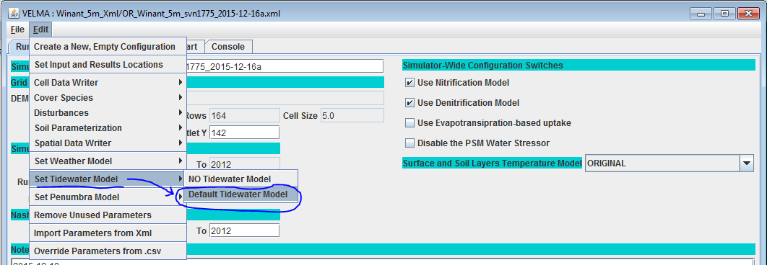

Note the “NO Tidewater Model” menu option – clicking it removes the Default Tidewater Model from your simulation configuration.

After click-setting the Default Tidewater Model, the VELMA GUI should shift your view to the model’s parameters in the “All Parameters” tab:

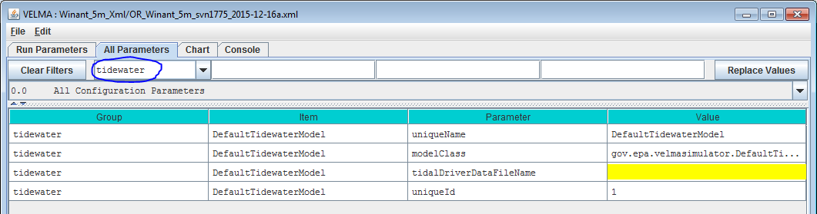

Notice that the Group selector has “tidewater” selected; you can always return the parameters table to display only tidewater parameters by clicking “Clear Filters” and then selecting “tidewater” in the drop-down list of the Group selector.

You Must Provide the Default Tidewater Model with a Driver Data File

The Default Tidewater Model needs daily values for the following data:

* Highest High Tide Elevation (for the 24-hour period of the day, in meters)
* Lowest Low Tide elevation (for the 24-hour period of the day, in meters)
* Seawater NO3 Concentration Coefficient (in micro-mols N / liter)
* Seawater NH4 Concentration Coefficient (in micro-mols N / liter)
* Seawater DON Concentration Coefficient (in micro-mols N / liter)

Set the name of the tidalDriverDataFileName to the name of a file that provides the above values.

The name (or fully-qualified path + name) you provide must be a file of comma-separated values (.csv). when presented with a file name without a path, the VELMA simulation engine’s initialization code will assume the file is located in the directory specified by the inputDataLocationRootName/inputDataLocationDirName path.

Each row of the .csv file specifies one day’s worth of tidewater driver data in the following field layout:

YEAR, JDAY, HIGH_TIDE, LOW_TIDE, NO3_K, NH4_K, DON_K

The year and jday fields must be integers, and the year field must be a full four-digit year.  
VELMA assumes that first row in the file will have YEAR = forcing_start and JDAY = 1, and that the last row in the file will have YEAR = forcing_end and JDAY = 365 (or 366 if forcing_end is a leap year).  
VELMA further assumes that there will be rows of data for every YEAR, JDAY combination in-between. That is, there can be no missing days in the driver data file.

The YEAR, JDAY, HIGH_TIDE and LOW_TIDE values are all **required**, but any or all of the nitrogen concentration coefficients are optional and may be left blank. Any nitrogen concentration coefficient value left blank defaults to a value of zero.

**Here are the first four rows of a tidalDriverDataFileName .csv driver file as an example:**

YEAR, JDAY, HIGH_TIDE, LOW_TIDE, NO3_K, NH4_K, DON_K  
2008, 1, 2.1858504, 0.38152240, 7.0, 5.0, 3.0  
2008, 2, 2.3199558, 0.36018744, 7.0, 5.0, 3.0  
2008, 3, 2.5942624, 0.40285736, 7.0, 5.0, 3.0  
2008, 4, 2.8990475, 0.60096769, 7.0, 5.0, 3.0  
[ . . .]

Note that in the above example, whitespace has been introduced after the comma-separators to make the fields easier to identify. In practice, such whitespace is *not* required and *not* encouraged.

The example above contains a header row, which is acceptable but not required. However, if the header row is present, it must start with an alphabet character, not a numeral.

The Default Tidewater Model’s Tidewater and Nitrogen Infiltration Amounts are Reported by Cell and Spatial Data Writers

When a DefaultTidewaterModel is part of a simulation configuration, any cell data writers specified automatically include columns reporting the following daily amounts for its specified cell location:

* Tidewater Added (in millimeters of water)
* NO3-infiltration (in grams nitrogen / meter2)
* NH4-infiltration (in grams nitrogen / meter2)
* DON-infiltration (in grams nitrogen / meter2)

Spatial Data Writers may be configured for the following Spatial Data keywords:

* Tidewater
* TidalNo3Infiltration
* TidalDonInfiltration
* TidalNh4Infiltration
* TotalTidalNInfiltration

Configure Spatial Data Writers with the keywords exactly as shown above (the mixed case must also be exact).

The Tidewater values reported in spatial data represent amounts of water (in millimeters) added “as if” they were part of the cell’s rainfall on the given day.

All the nitrogen infiltration values reported in Spatial Data output files specified by the above keywords are in units of grams nitrogen / meter2 and represent amounts added at each cell in the map by the specific nitrogen infiltration type. The TotalTidalNInfiltration values are the sum (NO3 + NH4 + DON) of the cells nitrogen infiltration addition for the day.

A simulation configuration that includes Spatial Data Writer parameterizations for any of the above, but does not include the DefaultTidewaterModel parameterization should not crash, but all any spatial data based on the DefaultTidewaterModel will be all zeros.

A Summary Description of the Default Tidewater Model’s Behavior and Effects

When a DefaultTidewaterModel is set for a simulation configuration, and provided with valid parameters from the tidal driver data file, the daily water balance code asks the tidewater model instance for a tidewater amount for each cell whose elevation falls below the HIGH_TIDE value for that day, and adds the (zero or more millimeters) resulting tidewater amount to the cell’s total rain amount for that day. The tidewater amount added is simply:

Tidewater amount = (HIGH_TIDE * 1000) – (cell elevation * 1000)

The multiplication by 1000 converts meters to millimeters.

After water balance computes tidewater amounts, the plant soil model (Psm4dLsr) code asks the tidewater model for the NO3, NH4 and DON infiltration amounts of every cell. Cells with zero tidewater addition automatically receive zero infiltration amounts, and all cells will receive zero infiltration (regardless of their day’s tidewater amount) for any concentration coefficient that was zero (either explicitly or through omission of the concentration constant from the file) in the driver data for that day.

Cells with tidewater amounts > zero, and with non-zero infiltration have their nitrogen infiltration computed as:

n-infiltration amount  
 = (concentration coefficient * 0.000014) * tidewater amount

The conversion factor of 0.000014 converts from the coefficient’s units of micro-mols/liter to grams/meter2.

Each of the three tidal infiltration amounts is computed by the equation above, but the amounts are assigned to different pools within VELMA.

* The NO3 infiltration amount is added to the NO3 pool’s layer 1 amount.
* The NH4 infiltration amount is added to the NH4 pool’s layer 1 amount.
* The DON infiltration amount is added to the DON pool’s layer 1 amount.

The amounts are added to their respective data pools prior to any daily nitrification and denitrification calculations. For example, the NO3 amount is added to the pool prior to denitrification, so the cell’s layer 1 denitrification amount for the day will be computed from the NO3 pool’s original amount + its tidal infiltration amount.

# E.1 | Mapping Surface Layer Permeabilities

#### Overview (Tutorial E.1 – Mapping Surface Layer Permeabilities)

Permeability of surface layers is an important property affecting infiltration of rainfall and surface runoff and accompanying dissolved contaminants and nutrients.

This document describes how to parameterize VELMA’s non-soil surface layer to represent the degree of permeability of overlying human structures (roads, roofs, compacted soils, etc.) and natural features (surficial bedrock, etc.) to water and dissolved chemicals.

1.0. Permeability Basics

The VELMA simulator engine allows specification of a spatial data map (grid) with permeability fractions as its cell values. When specified, the grid’s permeability fractions are included in determining how much of a cell’s total water inflow (from rain, snow melt, lateral surface movement, etc.) penetrates into the first layer of its layered soil column.

Permeability fraction values must be in the range [0.0, 1.0], where 0.0 is completely impermeable (no water penetrates from surface to soil layer 1) and 1.0 is completely permeable (all water penetrates from surface to soil layer 1).

1.1. Permeability Values Are Not Required by the VELMA Simulator

Permeability is *not* the sole factor determining how much water penetrates from surface into the first soil layer. The soil layer’s saturation, porosity and other parameters determine the primary amount of water transferred from surface to the layer. A cells permeability fraction is a secondary factor that may further reduce the primary amount.   
When a VELMA simulation configuration does not specify a permeability grid, the VELMA simulator engine behaves as if every cell has a permeability of 1.0 – i.e. no secondary reduction of the penetration water amount occurs.

1.2. Specify Permeability Values for Each Simulation Grid Cell in a Permeability Map File

The permeability grid map must be a Grid ASCII (.asc) file with the same header data as the DEM .asc file specified for the simulation configuration. The permeability grid file’s data values must be floating point numbers, each one within the range [0.0, 1.0].

1.3. Specify the Simulation’s Permeability Map File via a Configuration Parameter

Set the permeability fractions for the cells of the grid by providing the name of the permeability .asc map file as the value of the permeabilityFractionsFileName Calibration parameter.

You can find this parameter by entering “^perm” (without the double-quote marks) into the middle filter text box on JVelma’s “All Parameters” panel, like so:

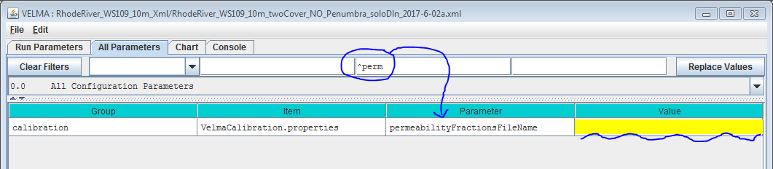

The Value for the permeabilityFractionsFileName parameter must be the name of an existing, accessible, valid Grid ASCII (.asc) file containing permeability fractions. If the Value provided is a fully-qualified path, the simulator will look for the .asc file at that location, with that filename. If the Value provided is a partial path or only a file name, the simulator will look for a file with specified name relative to the location specified by the inputDataLocationRootName/inputDataLocationDirName parameters.

2.0. How to Establish Pervious Surfaces for a VELMA Application

2.1. Data Sources

* Washington Transportation, Proprietary Roads (Statewide) - <http://geography.wa.gov/data-products-services/data/data-catalog>
  + Washington State Department of Natural Resources (WA DNR)
* National Elevation Dataset (30m) (DEM) – Flat processed by JPDEM
  + U.S. Geological Survey, The National Map, 2015, 3DEP products and services

2.2. Data Processing

A fractional pervious surface map is created by using a combination of impervious layer map(s) and an area of interest (AOI) DEM. The pervious surface maps permeability percent values will range from 0 to 1, where 0 completely impervious and 1 being completely pervious. Layers such as road polylines or raster green infrastructures are converted to a user resolution that is finer or equal to the resolution of the AOI raster, and must have the exact same extent of the AOI raster**.** For instance, a user would determine the appropriate road or impervious surface width (10m, 5m, 3m, 2.5m, or 1m etc.), all of which would evenly divide into a 30m processed DEM / AOI ASCII. The AOI raster may be of any resolution, as long as the impervious surface raster evenly divides into it. To illustrate, a 30m AOI that is 50 rows by 100 columns could be evenly divided by a 10m impervious surface ASCII that was 150 rows by 300 columns. When converting polylines, polygons, or rasters, as with all VELMA layers, they must be locked (snap) to the AOI to ensure proper overlap and alignment of higher resolution cells with the AOI.

The perviousness of finer resolution maps will be weighted by their cell size ratio to the AOI DEM when data is aggregated to the AOI map resolution. For example, to derive a 30m cell’s fraction perviousness, the number of higher resolution cells that are analyzed as road are summed together and then divided by the total number of cells. That percentage is then subtracted from 1. 1 being completely pervious and 0 entirely impervious. With the scenario drawn in Figure 1, this single 30m cell would evaluate to 1 – (15 / 36) = 58% or 1 – (8/9) = 11 % perviousness depending on whether a 10m or 5m road grid were used. An example of a processed permeability fraction map can be seen in Figure 2.

Multiple impervious map layers can be aggregated and weighted together to create the permeability map (Figure 3). When calculating the permeability value for a particular cell with multiple overlapping impervious cell values, the layers must be ordered or ranked by precedence of the layer’s influence. In figure 3 the “Roads” layer is ranked first and the “Green I.” layer ranked last. The “Roads” layer’s imperviousness value is 100% and the “Green I.” layer’s impervious cells values are 50%, and if any cells overlap each other the 100% value from the “Roads” layer will be used to calculate the partial influence of the 10m area that it represents in the permeability map’s 30m cell (Figure 3).

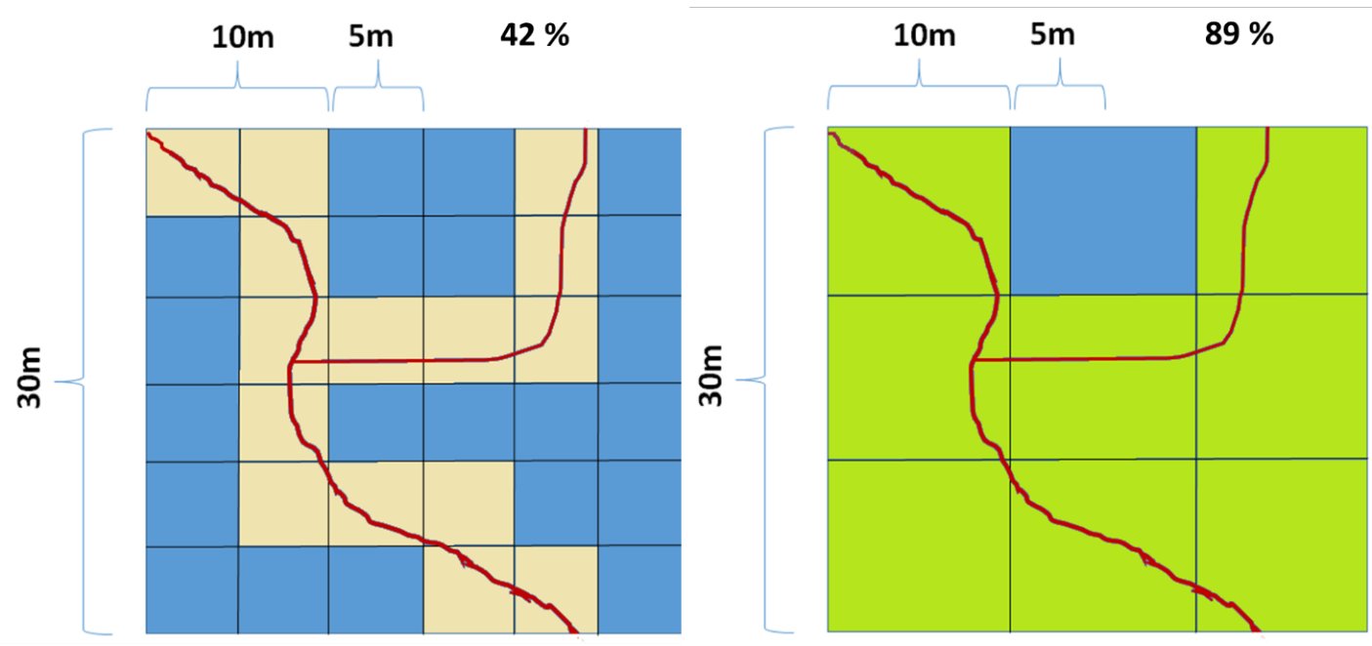

Figure 1. 30m cell overlap of 10m and 5m road grid.

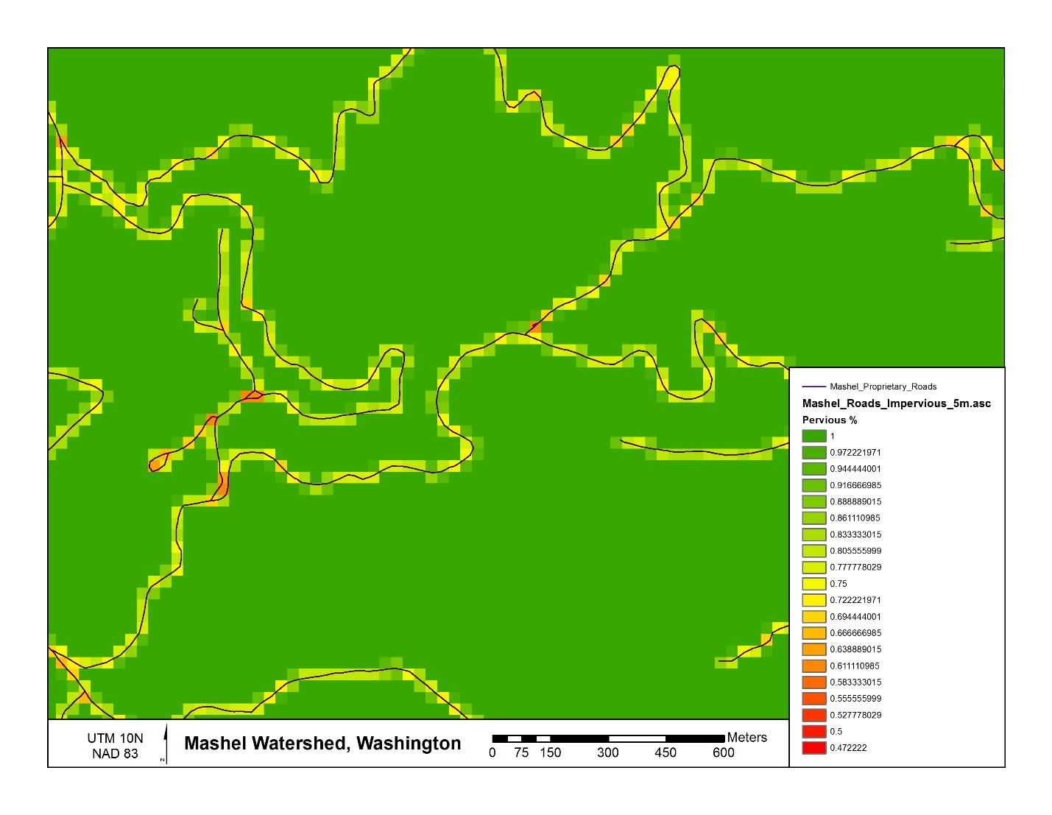

Figure 2. Processed permeability fraction map.

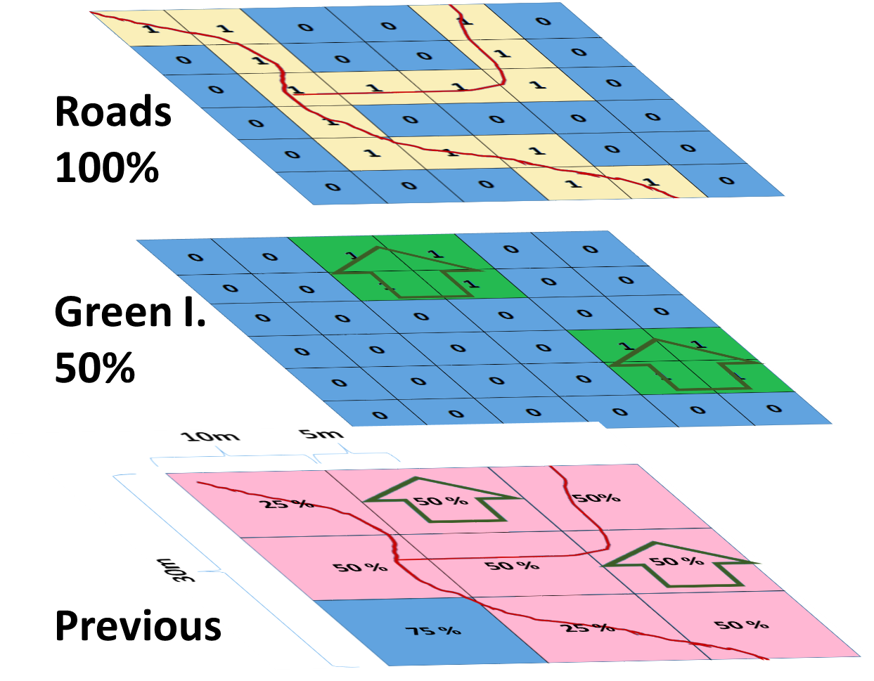

Figure 3 Aggregating multiple impervious surface maps into the permeability layers.

2.3. Software Requirements and Processing

To run and produce the processed permeability fraction map (ASCII) from the “roads” or impervious surface layer (ASCII), you will need the following:

1. Python version 2.x: Current release is 2.7.11
   1. Python comes pre-packaged within ArcGIS, so it is likely you already have it installed on your computer. For example, a default install is currently here: C:\Python27\ArcGIS10.2\python.exe. Check to see if you have Python installed before installing a new version. If Python is not installed, you can obtain a copy here: <https://www.python.org/download/releases/2.7/> *Note that Python 2.7 is currently considered safe for use on U.S. EPA network and non-network computers.*
2. ASCII Map requirements:
   1. AOI or processed DEM ASCII raster that matches the VELMA modeling resolution.
   2. Pervious/impervious surface rasters in ASCII format (.asc).
      * Impervious surface cell values set equal to 1 or greater, all other non-pervious and no-data cells values set to -9999, which is the default ERSI ASCII nodata value.
      * These map(s) should match the exact extent of the AOI / DEM ASCII regardless if they are higher resolution.
   3. For each impervious surface map, the user will have to determine how permeable that surface is. Permeability fraction values must be in the range [0.0, 1.0], where 0.0 is completely impermeable (no water penetrates from surface to soil layer 1) and 1.0 is completely permeable (all water penetrates from surface to soil layer 1).
   4. Output filename to be determined by the user.
3. The permeability fraction algorithm: “**Permeability_algorithm.py**” and can be run on the Command Prompt line with Python. This script requires, at minimum, one impervious surface map with a corresponding percent permeability, one AOI map, and one output file name. The script is designed to allow the user to input multiple impervious surface maps and their corresponding percent permeability.   
     
   *NOTE – The order of the input impervious maps determines their cell value assignment rank when creating the pervious surface output map.* The fist map argument takes precedence over the following maps, and so on for the next map listed. In the example below, if the “roads_5m.asc” has cell values that overlap “green_infrastructure_10m.asc” values, the “roads_5m.asc” pervious percentage will therefor win over the “green_infrastructure_10m.asc” values.

Command prompt input example:   
“python .\Permeability_algorithm.py -IMP C:\Temp\roads_5m.asc -PERC 0 -IMP C:\Temp\green_roof_3m.asc -PERC .5

-IMP C:\Temp\green_infrastructure_10m.asc -PERC .25

-AOI C:\Temp\ws1_30m_larger_flatalt.asc -OUT C:\Temp\perm.asc”  
“python C:\Path\To\Permeability_algorithm.py –help” for exact arguments (Figure 4).

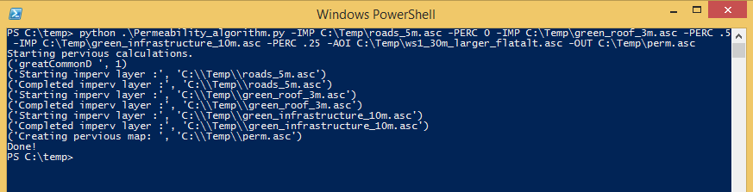

Figure 4. Command line example of running the pervious surface map algorithm

1. The permeability fraction algorithm also can be run from a Python development environment such as IDLE, by editing the default arguments paths of the inputs and outputs in the python code (Figure 4).

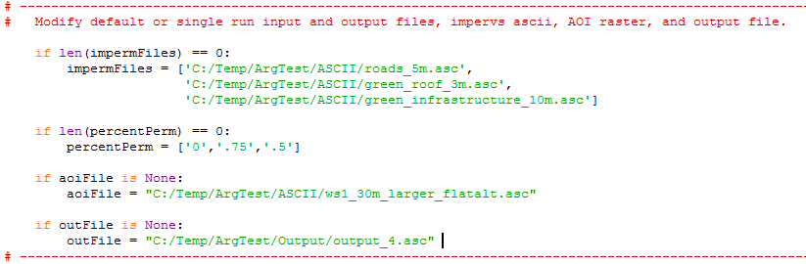

Figure 5. Default arguments paths.

Scripts

# Pervious_Fraction_Algorithm.py

# Author: Paul Pettus, Kevin Djang

# Date: 10-11-2016

# Description: To create a percentage / fraction permeable surface

#

# Output is a cell size ascii grid that matches the resolution of the AOI

# with percentage values that range from 1 to 0.

#

# Example, either a 5m and 10m imperv map grids are overlaid and divide evenly into

# a 30m grid, and cells that evaluate as imperv are counted up and divided

# by the total overlaid cells under the 30m grid cell. From which that

# percentage imperv cover is subtract from 1, 1 being completely permeable

# and 0 being completely impermeable.

#

#

# Note: Cells classified as "Roads" or "Impermeable" must have a value >= 1,

# while permeable cells must have a classified value of -9999

#

# Last updated: 6-8-2017

import os, sys, numpy, re, argparse

# ------------------------------------------------------------------------------------------------

# Error message class

class Usage(Exception):

def __init__(self, msg):

self.msg = msg

# Import an ascii file with header and array

class myASCIIFile:

def __init__(self,asciiFile):

if not os.path.exists(asciiFile):

raise Usage('Cannot find ASCII "' + asciiFile + '"')

# Open file and read in header info

readFile = open(asciiFile)

self.header = readFile.readline() #ncols

self.header += readFile.readline() #nrows

self.header += readFile.readline() #xllcorner

self.header += readFile.readline() #yllcorner

self.header += readFile.readline() #cellsize

self.header += readFile.readline() #NODATA_value

readFile.close()

self.headerList = self.header.rsplit()

self.ncols = int(self.headerList[1]) #ncols

self.nrows = int(self.headerList[3]) #nrows

self.xllcorner = float(self.headerList[5]) #xllcorner

self.yllcorner = float(self.headerList[7]) #yllcorner

self.cellsize = float(self.headerList[9]) #cellsize

self.NODATA = float(self.headerList[11]) #NODATA_value

self.array = numpy.loadtxt(asciiFile, skiprows=6, dtype= numpy.float64) # ASCII data to numpy array

def main(argv=None):

if argv is None:

argv = sys.argv

try:

parser = argparse.ArgumentParser(description='Outputs a percent permeability surface map'+

' from one to many impermeable file layer inputs and' +

' percentage arguments.')

parser.add_argument('-IMP', action='append', dest='impermFILE',default=[],

help='Fully-qualified path + name of ".asc" impermeable cover file.' +

' Add repeated values to a list.')

parser.add_argument('-PERC', action='append', dest='impermPERC',default=[],

help='Percent permeability of the impermeable surface raster (0-1).' +

' Add repeated values to a list.')

parser.add_argument('-AOI', action='store', dest='aoiFILE',default='D:/Temp/ArgTest/dem_30m_aoi_flat.asc',

help='Fully-qualified path + name of ".asc" AOI / DEM.')

parser.add_argument('-OUT', action='store', dest='outFILE',default='D:/Temp/ArgTest/Output/output.asc',

help='Fully-qualified path + name of ".asc" output file.')

args = parser.parse_args()

# args parsing

impermFileList = args.impermFILE

percentList = args.impermPERC

aoiFile = os.path.abspath(args.aoiFILE)

outFile = os.path.abspath(args.outFILE)

# do the work

percentPervious(impermFileList, percentList, aoiFile, outFile)

except Usage as e:

print(e.msg)

return 2

except Exception as e:

# STUB exception handler

# Warning: poor programming style.

# Catches almost any exception (but not KeyboardInterrupt -- which is a Good Thing)

raise e

def percentPervious(impermFiles, percentPerm, aoiFile = None, outFile = None):

# ---------------------------------------------------------------------------------------------------------

# Modify default or single run input and output files, impervs ascii, AOI raster, and output file.

if len(impermFiles) == 0:

impermFiles = ['D:/Temp/ArgTest/ASCII/roads_5m.asc',

'D:/Temp/ArgTest/ASCII/green_roof_3m.asc',

'D:/Temp/ArgTest/ASCII/green_infrastructure_10m.asc']

if len(percentPerm) == 0:

percentPerm = ['0','.5','.25']

if aoiFile is None:

aoiFile = "D:/Temp/ArgTest/ASCII/ws1_30m_larger_flatalt.asc"

if outFile is None:

outFile = "D:/Temp/ArgTest/Output/output_9.asc"

# ---------------------------------------------------------------------------------------------------------

# Check that AOI file exists

if not os.path.exists(aoiFile):

raise Usage('Cannot find AOI file "' + aoiFile + '"')

# Check that all impermeable rasters exist

for item in impermFiles:

if not os.path.exists(item):

raise Usage('Cannot find impermeable file "' + item + '"')

# Check that the number of permeable layer match the percentage input.

if len(impermFiles) != len(percentPerm):

raise Usage('Number of permeable layers do not match percentage inputs!')

print ("Starting pervious calculations.")

# read in AOI header and retrive cell size

aoiAscii = myASCIIFile(aoiFile)

# Empty list to hold all of the impervious layers cell sizes

impervCellSizes = []

for itemAscii in impermFiles:

# Read in each impervious file

impermAscii = myASCIIFile(itemAscii)

# Verify that the columns are evenly divisible into the AOI

if int(impermAscii.ncols) % int(aoiAscii.ncols) != 0:

raise Usage("Columns don't divide evenly. " + itemAscii)

# Verify that the rows are evenly divisible into the AOI

if int(impermAscii.nrows) % int(aoiAscii.nrows) != 0:

raise Usage("Rows don't divide evenly. " + itemAscii)

# Verify that the cell sizes are evenly divisible into the AOI

if float(aoiAscii.cellsize) % float(impermAscii.cellsize) != 0:

raise Usage("Cells sizes do not divide evenly. " + itemAscii)

# read in imperv file header and retrive cell size

impervCellSizes.append(int(impermAscii.cellsize))

# Find the finest resolution cell size

minCellSize = min(impervCellSizes)

# Get the greatest common divisor of cell sizes

def gcd(*numbers):

"""Return the greatest common divisor of the given integers"""

from fractions import gcd

return reduce(gcd, numbers)

# Get the greatest common divisor of cell sizes

greatCommonD = apply(gcd,impervCellSizes)

print("Greatest Common Divisor cell size: ", greatCommonD)

# Calculate number or rows and cols for the finest resolution array / raster

maxIpermRow = int(int(aoiAscii.nrows) * (float(aoiAscii.cellsize) / greatCommonD))

maxIpermCol = int(int(aoiAscii.ncols) * (float(aoiAscii.cellsize) / greatCommonD))

# Create the highest resolution array

# This array will hold all the imperious values for all layers

impermOverlapArray = numpy.zeros((maxIpermRow, maxIpermCol))

# Load input files as arrays

aoiArray = aoiAscii.array

impervArray = impermAscii.array

# create empty output array

row, col = aoiArray.shape

outArray = numpy.zeros((row,col))

percentPosition = 0

# Loop through all the impervious files

for itemAscii in impermFiles:

print("Starting imperv layer :", itemAscii)

# flip percentPerm to percentage impermeable so that empty or zero values in

# impermOverlapArray Array values can be evaluated as processed or empty

# impermeable values will be converted to permeable values after all

# layers have been processed

percentImperm = 1 - float(percentPerm[percentPosition])

# Read in impervious surface file

impermAscii = myASCIIFile(itemAscii)

# Calculate the ratio of imperv cells to finest resolution imperv raster cell size

cellRatio = int(float(impermAscii.cellsize)/float(greatCommonD))

# Calculate number of imperv cells per current imperv raster cell

impervCellsToSmall = cellRatio * cellRatio

# For each imperm layer cell assign a percent impervios value to the impermOverlapArray

if cellRatio != 1:

for i in xrange(int(impermAscii.nrows)):

for j in xrange(int(impermAscii.ncols)):

cellValue = impermAscii.array[i,j]

# Check that the cell has a value that is not NODATA

if cellValue != -9999:

# Loop through the over lapped impermOverlapArray cells, e.g. 30m / 5m = 6x6 overlap

for r in xrange(cellRatio):

for c in xrange(cellRatio):

impervRow = (i*cellRatio) + (r)

impervCol = (j*cellRatio) + (c)

# imperm cell has a value of > 0, completely permeable cells have a value of 0

# if a impermeable cell values over lap, the first layer argument will take

# priority and assign its value first. Poor Programing :(

if impermOverlapArray[impervRow,impervCol] == 0:

# Assign value to master array

impermOverlapArray[impervRow,impervCol] = percentImperm

# else: Ratio is equal to 1

else:

for i in xrange(int(impermAscii.nrows)):

for j in xrange(int(impermAscii.ncols)):

cellValue = impermAscii.array[i,j]

# imperm cell has a value of > 0, completely permeable cells have a value of 0

# if a impermeable cell values over lap, the first layer argument will take

# priority and assign its value first. Poor Programing :(

# Check that the cell has a value that is not NODATA

if cellValue != -9999:

# Assign value to master array

impermOverlapArray[i,j] = percentImperv

# increment the position of the percent list

percentPosition = percentPosition + 1

print("Completed imperv layer :", itemAscii)

# Get the ratio of the impermOverlapArray cells to AOI raster cells

aoiOverlapRatio = int(float(aoiAscii.cellsize)/float(greatCommonD))

print("Creating pervious map :", outFile)

# For each aoi cell calculate the percentage permeable

for i in xrange(row):

for j in xrange(col):

# impermSum holds the total of all imperm cell values set to zero each loop

impermSum = 0

# Loop through the over lapped impervious cells, e.g. 30m / 5m = 6x6 overlap

for r in xrange(aoiOverlapRatio):

for c in xrange(aoiOverlapRatio):

impervRow = (i*aoiOverlapRatio) + (r)

impervCol = (j*aoiOverlapRatio) + (c)

# retrieve cell value

cellValue = impermOverlapArray[impervRow,impervCol]

# add cell value to impermSum

impermSum = impermSum + cellValue

# Calculate pervious percentage from impervious values, converted back to pervious

permeableValue = 1 - (impermSum / (aoiOverlapRatio * aoiOverlapRatio)) # Calculate pervious percentage

# Assign pervious value to output array

outArray[i,j] = permeableValue

# Open output file

f = open(outFile, "w")

# Write AOI header to output file

f.write(aoiAscii.header)

# Save values array to output file

numpy.savetxt(f, outArray, fmt="%f")

f.close()

print("Done!")

if __name__ == "__main__":

sys.exit(main())

# E.2 | VELMA Surface Chemistry Pools

#### Overview (Tutorial E.2 – VELMA Surface Chemistry Pools)

This document describes how to implement surface chemistry pools in VELMA.

“Surface chemistry pools” is a new VELMA feature (version 2.1) that can be used to simulate additions of nutrients and contaminants to road surfaces or other non-soil layer positioned on top of a VELMA soil column (layers 1-4).

In previous model versions, atmospheric deposition of nitrogen, fertilizer additions and so forth had to added to soil layer 1 in VELMA. Now, chemical additions can be more realistically simulated as additions to surfaces that may differ with respect to their permeabilities.

The ability to simulate surface chemistry pools is important because deposited chemicals can potentially reside undissolved on a road or other impermeable surface for some time without being accessible to plant roots and other biogeochemical processes. Or, when rainfall does occur in sufficient amount, the dissolved chemical may run off laterally until reaching a downslope soil column with a more permeable surface.

Note that a new water permeability layer has also been added to VELMA. This feature lies between the surface chemistry pool and soil layer 1. For details see “*Tutorial E.1 – Mapping Surface Layer Permeabilities in VELMA*”.

The Surface Pools “Overlay” Their Corresponding Layered Pools

The surface NH4 pool can be thought of as “overlaying” the four layers of the NH4 chemistry pool, with the water permeability layer lying in between them. Similarly, surface NO3 overlays layered NO3, etc. Surface pool values are in grams of Nitrogen per square meter (g N/m2), the same as the layered pools, or g C/m2, in the case of DOC. Organic Contaminant parameterizations added to VELMA simulation configurations likewise will have a surface pool overlaying a layered pool.

The Nin (Nitrogen Deposition) Surface Pool is Special

Other chemistry surface pools are completely new functionality, but the Nin pool is a refactoring of the already-existing Nin code. Prior Nin behavior continues to be available, and is shunted through the new surface Nin pool.

You can select the type of Nin behavior via the useExperimentalNin configuration parameter.  
In prior simulation configurations, this parameter was a boolean with the following behavior:

|  |  |
| --- | --- |
| **OLD-Style Value** | **Simulation Behavior** |
| false | Use original/legacy Nin code:  Constant daily deposition rate. Vertical transport to NH4 pool layer 1. NO lateral transport. |
| true | Use Banked Michaelis-Menten Nin code:  Constant daily deposition rate.  Vertical transport to NH4 pool layer 1, based on Banked, water-sensitive M-M equation.  NO lateral transport. |

In new simulation configurations, the useExperimentalNin parameter is an enum with three possible settings:

|  |  |
| --- | --- |
| **NEW-Style Value** | **Simulation Behavior** |
| NIN_LEGACY | Use original/legacy Nin code:  Constant daily deposition rate. Vertical transport to NH4 pool layer 1. NO lateral transport. |
| NIN_BANKED_MICHAELIS_MENTEN | Use Banked Michaelis-Menten Nin code:  Constant daily deposition rate.  Vertical transport to NH4 pool layer 1, based on Banked, water-sensitive M-M equation.  NO lateral transport. |
| NIN_SURFACE_POOL | Use new, Surface Nin Pool code:  Constant daily deposition rate into SURFACE_N_IN pool.  Vertical transport to NH4 pool layer 1, based on transportable fraction of SURFACE_N_IN pool and water balance’s current vertical flow value.  Lateral transport to adjacent SURFACE_N_IN pool cells based on water balance’s current lateral flow value. |

When older, legacy simulation configuration .xml files are loaded into JVelma, the following mapping from old-style to new-style useExperimentalNin occurs automatically:

|  |  |
| --- | --- |
| **OLD-style Value** | **NEW-style Value** |
| false | NIN_LEGACY |
| true | NIN_BANKED_MICHAELIS_MENTEN |

Notice that there is no way for a legacy simulation configuration to automatically map to the new NIN_SURFACE_POOL mode’s code. This is deliberate. The NIN_SURFACE_POOL mode is currently considered *very* prototype and should not be used without explicit intent.

The Cells of Surface Pools Can Be Empty (and Start Out That Way).

Unlike the surface Nin pool, the other new, surface pools are *not* automatically utilized by any existing VELMA simulation code, submodel, or process.

All Surface Pools Are Affected by Water Movement, Subject to Permeability

All surface pools (Nin pool included, when useExperimentalNin = SURFACE_N_IN) are affected by the simulation’s daily, water-based vertical and lateral chemistry transport steps, but if a surface pool cell’s amount is zero, it is ignored for lateral and vertical outflow (it will still accept inflow). This behavior means that simulation configurations created before the introduction of the surface pools should run the same as they did before the surface pools existed. Vertical down-flow from surface pools takes the permeability value between the surface pool cell and its corresponding, underneath, layered pool into account.

The Cells in Surface Pools Stay Empty Unless Explicitly Filled.

Apart from the surface Nin pool, a cell in a surface pool only gains a quantity when you explicitly provide it with one. Once it has a quantity, that quantity may automatically move to surrounding surface cells, or down into layer 1 of the corresponding chemistry’s sub-surface layered pool (via water transport). However, cells only gain amounts when those amounts are explicitly provided.

Put Quantities into Surface Pool Cells via Disturbances.

You can introduce quantities of chemical into their respective surface pool by configuring your simulation to include one or more appropriate Disturbances.  
  
Quick summary/overview of the disturbances that affect Surface Pools

**SetSpatialDataByMapDisturbanceModel**  
This is the “standard” Set SpatialData by Map disturbance that assigns all the cells in a given pool via values from a Grid ASCII .asc map file. It is typically used to initialize the various biomass, detritus and chemistry pools. Since surface pools are “like any other pools”, you can set initial values for them with this disturbance the same way you would for any other pool.

**SurfaceDepositionDisturbanceModel**

This is a new disturbance designed to work specifically with surface pools. It allows assignment of specific amounts to specific surface pool cells at specific times during the simulation run. It achieves this pin-point specificity by requiring a more-advanced version of the Historical… disturbance’s “jagged array” input file.

**FertilizeLsrDisturbanceModel**

The “legacy” (i.e. pre-surface pool introduction) Fertilize disturbance model has been updated to include a depositionTargetOption parameter. Its default value is “SOIL”, which instructs the disturbance to assign specified amounts of NH4, NO3 and/or Humus to those pool’s layer 1 cells. (I.e. the legacy behavior). However, you can set the depositionTargetOption parameter to “SURFACE”, which will instead assign specified amounts of NH4 and/or NO3 to the respective surface NH4 and/or NO3 pools instead. Regardless of depositionTargetOption’s parameter value, Humus amounts are always deposited to Humus Layer 1, because there is, as yet, no surface pool for Humus.

**HistoricalFertilizeLsrDisturbanceModel**

The “legacy” Historical Fertilize disturbance model has the same depositionTargetOption as the non-historical FertilizeLsrDisturbanceModel. Note that the new option only alters which pool “layer” (layer 1 or surface) receives the deposition. Whether a give cell location gets fertilized at all is unchanged behavior for either type of fertilize disturbance.

NOTE: Fertilize disturbances only act upon NH4 and NO3 surface pools. Other chemistry (e.g. an Organic Contaminant of some parameterization) pools must be initialized/augmented via one of the other methods listed above.

Spatial Data Writers “Know” About Surface Pools

You can output the state of a surface pool by including a spatial data writer parameterization for that pool as part of your simulation configuration. The keywords for the new, core chemistry spatial data pools are: SURFACE_NH4, SURFACE_NO3, SURFACE_DON, SURFACE_DOC, and SURFACE_N_IN.  
Contaminant surface pool names have the text “CONTAMINANT_SURFACE_” plus the Contaminant’s uniqueName parameter value appended.

JVelma Provides New Runtime Spatial Displays for the Core Chemistry Surface Pools

There are two new spatial displays available in JVelma’s “Display” selector drop-down list:  
"Surface Chemistry Spatial" and "Surface Nin Spatial".

*(continued)*

Here are example screen-captures for each these displays

**Surface Chemistry Spatial** display for a simulation run that includes a Fertilization disturbance depositing NH4 and NO3 to surface layers.

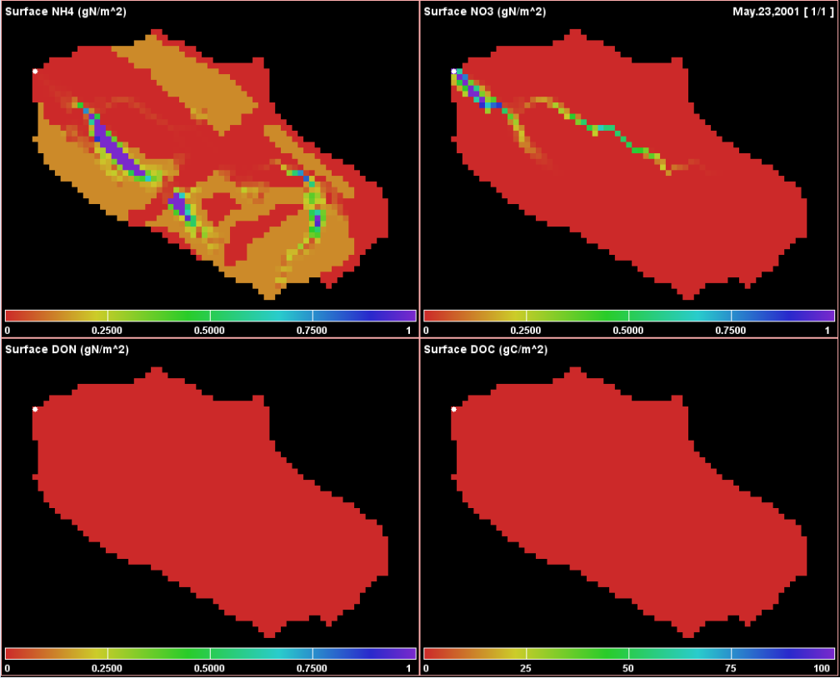

Applicable Display Range Parameters for the Surface Chemistry Spatial display are:

|  |  |
| --- | --- |
| **Chart Position** | **Display Range Parameter(s)** |
| UPPER LEFT | maxSurfaceNh4SaptialDisplay |
| UPPER RIGHT | maxSurfaceNo3SpatialDisplay |
| LOWER LEFT | maxSurfaceDonSpatialDisplay |
| LOWER RIGHT | maxSurfaceDocSpatialDisplay |

**Surface Nin Spatial** display for simulation run with useExperimentalNin = NIN_SURFACE_POOL

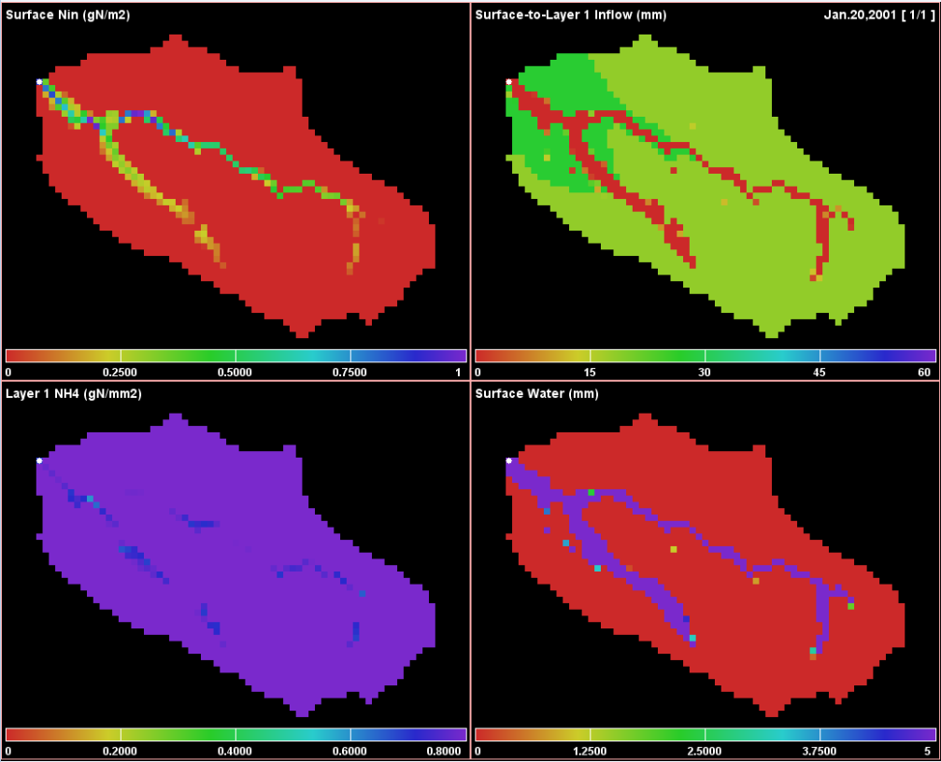

Applicable Display Range Parameters for the Surfacen Nin Spatial display are:

|  |  |
| --- | --- |
| **Chart Position** | **Display Range Parameter(s)** |
| UPPER LEFT | maxNinSpatialDisplay |
| UPPER RIGHT | maxRainSpatialDisplay |
| LOWER LEFT | maxNh4SpatialDisplay |
| LOWER RIGHT | maxNinSpatialDisplay (or)  maxStandingWaterSpatialDisplay |

Note that the LOWER RIGHT Surface Nin Spatial Display shows either Accumulated N-in (a “hidden” pool associated with Banked Michaelis-Menton mode) or Standing Water (i.e. Surface Water). The former is displayed when useExperimentalNin = NIN_LEGACY or NIN_BANKED_MICHAELIS_MENTEN, the latter when useExperimentalNin = NIN_SURFACE_POOL (as was the case for the above screen capture).

# E.3 | Deposition of Surface Chemicals

#### Overview (Tutorial E.3 – Surface Chemical Deposition)

This document describes how to use VELMA’s disturbance routine to control the timing, amount and location of a chemical to deposit to the surface pool (the surface pool is located above soil layers 1-4).

This tutorial builds upon two other VELMA surface layer tutorials. We recommend consulting these before applying this tutorial:

* *Tutorial E.1 – Mapping Surface Layer Permeabilities*
* *Tutorial E.2 – VELMA Surface Chemistry Pools*

A Surface Deposition Disturbance increases the amount of chemical in the surface pool of a specific chemical type (e.g. NH4, or a configuration-specific contaminant) at specific times and locations during a VELMA simulation run.

A single Surface Deposition Disturbance targets a single chemical type. If you need to perform surface deposition for more than one chemical (e.g. for NH4 and NO3) you much configure multiple, separate, Surface Deposition Disturbances.

The Surface Deposition Disturbance uses a diver schedule, encoded in a .csv file to specify WHEN (i.e., which simulation steps) and WHERE (i.e., which cells) additional amounts are deposited.  
(However, you specify the loops it occurs in via the activeLoops parameter.)

Overview: Configuration Steps for a Surface Deposition Disturbance

Adding one or more Surface Deposition Disturbances to a VELMA simulation configuration via JVelma involves the following two steps:

1. Create the deposition data .csv driver file for the surface deposition.
2. Add a new Surface Deposition disturbance parameterization group to the simulation configuration.

Creating a Surface Deposition Disturbance Driver Data File

Almost all the configuration information a Surface Deposition Disturbance requires is contained within a driver data file. The file consists of one or more rows of comma-separated values. Each row must contain at least four values (“fields”) which denote (in order):

iCell, yearRange, jdayRange, depositAmount.

Where:

iCell = the integer linear index of the cell location within the simulation watershed that will receive deposition amounts.

yearRange = the integer year (e.g. 1981) or range of years (e.g. 1981-1991) in which iCell will receive the specified depositAmount.

jdayRange = the integer Julian day of the year (e.g. 30) or range of jdays (e.g. 30-72) in which iCell will receive the specified depositAmount.

depositAmount = the decimal amount of chemical (in g/m2) to deposit in iCell on the specified yearRange, jdayRange (e.g. 0.5).

The yearRange, jdayRange, and depositAmount fields triplet may be repeated within a row, but it is an error to specify a given year, jday pair more than once in a single row (i.e. for a single iCell).

The file can contain a header row of comma-separated column header texts as its first row, but this is not necessary, and the header row is ignored if it exists. When a header row is present, it must *not* have a digit as the first character of the leftmost column header’s text.

Here is are the rows for a small example deposition driver .csv file:

iCell, yearRange, jDayRange, depositAmount  
5216, 1980, 30-60, 1.5  
5330, 1985-1990, 1, 0.25, 1992, 90-107, 0.3

The above example sets deposition times and amounts for two locations (cells 5216 and 5330) of the surface pool specified to the deposition disturbance. Notice that the deposition driver schedule in row 3 (for cell 5330) contains two (yearRange, jdayRange, depositAmount) “triplets” – and either row could contain as many more as necessary, so long as the year and Julian day values of any two triplets on the same row do not overlap/collide.  
Cell 5216 will receive 1.5 g/m2 to its surface pool during Julian days 30 through 60 of year 1980.  
Cell 5330 will receive 0.25 g/m2 to its surface pool on the first day of years 1985 through 1990, and 0.3 g/m2 during Julian days 90 through 107 of year 1992.

Note: whitespace is ignored by the disturbance’s file reader, the above spacing is for example readability.

Implicit in the creation of a deposition driver file is the assumption that the iCell values prefixing each row of the file are valid linear indices within the delineated watershed of the VELMA simulation configuration that the Surface Deposition Disturbance and driver data will be added to.  
It may be helpful to open VELMA the simulation configuration’s flat-processed DEM .asc file in JPDEM, delineate it at the configuration-specified outlet

Adding a Surface Deposition Disturbance Parameterization to a VELMA Configuration

Start with an appropriate VELMA simulation configuration .xml file and deposition driver data .csv file (i.e., the driver data .csv file’s cell indices are appropriate for the configuration .xml file’s DEM and delineation). Load the VELMA simulation configuration .xml file into JVelma, then click the  
Edit -> Disturbances -> “Add a Disturbance” menu item, as shown below:

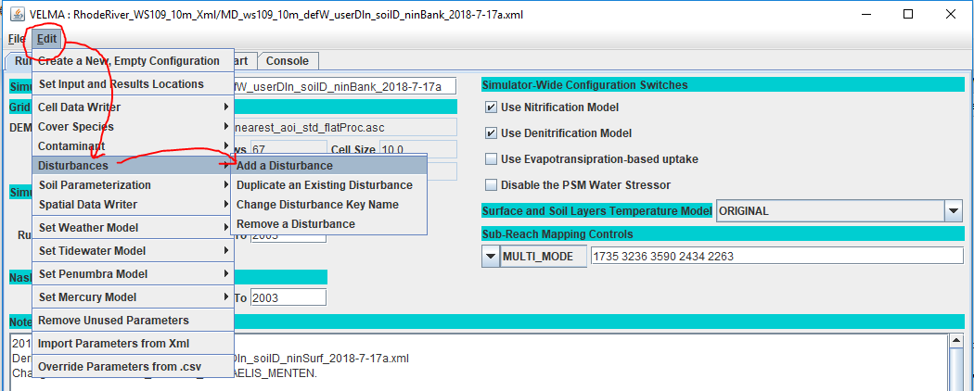

In the “Specify Disturbance model Type and Name” pop-up dialog that opens next, click the drop-down selector, scroll down, and click-select the SurfaceDepositionDisturbanceModel type:

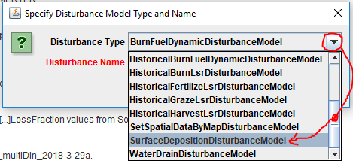

Next, type in a unique name for the disturbance in the “Disturbance Name” field of the dialog.  
Finally click the OK button, which adds a new parameterization group to the simulation configuration, and changes JVelma’s display to the “All Parameters” tab, with the Item-level filter set to only display the parameters for the newly-added contaminant.  
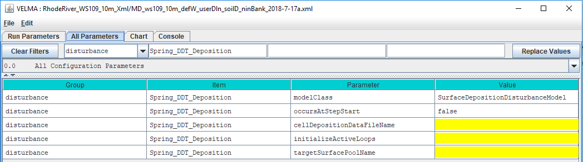

Parameters That Must Be Left Alone

The modelClass parameter is set by JVelma when you add the Surface Deposition Disturbance to the simulation configuration. Do Not Change this parameter’s value. Ever.

Parameters You Can / Must Provide Values For

The occursAtStepStart parameter is default-set to “false”, and indicates that the disturbance is run at the end of each simulation step. This means that the water balance, chemistry and chemical transport for that step has already taken place. Deposition amounts will be part of the next step’s calculations.  
The only other value for occursAtStepStart is “true” (without the quote marks) and indicates that the disturbance is run at the start of each simulation step, and be part of that step’s chemistry and chemical transport calculations. Neither value is “more correct” but setting occursAtStepStart to “true” may make analyzing results a bit simpler. (The default value of “false” is a legacy of earlier VELMA default behavior).

Set the initializeActiveLoops to the integer value or integer range of values when the disturbance should be active. For example, if your simulation was configured to run from year 2000 through 2015, and 5 loops, but you only want the Surface Deposition Disturbance to occur for the last 2 loops, set the value to “4, 5” or “4-5” (without the quote marks).

Set the cellDepositionDataFileName to the name of the deposition driver data .csv file you prepared for this Surface Deposition Disturbance. You can provide a fully-qualified path and name, a partial-path and name, or just a file name. When the name isn’t fully-qualified, JVelma assumes the file’s location is relative to the input location specified for the simulation run by the inputDataLocationRootName and inputDataLocationFileName (startups group) parameters.

The targetSurfacePoolName parameter specifies the surface pool that the disturbance will add chemical amounts to. You can deposit amounts to any of the VELMA core chemistry pools, or any contaminants parameterized for the simulation configuration.  
The values for the core chemistry pools are SURFACE_NH4, SURFACE_NO3, SURFACE_DON and SURFACE_DOC.  
To specify a contaminant surface pool, set the value of this parameter to CONTAMINANT_SURFACE_ + the value of the contaminant’s uniqueName parameter. Example, for a contaminant with uniqueName = DDT, the targetSurfacePoolName would be CONTAMINANT_SURFACE_DDT.

Capturing Output for a Surface Deposition Disturbance

No additional results are automatically recorded when a Surface Deposition Disturbance occurs.  
To record the results, set up a Spatial Data Writer parameterization for the same SURFACE_ pool that the disturbance deposits chemical amounts to, triggering it to write maps on the days you are interested in results for. You can also set Cell Data Writers for cell locations of specific interest.

# E.4 | Implementing Green Roof Applications in VELMA

#### Overview (Tutorial E.4 – Implementing Green Roof Applications)

Various green infrastructure (GI) can be included in VELMA watershed setups. This document provides guidance on how to implement green roofs in VELMA. As a user, the primary considerations are to change land cover and soil specifications to match the physical elements used for green roofs.

Intensive vs. Extensive Green Roofs

There are two general categories of green roofs: intensive and extensive. Intensive green roofs have thicker soil columns (6-36”) and allow much larger plant species to be maintained, while extensive green roofs have shallower soil columns (2-6”) and much smaller biomass plant species. Examples are shown below:

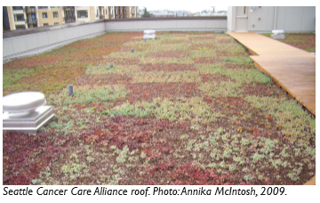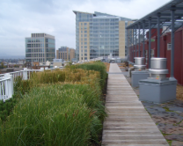

Figure 1. Examples of extensive (left) and intensive (right) green roof implementations. Images obtained from “Green roofs in Seattle: A survey of vegetated roofs and rooftop gardens”, which was prepared for the City of Seattle and the University of Washington Green Futures Lab by Annika McIntosh in August 2010 and can be located at <http://www.seattle.gov/Documents/Departments/OSE/Green-Roofs-In-Seattle.pdf>

VELMA Mechanism for Simulating Green Roofs

A VELMA user will need to make two sets of changes to correctly parameterize VELMA to simulate the implementation of green roofs within a watershed. These include cover type parameterizations and soil type parameterizations. The user will first need to create new cover and soil types that correspond to the locations of green roofs within their watersheds. This is accomplished in the same manner as adding any new cover or soil type, as discussed in other portions of the VELMA manual. Note that if extensive AND intensive green roofs are included in the same model simulation, then they need to have corresponding cover and soil types for each type.

Below is a sketch depicting the general use of green roofs in VELMA.

Layer 2

Layer 3

Layer 4

Green Roof

Impermeable Layer

Boundary

Layer 2

Layer 3

Layer 4

Layer 1

Boundary

Optional Impermeable Layer

Figure 2. Graphical depiction of simulating green roofs in VELMA. The arrows represent the flow of water and nutrients between adjacent cells.

Note that the first layer is used to describe the media used in the green roof. In the soil parameter section below, we will outline some example parameter specifications for how to implement different soil media types for the first layer of a cell. Also, note that the an impermeable layer must be simulated using parameter choices in order to reduce or eliminate all flow from the green roof to the belowground layers 2-4. This will be specifically described in a following section.

The next two sections will describe how the soil and cover parameters can be altered to implement green roofs on a given cell (or multiple cells). Then, we will specifically describe how to change parameterizations to reduce or eliminate flow from the first layer to the other layers (2-4).

Soil Type Specifications

The table below shows example soil type specifications for intensive and extensive green roofs. These data were obtained from Roof-Lite Media Data sheets (Skyland USA, LLC). These media characteristics have been approved for use as green roof media in Seattle, Washington to be eligible for stormwater credits. Note that you will want to verify these soil parameters and characteristics for your particular watershed before implementing these values.

|  |  |  |  |  |  |
| --- | --- | --- | --- | --- | --- |
|  | **Properties** | **General (Sandy Loam)** | **Extensive Roofs (Top Layer)** | **Intensive Roofs (Top Layer)** |  |
| Porosity (v/v) | 0.453 | 0.70 | 0.7 |
| Field Capacity (v/v) | 0.207 | 0.60 | 0.65 |
| Wilt Point (v/v) | 0.095 | 0.12 | 0.12 |
| Hydraulic Conductivity (mm/day) | 770 | 87,000 | 10,000 |
| Bulk Density (g/cm3) | 1.52 | 0.50 | 0.75 |
| Depth (mm) | 500 | 100 | 500 |

To specify these parameters in VELMA, create a new soil parameterization for Green Roofs.

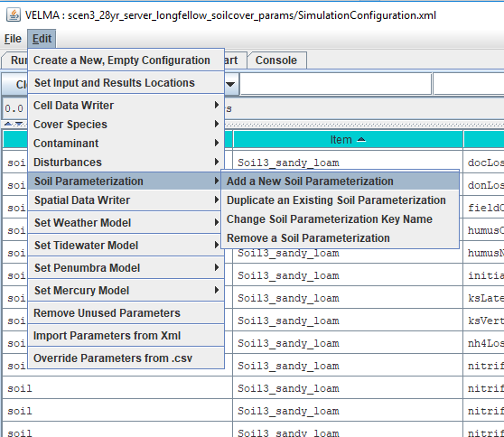

Then, set the parameters for the Green Roof soil to only apply to the 1st soil layer, as shown below.

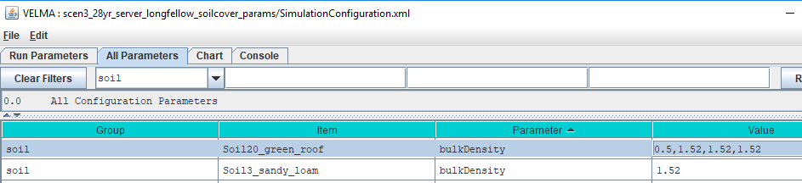

In the above screenshot, we have two soil layers (Soil20_green_roof and Soil3_sandy_loam). Note however, that the change in the bulkDensity parameter for the Green Roof soil type only pertains to the first soil layer. This can be done for the remaining soil parameters, e.g., porosity, field capacity, depth.

For a list of all relevant soil parameters that are parameterized to use Green Roofs, please see the VELMA .xml file of the Longfellow watershed in Seattle, Washington, which is provided as an example.

Cover Type Specifications

Extensive green roofs can support low-level biomass growth, while intensive green roofs can support much higher biomass values. We used Sedum album data from Getter et al. (2009), which provided average estimates of 240 and 1000 gCm2yr-1 for extensive and intensive green roofs, respectively.

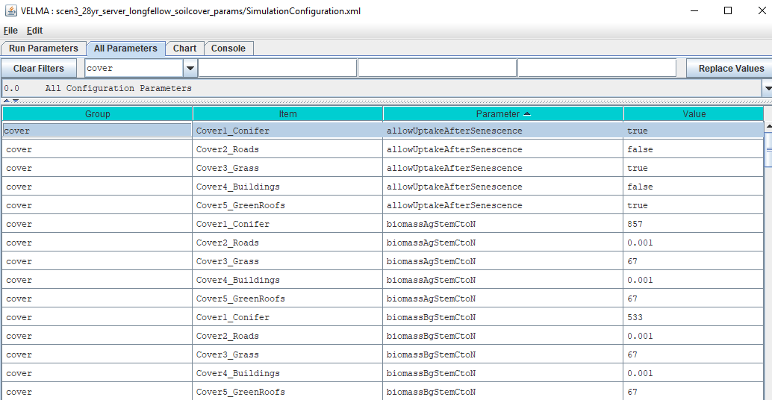There a large number of parameters that need to be properly parameterized to match the growth of aboveground and belowground biomass for a particular cell. Below is an example showing fiver cover types, including Conifer, Roads, Grass, Buildings, and Green Roofs. In some cases – for example, with extensive green roofs – you will want to match your parameterizations of the “Grass” cover type with the green roof cover. In other cases, you may want to use blends of parameterizations to represent species mixtures.

For a list of all relevant cover parameters that are parameterized to use Green Roofs, please see the VELMA .xml file of the Longfellow watershed in Seattle, Washington, which is provided as an example.

Limiting Flow from the 1st Layer to the Underground Layers

The final step to implementing green roofs in VELMA requires the user to reduce the amount of flow from the first layer to the second through fourth layers to a near-zero value. Note that the first layer represents the media contained in the green roof, and the other layers represent the soil material underneath the buildings; that is why we wish to remove the vertical flow from the first to the other layers.

The mechanism to perform this operation is the following VELMA parameter: */soil/<GreenRoofSoilName>/setSoilLayerKsVerticalValues.*

As shown in the following screenshot, the first of four values should be reduced to a near-zero value. Note that using 0 (or even 0.1) will oftentimes cause the model to crash, so the user will need to test different possibilities to find a solution that will not crash the model yet simulate the desired mechanism.

An example of a parameterization that resulted in a crashed model run.



An example of a parameterization that resulted in a successful model run.



Ultimately, the user will need to validate the use of particular ksVert and ksLat values by comparing simulated with observed data.

Conclusions

This document has outlined some basic ways to incorporate green roofs within VELMA. Much testing and validation is needed to verify that this mechanistic approach is suitable for simulating green roofs in particular watersheds. We emphasize the need to validate VELMA with observed data – not only at a single gauge at the watershed’s outlet but also with other site-specific or average observed data (e.g., soil moisture, evapotranspiration) that can be used to further constrain the model for particular green roof implementations.

References

Getter, K.L., Rowe, D.B., Robertson, G.P., Cregg, B.M. and Andresen, J.A., 2009. Carbon sequestration potential of extensive green roofs. *Environmental science & technology*, *43*(19), pp.7564-7570.

Skyland USA, LLC, Data sheets for parameterization information for different types of green roofs. <https://www.rooflitesoil.com/downloads/>

# E.5 | Irrigation Disturbance

#### Overview (Tutorial E.5 – Add Irrigation Disturbance)

This document describes how to build an Irrigation Disturbance in VELMA. This provides a way to add specific amounts of water to specific categories of cells within the simulated watershed, at specific steps during the simulation run, and for specific precipitation conditions.

Use the Irrigation Disturbance routine in VELMA to specify when (Julian days) and where (mapped cell locations) you want to add irrigation water. The irrigation water is added “as-if” it is a rain addition for the specified cell(s). This prevents irrigation water additions from perturbing VELMA’s water balance mechanisms.

Note that cell locations to be irrigated are limited to the Cover Types you specify. For example, suppose you wish to irrigate only a subset of grassland areas amongst all “Grassland” cover type areas within the simulated watershed. In that case, you will need to create a cover type named “IrrigatedGrassland” (or something similar), and assign a unique integer to all cells for that new cover type in the watershed’s Cover Type map. Otherwise all cells designated in the Cover Type map as “Grassland” will be irrigated.

Using the Irrigation Disturbance

Add an Irrigation Disturbance to your simulation configuration in JVelma via the menu Edit -> Disturbances -> Add a Disturbance item.

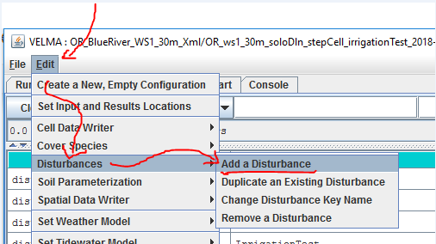

Clicking the "Add a Disturbance" item opens the "Specify Disturbance Model Type and Name" dialog. Select "IrrigationDisturbanceModel" in the dropdown selector as the model type.

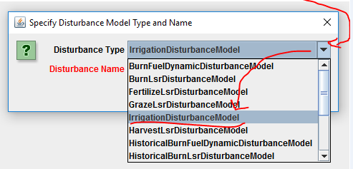

The Disturbance Name can be any meaningful text name, but it can only be composed of letters of the alphabet, the digits 0-9, and the underscore ("_") character.  
It must also be unique from any other disturbances named in the same simulation configuration.

After entering a name for the new Irrigation Disturbance, click the OK button, and JVelma will create a new parameterization group and filter the parameters table view to show only its parameters in the "All Parameters" tab.

Here is an example of a new Irrigation Disturbance, created with the name "Irrigation Test":

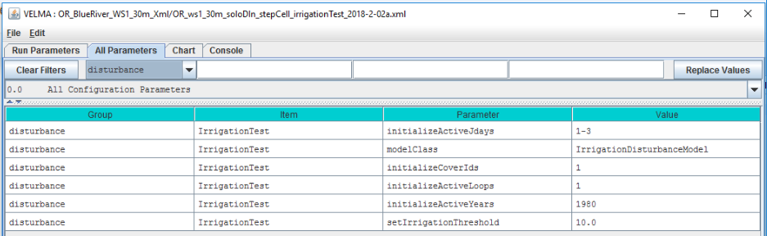

The example parameterization above schedules irrigation to occur for cells with Cover Type = 1 during the first simulation loop, on the first 3 days of year 1980.

Even during the 3 days of 1980 when irrigation *can* occur, it will *only* occur for Cover Type 1 cells in which (irrigationThreshold - totalPrecipitation) > 0.0.  
(Where totalPrecipitation is the total precipitation for a given cell on a given day – e.g. if irrigationThreshold = 10.0, but the totalPrecipitation = 5.0, no irrigation occurs even if the cell is otherwise-eligible.)

Capturing Irrigation Details in VELMA Simulation Results

To observe how much irrigation occurs (and when it occurs), add a SpatialDataWriter parameterization for the VERTICAL_WATER_ADDITION pool to your simulation configuration.

Here is an example, configured to emit .asc maps on the same days as the example Irrigation Disturbance configuration given above.

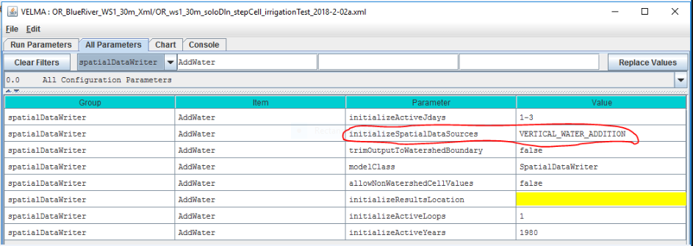

Be aware that the VERTICAL_WATER_ADDITION pool is shared by other disturbances and simulator engine mechanisms.

If you have Groundwater Storage, or Water Drain Disturbance configured and active in your simulation, the VERTICAL_WATER_ADDITION amounts represent the sum of the contributors than share the pool.  
(Currently, however, there are no other results reporting mechanisms for irrigation amounts.)

# E.6 | Groundwater Storage Mechanism

The VELMA simulator can handle over-saturation water amounts in two ways

#### Overview (Tutorial E.6_Groundwater Storage Box)

This document describes how to configure VELMA’s groundwater storage mechanism, an optional method for simulating vertical drainage of excess (over saturation) water to a pool of deep groundwater. Drainage to groundwater only occurs when all the layers (1-4) in a cell’s soil column are fully saturated.

When the groundwater storage mechanism is not invoked – for example when bedrock or other impermeable layer is present below layer 4 – no drainage to deep groundwater occurs and VELMA simulates upwelling of water within the saturated soil column to the surface.

Due to its original model design, and by its default implementation, the VELMA Simulator behaves as if there is an impermeable bedrock layer underlying the bottom layer of each cell’s soil column.  
When all the layers in a cell’s column are fully saturated, any additional water input on a given day “rebounds” up the water column to the surface of the cell, and – if the soil layer column is completely saturated -- becomes standing (i.e. surface) water for the cell.

However, the VELMA simulator also provides an alternate mechanism – the groundwater “storage box” – for handling water amounts over the fully-saturated amount a cell’s soil column can contain.  
When the groundwater storage mechanism is enabled (as part of a simulation’s configuration) a specified fraction [0.0 to 1.0] of the excess water that reaches the bottom of a saturated soil column is removed from the column and accounted for in a single “storage box” amount accumulator. The remaining excess water “rebounds” up the soil column. The fraction of the excess water transferred to the ‘storage box” is, in effect, removed from the watershed’s water dynamics.

The amount of water transferred to the groundwater storage box is tracked and reported, but is *not* spatially explicit, and is not returnable to the watershed after it is transferred to the “box”.  
In effect, water in the storage box has been removed from the simulation system.

However, the fraction that the determines the amount of water transferred may be either global or spatially explicit. I.e. different groundwater fractions may be specified for each cell in the watershed.

In testing, enabling the groundwater storage mechanism has the general effects of reducing watershed total runoff, and “dampening” the reactivity of the day-to-day runoff relative to water input (precipitation, snow melt, etc.).

Enabling the Groundwater Storage Mechanism

The groundwater storage mechanism is enabled/disabled by the setGroundwaterStorageFraction parameter’s value, which also specifies the global fraction or map of cell-specific fractions the mechanism employs.

The following table indicates the three types of values the parameter accepts:

|  |  |
| --- | --- |
| **Value of setGroundwaterStorageFraction** | **Groundwater Mechanism Status and Behavior** |
| Empty/blank | **Inactive** No groundwater storage occurs. |
| Single numeric value in range [0, 1] | **Active** Specified value is fraction used for every cell’s groundwater calculation. |
| Filename of an .asc map containing values, each in range [0, 1] | **Active**  Specified map’s values provide cell-specific fractions for groundwater calculations. |

To find and set the setGroundwaterStorageFraction parameter in JVelma:

1. Click the “All Parameters” tab.
2. Type the (case-sensitive) text setGroundwaterStorageFraction into the middle text-entry filter field.
3. Double-click the “Value” field of the setGroundwaterStorageFraction parameter row, and enter a value.

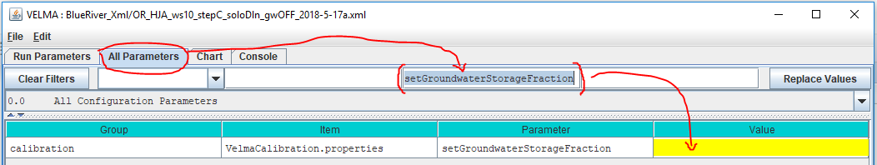  
  
To ***disable*** the groundwater storage mechanism set the setGroundwaterStorageFraction paremeter’s value to empty/blank.   
*(Note: The value 0.0 has the same effect, but use empty/blank, because this clearly signals “disable the groundwater mechanism” to the VELMA simulator.)*

Water “Lost” to the Groundwater Storage Box is Reported in Simulation Results

When the enableGroundwaterStorageBox parameter is set to true, over-saturation water amounts are transferred to the storage box, and are effectively removed from the watershed. (Currently, there is no mechanism for reintroducing water transferred to the storage box back into the simulation.)

The VELMA simulator reports the groundwater storage amount in the following results:

1. In the simulation runtime log file.  
   Usually named GlobalStateLog.txt (unless user-configured for a different name),  
   the runtime log contains an entry reporting the total amount of water (in mm) transferred to (and thus accumulated in) the groundwater storage box over the course of the entire simulation.  
   Here is an example of the output:  
   INFO 12:02:39 VelmaSimulatorEngine: Groundwater Storage true : storage amount=4.203496685912282E8
2. In the DailyResults.csv file.  
   Simulation runs with enableGroundwaterStorageBox == true write the per-day amount of water to a column named Groundwater_Storage_Addition(mm/day).  
   The amount is not an averaged-per-cell; it is the total amount of water in the storage box.  
   To determine the addition (as opposed to the total) amount of water added to the storage box on a given day, subtract the given day’s amount from the prior day’s amount.
3. In Cell Data Writer .csv results files.  
   If a groundwater storage-enabled simulation run also has one or more Cell Data Writers configured, each Cell Data Writer’s results file will contain a column named Groundwater_Storage_Addition. This column reports (in mm) the amount of water transferred from to cell to groundwater storage, per day. The values are not cumulative. To determine the cumulative amount over a span of days, sum the amounts in this data column for the days in question.

# E.7 | Spatial Data Writer Key Words for Generating ASCII VELMA Outputs for Data Visualization

#### **Overview** (Tutorial E.7_Spatial Data Writer Key Words for ASCII Data Visualization)

The VELMA GUI can be used to set up spatial data writer keywords corresponding to specific hydrological and biogeochemical VELMA outputs. VELMA has a spatial data writer disturbance submodel that users can configure to produce ASCII output files (georeferenced grid cell arrays) that are saved to the VELMA results folder. See the VELMA 2.0 User Manual (McKane et al. 2014) for details on how to set up VELMA spatial data writer disturbances.

The purpose of the present tutorial (E.8) is to update available spatial data writer keywords that must be specified if a user wants VELMA to produce ASCII files for outputs of interest. After a simulation ends, the user can load the ASCII files into GIS-based data visualization tools such as ArcGIS or VISTAS (<http://blogs.evergreen.edu/vistas/vistas-software/>).

Note: The 2014 VELMA User Manual is downloadable from the EPA VELMA website: <https://www.epa.gov/water-research/visualizing-ecosystem-land-management-assessments-velma-model-20>

How to set up VELMA spatial data writers with user-specified keywords

Section 23.4 of the VELMA 2.0 User Manual (McKane et al. 2014) provides instructions for implementing spatial data writers in VELMA 2.0 or 2.1. This tutorial is limited to updating the “Table of Spatial Data Sources” (keywords) described in the 2014 User Manual.

Spatial Data Writer Keyword Data Types

There are four kinds of keyword data types that users can specify when configuring spatial data writer VELMA outputs. These codes appear in the first column of Figure 1.

* Accessor = Spatial Data that is not directly stored in a spatial data pool object
* Direct = Spatial Data that is directly stored in a spatial data pool object
* Disturbance = Spatial Data **automatically** **written** (when enabled) by disturbances.
* Buffered = Spatial Data directly stored in a spatial data pool object, but only when a SpatialDataWriter requires it.

**Figure 1. Updated VELMA spatial data writer case sensitive keywords (enter exactly as shown)**

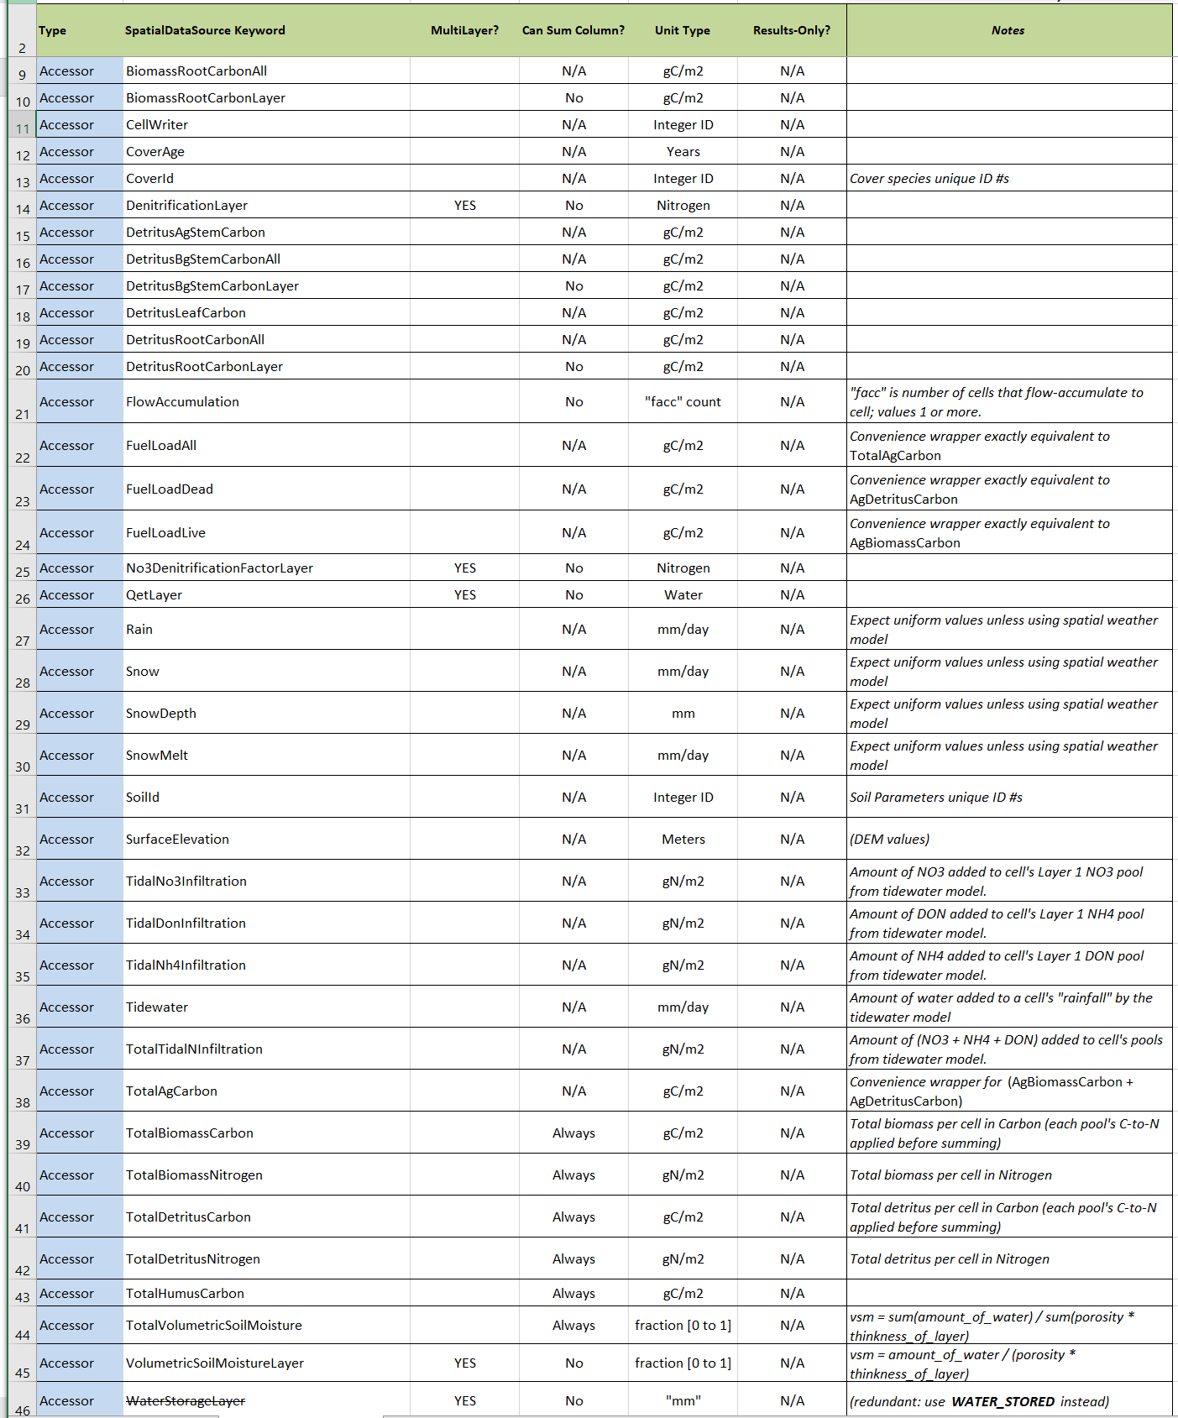

(continued)

**Figure 1 (continued). Updated VELMA spatial data writer case sensitive keywords (enter exactly as shown)**

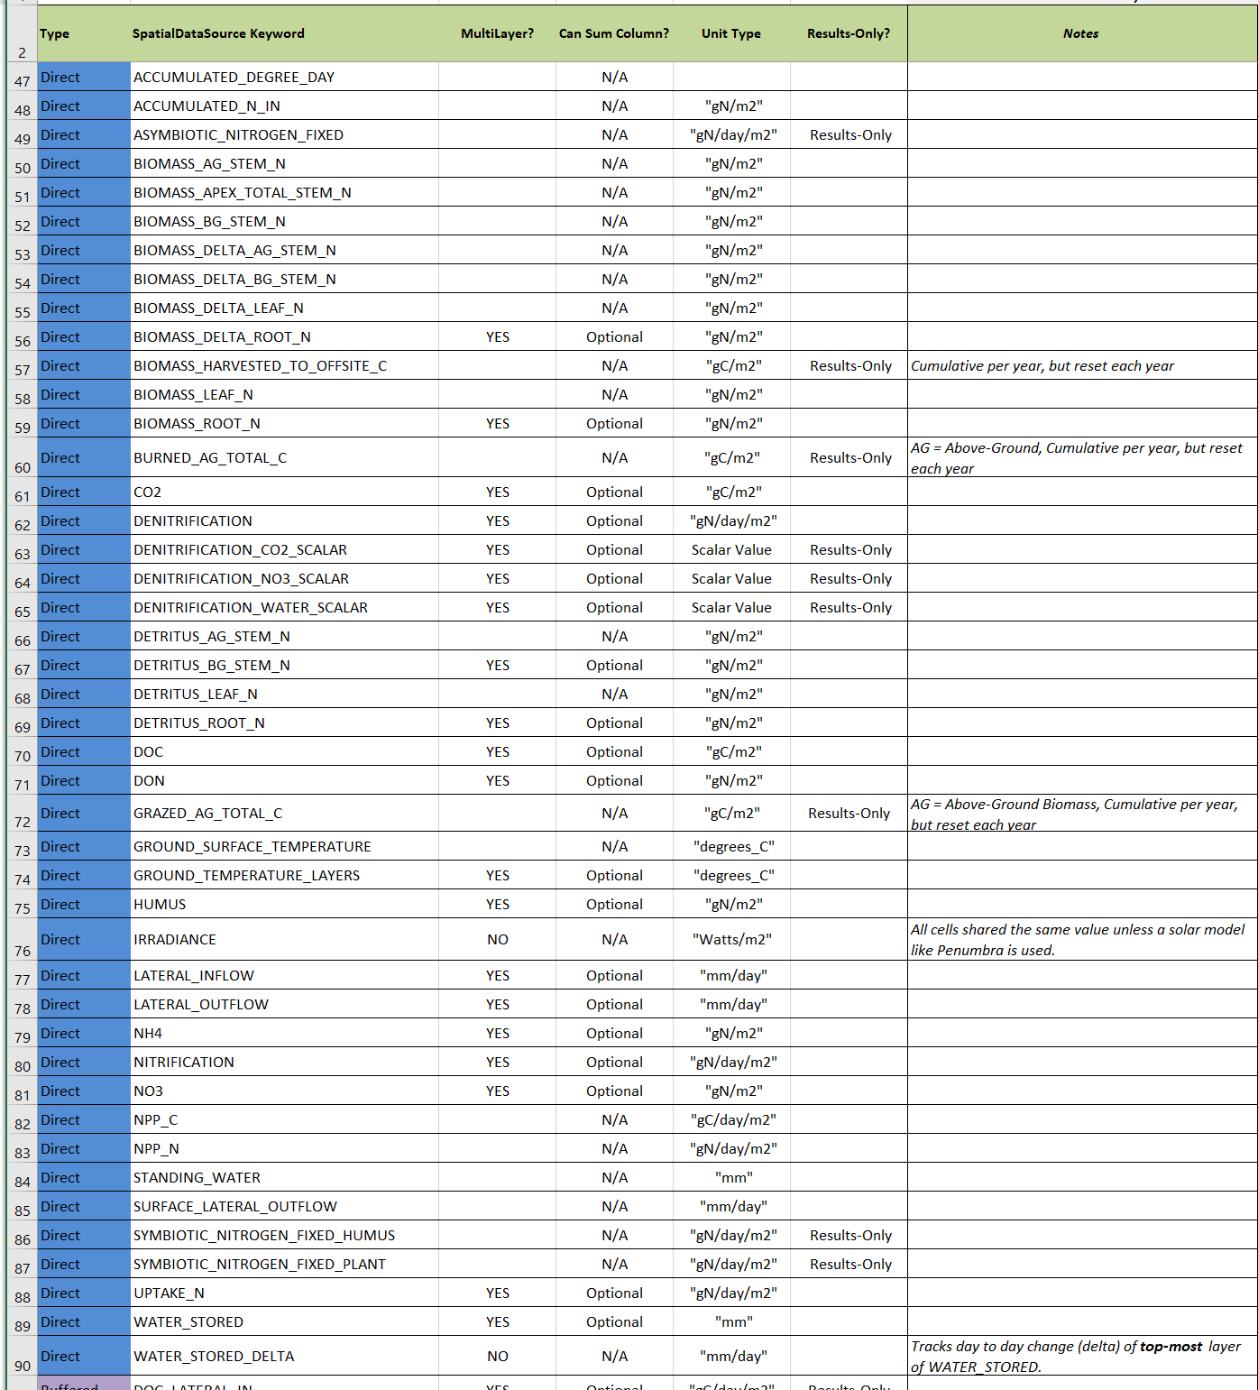

(continued)

**Figure 1 (continued). Updated VELMA spatial data writer case sensitive keywords (enter exactly as shown)**

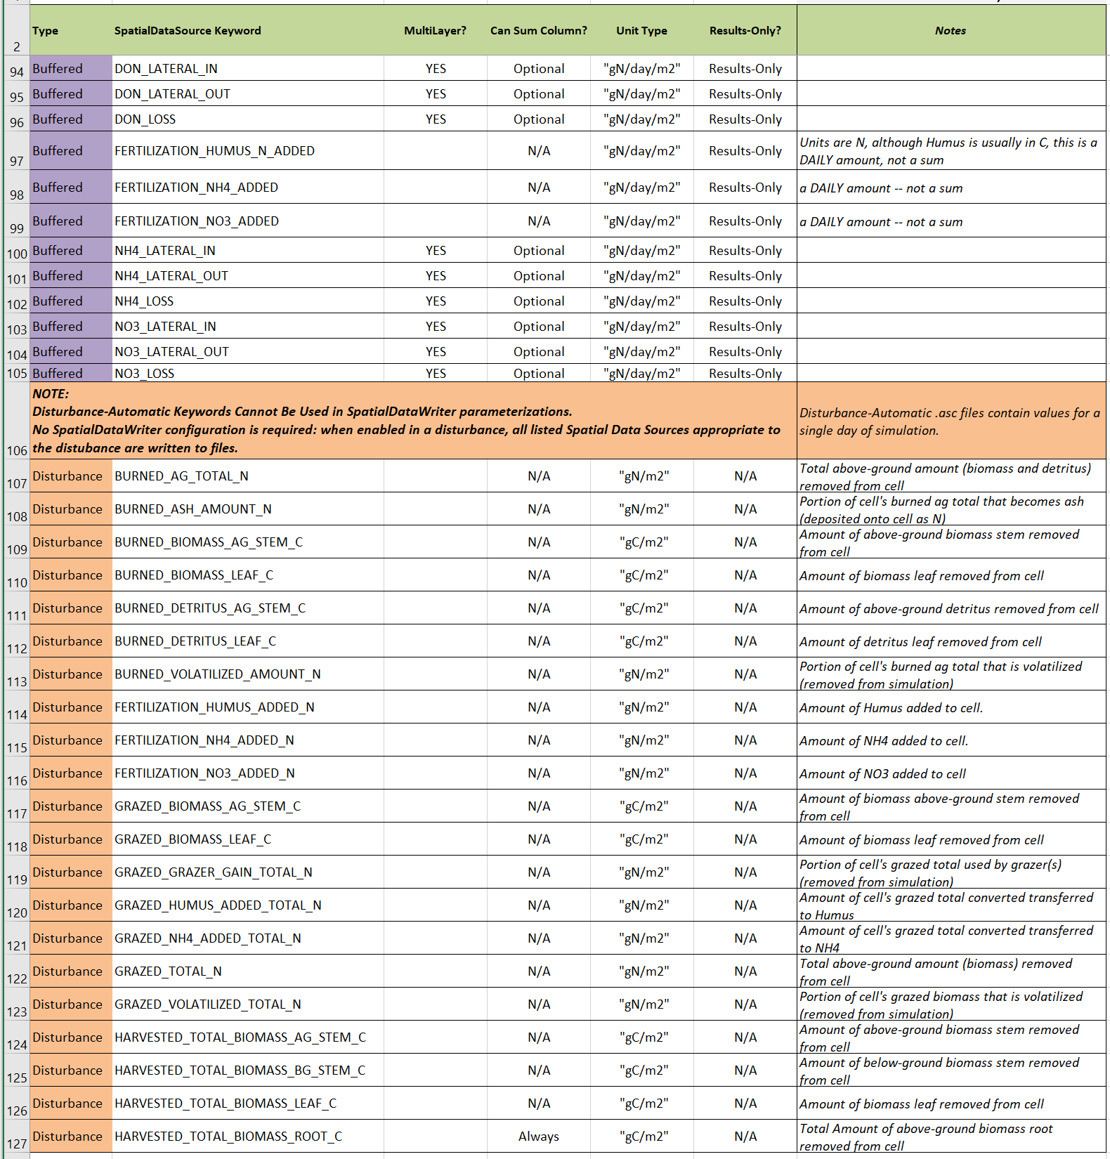

End

1. Two or more Set Spatial Data By Map disturbances may be set to use the same Grid Ascii map file as their input data source, but it’s more likely that a given spatial data pool to have its own unique input data source.